Name: 梁中瀚

Student ID: r09922a02

# Part 1

Detected corner for 1.png

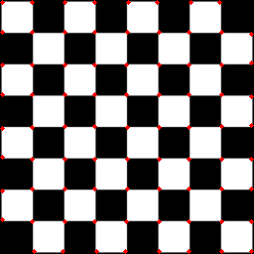

Detected corner for 2.png

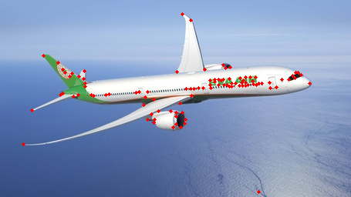

Detected corner for 3.png



Threshold 25 on 2.png

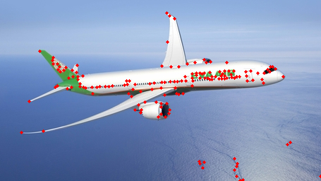

Threshold 50 on 2.png

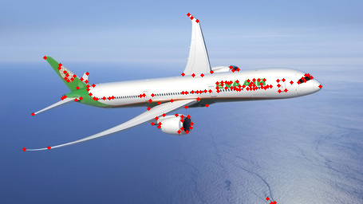

Threshold 100 on 2.png



三種threshold的差異

Threshold越小回傳的corner就越多。

Threshold從25變成50，比較明顯的變化在背景藍色的波浪。

Threshold從50變成100，就沒有太多明顯的減少。

比較特別的是飛機上的字體，不管threshold設多少，字體的corner都會被偵測到，可能是相對較穩定的特徵點。

# Part 2

1.png

Cost for each filtered image;

|  |  |
| --- | --- |
| RGB轉gray scale參數 | L1 norm大小 |
| CV2.cvtColor | 38009491 |
| 0.1,0.0,0.9 | 38133837 |
| 0.2,0.0,0.8 | 36887563 |
| 0.2,0.8,0.0 | 38791162 |
| 0.4,0.0,0.6 | 38206466 |
| 1.0,0.0,0.0 | 41995803 |

Original RGB image:

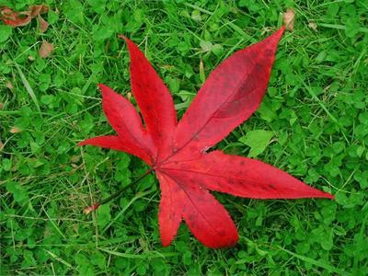

Lowest cost gray scale image:

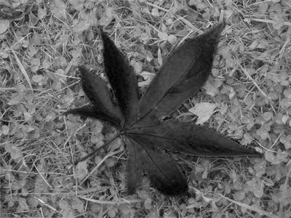

Lowest cost filtered RGB image:

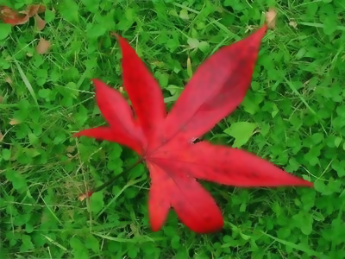

Highest cost gray scale image:

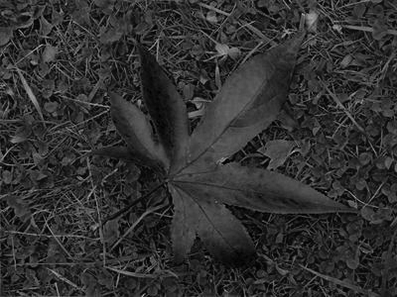

Highest cost filtered RGB image:

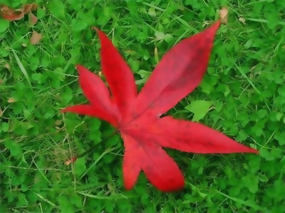

2.png