**Description**

Financial institutions suffered significant losses due to default on loans from users. This led to a tightening of loan guarantees and an increase in loan refusal rates. The need for a better credit risk assessment model was also raised by these institutions. This requires a study to estimate the determinants of vehicle loan defaults. The financial institution has hired you to accurately predict the likelihood of a user defaulting on the due date.

This is a synthetic dataset created to be used for academic purposes for beginners who want to practice financial analytics from a simple financial dataset. This dataset contains information on default payments and customer profile.

**Task**

* Create a model to predict default.

Create loan default prediction model to predict if a user will default or not.

**Evaluation**

Model are evaluated using F1 between the predicted and actual label.

F1 is calculated as follows:

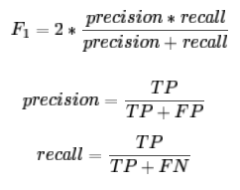

True Positive (TP) = your prediction is 1, and the ground truth is also 1  
False Positive (FP) = your prediction is 1, and the ground truth is 0  
False Negative (FN) = your prediction is 0, and the ground truth is 1

Example calculate F1 using sklearn in python:

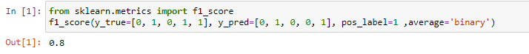

**Submission File**

For each ID in the test set, you must predict 1 if the user is default, and 0 otherwise. The file should contain a header and have the following format:

customer_id, default

9365, 0

999, 0

2835, 1

…, …

3190, 1