[1]

Distributed Computing Framework for Profit Maximizing Problem of the Load Serving Entity with Critical Peak Pricing

Jin Ma, Sung Chan Park,

*Abstract*—These instructions give you guidelines for preparing papers for IEEE Transactions t.

*Index Terms*—Enter key words or phrases in alphabetical order, separated by commas. For a list of suggested keywords, send a blank e-mail to [keywords@ieee.org](mailto:keywords@ieee.org) or visit <http://www.ieee.org/organizations/pubs/ani_prod/keywrd98.txt>

# INTRODUCTION

R

ecently, deregulation of the power industry empowers third party entities to participate in electricity wholesale market [1]. Among variety of business model in the industry, load serving entity (LSE) is one of the popular one for the entities. The main role of the LSE is to serve demand of customers with purchasing electricity from wholesale market. In the deregulated electricity market circumstance, wholesale market price which reflects supply and demand is time-varying same as markets for other commodities [2]. Thus, LSE who aims its own profit maximization in the environment should forecast the wholesale market prices to prevent loss that is occurred when market price is rise above retail price. Simultaneously, the loss should be reflected in retail price by some means for the LSE perspective. In other words, determination of the proper level of retail price is very important for the LSE.

Dynamic pricing scheme which retail price is time-varying same as fluctuating wholesale market price is widely used for the purpose, especially, RTP(Real-time Pricing)[3-5], TOU(Time-of Use)[6-8], CPP(Critical Peak Pricing)[9-14]. In this study, we focus on CPP which has unique feature, critical event, over other dynamic pricing schemes. Critical event is option for the LSE which relatively high retail rate is applied compared to other time periods. The high rate is often called as critical peak rate. LSE can maximize its profit through optimally scheduled critical events because the high retail rate induce customers demand reduction during the time period that wholesale market price is forecasted to be high.

Several studies in [9-14] tried to derive analytical or numerical solution for this profit-maximizing problem for the LSE using CPP. To the best of our knowledge, the problem started from determination of the CPP events time using dynamic programming framework which gives intuition for the LSE that it should trigger critical event when not only wholesale market price but also customers’ demand are forecasted to be high[9]. Then, the event scheduling problem is solved under various conditions, such as with wind power generation[10] or considering customers demand profile[11].

On the other hand, several studies focused on some parameters to be designed in the profit-maximizing problem of CPP: retail rates (peak and normal rate), numbers of events, event duration[12,13]. Among them, determination of the critical peak rate requires repetitive run of the event scheduling problem for all candidate for optimal critical peak rate which is computationally challenging works. Moreover, several frameworks used in solving profit-maximization problem such as dynamic programming[9], integer programming[10] incurs curse of dimensionality when the size or time horizon of the problem is very large.

To deal with this problem, we propose and implement computational system architecture which enables efficient calculation for two main problems in the profit-maximization problem of the CPP, event scheduling and parameter design. It is very crucial in real-world implementation of the CPP for the LSE who should derive optimal parameters for CPP using restricted time period and computational resources. Studies in [9-14] for the issues is mainly focused on parameter design methodology and improvement for it, however, there is few approaches for computational architecture for enormous calculation in the problems

To fill the gap between theoretical and industrial requirements for implementation, we used distributive processing scheme to reduce simulation time in solving profit-maximizing problem of the LSE because the problem can be separated into several numbers of sub-problems. For example, in [12], determination of the optimal peak rate requires solution of event scheduling problem for each candidate of the optimal peak rate. LSE simply pick the one which yields most huge profit for itself as optimal peak rate, it is the reason why LSE can separate each calculation as different workload. In this study, determination of the optimal peak rate will be conducted through distributed processing framework. By simulation time comparison, it is proved that profit maximizing problem in very long time horizon or large number of the states and variables is also practically solvable.

We implemented the CPP simulation on the EDISON[1, 2] platform that supports computational science engineering HPC (High Performance Computation) as a parallel processing computing resource, then applied the simulation, and compared it with the performance in the existing legacy environment.

EDISON (Education-research-industry Integration through Simulation On the Net) is a well-known online scientific-computing simulation platform developed by KISTI. This platform has been designed and developed to educate students and assist researchers to conduct their research online with a variety of large-scale computing software tools from diverse computational science and engineering fields.

Over the past seven years, the platform has become sufficiently mature to support approximately 60,000 cumulative users and more than 350 simulation software tools being used in Korea and a few foreign countries such as Taiwan. then, Providing user service in CFD(Computational Fluid Dynamics), CHEM(Computational Chemistry), Nano Physics, CSD(computational structural dynamics), Computer aided optimal design), CMED(Computational Medicine), UE(Urban Environment), CEM(Computational Electro Magnetics) and three of special site operate.

Another feature of the platform is that CPP Simulation code is written without MPI (Message Passing Interface) programming, but parallel processing can be performed using the functions provided by the platform. This implies that the user who wants to perform the simulation lowers the entry barriers so that the simulation can be performed even without MPI and programming knowledge.

We also confirmed the feasibility of using the supercomputer in the commercial domain. (중복느낌이지만 In this paper, we can confirm the possibility of using supercomputer for computational science and commercial domain and expanding field.)

This paper is organized as follows. In chapter 2, we gives brief summary about deregulated electricity market environment and profit maximizing problem of the LSE in the environment as background knowledge. In the problem, two main parameters of the CPP, optimal critical events time and peak rate, is target of the design. In chapter 3, we introduce computational architecture to deal with the problem described in chapter 2. Then, we expand our discussion to benefit of the architecture in numerical computation by comparison with that from legacy system in chapter 4. In chapter 5, ~~~

# Backgrounds

## Electricity Market Circumstance [Kirchen]

In deregulated electricity market circumstance, LSE는 electricity wholesale market에서 전력을 구매하여 its customers에게 serve한다. The wholesale market에서 구매하는 가격은 시간에 따라 time-varying하며 customers에게 resale하는 retail price는 LSE가 design한다.

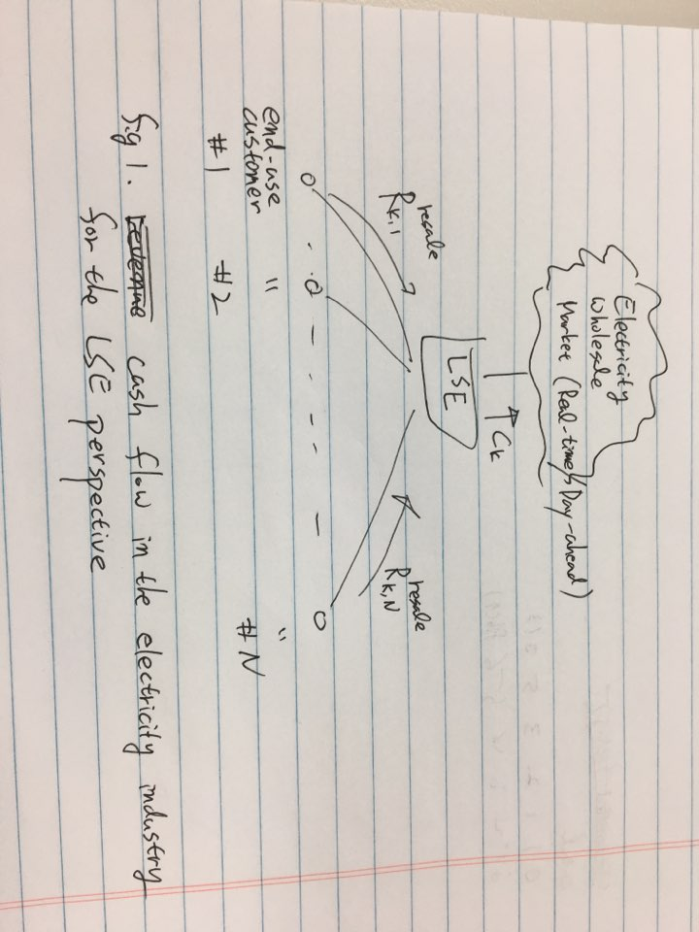

## Event Scheduling Problem[Joo],[기타등등]

Under the circumstance described in II.B, LSE maximize its profit which can be expressed as follow.

 (1)

Where,

 (2)

And

 (3)

$g_{k}$ profit function of LSE in time k

$ρ_{RT,k}$ real-time wholesale market price

$R_{k}^{resale}$ revenue of LSE from resale in time k

$C_{k}$ energy cost

$x_{k}$ remaining CPP event number of LSE decreasing one by one at a time LSE issues event

$N$ scheduling time period of the LSE

$N_{CPP}$ event number of the CPP during the period

$d$ duration of CPP event time

Profit function of the LSE is composed of two part, $R_{k}^{resale}$ and $C_{k}$, which can be expressed as

(4)

And

 (5)

, respectively.

$ρ_{CPP}$ retail rate when CPP is issued

$ρ_{N-CPP}$ retail rate when CPP is not issued

$q_{CPP,k}$ demand level at time k if CPP is issued

$q_{0,k}$ nominal demand level at time k

$u_{k}$ binary control variable about issuing CPP

In [xx], customers reduced demand due to CPP events is expressed as

 (6)

In the objective function to maximize profit, LSE forecasts demands $q_{0,k}$ and $ρ_{RT,k}$ and design optimal CPP scheme $ρ_{CPP}$*, $ρ_{N-CPP}$* and then filnally decide issue schedule $u_{k}$ under estimated customer’s responsiveness $β_{k}$*.*

The constraints are described in the following pharagraphs.

1. If once event is issued, it is continued during pre-determined event time duration time $d$. $I(statement)$ is a indicatoer function which have 1 if statement is true but 0 otherwise.

 (7)

.

1. The number of CPP event in the certain period is limited(e.g. 3 times in a month). This is necessary condition for limiting customer’s inconvenience due to frequent event issue.

 (8)

1. Minimum interval constraint is required between two consecutive CPP event(e.g., 24 hour). Due to we consider relatively long CPP event duration in constraint 1, customer need some recovery time after event. For example, due to reduction at noon responding to CPP event which have 3 hours of duration could cause lackness of time to boil hot water before the evening when customer want to take a shower. It is main difference between generator and demand resources, even it has infinite rame rate, more severe constraint is applied because of customer’s utility.

  (9)

## Determination of the Optimal Peak Rate[Park]

In terms of the optimal peak rate, we first need to define the profit index, which means an additional profit that the LSE will receive from triggering a critical event. Suppose that  denotes the optimal solution of the event scheduling problem for a given . Then, the profit index, , for a critical event in period  can be expressed as [11]

|  |  |
| --- | --- |
|  | (11) |

where the event duration is equal to the maximum event duration, , because the LSE’s profit is always maximized when the maximum event duration applies. Substituting (3) into (11) makes  a quadratic function of . Then, the critical point of the function is determined as the optimal peak rate without payback, , which has a form as

|  |  |
| --- | --- |
|  | (12) |

# Architecture of the System

## Basic Principles for the Platform

Chapter 2에서 살펴보았듯 Design of optimal peak rate는 base rate가 fix되어 있을 때 여러 candidate for the optimal peak rate 중 LSE profit을 maximize하는 peak rate를 choose하는 것이다. Each candidate에 대해 event scheduling problem을 풀어야 하는 문제로 기본적으로 piecewise 나누어 병렬처리가 가능한 문제이다. 따라서 우리는 아키텍쳐 설계 시 다음과 같은 principle을 제시한다.

* 효율적인 병렬처리가 가능할 것
* Effective parallel processing should be possible
* 반복적인 연산에 강 할 것
* Strong in repetitive operations (hardware or software aspects)
* (기타 EDISON을 써야 하는 이유들…)
* Reducing the time and cost by leveraging the current services that the platform

## Architecture Design for the System

The EDISON platform combines the latest research achievements in various specializations with advanced IT technology. It provides a cyber research environment that can be used in the fields of education, research, and industry.

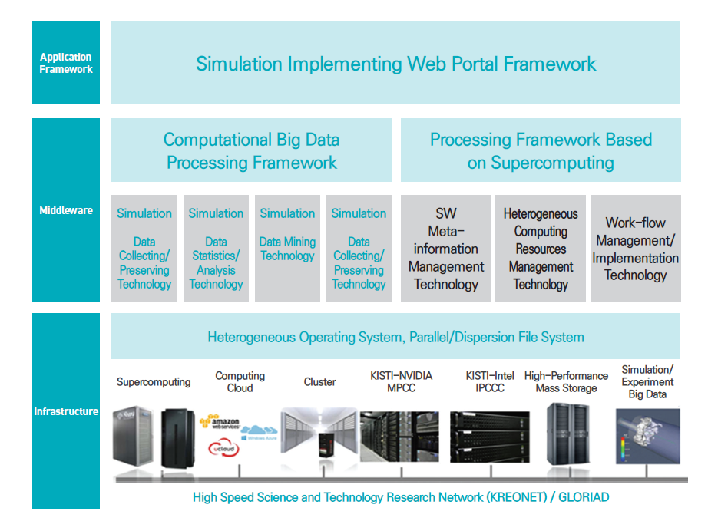

Fig. Overview of EDISON Platform Architecture and Technology

The advantages of the designed system are as follows.

▣ Building Ecosystems Between Simulation Calculation Tool Developers, Service Providers and Users

▣ Providing an Environment for Performing Computational Scientific Simulations Utilizing Large Scale Global Computing Resources

▣ Independent Software Platform for User Communities and Applicable Professional Field

▣ Providing Various Computational Science and Engineering Simulation Interpretative Tool and Pre- / Post-Processor

▣ Developing Intelligent Computational Science and Engineering Convergence Platform Based on HPC(High Performance Computing) and Data

In this paper, we have redesigned the system to collect, refine, forecast and optimize power price and demand data using existing computational science engineering platform.

~~(단순히 EDISON Platform이라고 하지 말고 전력가격/수요 데이터를 KPX API 붙어서 수집 – 정제 – 예측을 포함한 forecasting module과 이를 활용하여 계산하는 optimization module로 분리하고 시각화까지 하는 아키텍처 그림을 그려면 있어보인다…. 예를 들면 위 그림)~~

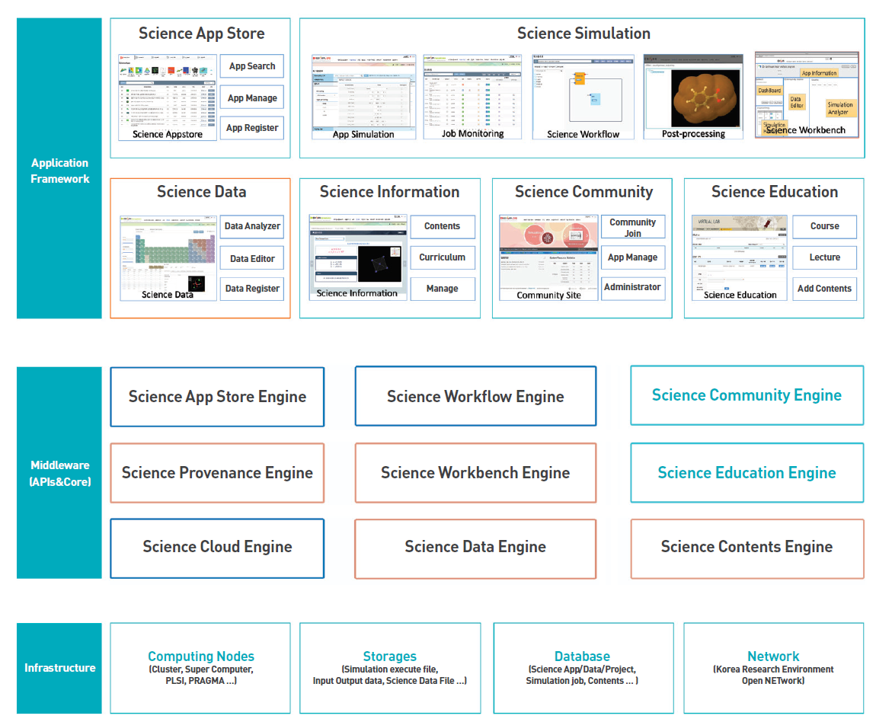

Fig. Redesigned platform architecture for power price and demand data (전력가격 및 수요데이터를 위해 재 디자인한 플랫폼 아키텍처)

The following figure is a computational science engineering platform architecture redesigned for power price and demand data. There are three major platforms.

The first infrastructure represents computing nodes, file storage and management, and networks. Data collection connected with KPX API is done in Database, and real time data (csv format) provided by PJM is stored and refined, and prediction and storage of optimized results of manage in Storage.

Simulation-related data and files stored in storage are provided through the EDISON file management system [17].

  The computation of the optimized CPP simulation designed and developed in Chapter 2 is performed through the EDISON Cluster, a computing node, and the SuperComputer [top 500] possessed by KISTI.

- 각 구성요소에 대해 기능이나 역할을 소개

- 플랫폼에서 시뮬레이션 실행되는 flow 설명

2장에서 설명한 알고리즘을 활용한 CPP 시뮬레이션은 Application Framework를 통해 등록 및 관리를 지원한다.

# Implementation

## System Specification

사용된 H/W, S/W spec

## Comparison Performance Between Legacy System and Proposed Architecture

비교1: horizon = 1달로 하고 legacy와 distributed system

비교2: horizon = 1년으로 하고 비교 1 반복

비교 3:계속 뭐 비교케이스 만들어봐….

# Conclustion

Use”

word “alternately” (unless you really mean something that alternates). Use the word “whereas” instead of “while” (unless you are referring to simultan

[1] Jamasb, Tooraj, and Michael Pollitt. "Electricity market reform in the European Union: review of progress toward liberalization & integration." The Energy Journal (2005): 11-41.

[2] Karandikar, R. G., S. A. Khaparde, and S. V. Kulkarni. "Strategic evaluation of bilateral contract for electricity retailer in restructured power market." International Journal of Electrical Power & Energy Systems Vol.32, Issue.5 (2010): 457-463.

[3] Yousefi S, Moghaddam MP, Majd VJ. Optimal real time pricing in an agent-based retail market using a

comprehensive demand response model. Energy 2011;36(9):5716–5727.

<http://dx.doi.org/10.1016/j.energy.2011.06.045>.

[4] Qian LP, Zhang YJA, Huang J, Wu Y. Demand response management via real-time electricity price control

in smart grids. IEEE Journal on Selected Areas in Communications 2013;31(7):1268–80.

<http://dx.doi.org/10.1109/JSAC.2013.130710>.

[5] Doostizadeh M, Ghasemi H. A day-ahead electricity pricing model based on smart metering and demand-side management. Energy 2012;46(1):221–30. <http://dx.doi.org/10.1016/j.energy.2012.08.029>.

[6] Yusta JM, Ramirez-Rosado IJ, Dominguez-Navarro JA, Perez-Vidal JM. Optimal electricity price

calculation model for retailers in a deregulated market. International Journal of Electrical Power and Energy

Systems 2005;27(5–6):437–47. http://dx.doi.org/10.1016/j.ijepes.2005.03.002.

[7] Vera S, Bernal F, Sauma E. Do distribution companies loose money with an electricity flexible tariff?: A review of the Chilean case. Energy 2013;55:295–303. http://dx.doi.org/10.1016/j.energy.2013.03.024.

[8] Yang L, Dong C, Wan CLJ, Ng CT. Electricity time-of-use tariff with consumer behavior consideration.

International Journal of Production Economics 2013;146(2):402–10.

<http://dx.doi.org/10.1016/j.ijpe.2013.03.006>

[9] Joo JY, Ahn SH, Yoon YT, Choi JW. Option valuation applied to implementing demand response via

critical peak pricing. In: Power Engineering Society General Meeting. IEEE; 2007.

http://dx.doi.org/10.1109/PES.2007.385559.

[10] Zhang X. Optimal scheduling of critical peak pricing considering wind commitment. IEEE Transactions on

Sustainable Energy ~~2013~~2014;5(2):637–45. <http://dx.doi.org/10.1109/TSTE.2013.2280499>.

[11] Zhang Q, Wang X, Fu M. Optimal implementation strategies for critical peak pricing. In: The 6th

International Conference on the European Energy Market. IEEE; 2009.

<http://dx.doi.org/10.1109/EEM.2009.5207139>.

[12] Park, S. C., et al. "Designing a critical peak pricing scheme for the profit maximization objective considering price responsiveness of customers." Energy 83 (2015): 521-531.

https://doi.org/10.1016/j.energy.2015.02.057.

[13] Park, Sung Chan, Young Gyu Jin, and Yong Tae Yoon. "Designing a profit-maximizing critical peak pricing scheme considering the payback phenomenon." Energies 8.10 (2015): 11363-11379.

https://doi.org/10.3390/en81011363

[14] Bin, Wu, et al. "The optimization of CPP strategy based on load data analysis." Electricity Distribution (CICED), 2016 China International Conference on. IEEE, 2016.

http://dx.doi.org/10.1109/CICED.2016.7576141.

[15] Jin Ma, Jongsuk Ruth Lee, Kumwon Cho and Minjae Park, “Design and Implementation of Information Management Tools for the EDISON Open Platform,” KSII Transactions on Internet and Information Systems, vol. 11, no.2, pp. 1089-1104, 2017.

http://dx.doi.org/10.3837/tiis.2017.02.026

[16] Young-Kyoon Suh and Jin Ma, "SUPERMAN: A Novel System for Storing and Retrieving Scientific-Simulation Provenance for Efficient Job Executions on Computing Clusters" in Proceedings of 2017 IEEE 2nd International Workshops on Foundations and Applications of Self* Systems(FAS*W), pp. 283-288, 2017.

http://dx.doi.org/10.1109/FAS-W.2017.160

[17] Jin Ma, Jerry Seo, Jong Suk Ruth Lee and Minjae Park, “Implementation and Application of the EDISON platform’s integrated file management service,” Journal of Internet Computing and Services (JICS), Vol.17, No.6, pp.71-79, 2016.http://dx.doi.org/10.7472/jksii.2016.17.6.71

1. This paragraph of the first footnote will contain the date on which you submitted your paper for review. It will also contain support information, including sponsor and financial support acknowledgment. For example, “This work was supported in part by the U.S. Depart­ment of Com­merce under Grant BS123456.”

   The next few paragraphs should contain the authors’ current affiliations, including current address and e-mail. For example, F. A. Author is with the National Institute of Standards and Technology, Boulder, CO 80305 USA (e-mail: author@ boulder.nist.gov).

   S. B. Author, Jr., was with Rice University, Houston, TX 77005 USA. He is now with the Department of Physics, Colorado State University, Fort Collins, CO 80523 USA (e-mail: author@lamar.colostate.edu).

   T. C. Author is with the Electrical Engineering Department, University of Colorado, Boulder, CO 80309 USA, on leave from the National Research Institute for Metals, Tsukuba, Japan (e-mail: author@nrim.go.jp).