**Periodic table project**

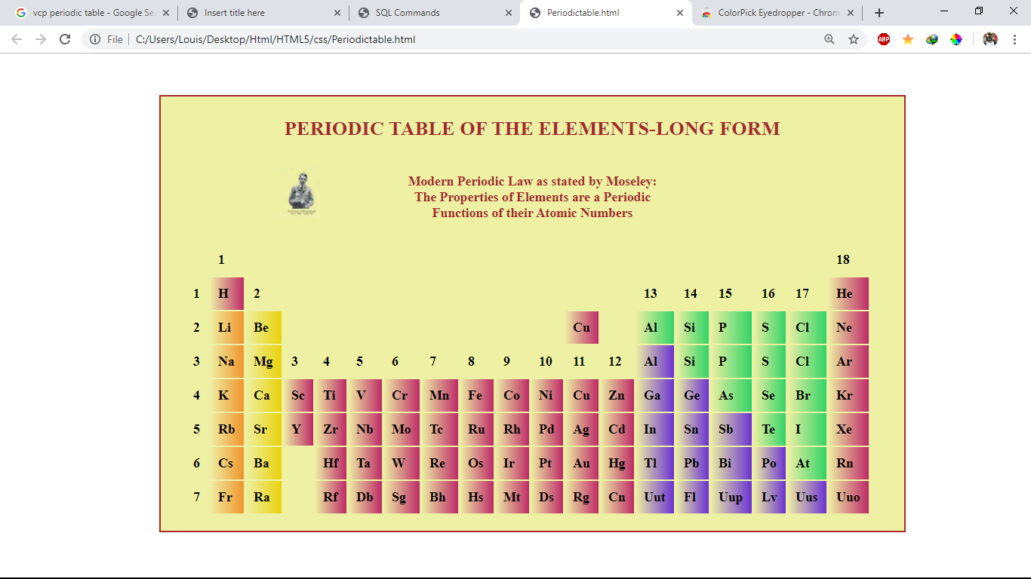

I have used html and css(external css) to create this periodic table project.

I have used <table> tag to create the table.

Added an image using <img> tag.

Used linear gradient as background image for table data blocks. To differentiate the group of elements in the periodic table.

<div> tag used for border and background color in this table.