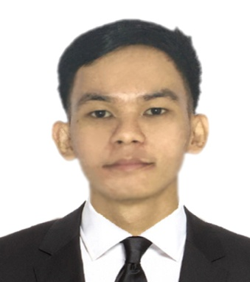**Name**: Louis Andrie Sta.Ana Cruz

**Address**: 004 Parola Street, Barangay San Roque, Cainta, Rizal

**Contact Number**: 09319250185

**E-mail**: [louitzkie@gmail.com](mailto:louitzkie@gmail.com)

**Portfolio**: <https://louitzkie.github.io/portfolio/>

**About Me**

Hi, I am Louis an aspiring self-taught graphic designer and web developer building website is my absolute passion and happiness when I see it live online.

**Skills**

HTML, CSS, JavaScript, ReactJS

Photoshop/photo manipulation

**Tools**

Adobe Photoshop, VScode

**Job Experience**

Freelancer

January 3, 2022 - present

Graphic Designer & Web Developer

Upwork

**On the Job Training**



Cainta of Municipality

Cainta Rizal

300Hours

Rospack Compound Barangay. Sto. Domingo

January 22, 2020 – March 16, 2020

IT Assistant



National Printing Office

Quezon City

486Hours

September 25, 2023 – December 20, 2023

Tech-Support / Web developer

**Educational Attainments**

ICCT College V. V. Soliven Avenue II, Barangay. San Isidro Cainta, Rizal

2015



**Tertiary**



**Secondary**

Francisco P. Felix Memorial National High School

2011