[](http://www.stakeholdermap.com/project-templates/project-management-templates.html)

## Segmentation des haies et arbres à partir de données LiDAR et de photographies aériennes

# Project initiation document

**Table of Contents**

<Project Name> i

<Project Reference> i

Project initiation document i

Document Control i

Document Information i

Document History i

Document Approvals i

Template Guide 1

project summary 2

purpose 2

project objectives 2

scope and exclusions 2

project deliverables 3

interfaces and dependencies 3

assumptions 3

acceptance criteria 3

monitoring and evaluation 3

project delivery 4

iNITIAL RISK LOG 4

PROJECT ORGANISATION STRUCTURE 4

COMMUNICATION PLAN 5

INTERNAL project communication 5

external project communication 5

quality management 6

quality management of the project 6

quality management of the deliverables 6

project milestones 6

resource plan 7

project tolerance and exception process 7

Appendix 7

record of amendments to the pid 7

deliverable / work package specifications 7

financial / budget requirements 7

detailed schedules 8

DOWNLOAD MORE PROJECT TEMPLATES 8

# project summary

*L'objectif de ce projet est de développer un algorithme capable de segmenter les haies et les arbres dans une zone géographique délimitée. Les données utilisées proviendront de capteurs LiDAR et de photographies aériennes.*

# project objectives

* *Développer un algorithme capable de segmenter les haies et les arbres dans une zone géographique délimitée.*
* *Calculer des métriques clés : la hauteur totale et la taille des arbres, avec une granularité d'un mètre carré.*
* *Utilisation des techniques de l'IA pour automatiser l'analyse des données LiDAR afin de :*
  + *Extraire des caractéristiques de la végétation*
  + *Identifier des zones de densité végétale élevée*
  + *Déterminer des seuils de risque.*

# scope and exclusions

*Describe the main work streams,* [*work packages*](https://www.stakeholdermap.com/project-dictionary/what-does-work-package-mean.html) *and products that will be delivered. This section could include a high-level* [*Work Breakdown Structure (WBS*](https://www.stakeholdermap.com/project-dictionary/work-breakdown-structure-meaning.html)*) presented as a graphical hierarchy or as a list with a hierarchy denoted by numbering. For example:*

*[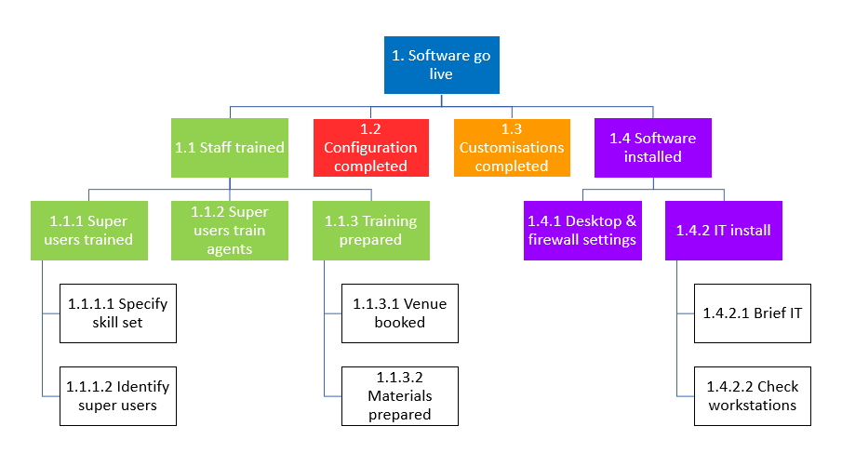](https://www.stakeholdermap.com/plan-project/plan-project-stage1.html)*

*Get a template for a graphical* [*Work Breakdown Structure*](https://www.stakeholdermap.com/plan-project/work-breakdown-structure-template.html) *or use* [*Lucidchart*](https://try.lucid.co/wbs-diagram-tool)*.*

*Get a template for a* [*Work Breakdown Structure in Excel*](https://www.stakeholdermap.com/project-templates/WBS-excel-template.html)*.*

*Download* [*example WBS*](https://www.stakeholdermap.com/plan-project/example-work-breakdown-structures.html)*’s.*

# project deliverables

*Provide a complete list of the deliverables/products the project will produce. Make sure each deliverable has a unique identifier. This section may include links or references to each product’s* [*Product Description*](https://www.stakeholdermap.com/prince2/prince2-glossary-P-performance.html#product-description)*.*

|  |  |  |
| --- | --- | --- |
| ***Deliverable ID*** | ***Deliverable Title*** | ***Deliverable Description*** |
| *1.1.3.2.1* | *Delegate pack & venue guide* | *250 gsm, 20 pages, 2 colour, stapled booklet, 4 colour cover.* |
| *1.1.3.2.2* | *Delegate pack cover design work* | *4 colour cover, logo with library image HT-027-12-TIFF, and training title.* |
|  |  |  |
|  |  |  |

# interfaces and dependencies

*Note any other groups, projects and organizations that will be involved in the project or will be impacted by the project. Include any dependencies here, for example if the project is dependent on an external product or an external decision.*

|  |  |  |
| --- | --- | --- |
| ***Interface or dependency with:*** | ***Description*** | ***Management plan*** |
| *Recruitment team* | *Recruitment of project manager by x date* | *Keys tasks documented in project plan with owners assigned. Job description already in place.* |
|  |  |  |

*See* [*example job descriptions for project managers*](https://www.stakeholdermap.com/project-templates/job-description-project-manager.html)

# assumptions

*List the* [*assumptions*](https://www.stakeholdermap.com/project-dictionary/assumptions-meaning.html) *that have been made in order to conceive of and plan this project. For example, assumptions may have been made around legislation, other projects, market conditions, recruitment etc.*

# acceptance criteria

*Describe in measurable terms the criteria that* [*Project Sponsor*](https://www.stakeholdermap.com/project-dictionary/project-sponsor-meaning.html) *will use to evaluate and accept or reject the project deliverables and outputs. This might include conditions that are not related to products like delivery by a certain date.*

# monitoring and evaluation

*Document how the project will be* monitored and evaluated. For example:

* *How feedback will be collected on the value of this project by users of the products.*
* *The monitoring and evaluation methods the* [*Project Sponsor*](https://www.stakeholdermap.com/project-dictionary/project-sponsor-meaning.html) *will use to determine that the project has been delivered to specification and has had the intended impact*
* *The time scales and key dates for collecting the above information.*
* *How, when and to whom the feedback and the monitoring and evaluation findings will be reported.*

# project delivery

## iNITIAL RISK LOG

*List the known risks to the successful delivery of the project. These should be specific to the project and not just a reiteration of* [*common project risks*](https://www.stakeholdermap.com/risk/register-common-project-risks.html)*.*

*Helpful guides for this section:* [*A guide to Risk Management*](https://www.stakeholdermap.com/risk/risk-management.html)*. Example* [*Risk Register*](https://www.stakeholdermap.com/risk/risk-register.html)*.* [*Possible responses to risk*](https://www.stakeholdermap.com/risk/risk-responses.html)*.*

*Complete the following table:*

|  |  |  |  |
| --- | --- | --- | --- |
| **Description** | **Likelihood** | **Impact©** | **Mitigating Actions** |
| *Inability to recruit skilled resource* | *Low* | *Very High* | *Involve retained recruitment consultant to source team members. Consider using consultants on fixed term contracts.* |
| *Technology solution is unable to deliver required results* | *Medium* | *High* | *Complete a pilot project against most business-critical requirements. Consider using* [*Agile*](https://www.stakeholdermap.com/project-dictionary/agile-meaning-definition.html) *methods to deliver working product in Sprints.* |
| *Additional capital expenditure may be required in addition to that approved* | *Medium* | *Medium* | *Monitor projects spend as per the project methodology. Report on spend bi-weekly to the project board. Assign PMO Director to support Project Manager in cost control.* |
|  |  |  |  |

## PROJECT ORGANISATION STRUCTURE

BELARIF Louiza  
Dev

BERTRAND Félicien  
Manager

MAOURID Amine  
Manager

HAMADENE Yasmine  
Dev

BENAMEUR Kaoutar  
Dev

LASKRI Sonia  
Dev

## [quality management](https://www.stakeholdermap.com/prince2/prince2-glossary-Q-quality.html#quality-management)

*Two aspects of* [*quality management*](https://www.stakeholdermap.com/prince2/prince2-glossary-Q-quality.html#quality-management) *should be considered within the PID: firstly securing high quality project management and secondly ensuring that deliverables are produced to agreed quality standards.*

quality management of the project

*For some projects quality of project delivery may be provided through pre-existing governance provided by program, portfolio management or a project management office. In these cases, this section may just require a reference to pre-existing policies and procedures.*

***Example text:***

*Responsibility for checking that all procedures have been correctly followed in preparing this PID rests with: [Insert Name] Senior Project Manager.*

*Responsibility for checking and signing off this PID and for ensuring it follows the PID guidance rests with: [Insert Name] Program Manager.*

*Responsibility for ongoing monitoring and supervision to ensure that ongoing project management complies with the agreed procedures and processes rests with [Insert Name] of the Programme Office*

quality management of the deliverables

*In this section document what the quality standards, quality assurance process and quality checking are for each project deliverable. A table like the below may be used.*

|  |  |  |  |
| --- | --- | --- | --- |
| ***Deliverable ID and title*** | ***Quality standards*** | ***Quality assurance*** | ***Quality checking*** |
| *0034 Web pages* | *Follow existing branding specification.*  *Meet Accessibility compliance guidelines*  *Meet browser compatibility policy* | *Follow publishing review process.*  *Pre-approved suppliers only.* | *Web change advisory board via unit test, user acceptance testing and go live testing.* |
|  |  |  |  |

## [project milestones](https://www.stakeholdermap.com/project-management/project-milestones.html)

*List the* [*project milestones*](https://www.stakeholdermap.com/project-management/project-milestones.html) *(key points in a project life cycle). They might be target dates that must be met or delivery of important* [*work packages*](https://www.stakeholdermap.com/project-dictionary/what-does-work-package-mean.html) *or markers of progress. This section will likely contain a table similar to the one below.*

|  |  |
| --- | --- |
| ***Milestone*** | ***Milestone target date*** |
| *Project Kick off* | *Day month year* |
| *Design phase* | *Day month year to day month year* |
| *Build starts* |  |
| *Start of User Acceptance Testing* |  |
|  |  |
|  |  |

## resource plan

*This section lists the resources - people and machine that are required for the project. A description of all of the Roles and Responsibilities should be included along with the resources needed, their skill set, when they are needed, how long for and the associated costs. Get a* [*Resource Planning Template*](https://www.stakeholdermap.com/project-templates/resource-planning-template.html)*.*

## [project tolerance and exception process](https://www.stakeholdermap.com/project-management/project-tolerance.html)

*Document the agreed* [*Project Tolerances*](https://www.stakeholdermap.com/project-management/project-tolerance.html) *and provide a brief confirmation of the* [*Exception Procedure*](https://www.stakeholdermap.com/project-management/project-tolerance.html#exception-process) *to be followed if there is a deviation from the approved plan that is forecast to exceed Tolerance. Refer also to the* [*Change Control Process*](https://www.stakeholdermap.com/change/change-management-process.html) *that will be followed for this project. See example* [*cost and time tolerances*](https://www.stakeholdermap.com/project-management/project-tolerance.html#cost-and-time-tolerances)*.*

# Appendix

## record of amendments to the pid

*Keep a record of the changes made to each version of the PID. This section may form part of the PID header/document information page, or an appendix.*

## deliverable / work package specifications

*Include the specifications for the* [*work packages*](https://www.stakeholdermap.com/project-dictionary/what-does-work-package-mean.html) *and project deliverables. For example, a unique reference for each deliverable, title, purpose, composition, format, owner,* [*quality criteria*](https://www.stakeholdermap.com/prince2/prince2-glossary-Q-quality.html#quality-criteria)*, location/storage.*

|  |  |  |  |  |  |
| --- | --- | --- | --- | --- | --- |
| ***Deliverable ID & Title*** | ***Purpose*** | ***Composition*** | ***Format & location*** | ***Owner*** | ***Quality criteria*** |
|  |  |  |  |  |  |
|  |  |  |  |  |  |

## financial / budget requirements

*Document the budget, cost and revenue forecast and any payment milestones as appropriate for the project.*

## detailed schedules

*Provide a detailed project schedule. For example, a Microsoft Project plan may be attached here or referenced in this section. Get ready made* [*Microsoft Project Plans*](https://www.stakeholdermap.com/project-templates/ms-project-templates.html)*. This may also include detailed team plans and resource plans. Get a* [*Resource plan Template*](https://www.stakeholdermap.com/project-templates/resource-planning-template.html)*.*