Exercises 2.2
1.f. 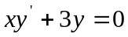
Solution: Method 1. 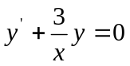
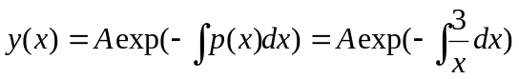
Method 2. Using separation of variables.
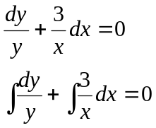
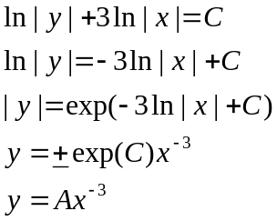
Exercises 2.3.
1.n 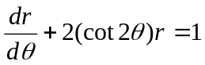
Solution: Method 1. Using (14)
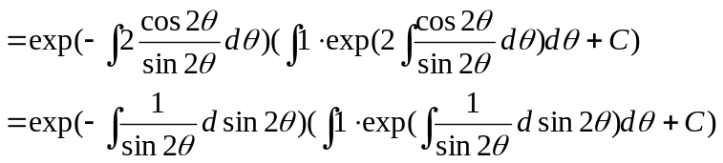
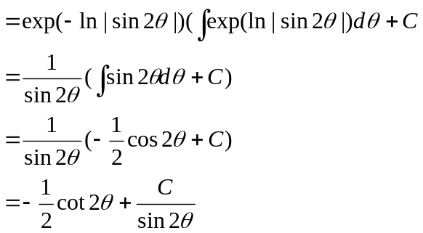
Method 2.
