Exercises 6.7
2e. Solution: 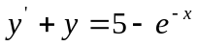
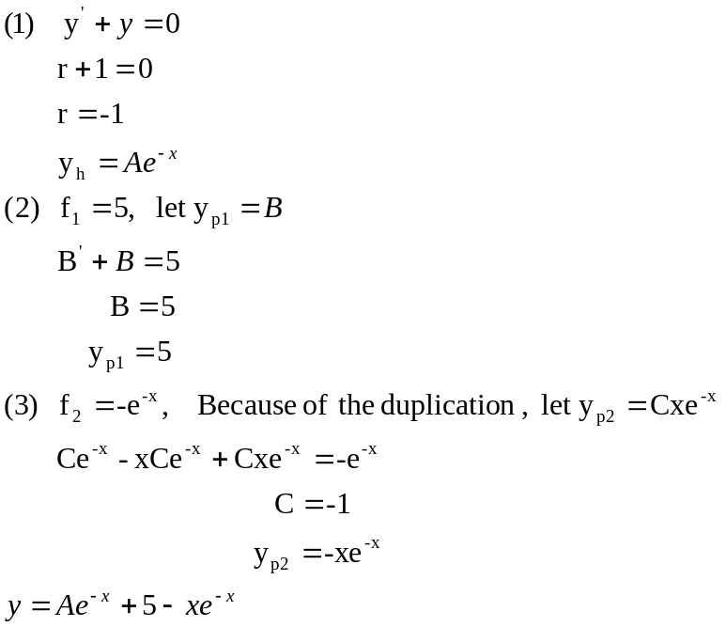

Exercises 7.2
7. Solution:
(a). If c=c_{r} ,
then 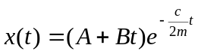
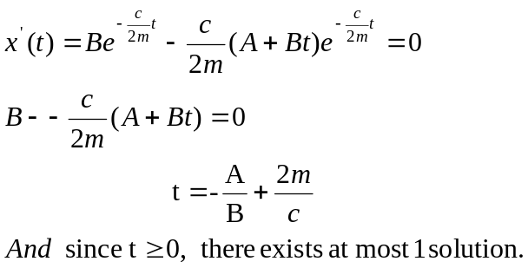
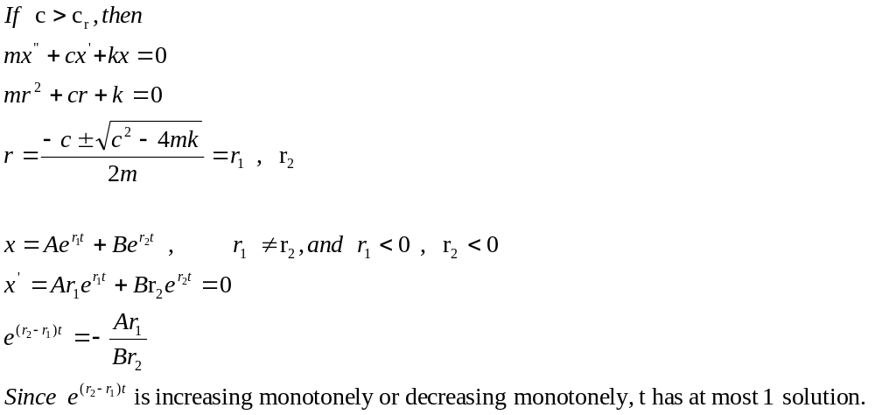
So, if

(b). Give an example that has no flat point.
Let m=1, k=4, c=4, x(0)=1, x’(0)=-1,
Then 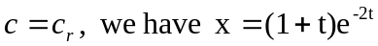
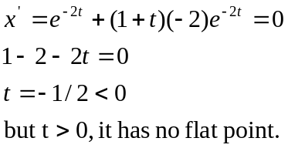

( c ) Give an example that has 1 flat point.
Let Let m=1, k=4, c=4, x(0)=1, x’(0)=2,
Then 