Exercises 6.7
4h. Solution: 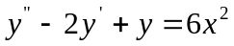
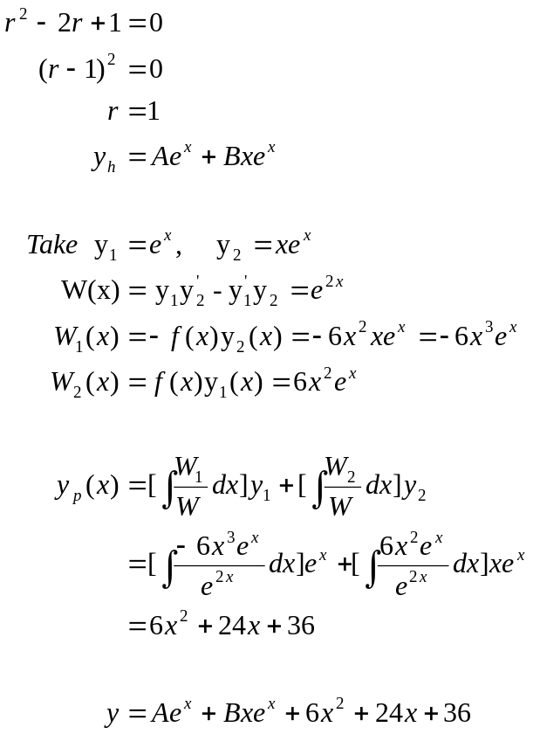

Exercises 7.5
3. Solution:
