Exercises 9.3
3e. Solution:
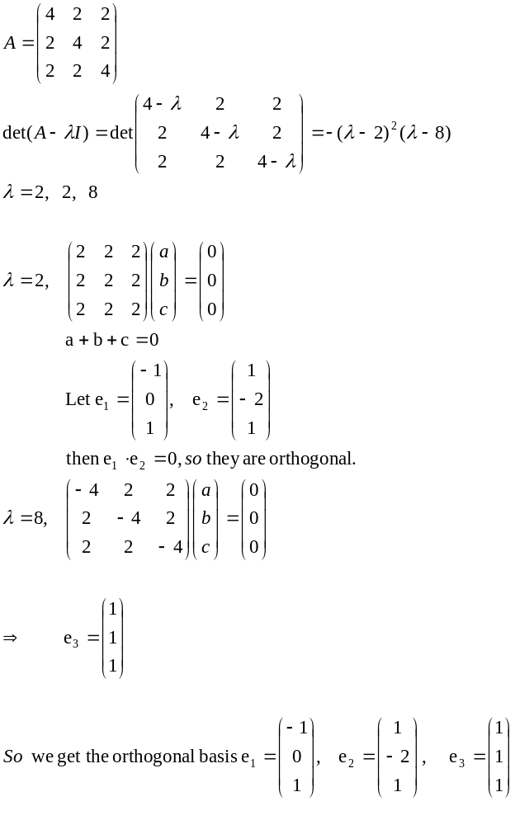
Exercises 9.4
1b Solution:
