Exercises 3.2
6.e. 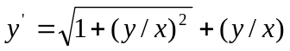
Solution: 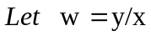
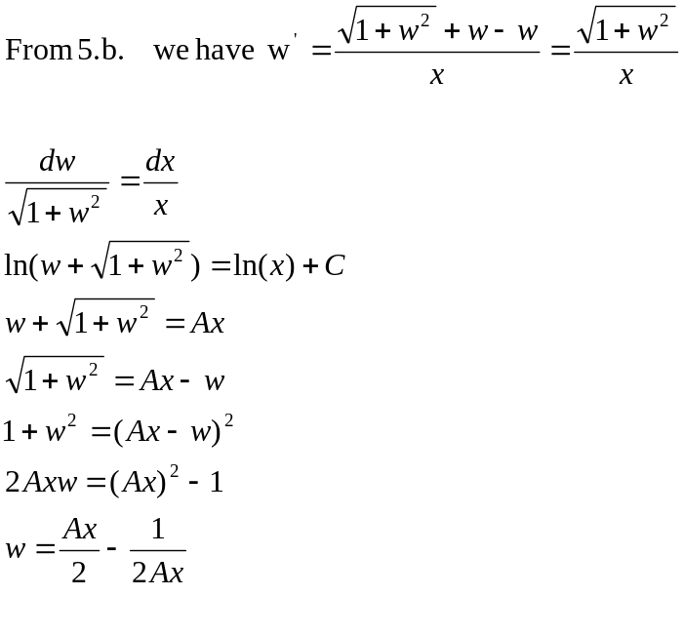
Since 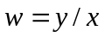, so the above becomes
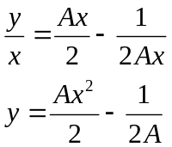

Exercises 3.3
1.b.
Solution: 