Exercises 2.4.
17.(b) Solution:
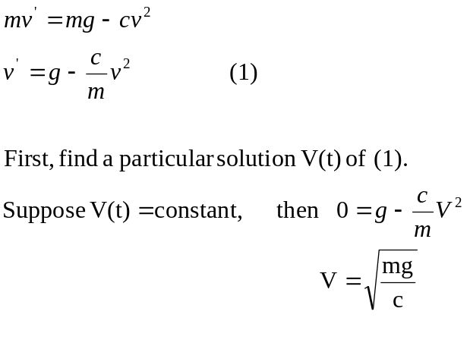
According to Exercises 2.3 #9. let 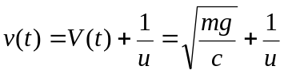
Then (1) becomes
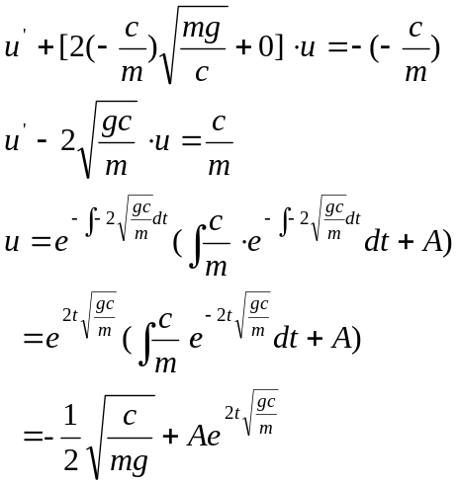
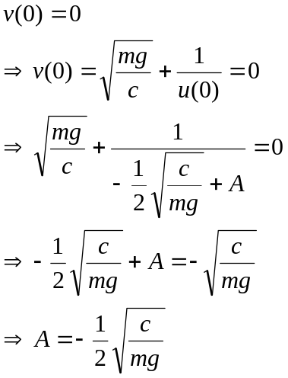
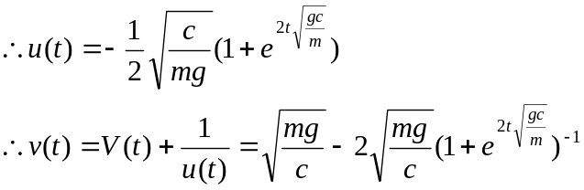

Exercises 3.4
1f. Solution:
- Show the equation is exact.
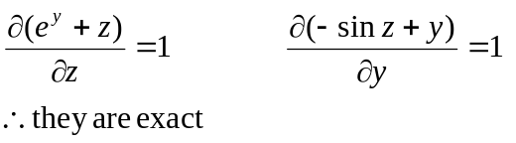
- Obtain the general solution.
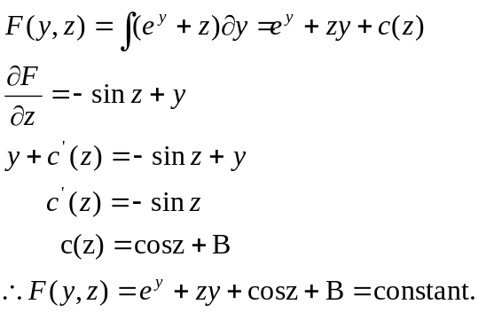
- Find the particular solution corresponding to the initial condition z(0)=2.
From the general solution, we have
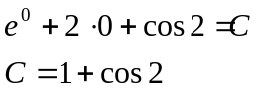
The particular solution is 