Exercises 4.5
13b. Solution: 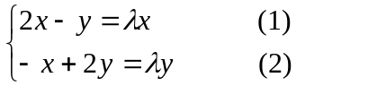
Method 1.
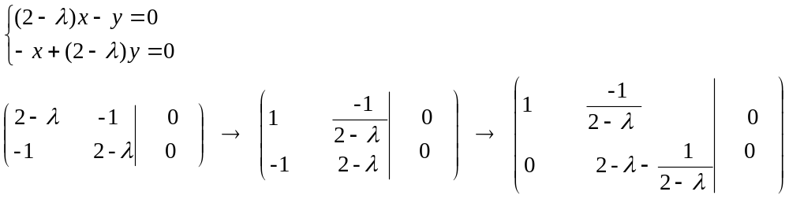
To get non-trivial solutions, we have 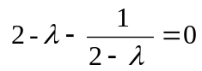
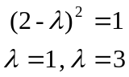
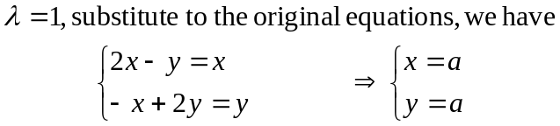
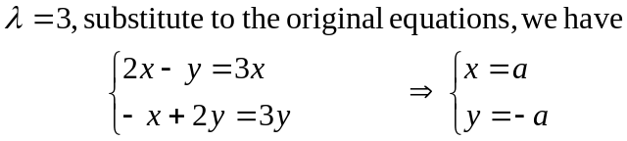

Method 2. From (1) we have 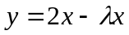
Substitute in (2), we have
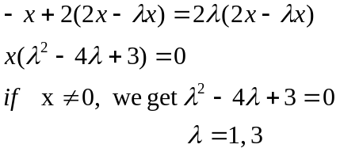
Exercises 4.6
4f. Solution: Let
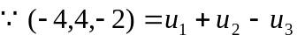, 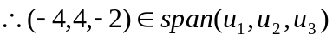.
But 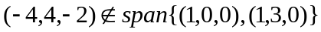, So these two spans are not identical.

