Exercises 4.7.
6a. Solution: The statement is not true. Just need to give a counter-example to disprove the statement.
e.g. Suppose u₁=(1,0), u₂=(2,0), v=(1,1)
then -2 u₁+ u₂+0v=0, so {v, u₁, u₂} is LD.
But 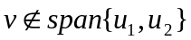. So the statement is not true.

Exercises 4.8. x₂
6b. Solution: The shaded region B is not
a subspace of R² .
u₂ Since it is not closed under
X₁ addition.
v
u₁ 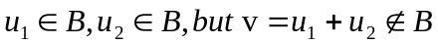

(shown in the figure)

