Exercises 5.2.
22. Solution: 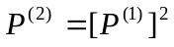
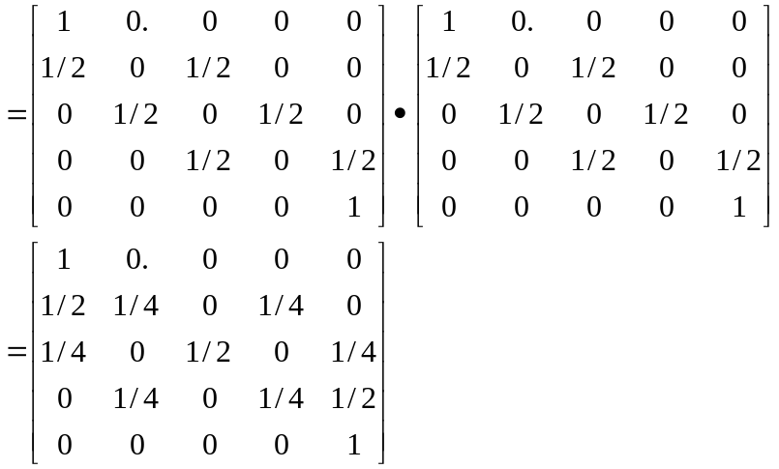

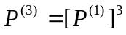
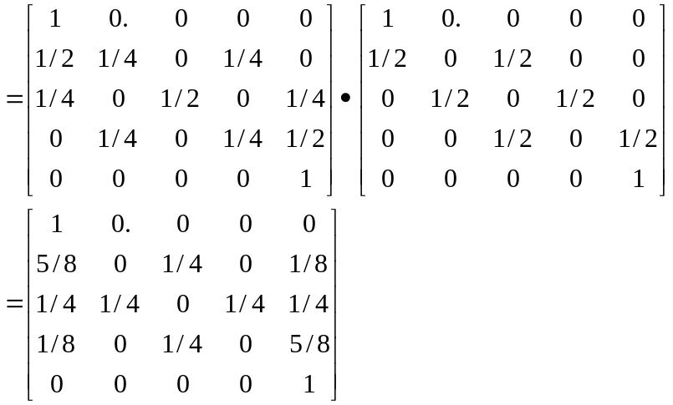

The probability that A is bankrupt after (at most) three matches

if A starts with $2, probability= 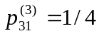

if A starts with $3, probability= 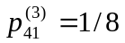

if A starts with $2, probability= 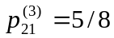

Exercises 6.4
1b. Solution: 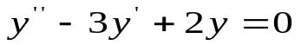
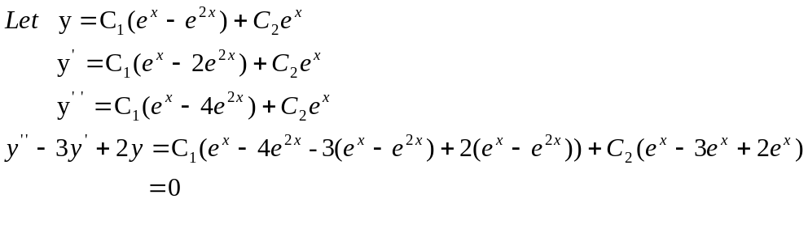
So 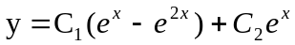 is the general solution.

