Exercises 6.5
2h. Solution:
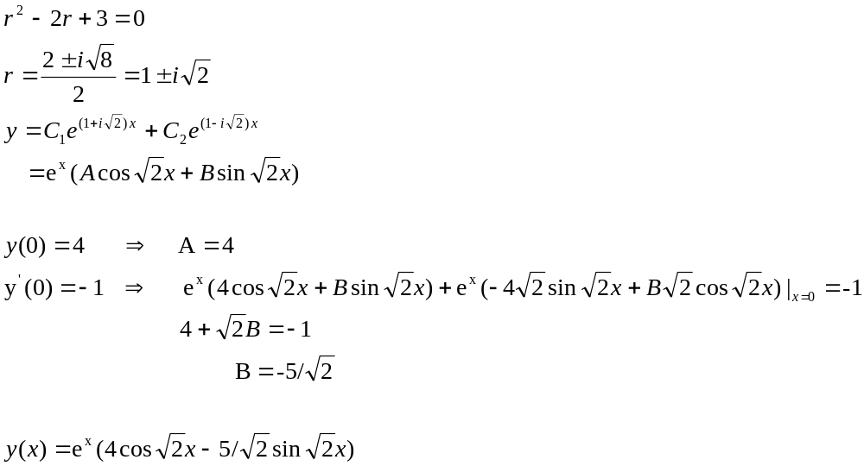

Exercises 6.5
4c. Solution:
