PromptOps
System Design, Architecture & Learning Guide
Complete Technical Reference for the ML Engineer

7 System Diagrams | Full Architecture | What to Learn
Data Models | Flow Charts | Skill Roadmap

1. System Overview

This document is your complete technical reference for PromptOps. It covers every architectural decision, data flow, system component, and the exact skills you need to build it. Each section is paired with a visual diagram — read the explanation first, then study the diagram to lock in the mental model.

🎯 | What This Doc Covers  System architecture · Prompt lifecycle flow · Versioning engine internals · Evaluation pipeline · A/B testing design · Core data model · Full learning roadmap with technologies

1.1 The Core Problem PromptOps Solves
LLM applications have two critical assets: models and prompts. The ML world has excellent tooling for model management (MLflow, W&B, HuggingFace Hub) — but zero standardized tooling for prompts. Prompts are stored in text files, hardcoded in source code, and changed without any tracking, review, or evaluation. PromptOps brings the same engineering discipline to prompts that Git brought to code.

1.2 The Three Core Pillars

Pillar | What It Means | Analogy
Version Control | Every prompt change is hashed, stored, and diffable — just like a Git commit. You can see exactly what changed, when, and why — and roll back instantly. | Git for prompts
Evaluation | Every commit auto-triggers a scoring pipeline measuring accuracy, hallucination rate, relevance, and latency. No prompt reaches production without a quality gate. | Quality assurance
Deployment | Prompts are decoupled from application code. Deploy a new prompt to production via API — no code change, no redeploy, instant rollback if scores drop. | Operational safety

2. High-Level System Architecture

The architecture is a layered system. Each layer has a single responsibility and communicates only with the layers directly adjacent to it. This design makes the system extensible — you can add new LLM providers, new scorers, or new dashboard views without touching the core.

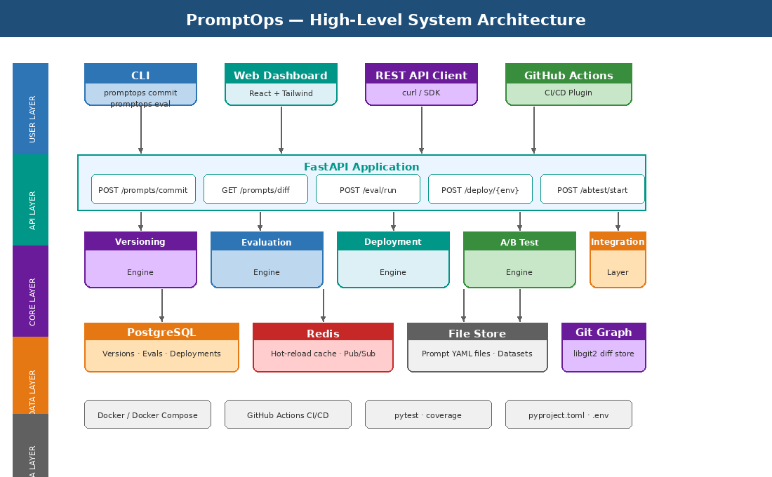

2.1 Layer Breakdown

Layer | Components | Responsibility
User Layer | CLI, Web Dashboard, REST API clients, GitHub Actions | How engineers interact with PromptOps
API Layer | FastAPI application with versioned REST endpoints | The single entry point for all operations
Core Layer | Versioning, Evaluation, Deployment, and A/B test engines | The business logic — where all the intelligence lives
Data Layer | PostgreSQL, Redis, File Store, libgit2 graph | Persistence and caching
Infra Layer | Docker, GitHub Actions, pytest, pyproject.toml | Build, test, and deployment infrastructure

2.2 Key Design Decisions

🔑 | Modular Core Engines  Each engine (versioning, eval, deploy, A/B test) is a completely independent Python module. This means you can use the evaluation engine standalone without the CLI, or the deployment engine without the dashboard. This is what makes PromptOps composable and easy to integrate.

⚡ | Redis for Hot Reload  Production applications fetch the active prompt via a Redis cache — not PostgreSQL. This gives sub-millisecond response times. PostgreSQL is the source of truth; Redis is the fast-serving layer. When a new version is deployed, Redis is invalidated and refilled instantly.

🔒 | Prompt-as-Code via YAML  Prompts are stored as structured YAML files — not raw strings. This means they carry metadata (model, temperature, tags, version) alongside the content itself, making them versionable, diffable, and self-documenting.

3. Prompt Lifecycle Flow

Every prompt in PromptOps goes through the same lifecycle: write → stage → commit → evaluate → review → deploy → monitor. This is deliberately modeled after Git + CI/CD workflows that engineers already know. The key insight is that a prompt update is treated as a software release — with the same gates, reviews, and safety checks.

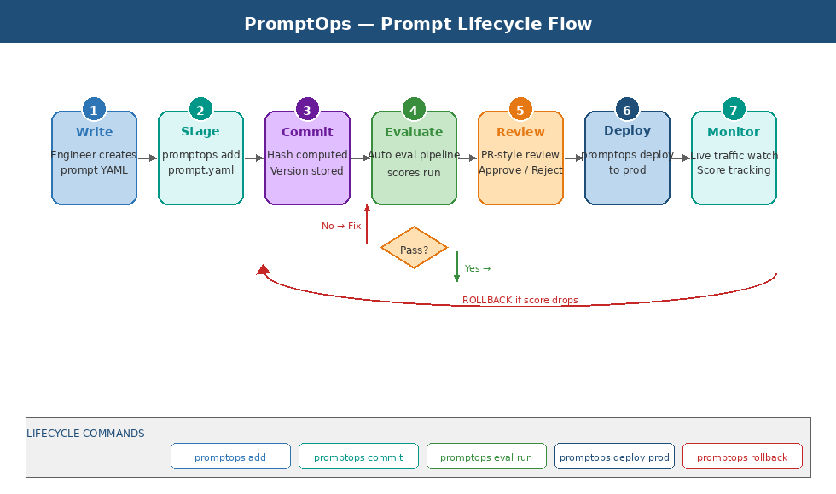

3.1 Each Step Explained

Step | What Happens
1. Write | Engineer creates or edits a prompt.yaml file with content, model params, and tags. Uses any editor — PromptOps is editor-agnostic.
2. Stage | promptops add prompt.yaml tells the system which files to include in the next commit — exactly like git add.
3. Commit | SHA-256 hash is computed from content + metadata. Version node is stored in PostgreSQL with parent reference, creating a linked chain.
4. Evaluate | The eval engine automatically runs the prompt against a test dataset and computes accuracy, hallucination, latency, and consistency scores.
5. Review | For team workflows, a PR-style review is created. A second engineer approves or rejects with comments — just like a code review.
6. Deploy | Approved version is pushed to the target environment (dev/staging/prod). Redis cache is updated. Application fetches new prompt on next request.
7. Monitor | Score metrics are tracked continuously in production. If scores drop below threshold, an automatic rollback is triggered.

3.2 The Rollback Safety Net
The most powerful feature is automatic rollback. If the deployed prompt causes evaluation scores to drop by more than 5% from baseline, the deployment engine triggers a rollback automatically — reverting to the last known-good version without any human intervention. This is the safety net that makes it safe to deploy prompts rapidly.

4. Versioning Engine — Git-Style Internals

The versioning engine is the heart of PromptOps. It borrows Git's core concepts — content-addressed storage, parent references, branches, and diffs — but applies them specifically to prompts. Understanding this engine means understanding directed acyclic graphs (DAGs), SHA hashing, and how Git actually works under the hood.

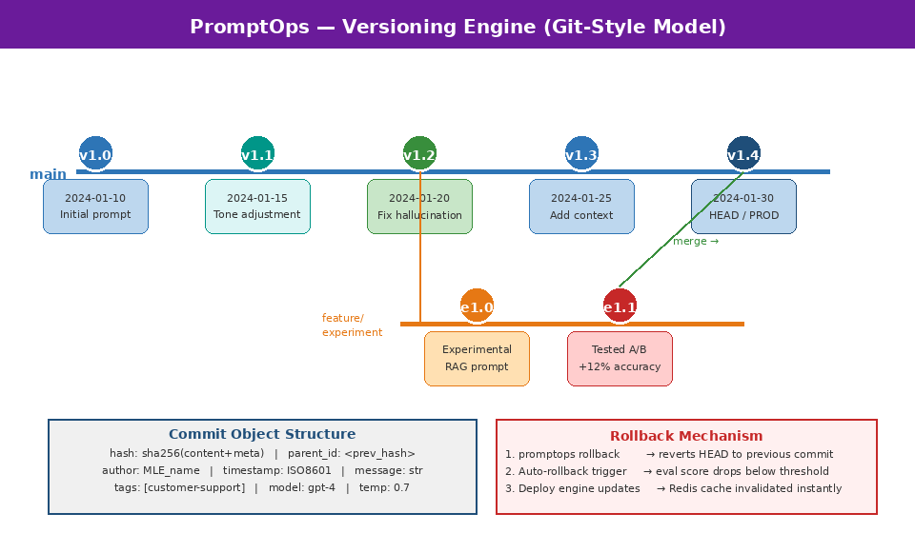

4.1 Content-Addressed Storage
Every commit is identified by a SHA-256 hash of its content + metadata. This means two identical prompts always get the same hash. It also means you can verify integrity — if the hash matches, the content is unmodified. This is exactly how Git stores blobs.

4.2 The Commit DAG
Versions form a Directed Acyclic Graph. Each commit has a parent_id pointing to the previous version. Branches are just named pointers to specific nodes in the graph. Merging is handled by creating a new commit with two parent references. This structure makes it impossible to have cycles — you can always trace back to the origin.

4.3 What You Need to Learn for This

Concept | Tool / Library | Why It Matters
SHA-256 Hashing | hashlib in Python | How content-addressed identity works
DAG Data Structures | Graph theory basics | Why Git uses a DAG instead of a tree
pygit2 / libgit2 | C library with Python bindings | The actual versioning storage layer
Diff Algorithms | Myers diff algorithm | How line-level diffs are computed
Branching Model | Git branch as pointer | Feature branches for prompt experiments

5. Evaluation Pipeline Architecture

The evaluation engine is what separates PromptOps from a simple version control system. Every committed prompt is automatically scored across five dimensions. The scores are stored alongside the version, making it trivial to compare any two versions and detect regressions over time.

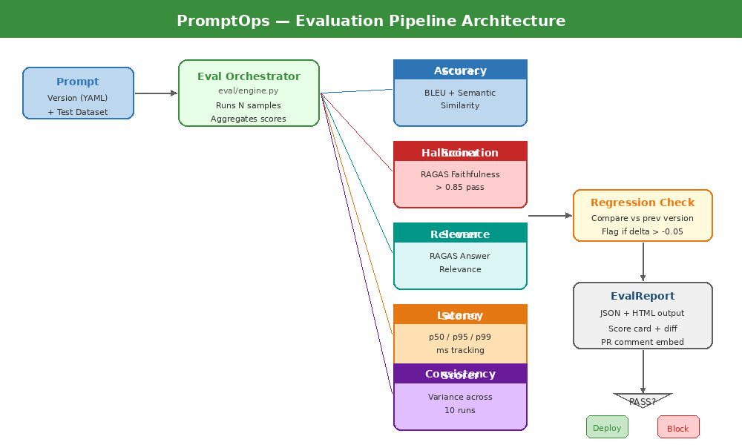

5.1 The Five Scoring Dimensions

Dimension | How It Works | Pass Threshold
Accuracy | Compare outputs to a golden dataset using BLEU score + sentence-transformer cosine similarity. Measures how factually correct the output is. | > 0.85 target
Hallucination | RAGAS Faithfulness metric. Measures whether every claim in the output is grounded in the provided context. Catches confabulation. | > 0.85 target
Relevance | RAGAS Answer Relevance. Measures whether the output actually answers the question asked. High relevance = on-topic response. | > 0.80 target
Latency | Tracks p50, p95, p99 response time across N evaluation runs. Critical for production SLAs. | p95 < 2s target
Consistency | Measures output variance across 10 identical runs. Low variance = the prompt produces reliable, stable outputs. High variance = unreliable. | CV < 0.10 target

5.2 RAGAS — The Core Evaluation Framework
RAGAS (Retrieval Augmented Generation Assessment) is the open-source library that powers PromptOps' hallucination and relevance scoring. It works by comparing the LLM output against the source context and the original question using a judge LLM. Understanding RAGAS internals — how it constructs evaluation prompts, how it aggregates scores, and how it handles edge cases — is essential for building a reliable evaluation engine.

📚 | Key RAGAS Concepts to Master  ragas.evaluate() function · Dataset format (question, answer, contexts, ground_truth) · Faithfulness vs AnswerRelevancy vs ContextRecall · How to write custom metrics · Batch evaluation for cost efficiency

5.3 Regression Detection
After every evaluation run, the scores are compared against the immediately previous version. If any score drops by more than the configured threshold (default 5%), the system flags it as a regression and optionally blocks deployment. This is the quality gate that prevents bad prompts from reaching production.

6. A/B Testing Architecture

A/B testing in PromptOps is scientific. Instead of guessing whether a new prompt is better, you route real traffic to both versions simultaneously, measure the outcomes, and let statistics declare the winner. The engine handles traffic splitting, sample size calculation, p-value computation, and automatic winner deployment.

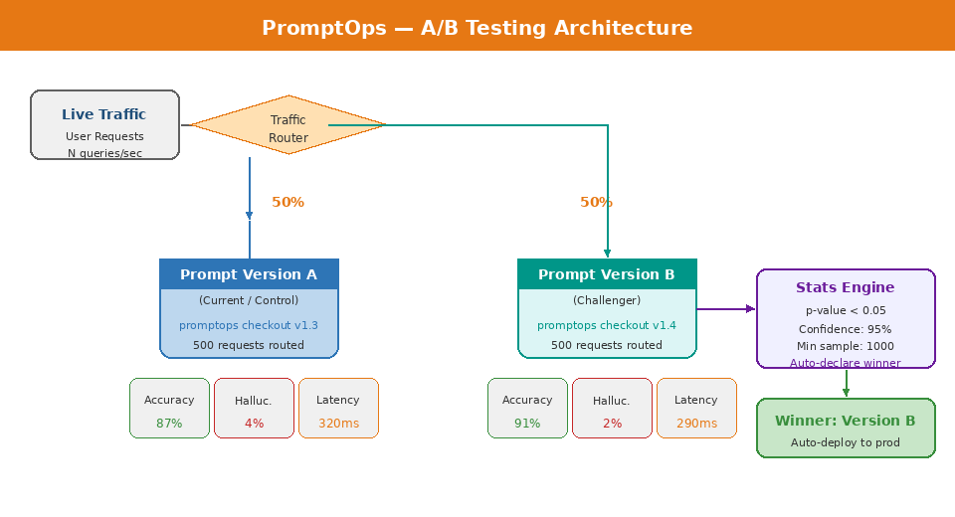

6.1 How the Traffic Router Works
When an A/B test is started, the deployment engine registers a routing rule in Redis. On every incoming prompt fetch request, the router uses a deterministic hash of the request ID to consistently assign it to either Version A or Version B — the same user always gets the same version, avoiding confusing mixed experiences.

6.2 Statistical Significance
The A/B test engine uses a two-proportion z-test to determine when a winner can be declared. Key parameters:

Parameter | Explanation
Minimum Sample Size | 1,000 requests per variant before any conclusion is drawn — prevents premature conclusions from small samples
Significance Level | p-value threshold of 0.05 (95% confidence). The winner must show a statistically significant improvement, not just a lucky run
Effect Size | Minimum detectable improvement of 2% — smaller differences are noise, not signal
Auto-Declare | When statistical significance is reached AND minimum samples collected, the winner is automatically deployed and the loser retired

6.3 What to Learn for A/B Testing
- Two-proportion z-test and p-value interpretation
- Statistical power and sample size calculation
- The difference between statistical significance and practical significance
- Feature flag patterns — how to route traffic without code changes
- Redis pub/sub for real-time routing rule updates

7. Core Data Model

The data model is the foundation everything else is built on. Six entities capture the full state of the system: versions, evaluation results, deployments, A/B tests, datasets, and reviews. Every relationship is explicit and enforced via foreign keys.

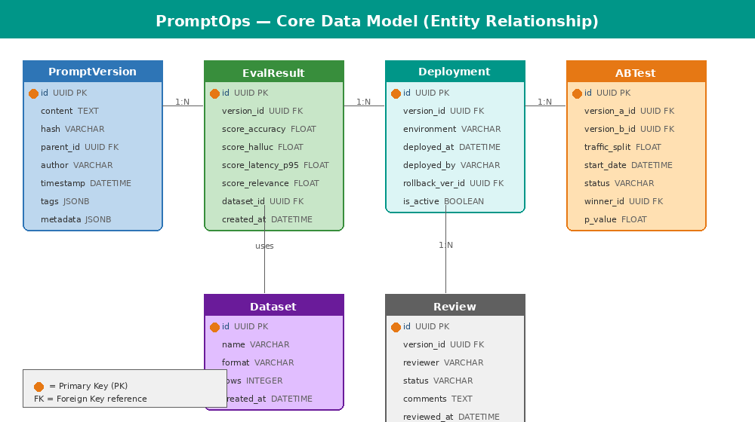

7.1 Entity Descriptions

Entity | Description
PromptVersion | The central entity. Stores the actual prompt content, its hash, parent reference (for the version chain), author, timestamp, and metadata like model parameters and tags.
EvalResult | Stores the output of every evaluation run. Linked to a PromptVersion via version_id. Contains all five metric scores and a reference to which dataset was used.
Deployment | Records every deployment event — which version was deployed, to which environment, when, and by whom. Also stores the rollback version ID for instant recovery.
ABTest | Captures the full configuration and outcome of an A/B test — which two versions were compared, the traffic split, start date, current status, statistical results, and the declared winner.
Dataset | Stores metadata about evaluation datasets. Actual dataset rows are stored as JSON files on disk, referenced by the Dataset record.
Review | Records PR-style review decisions — reviewer identity, approval status, and comment threads — enabling team collaboration and audit trails.

7.2 Key Database Skills to Learn
- PostgreSQL JSONB columns — used for tags and metadata (flexible schema within a structured record)
- SQLAlchemy ORM — mapping Python classes to database tables
- Alembic — schema migrations as code, version-controlled alongside the application
- Database indexing strategy — which columns to index for fast queries (version_id, timestamp, environment)
- Connection pooling with asyncpg for high-throughput async FastAPI endpoints

8. Complete Learning Roadmap

This section maps every technology you need to learn to build PromptOps — organized by project phase so you learn what you need exactly when you need it. Do not try to learn everything upfront. Follow the phase order.

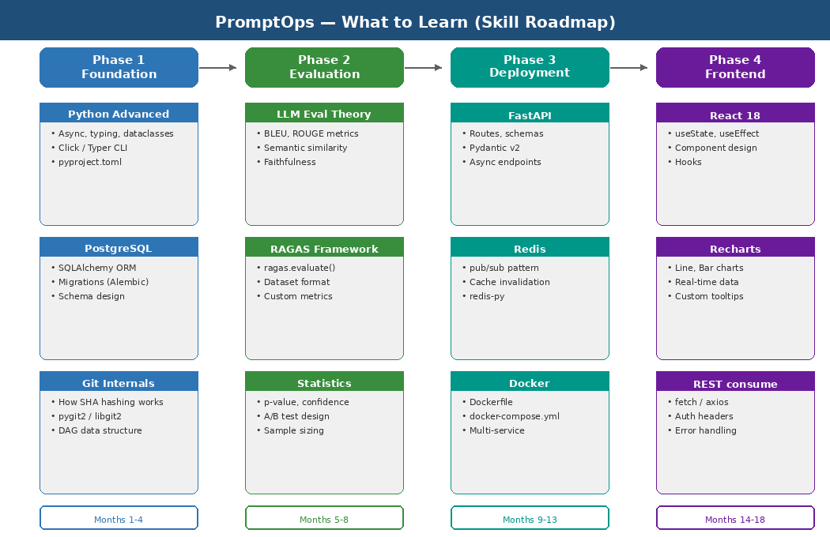

8.1 Phase 1 — Foundation (Months 1–4)

Python Advanced Patterns
You need advanced Python — not just scripting. Focus on: type hints and mypy for type safety, async/await for non-blocking I/O, dataclasses and Pydantic for data modeling, and Click/Typer for building professional CLIs.

Technology | What to Focus On
Click / Typer | CLI framework — how to define commands, arguments, options, and help text
Pydantic v2 | Data validation — how to define schemas that auto-validate input and serialize output
asyncio | Async programming — concurrent I/O without threads
hashlib | SHA-256 hashing — content-addressed storage for version IDs
pygit2 | libgit2 Python bindings — the actual versioning storage layer
SQLAlchemy 2.0 | Modern ORM with async support — how to map Python models to PostgreSQL tables
Alembic | Database migration framework — schema changes as versioned code

Resources for Phase 1
- Book: Fluent Python (2nd ed.) — advanced Python patterns
- Docs: typer.tiangolo.com — Typer CLI framework
- Docs: docs.sqlalchemy.org — SQLAlchemy 2.0 async
- Video: 'Git Internals' by Scott Chacon — understanding the Git object model

8.2 Phase 2 — Evaluation Engine (Months 5–8)

LLM Evaluation Theory
This is the most intellectually demanding phase. You need to understand how to measure LLM output quality rigorously. The key concepts are: reference-based metrics (BLEU, ROUGE), reference-free metrics (G-Eval), and embedding-based similarity.

Technology | What to Focus On
RAGAS | The evaluation framework — learn ragas.evaluate(), all built-in metrics, and how to write custom metrics
Sentence Transformers | Embedding-based similarity — all-MiniLM-L6-v2 for fast semantic similarity scoring
Statistics Basics | Mean, variance, standard deviation, p-value, confidence intervals — essential for interpreting scores
Pandas | Dataset manipulation — loading, cleaning, and analyzing evaluation datasets
Matplotlib / Seaborn | Score visualization — plotting score trends over time for the eval dashboard

Resources for Phase 2
- Paper: RAGAS — Automated Evaluation of RAG Pipelines (arXiv 2023)
- Paper: G-Eval: NLG Evaluation using GPT-4 — understanding judge LLM evaluation
- Course: Statistics for Data Science (Khan Academy) — p-values and confidence intervals
- Docs: sbert.net — Sentence Transformers documentation

8.3 Phase 3 — API & Deployment (Months 9–13)

FastAPI & Production Patterns
FastAPI is the API framework you will use. It generates OpenAPI docs automatically, has native async support, and uses Pydantic for request/response validation. The key things to master are: dependency injection, background tasks, middleware, and error handling.

Technology | What to Focus On
FastAPI | Route definitions, dependency injection, background tasks, middleware, OpenAPI auto-docs
Redis (redis-py) | Pub/Sub pattern, cache-aside pattern, key expiry, connection pooling
Docker | Writing Dockerfiles, multi-stage builds, docker-compose for local orchestration
GitHub Actions | Workflow YAML syntax, matrix builds, secrets management, PR integration
Uvicorn / Gunicorn | ASGI server configuration — workers, timeouts, keep-alive for production serving

Resources for Phase 3
- Docs: fastapi.tiangolo.com — official FastAPI documentation (excellent)
- Docs: redis.io/docs — Redis data structures and patterns
- Book: Docker Deep Dive by Nigel Poulton — container fundamentals
- Docs: docs.github.com/actions — GitHub Actions workflow reference

8.4 Phase 4 — Web Dashboard (Months 14–18)

React & Data Visualization
The dashboard is a single-page React application. You need to be comfortable with React hooks (useState, useEffect, useContext), component composition, and consuming REST APIs. For visualization, Recharts is the library of choice — it is React-native, composable, and well-documented.

Technology | What to Focus On
React 18 Hooks | useState, useEffect, useCallback, useMemo, useContext — the foundation of modern React
Recharts | LineChart for score trends, BarChart for comparisons, ComposedChart for A/B results
React Query | Server state management — data fetching, caching, and background refetching
Tailwind CSS | Utility-first CSS — rapid UI development without writing custom CSS
Vite | Modern frontend build tool — fast dev server and optimized production builds

Resources for Phase 4
- Docs: react.dev — official React docs (redesigned in 2023, excellent)
- Docs: recharts.org — Recharts component reference
- Course: React Query course by Dominik Dorfmeister (TkDodo's blog)
- Docs: tailwindcss.com — Tailwind utility class reference

9. Skill Priority Matrix

Not all skills are equal. This matrix ranks every technology by how critical it is to the project and how difficult it is to learn — so you know exactly where to invest your time first.

Skill / Technology | Priority | Difficulty + Notes
Python Advanced | CRITICAL | Medium — you already know Python; deepen it
FastAPI | CRITICAL | Easy — excellent docs, intuitive design
PostgreSQL + SQLAlchemy | CRITICAL | Medium — SQL fundamentals + ORM patterns
RAGAS Evaluation | CRITICAL | Hard — new paradigm, requires LLM theory understanding
Redis | HIGH | Easy — simple mental model, great docs
pygit2 / libgit2 | HIGH | Hard — low-level C bindings, complex internals
Docker | HIGH | Medium — learn Dockerfile + compose, skip Kubernetes for now
Statistics (A/B) | HIGH | Medium — focused subset: z-test, p-value, sample sizing
React 18 | MEDIUM | Medium — hooks model takes time; defer to Phase 4
Sentence Transformers | MEDIUM | Easy — one-liner API for embeddings
GitHub Actions | MEDIUM | Easy — YAML config, well-documented
Recharts | LOW | Easy — component-based, copy-paste friendly

9.1 Learning Order Recommendation

1️⃣ | Start Here (Week 1–2)  Advanced Python patterns (typing, async, dataclasses) + Click/Typer CLI framework. Everything else builds on top of solid Python fundamentals.

2️⃣ | Core Infrastructure (Week 3–6)  PostgreSQL + SQLAlchemy 2.0 (async) + Alembic migrations. This is your data layer — get it right before writing any business logic.

3️⃣ | The Hard Part (Week 7–12)  pygit2 internals + RAGAS evaluation framework. These are the two technically deepest components. Invest serious time here — they are the unique technical moat of the project.

4️⃣ | API & Deploy (Week 13–18)  FastAPI + Redis + Docker. These are industry-standard tools with great documentation. You will pick them up quickly given solid Python fundamentals.

5️⃣ | Frontend (Month 4+)  React + Recharts + Tailwind. Tackle this only after the backend is solid. The dashboard is valuable but not the core technical innovation.

10. Key System Design Decisions

Every architectural decision in PromptOps was made for a reason. Understanding the why behind each decision is as important as understanding the what — it shows architectural thinking that interviewers and collaborators will respect.

10.1 Why PostgreSQL over MongoDB?
Prompt versions have a strict relational structure — versions reference parents, eval results reference versions, deployments reference versions. This is a strongly relational schema. MongoDB's flexibility would be wasted here and its lack of strict foreign key enforcement would create data integrity risks. PostgreSQL's JSONB columns give the flexibility where it is actually needed (tags, metadata) without sacrificing relational integrity everywhere else.

10.2 Why Redis for Deployment Serving?
Production applications must fetch the active prompt on every LLM request. If we hit PostgreSQL for every fetch, we add 5–20ms of database latency to every LLM call. Redis serves the active prompt from RAM in under 1ms. When a new version is deployed, we invalidate the old Redis key and write the new value — a single atomic operation that takes effect immediately across all application instances.

10.3 Why YAML for Prompt Files?
Prompts need more than just text. They need model parameters (temperature, max_tokens), tags for organization, version metadata, and structured content. YAML handles all of this cleanly, is human-readable, and is diff-friendly — you can see exactly what changed between two versions in a git diff. JSON would work but is noisier. Plain text cannot carry the required metadata.

10.4 Why Separate the CLI from the API?
The CLI calls the Python core engines directly — no HTTP round-trip. The API wraps the same core engines behind HTTP endpoints for dashboard and programmatic access. This means: (1) the CLI is fast with no network overhead, (2) the core logic is tested once and used by both interfaces, and (3) you can use PromptOps without running a server at all for local development.

Design Decision | Rationale
Monorepo structure | Single repo for CLI + API + dashboard — easier to keep in sync and test end-to-end
Content-addressed IDs | SHA-256 hash as version ID — deterministic, tamper-proof, deduplicating
Environment separation | dev / staging / prod are first-class concepts — prevents accidental prod deployments
Async-first API | FastAPI + asyncpg + aioredis — non-blocking I/O for high-throughput eval requests
Plugin architecture for LLMs | Abstract base class for LLM clients — adding a new provider is one file
Eval runs in background tasks | FastAPI BackgroundTasks for eval — commit returns immediately, eval runs async

— Build it. Ship it. Learn from it. —

