Dungeons and Dragons Character Sheet App

Louis Perral
Vanderbilt University
Nashville, USA
louis.n.perral@vanderbilt.edu

Tristan Rocha
Vanderbilt University
Nashville, USA
tristan.rocha@vanderbilt.edu

Abstract—Have you every played Dungeons and Dragons and thought that there should be a better way to keep track of character sheets? In a lot of games, players must lug around hefty character sheets that could often get lost or damaged. Our solution entails the creation of a Chameleon Cloud based Dockerized MySQL database that could be accessed from a web app that would allow users to create characters and update their attributes. After the application’s creation we found that this was an extremely easy and convenient way to keep track of characters as the database could hold the dataset as well as change it without the need for constant erasures and rewrites.
Keywords—dockerized, MySQL, attributes, update.

Introduction
Dungeons and Dragons is a widespread, hyper popular game that has garnered the affection of many who come across it. Due to this fact, certain issues have in turn become widespread themselves, an obvious one being that players must carry character sheets around with them if they want to play the game. In the Dungeons and Dragons game, players must create their own characters who in turn have their own stats and other pieces of information pertaining to identity. Aside from having to carry around a flimsy character sheet, another problem lies in the updating of different stats/attributes. Players will either have to get another sheet and refill out the information completely, or erase what they wrote before to replace the old stats. Because of this hassle, we wanted to extinguish the need for paper tracking methods, the medium of which could get lost, crumpled, torn, etc. We decided that it would be a fantastic idea to have a character sheet database that is accessible by webapp. In this way, players could carry with them multiple character sheets in a single place while also being able to easily update their attributes.

Design and Architecture

Design
For this project, we are aiming to create a MYSQL database running inside a Dockerized container. We chose to structure our project around database manipulation because we found that character sheets and the attributes that make up the characters can be easily represented through SQL tables. Data manipulation and viewing are supported by SQL through some readily available commands.

Architecture
For our cloud platform, we used Chameleon Cloud services and a single cloud virtual machine (VM). We were originally planning to present the completed project in AWS because of its resource rich backing and full support system but found that the starter education plan was too limiting for our purposes, especially the time limit for sessions. Because of this and the fact that we had already begun constructing the skeleton of the project with the Chameleon VM for testing, we chose to continue the project with Chameleon and found that we did not run into provisioning, connecting, etc. issues.
For our database, we created a MySQL server inside a Dockerized container. We opted to have the service run inside a container because of the container’s resource saving properties. We were not sure how much resources running a full database and a webapp would take so we decided it was a good idea to deploy the server in a Docker container. This isolated environment allows users to use only the resources they need while shaving off needless ones that could slow down the machine or other such occurrences.
In order to feed data into the MySQL server, we picked up a JSON file that contained character sheet data from GitHub. This came with character attribute categories for us to eventually turn into SQL columns.
For the webapp, we used Laravel, a PHP framework, to connect to our Dockerized MySQL server. Creating this webapp from scratch would allow us to manually decide which options to keep and implement. We used the model-view-controller (MVC) architectural pattern in order to separate the app’s 3 different functions. The model part pertains to data, the view allows us to visualize the data, and the controller allows users to update, remove, and overall mess with the data.

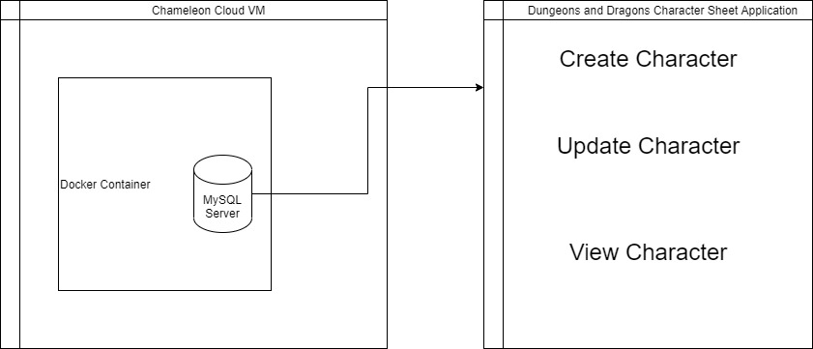

implementation
Firstly, we Dockerized the MySQL server service. We created the container using the latest MySQL image, using the port 3306 as our starting point. We then connected to the container using a local MySQL shell client which we used for all our SQL commands. After the JSON file was converted to an SQL file, we fed it into the MySQL server. While inside the MySQL shell, we created a character database which used the converted SQL file as its source. In doing this, tables within the database were populated with values pertaining to character attributes. We then used SELECT statements to check whether the database was performing as intended and showing the attributes and their assigned values.
In order to build the webapp, we used Laravel services and started from scratch. By using Laravel, visualization became easier as front end dependencies were easy to install, through npm, and were fully supported. Starting from scratch, we used the MVC architectural pattern to guide the design of our app. The model aspect connects to our previously created MySQL server. It takes from the database filled with the character data SQL file and uses it as a data backbone. The view aspect reads from the database and spits it out to the user. This is what handles the visualization of the user’s character sheet. Finally, the controller aspect deals with the creation of the character sheets and the updating of the attributes. Creating a new character populates the character sheet table with a new row. Users are prompted to then fill out their attributes, which when sent to the server, updates the columns for that row with the values they input. When a character levels up, users can update their attributes without having to create a whole new character. The update option would pull the character in question from the database and it would be up to the user to make changes. After the update is finished, the data is sent back to the database to be solidified.

Teamwork
As this project was a great undertaking, we decided it would be a good idea to split up the minor steps while working concurrently with the major components. For the minor steps, Louis created the MySQL server inside a Dockerized container environment and loaded the character sheet SQL file. Tristan converted the JSON file into an SQL format the database could read. Furthermore, he formatted the file to fit our vision’s needs (relevant character attributes).
For the major components of the project, we used Zoom to collaborate live. We used the share screen and remote control features to work on the same Chameleon Cloud VM instance and build the code together. We designed the project together in this way and together came up with how the app should operate. Additionally, we took turns editing the final report document.

Conclusion

All in all, we created this project in order to ease the plights of Dungeons and Dragons players. We believe that by having this application available, players will not have to bring around flimsy pieces of paper that are hassles to alter and bring around. Instead, they can just use the app to handily create characters and/or update old ones. We created a MySQL server inside a Dockerized container in order to house our database. This database would be fed an SQL file containing the attributes needed for a character. The
Laravel webapp we created would allow users 3 options: creating their characters, updating their characters, and viewing the character sheet. A stumbling block we encountered during this project would be connecting to the Laravel app. We fully coded the environment per our design but we kept getting an access denied error in which we could not connect to our app. Therefore, we were not able to fully test the app. For the future, we could try to redo the project in a local environment to allow for a much easier connection to the PHP framework. Additionally, we would like to see if a VM running a non-containerized MySQL server would visibly run less optimally than our containerized server. We would have to deploy Kafka to find upload times and other such timing metrics. Our files for the Laravel build can be found at: https://github.com/rochat2021/cc-final-project

