**The UN SDGs – Intro**

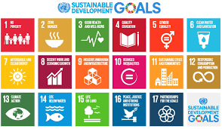

|  |
| --- |
| **Introduction** |
| What are the UN SDGs? |
|  |
| Take notes on the background to the UN SDGs |
|  |
| What do you think about the UN SDGs? Write a paragraph on this. |
| Are they good idea?  Do they target the right things?  Do you feel any connection with them? |

|  |
| --- |
| **SDG Investigation:** |
| Goal 11& Name: |
|  |
| What are the aims of this goal? |
|  |
| Why is this goal important? |
|  |
| Choose 2 targets of the goal! |
|  |
| Describe 2 current events that are related to your targets |
|  |
| Explain how meeting the goal could reduce the impact of this current event |
|  |
| How could meeting this goal impact student at Riga State Gymnasium No.1? |
|  |
| What types of actions could students at RSG#1 take to help meeting this goal? You should refer to the 4 types of service for this ( think about your possibilities for service next school year) |
| Direct:  Indirect:  Advocacy:  Research: |
| **Summary pitch:** Make a final pitch on why your goal is important and why students should engage in action to help meet the goal. |
|  |