# nRF24L01+

The nRF24L01+ module is a 2.4G wireless communication module developed by Nordic based on the nRF24L01 chip. Adopt FSK modulation and integrate Nordic's own Enhanced Short Burst protocol. Point-to-point or 1-to-6 wireless communication can be achieved. Wireless communication speed can reach up to 2M (bps). The NRF24L01 has four operating modes: transceiver mode, configuration mode, idle mode, and shutdown mode.The picture of nRF24L01+ as follows: 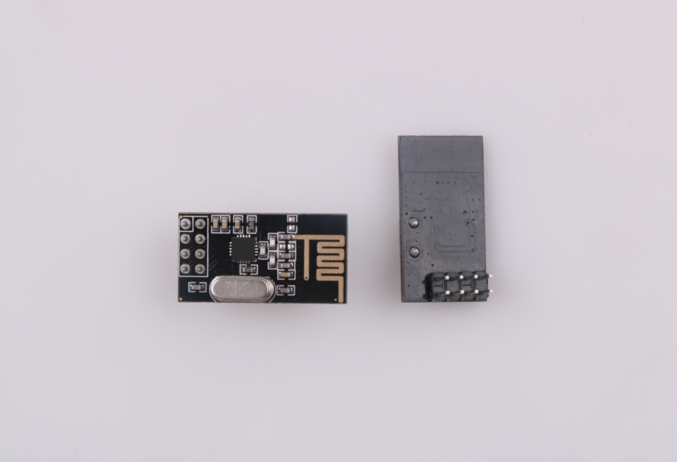

## Module features

* 2.4GHz ,small size，15x29mm（including antenna）
* Support six-channel data reception
* Low working voltage: 1.9～3.6V
* Data transfer rate supports: 1Mbps、2Mbps
* Low power consumption design，working current at receiving is 12.3mA, 11.3mA at 0dBm power emission, 900nA at power-down mode
* Automatic retransmission function, automatic detection and retransmission of lost data packets, retransmission time and retransmission times can be controlled by software
* Automatic response function, after receiving valid data, the module automatically sends an answer signal

NRF24L01 chip details please refer to《nRF24L01 Datasheet.pdf》

## Pin information

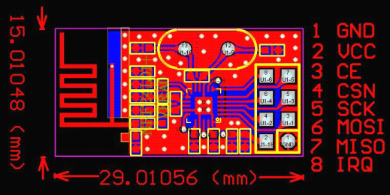

|  |  |  |  |
| --- | --- | --- | --- |
| **Pin** | **Symbol** | **Function** | **Direction** |
| 1 | GND | GND |  |
| 2 | +5V | Power Supply |  |
| 3 | CE | Control Line At Working Mode | IN |
| 4 | CSN | Chip Select Signal, Low Level Working | IN |
| 5 | SCK | SPI Clock | IN |
| 6 | MOSI | SPI Input | IN |
| 7 | MISO | SPI Output | OUT |
| 8 | IPQ | Interrupt Output | OUT+ |

## Experimental Purpose

1. Learn about nRF24L01+module and how to connect with Arduino.

2. How to use arduino and nRF24L01+ module to finish receiving and sending data.

## The components needed for this experiment

* Arduino UNO R3 Motherboard *1
* Arduino NANO Motherboard
* nRF24L01 Module*2
* Several wires

## Experimental schematic diagram

## Experimental connection diagram

## Arduino and NRF24L01 connection

|  |  |
| --- | --- |
| arduino Nano | nRF24L01 |
| +3.3V | VCC |
| GND | GND |
| 9pin | 4pin CSN |
| 10pin | 3pin CE |
| 11pin | 6pin MOSI |
| 12pin | 7pin MISO |
| 13pin | 5pin SCK |

|  |  |
| --- | --- |
| arduino Uno | nRF24L01 |
| +3.3V | VCC |
| GND | GND |
| 9pin | 4pin CSN |
| 10pin | 3pin CE |
| 11pin | 6pin MOSI |
| 12pin | 7pin MISO |
| 13pin | 5pin SCK |

## Program principle

**Launch process**

1、Firstly,configure the nRF24L01 to transmit mode.

2、Then write the address TX_ADDR of the receiving end and the data TX_PLD to nRF24L01 buffer area by the SPI port in time sequence.

3、Set CE to be high voltage for at least 10 μs and transmits data after a delay of 130 μs. If the auto answer is on, the nRF24L01 enters the receive mode immediately after transmitting the data and receives the answer signal. If a reply is received, the communication is considered successful.

4、NRF24L01 will automatically set TX_DS high and the TX_PLD will be cleared from the transmit stack. If no response is received, the data will be automatically retransmitted. If the number of retransmissions (ARC_CNT) reaches the upper limit, MAX_RT will set high and TX_PLD will not be cleared; If MAX_RT or TX_DS is set high, IRQ goes low to trigger MCU interrupt. When the last transmission is successful, if the CE is low, the nRF24L01 will enter standby mode.

5、If there is data in the transmission stack and CE is high, the next transmission is started; if there is no data in the transmission stack and CE is high, the nRF24L01 will enter standby mode 2.

**Receive data process**

1、When the nRF24L01 receives data, please configure the nRF24L01 to receive mode firstly.

2、Then delay 130μs into the receiving state to wait for the arrival of data. When the receiver detects a valid address and CRC, it stores the data packet in the receiver stack. At the same time, the interrupt sign RX_DR is set high and the IRQ goes low to notify the MCU to fetch the data.

3、If auto-response is turned on at this time, the receiver will enter the transmit status echo response signal at the same time. When the last reception is successful, if CE goes low, the nRF24L01 will go into idle mode 1.

Sender program

//Transmitter program

#include <SPI.h>

#include "Mirf.h"

#include "nRF24L01.h"

#include "MirfHardwareSpiDriver.h"

Nrf24l Mirf **=** Nrf24l**(**10**,** 9**);**

int value**;**

void setup**()**

**{**

Serial**.**begin**(**9600**);**

Mirf**.**spi **=** **&**MirfHardwareSpi**;**

Mirf**.**init**();**

//Set your own address (sender address) using 5 characters

Mirf**.**setRADDR**((**byte **\*)**"ABCDE"**);**

Mirf**.**payload **=** **sizeof(**value**);**

Mirf**.**channel **=** 90**;** //Set the channel used

Mirf**.**config**();**

**}**

void loop**()**

**{**

Mirf**.**setTADDR**((**byte **\*)**"FGHIJ"**);** //Set the receiver address

value **=** random**(**255**);** //0-255 random number

Mirf**.**send**((**byte **\*)&**value**);** //Send instructions, send random number value

Serial**.**print**(**"Wait for sending....."**);**

**while** **(**Mirf**.**isSending**())** delay**(**1**);** //Until you send successfully, exit the loop

Serial**.**print**(**"Send success:"**);**

Serial**.**println**(**value**);**

delay**(**1000**);**

**}**

Sender program

//Receiver program

#include <SPI.h>

#include "Mirf.h"

#include "nRF24L01.h"

#include "MirfHardwareSpiDriver.h"

Nrf24l Mirf **=** Nrf24l**(**10**,** 9**);**

int value**;**

void setup**()**

**{**

Serial**.**begin**(**9600**);**

Mirf**.**spi **=** **&**MirfHardwareSpi**;**

Mirf**.**init**();**

Mirf**.**setRADDR**((**byte **\*)**"FGHIJ"**);** //Set your own address (receiver address) using 5 characters

Mirf**.**payload **=** **sizeof(**value**);**

Mirf**.**channel **=** 90**;** //Set the used channel

Mirf**.**config**();**

Serial**.**println**(**"Listening..."**);** //Start listening to received data

**}**

void loop**()**

**{**

**if** **(**Mirf**.**dataReady**())** **{** //When the program is received, the received data is output from the serial port

Mirf**.**getData**((**byte **\*)** **&**value**);**

Serial**.**print**(**"Got data: "**);**

Serial**.**println**(**value**);**

**}**

**}**

## Experimental

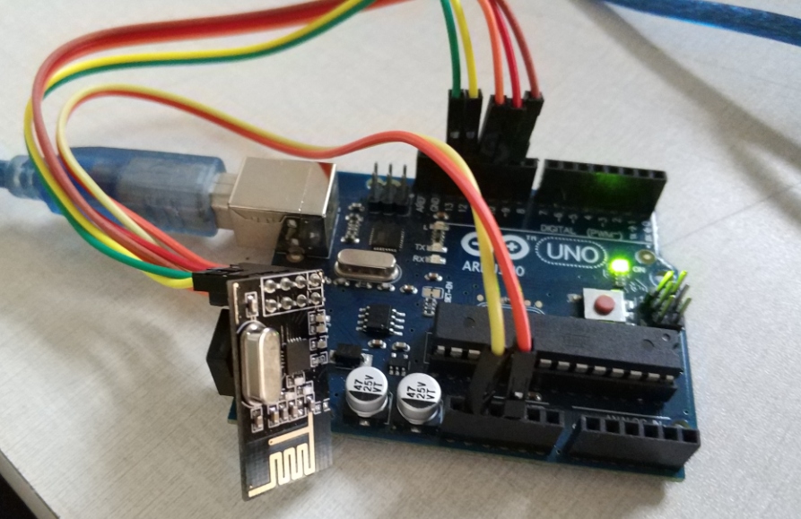

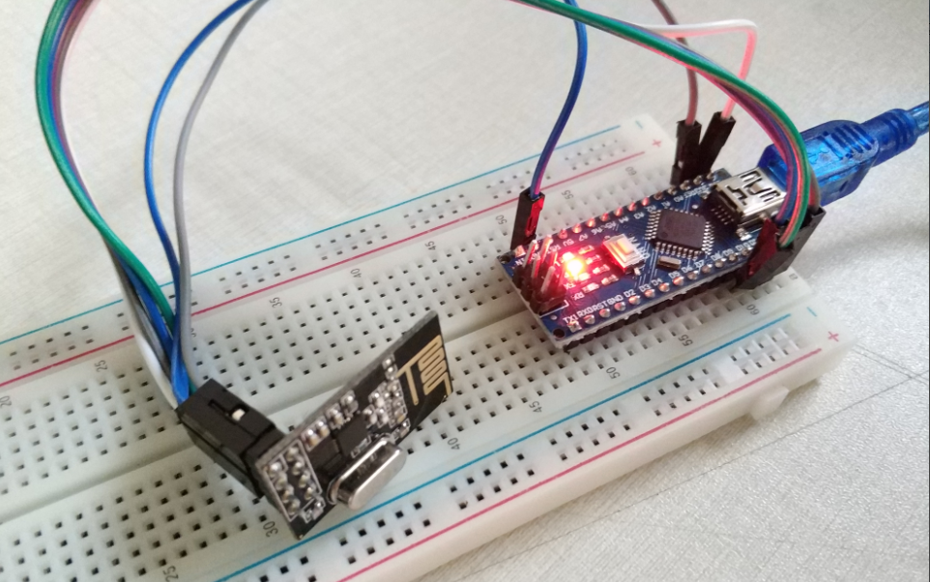

**Result：**

