长沙市2008年初中毕业学业考试
英语
第Ⅰ卷
一、听力技能
第一节 根据所听到内容，选择相应的图画。听每段材料前，你将有时间阅读各个小题，每小题5秒钟；听完后，各小题将给出5秒钟的作答时间。
1.
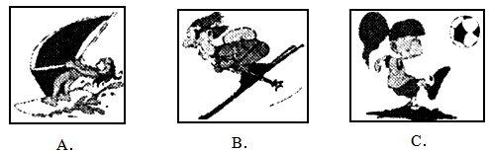
2.
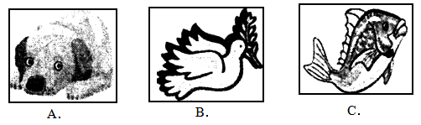
3.
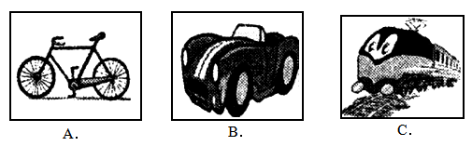
4.
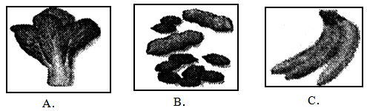
5.
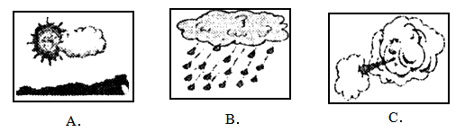
第二节 对话理解，听下面的对话，从题中所给的人B、C三个选项中选出最佳答案。
听每段对话前，你将有时间阅读各个小题，每小题5秒钟；听完后，各小题将给出5秒钟的作答时间。
听下面的对话，回答第6题。
6．（2008年，长沙）What is Lily’s father?
A．A singer. | B．A doctor. | C．A policeman.
听下面的对话，回答第7题。
7．（2008年，长沙）What subjects does the girl like?
A．Maths and English.
B．Chinese and history.
C．Music and chemistry.
听下面的对话，回答第8题。
8．（2008年，长沙）Where is Lucy’s mother now?
A．In Changsha. | B．In Shanghai. | C．In Beijing.
听下面的对话，回答第9题。
9．（2008年，长沙）How much is the watch now?
A．120 yuan. | B．60 yuan. | C．30 yuan.
听下面的对话，回答第10题。
10．（2008年，长沙）Where are Lucy and her father?
A．In the street. | B．In the hospital. | C．At home.
听下面的对话，回答第11，12题。
11．（2008年，长沙）How often does the girl go to the movies?
A．Once a week. | B．Twice a week. | C．Twice a month.
12．（2008年，长沙）Why does the boy usually go to Hunan Great Theatre to see a film?
A．Because the cinema is very big.
B．Because the cinema has comfortable seats.
C．Because the cinema is beautiful.
听下面的对话，回答第13，14题。
13．（2008年，长沙）What did Lily do in America?
A．She visited some friends.
B．She learned English.
C．She taught Chinese.
14．（2008年，长沙）How many cities did Lily visit in America?
A．Three. | B．Four. | C．Five.
听下面的对话，回答第15至17题。
15．（2008年，长沙）Where did Tom go?
A．The hospital. | B．The train station. | C．The airport.
16．（2008年，长沙）When will Tom come back?
A．At 9:10. | B．At 11:00. | C．At 11:10.
17．（2008年，长沙）What will Tom do when the visitors come?
A．He will dance for them.
B．He will sing some English songs.
C．He will play the piano for them.
第三节 （2008年，长沙）笔录要点。根据你所听到的内容，填写下面的表格，每空不超过3个单词。
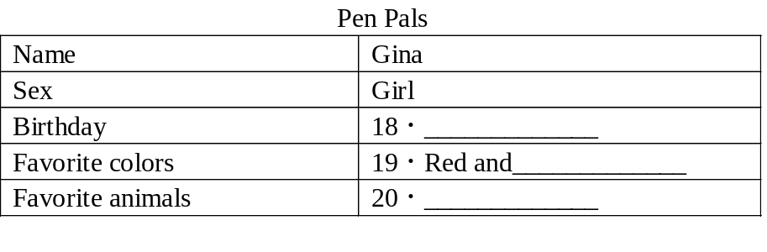
二、知识运用
第一节 单项填空
从A、B、C三个选项中选出最佳答案填空。
21．（2008年，长沙）There is _________apple tree in our school.
A．a | B．the | C．an
22．（2008年，长沙）All the teachers live on ________floor.
A．the second | B．two | C．second
23．（2008年，长沙）Who runs _________, Tom or Jim?
A．fast | B．faster | C．fastest
24．（2008年，长沙）There are many tall buildings on ________sides of the street.
A．either | B．all | C．both
25．（2008年，长沙）—Was the boy saved?
—No. The doctors tried their best, ________they failed.
A．and | B．so | C．but
26．（2008年，长沙）—May I speak to Tom?
—Sorry, he is not at home. He ________to Shanghai.
A．has been | B．has gone | C．goes
27．（2008年，长沙）My mother asks me ________TV before finishing my homework.
A．not to watch | B．not watch | C．not watching
28．（2008年，长沙）—Is Lucy knocking at the door?
—No. It ________be Lucy. She is in Japan now.
A．needn’t | B．must | C．can’t
29．（2008年，长沙）—Do you plant trees in spring?
—Yes. Many trees _________in our city every year.
A．are planting | B．are planted | C．were planted
30．（2008年，长沙）—What are you looking for?
—I am looking for the book ________I bought yesterday.
A．who | B．which | C．whose
第二节 完形填空
（2008年，长沙）通读下面的短文，掌握其大意，然后从所给的A、B、C三个选项中选出一个最佳答案
You don’t have to give thousands of dollars to help someone. Sarah, a girl from Michigan, the USA, makes a difference just by giving her (1) . Sarah was serious ill (2) she was a baby. It is (3) for her to move. Sarah has to (4) around with a walker. However, the 11-year-old girl doesn’t give up; she uses her experience to help others.
Last summer, Sarah (5) three days a week for seven weeks at the Grand Rapids Comprehensive Therapy Center. She was one of the youngest (6) for “Therapy（治疗）and Fun”, a program for special-needs children. Sarah’s job was to help the special-needs children and provide them (7) advice and encouragement（鼓励）.
Sarah says that she’s (8) she can share her knowledge with others, and that working at the center taught her a lot, too. “I feel my life is getting better because I can help others in (9) way.” she said. Mary VanWingerden, Sarah’s fourth-grade teacher, said that, “Sarah has the help of other students around her, but she shows them that she’s there (10) them also.”
(1)
A．money | B．house | C．time
(2)
A．when | B．after | C．until
(3)
A．easy | B．interesting | C．difficult
(4)
A．speak | B．walk | C．listen
(5)
A．worked | B．lay | C．sat
(6)
A．doctors | B．nurses | C．volunteers
(7)
A．with | B．to | C．for
(8)
A．sad | B．glad | C．worried
(9)
A．her | B．my | C．your
(10)
A．to help | B．to watch | C．to find
三、阅读技能
第一节 （2008年，长沙）阅读短文，判断下列句子是否符合短文内容。符合的写(T)，不符合的写(F)。
A little girl thought she was not as beautiful as other girls, and nobody liked her. So she was always unhappy and didn’t like to talk to others. However, one day, her mother gave her a beautiful hair clip（发夹）. When she wore it, she looked much more beautiful than before. She decided to wear it to school.
On her way to school she found that everyone who saw her smiled at her. Most of her schoolmates said “hello” to her, but this never happened before. She thought that the beautiful hair clip had brought her them all. She was so happy about all of the wonderful things. Although she didn’t tell her classmates about her beautiful hair clip, they all wanted to know what had happened to her.
When she went back home after school, her mother asked her, “Did you know you dropped your hair clip? I found it by the door this morning.”
She understood that she hadn’t worn the hair clip to school at all.
It is not important what we wear or how we look. The most important is how we think about ourselves.
(1) The little girl was not beautiful because she had no money to buy a hair clip.
(2) Her mother didn’t like the little girl, either.
(3) Most of the schoolmates liked her beautiful hair clip very much on that day.
(4) Her mother found the clip by the door after the girl went to school.
(5) It is not important what we wear or how we look.
第二节 （2008年，长沙）阅读短文，从每题所给的A、B、C三个选项中，选出最佳选项回答问题或完成句子。
A
Many Chinese students think American students enjoy more freedom than them at school. But American schools also have their rules. If the students break the rules, they will get punishment, too.
On the first day of a new term, 128 students of Morton High School were sent home for wearing the wrong clothes. There are altogether 1 200 students in the school. Usually only 20 students break the school dress rule every day. So the headmaster Theresa Mayerik said it was the worst new term she had ever seen.
At Morton High School, students’ favorite clothing such as baggy（宽大的）trousers, low-necked shirts and tank tops（紧身短背心）are not allowed in classrooms. Some students think they have the right to choose what to wear, but the headmaster doesn’t think so. “I’d be supportive if half the school was sent home, because 99% will get the message that our school are for education.”“Freedom”does not mean “free of restrictions（约束）”. That is to say there is no total freedom in the world, no matter in the US or in China.
(1) Many Chinese students think that___________.
A．American students are very free at school
B．American students are not so clever as them
C．American students don’t love their school at all
(2) 128 students of Morton High School were sent home for________.
A．not finishing their homework
B．being late for school
C．not wearing the right clothes
(3) Some students in Morton High School think that they have the right to _______.
A．decide when to go to school
B．choose what to wear
C．eat and drink in class
(4) What does the underlined word “supportive” mean in Chinese?
A．高兴的 | B．支持的 | C．害怕的
(5) What’s the writer’s attitude（态度）to the school dress rule?
A．Agree.
B．Disagree（不同意）.
C．Not sure.
B
China will be the first developing country to host the Olympic Games in modern Olympic history. It hopes to learn from other countries that have held Olympic Games. As well as new buildings, the government wants more people to work in all the services in Beijing. There will be a lot more people in the city, because of all the visitors to the Olympics. The city will need more places to eat and drink, because visitors eat out a lot.
The government says the Beijing Olympics will be “green”,“hi-tech”（科技）, and“the People’s Olympics”. They want everyone to feel part of the Olympics. So the Chinese people are preparing for the Olympics too. Many people are learning English to work as guides in 2008.
The Beijing organizers（组织者）are making sure everything that is built for the Olympics will be used after the Games are over. So the Chinese people will work for the Olympics and they will benefit（受益）from the Olympics too. When the Olympics are over, the people of Beijing will use the swimming pools and other Olympic sports centers.
(1) China will be ________country to host the Olympic Games in modern Olympic history.
A．first
B．the first developing
C．the first Asian
(2) Why does the government want more people to work in Beijing?
A．Because the services in Beijing used to be very poor.
B．Because many people can’t find jobs in their hometown.
C．Because many visitors will come to Beijing.
(3) The new buildings for the Olympics will ________
A．be used by the people after the Olympic Games
B．be closed after the Olympic Games
C．be only reopened when the next Olympic Games come
(4) What does “the People’s Olympics” mean?
A．It means that everyone in China will be a player in the Olympic Games.
B．It means that everyone in China feels part of the Olympics.
C．It means that all the Chinese people are rich enough to go to Beijing and watch the Olympic Games.
(5) What does .this passage want to tell us?
A．The people in Beijing enjoy learning English.
B．The new buildings for the Olympics are very modern.
C．Everyone in China should do something for the Olympics and can also get a lot from the Olympics.
第三节 （2008年，长沙）阅读下列图表，从每题所给的A、B、C三个选项中，选出最佳选项回答问题或完成句子。
(1) We can learn from the PROFILE on the right that________.
A．Kaka is a football player
B．Kaka is from England
C．Kaka is 28 years old in 2008
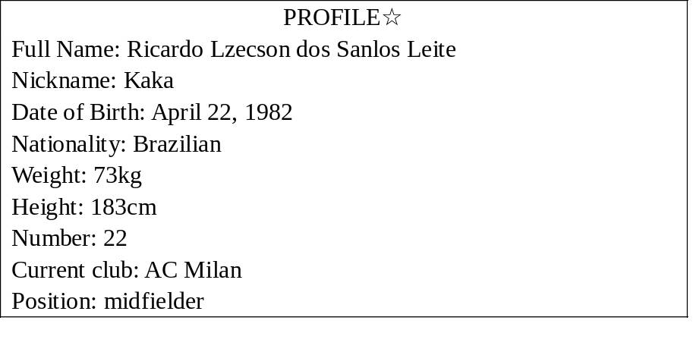
(2) It is very good advice for you to protect yourself_______.
A．when a traffic accident happens
B．when you go out for a picnic
C．when an earthquake（地震）hits
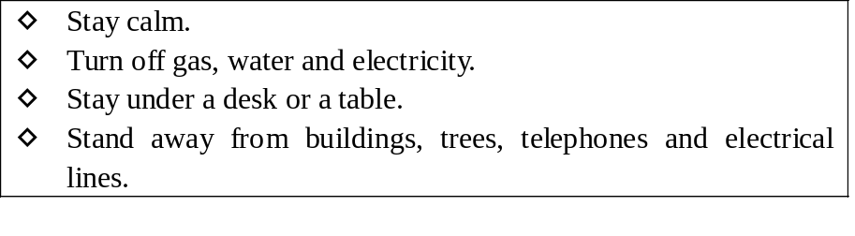
(3) The survey（调查）on the right is about _________.
A．reading books
B．doing sports
C．making friends
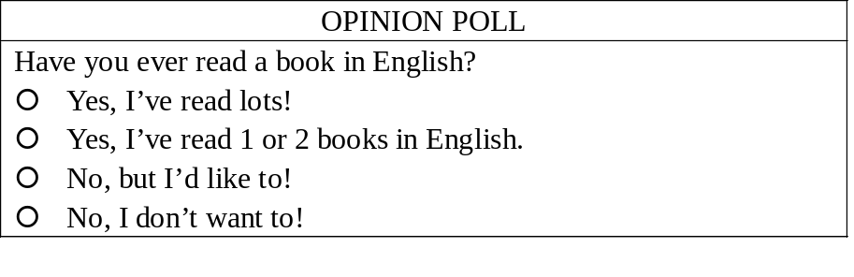
(4) Please read the notice and find out which of the following is WRONG?
A．Benny and Paula will have a birthday party.
B．Benny and Paula have just moved to a new house.
C．Benny and Paula’s new house is on 44 Wright Avenue
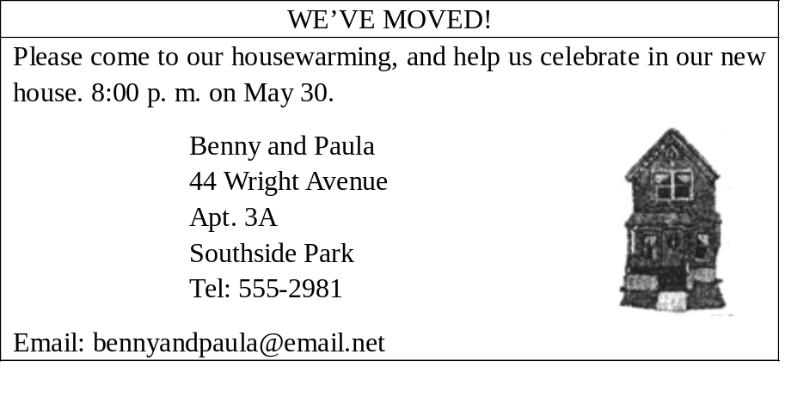
(5) Please read the tour information and find out which of the following is TRUE?
A．Only the students under 12 can have the discount（折扣）.
B．If you set off at 9:15, you can’t visit Heartlands and Heroes.
C．If you have only ￡25, you can visit Loch Ness and Legends.
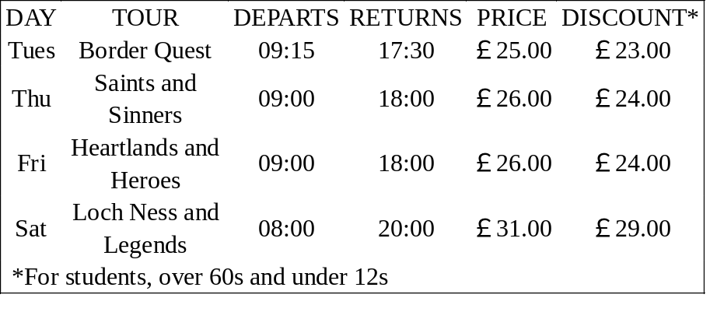
第四节 （2008年，长沙）阅读下面的材料，然后根据材料内容回答所提问题。
The time may be10 a.m. inBeijingand2 a.m. in New York. It is set on the same time—Greenwich Mean Time. This is because in 1884, many nations met to decide how to prevent the confusion（混乱）made by almost every town having its own time.
Such a time rule was devised（设计）by Sir Sanford Fleming (1827—1915). He was an engineer who lived in Canada. He held a meeting in 1884 to discuss the time problem. He suggested that there should be 24 meridians（子午线）dividing the world into 24 time zones（时区）. The zero meridians would pass through the village of Greenwich near London. The time at Greenwich would be called Greenwich Mean Time, and al each of the 24 meridian lines, the time would go forward or backwards by one hour.
Twenty-seven nations agreed to this suggestion, and since then GMT has been the centre of time-keeping for all nations. Most nations have only one time zone; however, large nations such as the USA and Australia are divided into several time zones.
(1) What time is it in New York when it is 10 a.m. in Beijing?
(2) Who devised Greenwich Mean Time?
(3) When was the meeting held to discuss the time problem?
(4) How many nations agreed to Greenwich Mean Time?
(5) Does Australia have only one time zone?
第Ⅱ卷
四、写作技能
第一节 （2008年，长沙）完成对话。通读下面的对话，然后根据上下文补全对话内容。
A: Hi, John. You didn’t come to school yesterday afternoon. What was wrong with you?
B: (1) __________.
A: I’m sorry to hear that. (2) __________?
B: Much better. But I still cough and I feel weak.
A: (3) __________?
B: Yes, I have. I went to the doctor’s last night: The doctor gave me some medicine and asked me to stay in bed for three days.
A: (4) ___________?
B: Because I’m afraid I'll miss more lessons and fall behind.
A: Don’t worry about that. (5) _________.
B: It’s very kind of you to say so. Thanks a lot.
A: You’re welcome.
第二节 （2008年，长沙）翻译语篇。阅读下面的短文，将画线部分的句子译成汉语。
(1) In the United States people sometimes go camping for vacation. Instead of staying at modern hotels and restaurants, they live in the woods and do everything for themselves for a few days to relax.
(2) When you are camping, you make all of your own food. It is rather like a large, many-day picnic. Barbeques（烤肉架）are very common while camping. You can bring meat and vegetables to the camp. To make a fire, you can find or bring your own wood and light it with a lighter（打火机）
(3) Remember to put stones around the fire so that it won’t get too big and dangerous! When the fire is ready, you can cook food over it.
Besides meat and vegetables, you can also cook marshmallows（果酱软糖）with the fire.
(4) Children really like this activity at night. The whole family sits around the fire, eat marshmallows, and drink hot chocolate--especially when it is cold outside! Everyone can sing camping songs and dance together.
(5) Camping is a fun activity for the family to do. Vacation does not have to mean going to visit faraway places; it could be as simple as setting up a tent in a nearby forest!
第三节 （2008年，长沙）情景作文
下图是Gina对班上同学的周末活动进行调查后得出的结果；同学们的周末活动真是丰富多彩。想想你和你的同学是如何度过周末的?写一篇名为“Weekend Activities”的文章谈谈你们的周末活动。
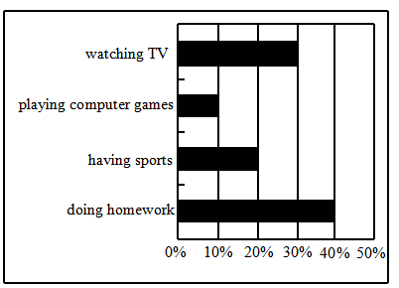
要求：1．语意连贯，句式规范，字迹工整；
2．文中不得出现你的真实校名和姓名；
3．词数60—80；
4．开头已给出,不计入总词数。
Weekend Activities
In my class, most of my classmates have colorful weekends. _____________
______________________________________________________________________________________________________________________________________________________________________________________________________________________________________________________________________________________________________________________________________________________________________________________________________________________________________________________________________________

