2009年湖南省长沙市中考英语试题
I .听力技能（三部分，共20小题，计20分）
第一节根据所听到的内容，选择相应的图画。听每段材 料前，你将有时间阅读各个小题，每小题5秒钟；听完后，各小题将给出5秒钟的作答时间。（共5小题，计5分）
1. 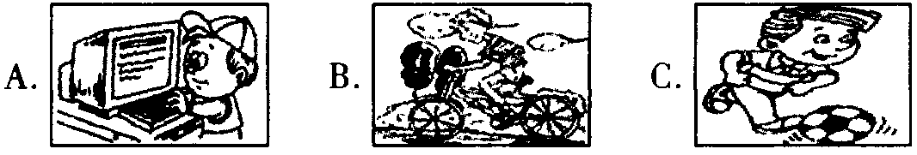
2. 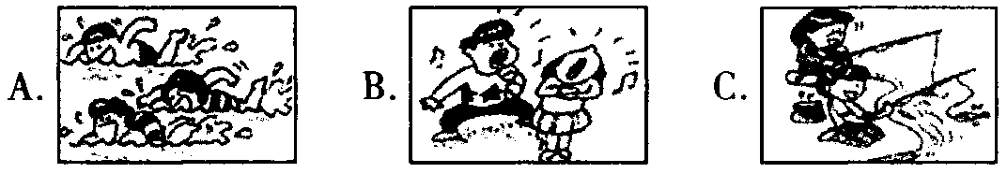
3. 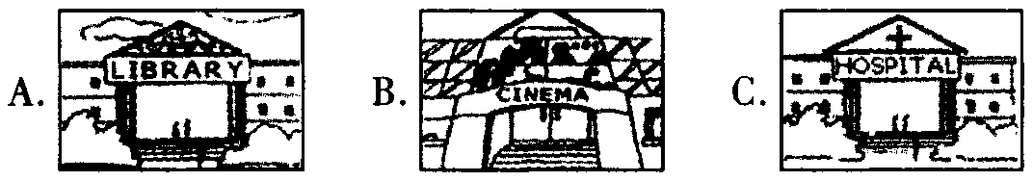
4. 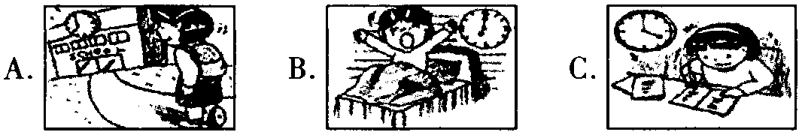
5.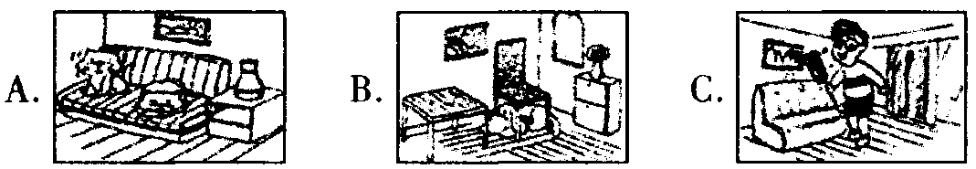
第二节对话理解听下面的对话，从题中所给的A、B、C
三个选项中选出最佳答案。听每段对话前，你将有时间阅 读各个小题，每小题5秒钟；听完后，各小题将给出5秒钟 的作答时间。（共10小题，计10分）
听下面的对话，回答第6小题。
6. What does the boy like?
A. Tea. B. Coffee. C. Wine.
听下面的对话，回答第7小题。
7. Where is the girl's watch?
A. On the bed. B. Under the table. C. On the desk.
听下面的对话，回答第8小题。
8. How long will Li Ming stay in Ghangsha?
A. Four days. B. Five days. C. Six days.
听下面的对话，回答第9小题。
9. When will the bus arrive?
A.9:10. B.9:20. C.9:30.
听下面的对话，回答第10小题。
10. When can people go to the new sports club?
A. On Monday morning. B. On Monday afternoon. C. On Sunday morning.
听下面的对话，回答第11至12小题。
11. What is the man looking for?
A. Some history books. B. Some English books.
C. Some math books.
12. Where are they talking?
A, In the hospital. B. In the library. C. On the farm.
听下面的对话，回答第13至15小题。
13. Why does the girl want to change her coat?
A. Because the coat doesn't fit her.
B. Because the coat is too expensive.
C. Because she doesn't like the colour.
14. Who bought the coat for the girl?
A. Her brother. B. Her sister. C. Her mother.
15. Which coat will the girl probably take?
A. A red one, Size 11. B. A yellow one, Size 9.
C. A blue one, Size 11.
第三节笔录要点根据你所听到的内容，填写下面的表 格，每空不超过3个单词。（共5小题，计5分）
Name | Country | Age | Hobby | Time
Andy | Canada | 16 | Collecting stamps | 17
Mike | 18 | 24 | Playing football | Five years
19 | England | 30 | 20 | Fifteen years
n .知识运用（两部分，共20小题，计20分）
第一节单项填空从A、B、C三个选项中选出最佳答案 填空。（共10小题，计10分）
21. Mary has a bad cold. She has to stay in bed.
A. a B./ C. the
22. ―Help to some fish, my boy.―Thanks.
A. you B. yours C. yourself
23. ― have you been learning English?
―I have been learning English for six years.
A. How long B. How often C. How far
24. ―Don't forget my parents when you are in Beijing.—OK! I won't.
A. to see B. sees C. seeing
25. Father' s Day is on Sunday of June.
A. three B. third C. the third
26. Tom knew nothing about it his sister told him.
A. since B. if C. until
27. ―What are you looking for?
―I'm looking for the pen I bought yesterday.
A. who B. which C. whose
28. ―When were you bom?
一I was bom the morning of May 7 th, 1995.
A. in B. on C. at
29. In Ghangsha, it's hot in July, but it' s even in August.
A. hot B. hotter C. hottest
30. 一Do you often plant trees in spring?
一Yes. Many trees in our school every year.
A. plant B. are planting C. are planted
第二节完形填空通读下面的短文，掌握其大意，然后从 所给的A、B、C三个选项中选出一个最佳答案。（共10小 题，计10分）
Umbrellas are common in our daily life. On rainy days, many people hold them to prevent the 31 . But it' s not easy to hold an umbrella if there is heavy rain and 32 wind. And it' s harder to make a phone call or ride a bike 33 an umbrella in the hand. An American named Alan Kaufman and his company 34 6 years inventing a hand-free umbrella. 35 , they made it.
They called it Nubrella. Just touch a button (按钮)，and the Nubrella will open 36 . With the help of its " shoulder support (支持)"，the umbrella can rest on the user's 37 . So the user needn't hold the umbrella any more. He can walk with hands 38 even in the strong wind.
The hand-free umbrella is $ 59.94 each. People all around the world like it very much. Because of this smart 39 ， they can use their phones to talk and send short messages in the rain now. 40 in the rain under a Nubrella is really cool， isn't it?
31. A. snow B. water C. sun
32. A. tall B. short C. strong
33. A. by B. without C. with
34. A. spent B. took C. paid
35. A. At first B. At last C. At most
36. A. easily B. hardly C. nearly
37. A. feet B. legs C. shoulders
38. A. free B. busy C. difficult
39. A. invention B. magazine C. book
40. A. Lying B. Flying C. Walking
III.阅读技能（四部分，共25小题，计50分）
第一节阅读短文，判断下列句子是否符合短文内容。符 合的写(T)，不符合的写（F)。（共5小题，计10分）
National Middle School Games will be held in Ghangsha Sports are good for our health. Sports can make our bodies strong. To make more students know their importance ， a sports meeting for middle school students is held in China. This year is its 10th birthday. It will be held from August 16th to 21st in Ghangsha ， the capital city of Hunan Province. It is the Nation al Middle School Games.
The Games have eight events. They are track and field (田径)，swimming ， basketball folleyball ， table tennis ， Wushu, aerobics(健美操)and soccer.
The National Middle School Games are held every three years. Nine Games have been held successfully until now and many middle school students have taken part in the Games.
It is reported that 205 teams with nearly 5 ， 000 athletes (运动员)will take part in the Games in 2009. All the athletes are from different parts of the country including Hong Kong and Macau. They are training hard and will come to Ghangsha for the games. We hope they will love the beautiful city and that their dreams will come true.
41. The 10th National Middle School Games will be held in Ghangsha.
42. The Games will start on August 16th, 2009.
43. The Games are held every four years.
44. About 5 ,000 students will take part in the Games.
45. Now all the athletes are training hard in Ghangsha.
第二节阅读短文，从每题所给的A、B、C三个选项中，选 出最佳选项回答问题或完成句子。（共10小题，计20分）
A
Barack Obama ， a black man ， is the president of the Unit ed States now. He was bom on August 4th ， 1961 ， in Hawaii (夏威夷)and has lived in many places. His mother was from Kansas(堪萨斯州)and his father was from Kenya(肯尼亚). Obama went to Columbia University in New York and got a law degree at Harvard University in Massachusetts. His wife is Mi chelle Obama. She also worked as a lawyer (律师)and later worked for the University of Chicago. They have two young daughters.
Obama wrote a book Dreams from my father. " I always live in the dream of my father and American people ，" Obama once said. He was bom in a poor family. And he was taken good care of by his grandparents when he was young. He also lived and worked in Africa. Then he got good education in Harvard University. On November 4th, 2008， he became the new president of America for the next four years.
46. Where was Barack Obama bom?
A. In Hawaii. B. In Kansas. C. In Massachusetts.
47. universities are mentioned in the passage.
A. Three B. Four C. Five
48. Which of the following is NOT true?
A. Obama' s father was from Kenya.
B. Obama has a son and a daughter.
C. Obama once worked in Africa.
49. Barack Obama becanu? President at the age of .
A. 37 B.47 C.57
50. Which is the best title(标题)of this passage?
A. Education of a president B. Dreams from my father C. Life of Barack Obama
B
A stamp tells a story about the country which it comes from. You can find stamps that show almost anything. Some stamps honor special events, places, or people. As people col led these pieces of paper, no one knows how valuable (有价值 的)they c'dii become. One stamp from 1893 that celebrates Christopher Columbus is worth thousands of dollars ！ Stamp col lecting has become popular. You can join groups and have a look at others' stamps.
Who decides what is printed on a stamp? Many Americans come up with(提出)ideas lor the pictures that go on stamps. They send their ideas to artists (艺术家)，business people ， and stamp collectors. They pick the best ideas and the Post master General(首席邮政局长），the head of the Post Office, makes the final decision.
Today ， stamps have different shapes ， sizes ， and colours. But they slill get your mail where you want it to go, just like long ago. So when you send a letter, remember all the impor tant things that make up that little stamp.
51. can show almost anything of a country.
A. Stamps B. Places C. Colours
52. The stamp from 1893 is .
A. red B. expensive C. cheap
53. decides what is printed on a stamp.
A. An artist B. A stamp collector C. The Postmaster General
54. What does the underlined " make up" mean in Chinese?
A.构成 B.补偿 C.销售
55. From this passage, we can infer(推断)that .
A. people don’t like stamps
B. stamps aren't useful
C. stamps show important things
第三节阅读下列图表，从每题所给的A、B、C三个选项中， 选出最佳选项回答问题或完成句子。（共5小题，计10分）
56. Where is Mary from according to the ID Card on the right?
A. Asia. B. Europe. C. Africa.
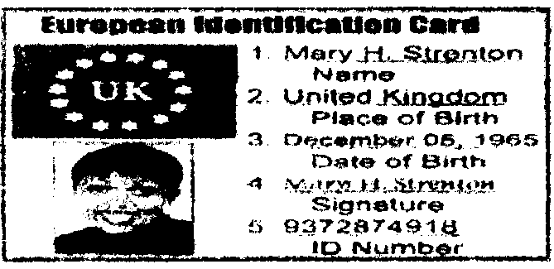
57. This picture is an introductkm(介绍)of .

A. a question B. a CD C. a dictionary
58. This ad tells us .

A. the name of the shop B. the price of the goods(商品)
C. the time of a basketball game
59. The Birds & Beasts Pet Shop is not open at .

A. 6:30 pm, Sunday B. 10:30 am, Monday C. 6:30 pm, Tuesday
60. Which of the following is NOT true about the shop of Walter Evans Painting?

A. Its phone number is 925 - 432 -2726.
B. Perhaps it started in 1988.
C. It sells a house for only $20.
第四节阅读下面的材料，然后根据材料内容回答所提问 题。（共5小题，计10分）
Paris is the capital of France. Its subway (地铁)is also very special. You can enjoy its culture when you are in this city. First you can see many people reading books in the sub way. Whenever they are in the subway or at the station, there is always a book in the hand.
The subway station in Paris is not big, but each of them has its special facts. Some stations look like ships. Some sta tions have clothes, caps and shoes. And every station has a big advertisement picture. But many of them are for selling clothes and cosmetics (化妆品).
You can meet some beggars (乞丐)in the subway. But the beggars in the Paris subway are also very special. They of ten play the violin or guitar in the train. They don't feel shy at all. Instead they think it is natural. After playing, they will go around the train and ask you to give them some money.
If you want to learn more about Paris, go to the subway and enjoy its culture by yourself.
61. Which city is the capital of France?
62. What do people usually do when they are in the subway?
63. Is the subway station very big in Paris?
64. What can you buy in some subway stations?
65. How do the beggars get money from people in the subway?
IV.写作技能（三部分，共11小题，计30分）
第一节完成对话通读下面的对话，根据上下文补全对 话内容。（共5小题，计10分） John ： Hello ！ Is that Mike speaking?
Mike: 66 .
John ： Mike, do you enjoy your new school?
Mike ： Yes, very much. But things are quite different here.
John:Really? 67 ？
Mike ： Yes. I go to school every day. But on Friday afternoon we do a lot of activities in the school clubs.
John: Sounds great！ 68 ？
Mike：Seven subjects. They are English, math, history, sci ence ,physics, art and P. E.
John: 69 ？
Mike ： I like math best. My math teacher says I am doing well in it.
John：Well done! Will you come back this summer?
Mike：Sure！ See you then! John ： 70 ！
第二节翻译语篇阅读下面的短文，将画线部分译成英 文或中文。（共5小题，计10分）
Cindy found three baby birds on the grass in the yard. Near the babies ， there was a bird 's nest (鸟窝)71.在地上. She also noticed two birds jumping up and down in a tall tree nearby. " You must be the mommy and daddy," Cindy said. "r 11 get your babies back to you. " So she called her aunt for help.
72.午饭后，Aunt arrived and knew what had happened. "I'm sure the wind blew the nest out of the tree," she said. "We, d better make a new nest. "73. She found an empty plas tic basket, washed and dried it. Then Cindy put the bird 's nest in it and put the baby birds inside the nest. After these, they went outside with the nest and a ladder (梯子).Aunt climbed up the ladder and tied the new nest to the tree. 74, " Let 's watch the nest from the window in the house ，" Aunt said. They waited and waited and finally the mommy and dad dy birds jumped to the place where the nest hung. One of the birds put food into the babies' mouths. 75. Cindy smiled when she watched the babies eat their lunch.
71.
72.
73.
74.
75.
第三节作文(计10分）
76."快乐女声（Happy Girls)"正掀起一股热潮，部分中 学生也积极参选。假如你是李明，上周你们班围绕这种现 象展开了讨论。请根据下表内容用英语给某英文刊物写一 封电子邮件，并谈谈你对此现象的看法。字数:60—80
Some students think | Some students think | I think
Experience different things | Waste of time | …
Become self-confident (自信的) | Difficult to succeed | …
Easy to be famous | Be laughed at | …
Dear editor (编辑），
Last week our class had a discussion about Happy Girls. Some students think

Best wishes.
Yours ， Li Ming

2009年湖南省长沙市中考英语试题参考答案和听力材料
1—5 ACBBA 6—10 BCCAC 11—15 ABABA 16.18 17. Ten years 18. America 19. Mary 20. Playing ping-pong
21. B考査冠词。stay in bed意为"待在床上"，是固定搭配，此时bed前不加冠词。
22. C考查反身代词的短语搭配。help yourself to...表示"随便吃……"C
23. A考杏特殊疑问词。根据答语可知此处要用how long"多长时间"。
24. A考査forget的用法。forget to do sth.表示"忘记要^做某事"，隐含事情还没有做；而forget doing sth.表示"忘曾经 做过某事"，隐含事情已经做过。根据答语"0K! I won't." 『1了以推断出事情还没有做。故选A。
25. C考査数词。句意为"父亲节在六月的第三个星期天"，此时要用序数third, 前要加定冠词 the。
26. C考查连词用法。句意为：直到汤姆的姐姐告诉他这件事，他才知道。由此"了知答案为c。
27. B考查定语从句的引导词。先行词为the pen，表示物，且关系代词在定语从句中作宾语，故用which ，也可用that ，还可以略。故选B。
28. B考查介词。在14体某大的上午、下午或晚上要用介词on。
29. B考查形容词的比较级。根据题意以及修饰词even可判断答案为hotter。
30. C考查被动语态。主i/i为many trees，且句中含有every year,ril此可推断此处要用一般现在吋的被动语态。
31. B 由句中的On rainy days可推断答案为water。
32. C表示"强风"时要用strong来修饰wind。
33. C 此处应用with /'with an umbrella in the hand"在此表伴随状态。
34. A本句的主语是人，故表"花费"的动词是spend或pay; 由II；后的inventing可推断出答案为A。
35. B句意为后他们成功了"。 al last为"最后;终于"。
36. A句意为"只要摸一下按钮，就能很容易地打幵Nubrella"。"容易地"为easily。
37. C根据前面的"shoulder support" 可以推断出Ntubrella 可以放在使用者的"肩膀"上。故选c。
38. A 根据短文提到的a hand-free umbrella可知选A。
39. A invention意为"发明"。
40. C本句所要表达的意思是"打若Nubrella在雨中散步是一件很酷的事情"。故答案为C。
41. T 根据文章第一段中的"This year is its 10th birthday. It will be held from August 16th to 21 si in Changsha..."
42. T 根据文中第一段屮的It will be held from August 16th to 21st in Changsha 知答案。
43. F 根据文中第1段幵头处的"...are held every three years."可知答案。
44. T根据文章第四段开头处的"...with nearly 5 ,000 athletes will take part in..."可知答案。
45. F 根据最后一段中的"They are training hard and will come to Changsha for the games."可知，运动员现在并没有在长沙训练。
46. A 由第一段中的"He was bom on August 4th, 1961 ， in Hawaii..."可知答案。
47. A文章中共列举了三:所大学，它们分别是Columbia University, Harvard University以及the University of Chicago 。 故选A。
48. B根据第一段的最后一句可知，他有两个女儿。
49. B ft巴马出生于1961年，于2008年当选美国总统，由此可推断他在47岁时当选。
50. C本文写的是美国总统奥巴马的学习、工作和生活经历。
51. A由第一段的描述可知答案。
52. B 根据文章第一段中的"One stamp from 1893 that celebrates Christopher Columbus is worth thousands of dollars ！"可知这 张邮票非常昂贵，所以选B。
53. C由第二段的结尾处可知答案。
54. A make up意为"构成;组成"。
55. C由第一段的描述可知答案。
56—60 BCAAC
61. Paris.
62. People usually read books when they are in the subway.
63. No, it isn't.
64. We can buy clothes, caps and shoes.
65. They often play the violin or guitar in the train.
66. Yes, it is
67. Do you go to school every day
68. How many subjects do you have
69. What is your favourite subject
70. See you
71. on the ground
72. After lunch
73. 她找到一个空的塑料篮子，并洗净、弄干了它。
74. 让我们待在房间里透过窗户观察鸟窝吧。
75. 看到小鸟吃午餐，辛蒂笑了。 One possible version ：
Dear editor (编辑），
Last week our class had a discussion about Happy Girls. Some students think young people need to experience different things. They will become self-confident if they have the chance to show their ability. It's easy to be famous and make more money.
However, some believe it's a waste of time. It's difficult to suc ceed. If you don't sing well, you will be laughed at. Students should study hard/
I think ， as a student ， we should spend more time on our lessons and try our best to make our country stronger. Best wishes.
Yours ， Li Ming
附：听力原文
2009年长沙市初中毕业学业考试英语试卷第一大题听力测试现在开始。听力材料以屮速朗读两遍。
第一节根据所听到的内容，选择相应的图画。听每段材料前，你 将有时间阅读各个小题,每小题5秒钟；听完后，各小题将给出5 秒钟的作答时间。
1. The boy is good at playing computer games.
2. The two people are fishing in the river.
3. People often see films with friends or families in the cinema.
4. The girl usually gets up at seven o' clock.
5. look ! Two cats are staying on the sofa.
第二节对话理解听下面的对话，从题中所给的A、B、C三个选 项中选出最佳答案。听每段对话前，你将有时间阅读各个小题，每 小题5秒钟；听完后，各小题将给出5秒钟的作答时间。 听下面的对话，回答第6小题。
6. W: Do you like tea, Tom?
M ： No. I like coffee very much. 听下面的对话，冋答第7 题。
7. W; Where is my watch, Dad?
M: It' s on your desk.
听下面的对话，回答第8小题。
8. W: How long are you going to stay in Changsha, Li Ming?
M ： From Monday to Saturday.
听下面的对»，回答笫9小题。
9. W： Excuse me, do you know when the bus will arrive?
M . Yes. It is nine now and the bus will arrive in ten minutes.
听下面的对话，回答第10小题。
10. W: There is a new sports club in our city. Shall we go there today?
M: Not today. It opens every day except Monday.
听下面的对话，回答第11至12小题。
W ： What are you looking for?
M: I’m looking for some books on history of Hunan. W; Here you we.
M ： Thank you ， madam. How long may I keep them?
W: Remember to return the books in a week, please.
M ： Of course ， I will.
听下面的对话，回答第13至15小题。
M: Can I help you?
W: Yes, I'd like to change this coat.
M ： What's wrong with it?
W: It's the wrung size. I wear Size 11, but it's Size 9.
M ： Didn' t you try it on when you bought it?
W; The coat \is r gift from my sister. She didn' t know how tall I am.
We haven't seen each other for three years.
M ： OK. We can change it for you. But we don' t have this colour.
W ： What colour do you have then?
M：Yellow, red and blue. W ： Red is my favourite.
第三:节笔录要点根据你所听到的内容，填写下面的表格，每空不超过3个单词。
Good morning ！ Wc arc happy to be here. Now let mc introduce myself and my friends to you. My name is Andy. I ， m from Canada. I am eighteen. I have many hobbies. But collecting stamps is my favourite. I have been collecting stamps for ten years. He is Mike. He is from America. He is twenty-four. He likes playing football. He started to play football five years ago. She is Mary. She is from England. She is thirty. Playing ping-pong is her favourite. She began to play ping-pong when she was fifteen years old.
That' s all, thank you ！

