2013年长沙市初中毕业学业水平考试试卷
姓名 准考证号

英 语
注意事项：
1、答题前，请考生先将自己的姓名、准考证号填写清楚，并认真核对条形码上的
姓名、准考证号、考室和座位号；
2、必须在答题卡上答题，在草稿纸、试题卷上答题无效；
3、答题时，请考生注意各大题题号后面的答题提示；
4、请勿折叠答题卡，保持字体工整、笔迹清晰、卡面清洁;
5、答题卡上不得使用涂改液、涂改胶和贴纸；
6、本学科试卷中听力材料以中速朗读两遍。试卷分四个部分，共8页，76小题，
时量120分钟，满分120分。
I．听力技能（三部分，共20小题，计20分）
第一节 根据所听到的内容，选择相应的图画。听每段材料前，你将有时间阅读各个小题，
每小题5秒钟；听完后，各小题将给出5秒钟的作答时间。（共5小题，计5分）
1． | A． |  | B． |  | C． | 
2． | A． |  | B． | 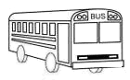 | C． | 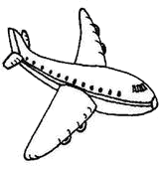
3． | A． | 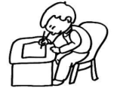 | B． | 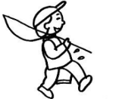 | C． | 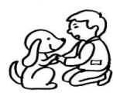
4． | A． |  | B． |  | C． | 
5． | A． | 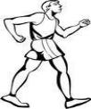 | B． | 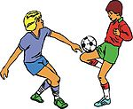 | C． | 

第二节 对话理解 听下面的对话，从题中所给的A、B、C三个选项中选出最佳答案。
听每段对话前，你将有时间阅读各个小题，每小题5秒钟；听完后，各小题将给出5秒钟的作答时间。（共10小题，计10分）
听下面的对话，回答第6小题。
6．Who is looking for Lucy?
A．Linda. B．Sue. C．Tom.
听下面的对话，回答第7小题。
7．How many girls are there in your class?
A．45. B．25. C．20.
听下面的对话，回答第8小题。
8．Where are the two speakers?
A．In a restaurant. B．In a bank. C．In a classroom.
听下面的对话，回答第9小题。
9．When will the woman come back?
A．At 7:15. B．At 7:30. C．At 7:45.
听下面的对话，回答第10小题。
10．What will the weather be like tomorrow?
A．It will be sunny. B．It will be rainy. C．It will be cloudy.
听下面的对话，回答第11至12小题。
11．How often does the bus run on Saturday?
A．Once an hour. B．Twice an hour. C．Three times an hour.
12．How far is the school from here?
A．About 5 miles. B．About 15 miles. C．About 25 miles.
听下面的对话，回答第13至15小题。
13．What was Susan doing when Robert called her last night?
A．She was seeing a film. B．She was singing. C．She was reading.
14．Why can’t Susan climb the Yuelu Mountain tomorrow morning?
A．Because she’ll call up Robert.
B．Because she’ll see a film in the cinema.
C．Because she’ll have to stay at home and study.
15．How will they get there?
A．By bike. B．By bus. C．By taxi.
第三节 笔录要点 根据你所听到的内容，填写下面的表格，每空不超过3个单词。
（共5小题, 计5分）
Name | Clothes | Character (性格) | Hobbies
Lily | a red skirt | 16. and funny | drawing
Sam | a blue 17. | 18. and clever | collecting stamps
Mary | 19. | active and outgoing | 20.
II．知识运用（两部分，共20小题，计20分）
第一节 单项填空 从A、B、C三个选项中选出最佳答案填空。（共10小题，计10分）
21．Mary was born in 1998 and she began to play _______ guitar at the age of seven.
A．a B．不填 C．the
22．He has written many books, but _______ of them are good.
A．few B．many C．any
23．The man makes a living _______ teaching.
A．without B．with C．by
24．—Does she like singing English songs?
—Yes. She _______ to sing English songs in her room.
A．often does B．is often heard C．often hears
25．—________I have lunch now, Mom?
—No. You must wash your hands first.
A．Would B．May C．Ought to
26．______ clever the boy is!
A．How B．What C．What a
27．When Jim’s mother came in, he _______ his homework.
A．is doing B．has done C．was doing
28．—It’s too late. I have to go now.
—Oh, it’s raining outside. Don’t leave _______it stops.
A．since B．until C．while
29．—Which season do you like _______, summer or winter?
— Summer.
A．well B．best C．better
30．—What are you looking for?
—I’m looking for the watch _______ I bought yesterday.
A．which B．who C．whose
第二节 完形填空 通读下面的短文，掌握其大意，然后从所给的A、B、C三个选项中选出一个最佳答案。（共10小题，计10分）
Bruce shook his money box again.
Nothing! He carefully counted the coins that lay on the bed. All that he had was $24.52. The 31 which he wanted was at least $90. How on earth(究竟) was he going to get the rest of the 32 ?
He knew that his friends all had bicycles. It was hard to hang out(闲逛) with people when you were the only one 33 a bicycle. He thought about 34 he could do. He couldn’t get money from his parents, because he knew they had no extra(额外的) money.
There was only one way to get money, and that was to earn(挣钱) it. He would have to find a job. He decided to ask Mr Clay for 35 .
“Well, you can start right here,” said Mr Clay. “You see, my windows need cleaning and my car needs washing”.
That was the beginning of Bruce’s part-time(兼职) job. For the next three 36 he worked every day after finishing his homework. He took dogs for walks and cleaned rooms.
The day finally came when Bruce 37 his money and found $94.32. He wasted no time and went down to the shop to 38 the bicycle he wanted. He rode home proudly, looking forward to 39 his new bicycle to his friends. Bruce liked his bicycle very much because he had bought it with his own money. At last, his dream came true, and his parents were 40 of him.
31．A．car B．bicycle C．truck
32．A．money B．help C．food
33．A．with B．without C．behind
34．A．why B．how C．what
35．A．food B．advice C．water
36．A．months B．minutes C．seconds
37．A．lent B．lost C．counted
38．A．choose B．sell C．drive
39．A．borrowing B．showing C．asking
40．A．famous B．strict C．proud
III．阅读技能（四部分，共25小题，计50分）
- 阅读短文，判断下列句子是否符合短文内容。符合的写（T），不符合的写（F）。
（共5小题，计10分）

Carrots(胡萝卜) are grown on farms and in small family gardens all over the world. They are easy to plant and easy to harvest(收获). They have a good taste.
When people think about carrots, they usually think they are a kind of long, thin, orange-colored vegetable. In fact, carrots are in many different sizes and shapes. And not all carrots are orange.
Carrots should be grown in a field that does not have water for a long time. The earth also should not be too hard. To prepare your carrot garden, dig up the earth and turn it over(翻土).
Weather, soil condition(土壤状况), and time affect(影响) the taste of carrots. Warm days and cool nights are the best time to grow great delicious carrots.
The best way to decide if a carrot is ready to be harvested is by its color. Usually, the brighter the color is, the better the taste is.
Most people do not know that carrots can be grown during the winter months. If the winter is not cold enough to freeze the ground, you can grow carrots the same way as you do during the summer months.
Carrots are prepared and eaten in many different ways. They are cut into thin pieces and cooked with other vegetables or meat. Or, they are washed, and eaten just as they come out of the ground.
41．Carrots are easy to plant but hard to harvest.
42．Carrots should be grown in a field without water for a long time.
43．The best way to decide if a carrot is ready to be harvested is by its size.
44．Everyone knows that carrots can be grown during the winter months.
45．We can prepare and eat carrots in many different ways.
第二节 阅读短文，从每题所给的A、B、C三个选项中，选出最佳选项回答问题或完成
句子。（共10小题，计20分）

A
We spend hours, days and years of our lives in school. Imagine(想象) you could design(设计) your dream school, what would it be like? What would you be doing? We wanted to find out what teenagers around the world thought. Here is what they said:
Richard from the USA: My dream school would have a big swimming pool and two soccer fields. It would also have a cinema, a gym and a shopping centre. My school has none of these, and I think there should be more pleasant things for students to do while they are studying.
Sonia from Italy: I’d like a room where we can relax and play computer games. I’d also like to have a music room. I think there should be a place for everyone to go and relax after class.
Wu from Beijing: I think it would be great to have another day off (休息日) every week, besides the weekend. If that day was a Friday or a Monday, we would have a long weekend every week. What fun! I also think school should start later, at about 10 o’clock, and finish earlier.
Hannah from Australia: In my dream school, I think the teachers should give us more freedom(自由) and choice about how we study and what we study. I also think it’s not necessary for us to wear school uniforms every day. I really don’t like wearing it.
46．There would be_______ in Richard’s dream school.
A．a big swimming pool and a music room
B．a room to relax and play computer games
C．a big swimming pool, two soccer fields, a cinema, a gym, and a shopping centre
47．How many days off does Wu want to have in a week?
A．2. B．3. C．4.
48．Which country is NOT mentioned(提到) in the passage?
A．Italy. B．Japan. C．Australia.
49．From the passage, we know that_________.
A．Sonia from Italy would like a room where she can relax and play computer games
B．Richard from the USA thinks his dream school should start at 10 o’clock
C．Hannah from Australia likes wearing a school uniform every day
50．Which is the best title (标题) for the passage?
A．Schools in the past. B．Schools today. C．Dream schools.
B
This March, the H7N9 virus (病毒) hit Shanghai, Anhui, Jiangsu, Zhejiang and so on. It seemed that most people who were infected(被感染) with H7N9 had the common flu. Some people suffered from a fever or a cough.
Don’t be afraid—it’s not easy to be infected with the virus. Here is some advice to help you protect yourself when it comes.
Wash your hands. You need to wash your hands with soap and hot water before you eat, after you use the toilet, and after you touch animals, because your hands may carry viruses.
Cover your nose and mouth. When someone sneezes(打喷嚏) or coughs, flu viruses can travel as far as one meter through the air, so you’d better stand a proper distance (距离) while talking to someone who has a cold. And always cover your mouth and nose with a piece of paper when you sneeze or cough, and then clean your hands.
Wear a mask(口罩). Some doctors say that masks can stop the flu as much as 80%, but if
you don’t wash your hands often, it’s no use wearing a mask. And it’s necessary to wear the mask in the groups of people.
Do sports often. Exercises will help make your body strong enough to resist the virus.
51．When did the H7N9 virus hit Shanghai?
A．In March, 2013. B．In May, 2013. C．In March, 2012.
52．Which of the following is TRUE according to the passage?
A．Some people who were infected with the H7N9 virus had a toothache.
B．You should cover your mouth and nose with a piece of paper when you sneeze or cough.
C．Some doctors say that masks can stop the flu as much as 100%.
53．How many ways to stop the virus are mentioned in the passage?
A．Three. B．Four. C．Five.
54．What does the underlined word “resist ” mean in Chinese?
A．抵抗 B．传播 C．感染
55．What’s the main idea of this passage?
A．It tells us how to wash hands.
B．It tells us why we should use masks.
C．It gives us some advice on how to protect ourselves when the H7N9 virus comes.
第三节 阅读下列图表，从每题所给的A、B、C三个选项中，选出最佳选项回答问题或完

成句子。（共5小题，计10分）
56．From the information in the picture,
we know that Lily was born on ______.
A．June 8, 2005
B．June 22, 2005
C．June 22, 2013
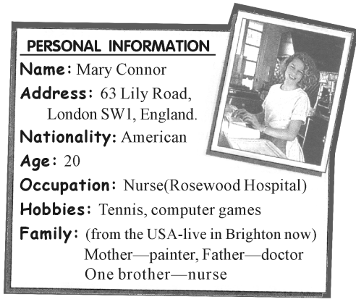

57．According to the personal information,
we know that Mary Connor lives in .
A．Canada
B．America
C．England

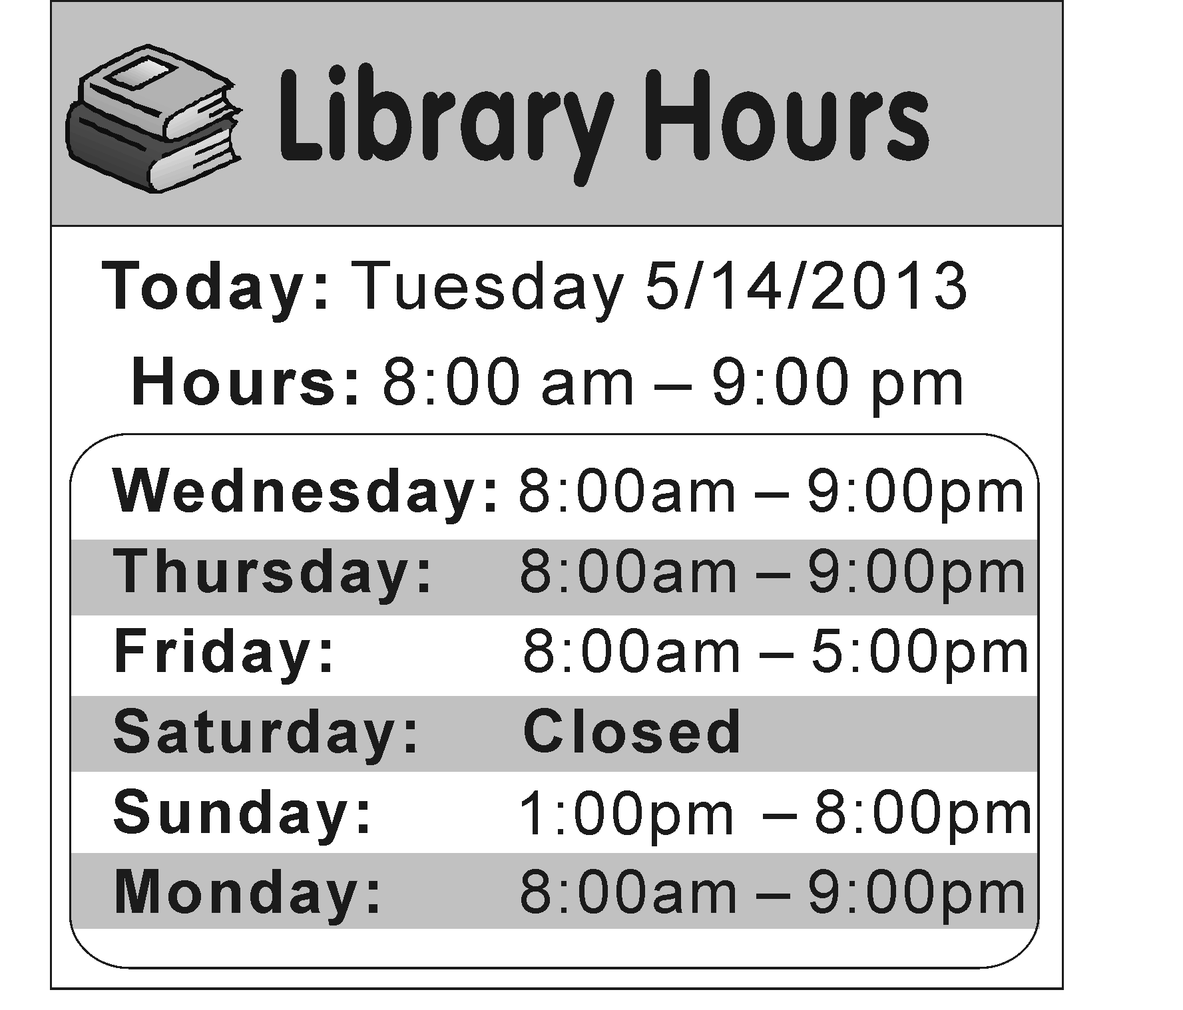

58．You can borrow books_________.
A．at 10:30 am on Monday
B．at 10:00 pm on Thursday
C．at 3:30 pm on Saturday

59．According to the survey(调查) of 2,000 American online shoppers, ________people shop online from 5pm to 8pm.
A．320. B．640. C．800.
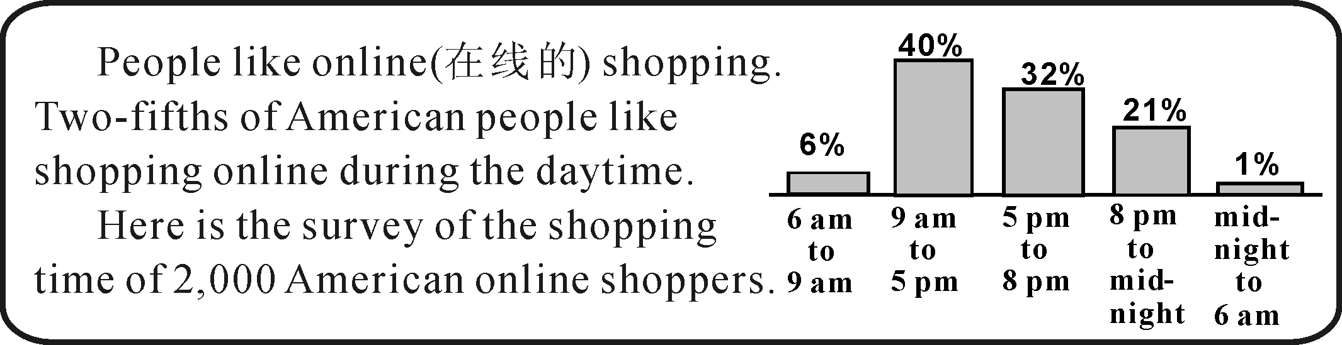

60．Which of the following is NOT TRUE?
A．You’d better wear your sun hat to enjoy wonderful sunshine.
B．The boats will take you to different places for swimming.
C．Mr Smith and his child need to pay $160 for the tour.
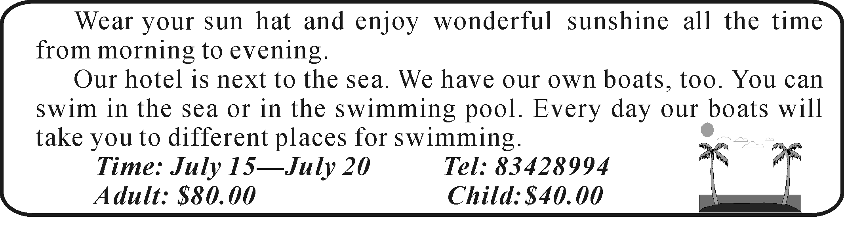

第四节 阅读下面的材料，然后根据材料内容回答所提问题。（共5小题，计10分）
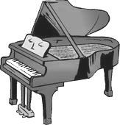
Liu Wei is very famous in China because he can play the piano with
his toes(脚趾).
One day when Liu Wei was only 10 years old, he played a game with
some friends. He lost both his arms because of electricity(电).
Liu Wei was very sad when both his arms were cut off after the
accident. But soon he had to make a choice.
“For people like me, there were only two choices. One was to give up all the dreams, which would cause a quick death. The other was to work hard without arms to live an excellent life.” says Liu Wei.
Liu’s dream was to be a pianist. His excellent life included a show on China’s Got Talent(《中国达人秀》) and a wonderful performance (演奏) playing the beautiful Marriage D’amour with his two feet on the piano.
Liu Wei learned to play the piano with his feet. And teaching himself to play the piano with his feet was very hard. Many times he wanted to give it up, but his parents went on encouraging(鼓励) him and he wanted to make his parents proud.
Maybe you can not believe that Liu Wei is able to play well only with his toes. The audience(观众) were deeply moved and very excited when they watched his performance.
61．Why is Liu Wei very famous in China?
62．How old was Liu Wei when he lost his arms?
63．Was Liu Wei very sad when both his arms were cut off?
64．Who encouraged Liu Wei to play the piano?
65．How did the audience feel when they watched Liu’s performance?
IV．写作技能（三部分，共11小题，计30分）
第一节 完成对话 通读下面的对话，根据上下文补全对话内容。（共5小题，计10分）
A: Hello, Betty. What did you do last summer vacation?
B: I visited my uncle.
A: 66 ?
B: He lives in Dalian, a beautiful city.
A: 67 ?
B: I stayed there for a week. 68 ?
A: No, I haven’t. But I’m going to spend a holiday there.
B: You’d better go to Dalian in summer. So you can enjoy swimming in the sea.
A: 69 . I will go there this summer vacation.
B: 70 ?
A: By plane.
第二节 翻译语篇 阅读下面的短文，将划线部分译成英文或中文。（共5小题，计10分）
Australia is the greatest island in the world. 71.澳大利亚比中国小一点.
Australia is big, but there are fewer people there. The population(人口) of Australia is smaller than that of Shanghai, a city of China.
72.Australia is in the south of the earth. So when it is hot summer in our country, Australia will be cold winter. The seasons in Australia and in China are just opposite(相反的). Summer in Australia is from December to February, and winter is from July to August. 73.When it’s spring in China, it will be autumn in Australia.
74.澳大利亚因绵羊和袋鼠而著名. They are both popular in Australia.
75.You can see kangaroos(袋鼠) not only in zoos but also outside the cities and towns. There are ten sheep for everyone in the country. So people call Australia “The country on the backs of sheep”. After a short drive from any town, you will find yourself in the middle of white sheep. Sheep, sheep, sheep, sheep are everywhere.
Have you seen a kangaroo? It has a “bag” on its body. The mother kangaroo keeps its baby kangaroos in the “bag”. It’s very strange, isn’t it?
71．
72．
73．
74．
75．
第三节 作文（计10分）
76．大多数中学生认为校园生活是丰富多彩的，学习是快乐有趣的。然而，无论在城市
还是农村学校都有一些厌学的学生。请围绕该话题用英语谈谈你的看法。
要求：（1）内容包括 ① 中学生厌学的主要原因。
② 你对该现象的看法。
（2）字数：60-80词。
（3）短文中不得出现你的真实姓名、学校名和地名。

2013年长沙市初中毕业学业水平考试试卷
英语听力测试朗读材料

2013年长沙市初中毕业学业水平考试英语试卷第一大题听力测试现在开始。听力材料以中速朗读两遍。

第一节 根据所听到的内容，选择相应的图画。听每段材料前，你将有时间阅读各个小题，每小题5秒钟；听完后，各小题将给出5秒钟的作答时间。
1. Li Ming likes grapes very much.
2. I usually go to school by bike.
3. Jack’s brother likes playing with a dog.
4. My favorite animal is a monkey.
5. Look! Two boys are playing football on the playground.
第二节 对话理解 听下面的对话，从题中所给的A、B、C三个选项中选出最佳答案。
听每段对话前，你将有时间阅读各个小题，每小题5秒钟；听完后，各小题将给出5秒钟的作答时间。
听下面的对话，回答第6小题。
6. W: Hi, Tom. Have you seen Lucy?
M: No, I haven’t. Linda, don’t worry. You may ask Sue.
听下面的对话，回答第7小题。
7. M: How many students are there in your class?
W: Forty-five. And twenty of us are boys.
听下面的对话，回答第8小题。
8. W: May I have a look at the menu, please?
M: Here you are, Madam. I’ll be back for your order in a minute.
听下面的对话，回答第9小题。
9.W: Excuse me, may I clean your room now?
M: Sorry. It’s a quarter past seven now. Will you please come back in half an hour?
听下面的对话，回答第10小题。
10. W: What’s the weather like today?
M: It’s sunny, but the radio says it will rain tomorrow.
听下面的对话，回答第11至12小题。
W: The bus is late, isn’t it?
M: No, today is Saturday. The buses only run twice an hour on Saturday.
W: Oh, I didn’t know that. I usually take the bus on the weekdays.
M: Do you take the bus to school?
W: Yes, I do.
M: Is your school far from here?
W: Yes. It’s about 25 miles.
听下面的对话，回答第13至15小题。
M: Hello!
W: Hi, Robert. It’s Susan. I’ve got your message.
M: Thanks for calling me back. What were you doing when I called you last night?
W: Oh, I was seeing a film in the cinema. So, what’s up?
M: Well, would you like to climb the Yuelu Mountain tomorrow morning?
W: Tomorrow morning? I am afraid I can’t. I’ll have to stay at home and study.
M: Oh, it’s a pity. How about Sunday morning?
W: Sure, I’d love to. How shall we get there, by bike or by bus?
M: What about taking a bus?
W: OK.

第三节 笔录要点 根据你所听到的内容，填写下面的表格，每空不超过3个单词。
Hello, everyone! Now, let me introduce my friends. This is my best friend Lily. She is wearing a red skirt. You will like her, because she is friendly and funny. She likes drawing. This is Sam. He is wearing a blue T-shirt. He is handsome and clever. He likes collecting stamps. Oh, that is Mary. She is wearing a white dress. She is active and outgoing. She likes playing tennis. I love my friends.

听力测试到此结束。
听力部分：
1-5 BACAB 6-10 ABACB 11-15 BCACB
16.friendly 17.T-shirt 18.handsome
19.a white dress 20.playing tennis
单选：
21-25 CACBB 26-30 ACBCA 31-35 BABCB
36-40 ACABC 41-45 FTFFT 46-50 CBBAC
51-55 ABBAC 56-60 BCABC
回答问题
61. Becaue he can play the piano with his toes.
62. He was only 10 years old.(可以只答10 years old.)
63. Yes.
64. His parents encouraged him to play the piano.（可以只答His parents）
65. They were deeply moved and excited.
对话
66. Where does he live?
67. How long did you stay there?
68. Have you been to Dalian?
69. That's a good idea./
I think so./ That sounds great.
I agree with you.
70. How will you get/go there?
翻译
71. Australia is a little smaller than China.
72. 澳大利亚在地球的南部。
73. 当中国是春季时，澳大利亚是秋季。
74. Australia is famous for sheep and kangaroos.
75. 你不但在动物园可以看到袋鼠，而且在城，镇以外的地方可以看到袋鼠

