2016年长沙市初中毕业学业水平考试试卷
英 语
注意事项：
1、答题前，请考生先将自己的姓名、准考证号填写清楚，并认真核对条形码上的
姓名、准考证号、考室和座位号；
2、必须在答题卡上答题，在草稿纸、试题卷上答题无效；
3、答题时，请考生注意各大题题号后面的答题提示；
4、请勿折叠答题卡，保持字体工整、笔迹清晰、卡面清洁;
5、答题卡上不得使用涂改液、涂改胶和贴纸；
6、本学科试卷中听力材料以中速朗读两遍。试卷分四个部分，共8页，76小题，
时量120分钟，满分120分。
Ⅰ.听力技能（两部分，共20小题，计20分）
第一节 对话理解 根据所听到的对话，从题中所给的A、B、C三个选项中选出最佳答案回答问题。听每段对话前，你将有时间阅读各小题，每小题5秒钟；听完后，各小题将给出5秒钟的作答时间。（共15小题，计15分）
听下面武断对话，每听完一段对话后，回答1个问题
- What is Tom’s favorite sport?
A. Football B. Basketball C. Volleyball
- Who helped the boy to paint the picture?
A. Tina B. Jane C. Jack
- How far is the cinema from the school?
A. 8 kilometers B. 15 kilometers C. 18 kilometers
- Where will they meet tomorrow?
A. At the supermarket B. At the park C. At the hospital
- How does the girl go to school everyday?
A. By subway B. By bus C. By bike
听第六段对话，回答第6至7题。
- What does Frank’s father do?
A. A doctor B. A worker C. A cook
- When did Frank’s father start to work there?
A. 12 years ago B. 16 years ago C. 20 years ago
听第七段对话，回答第8至9题。
- What are they talking about?
A. Vacations B. Customs C. Rules
- How did he girls spend the rainy day?
A. By playing on the beach B. By visiting friends C. By staying inside
听第八段对话，回答第10至12小题
- Who has taught the girl to make kites?
A. Her brother B. Her father C. Her grandfather
- What is Jack doing at the moment?
A. Reading B. Dancing C. Sleeping
- When will the football match be held?
A. This Friday B. This Saturday C. Next Sunday
听第九段对话，回答第13-15题
- What does Mark think of yesterday?
A. A lucky day B. A bad day C. A nice day
- Why was Mark late yesterday morning?
A. Because he got a cold
B. Because his alarm didn’t go off
C. Because the taxi broke down halfway
- How many times has Mark been late this month?
A. Once B. Twice C. Three times
- 笔录要点 根据你所听到的内容，填写下面的表格，每空不超过3个单词。（共5小题，计5分）
Life in the future
Aspects（方面） | Changes
Diet（饮食） | - Eat more 16  - stay away from junk food（垃圾食品）
17 | - Study on computers at home  - 18 online
Work | - Work 19 than we do now  - Have robots do dangerous and 20
Ⅱ. 知识运用（两部分，共20小题，计20分）
- 语法填空 从A、B、C三个选项中选择最佳答案填空。（共10小题，计10分）
- Miss Smith, an American lady , has taught ________ English for three years.
A. we B. us C. our
- ---- _________ will you fly to Beijing?
---- In two days.
- How long B. How often C. How soon
- ---- I think I’ll take a bus to the meeting.
----The bus? If you _____, you will be late.
- do B. have done C. will do
- ---- What do you think of the movie Zootopia?
----Hmm...I think it is _______ movie that i have ever seen these years.
- a good B. a better C. the best
- ---- Your coat fits you well.
---- Thank you. I ______ it when I was on vacation.
- have bought B. buy C. bought
- ---- Did you win the game yesterday?
---- Not really. ________ we all tried our best, we lost it.
- If B. Though C. Unless
- ---- Finally, they came back.
---- They ________ be hungry after such a long walk.
- Can’t B. must C. needn’t
- ---- Jane’s spoken English is pretty good.
---- Yeah, she works hard and practices _________ it both in and out of class.
- spoke B. to speak C. speaking
- ---- What are you doing ,Tim?
---- I am listening to the song Long Live _________ makes me feel excited.
- which B. who C. /
- Now smart phones ________ in many ways in our daily life.
A. are used B. is used C. are using
第二节 词语填空 通读下面的短文，掌握其大意，然后从各题所给的A、B、C三个选项中选出最佳答案。（共10小题，计10分）
Do you believe that we can have an important influence on anyone we meet? The right words at just the right time could 31 someone’s life.
When I was 3 years old , my parents discovered I was 32 . After asking many doctors and parents of other deaf children, they decided not to put me in a special school. Although I seemed outgoing, my self-esteem（自尊心）was quite low. On my first day at school, the other kids 33 me because of my hearing aid and the way I talked. I was hurt deeply and I saw myself as a(n) 35 kid
Mrs. Green , my 36 , changed all of that with a simple three-word phrase. One morning, she asked the class a question. Sitting at my desks silently, I 36 her lips（嘴唇）and raised my hand right away. She called on me in front of the blackboard. I took a deep breath and 37 answered Mrs. Green’s question.
I will 38 forget what happened next. Mrs. Green pointed directly at me. With sparking（闪光的）eyes and a big smile she cried:”That’s right, Ben!”
For the first time in my young life, my confidence（自信）rose. At that moment, I decided hat no matter how many 39 I may face, I can overcome（克服）them. Thanks to those three
40 words, my whole life changed from that moment.
- A. end B. change C. lose
- A. blind B. deaf C. fat
- A. made fun of B. took care of C. made friends with
- A. ugly B. smart C. handsome
- A. driver B. doctor C. teacher
- A. read B. touched C. reached
- A. nervously B. lazily C. carelessly
- A. often B. ever C. never
- A. aims B. difficulties C. interests
- A. unkind B. bitter C. simple

Ⅲ 阅读技能 （三部分，共25题，计50分）
- 图表理解 阅读下列图表，从每题所给的A、 B、 C三个选项选出最佳答案回答问题或完成句子（共5小题，计10分）

 | Smart Kids Club  Fridays & Sundays  5:00pm to 6:30pm  In the school library  For age groups:5-10 years old  $2.00 each week  Register（登记）：in the gym  Contact（联系）：Smart Kids Club2@hotmail.com

- Smart Kids club is open to the members ________
A. at 6:00am on Fridays B. at 5:00pm on Saturdays C. at 5:30pm on Sundays
- If Mrs. Black’s twin daughters of 8 both join the club, how much should she pay each week?
A. $2. B. $4 C. $16

B

Theme Parks
Universal Studios（环球影城）  --a dream land for Hollywood movie fans | The history of movies, the lives shows and film tricks（技巧）can be found here and it has parks in the USA, Japan and Singapore.
Legoland  --a word made of Lego bricks（乐高积木） | You’ll be sent back to your childhood time by the buildings and dolls made of Lego bricks and there are seven Legoland parks in the world and the one nearest to us is Malaysia.
Ferrari World  --a paradise（乐园）for car lovers | You can experience the feeling of driving an Ferrari（法拉利）car and see hoe Ferrari’s racing cars are produced in Abu Dhabi.

- Lucy is interested in film making. Which park could be the best choice for her?
A. Universal Studios B. Legoland C. Ferrirari World
- While an adult is visiting Legoland, what will probably be thought about?
A. His or her childhood B. His or her parent C. His or her future
- According to the chart（图表）,we know that ____________
A. We can visit Universal Studios only in America
B. The building and dolls at Legoland are made of Lego bricks
C. We can get Ferrari car for free when we visit Ferrari World

第二节 短文理解 阅读下列短文，从每题所给的A、B、C三个选项中选出最佳的答案回答问题或完成句子。（共15小题，计30分）
A
The Lantern Festival falls on the 15th of the first month of the lunar calendar（阴历）. This day is always the first full moon in the new year. Ancient people also called is Shangyuan Festival. Celebrations and traditions on this day began from the Han Dynasty（朝代）and become popular in the Tang Dynasty.
Watching the red lantern is one of the main traditions. Lanterns of different shapes and sizes are usually put on trees, or along river banks on show. It is said that sky lanterns were first used by Zhuge Kongming to ask for help when he was in trouble. Today, when the lanterns slowly rise into the air, people make wishes.
Another tradition is guessing lantern riddles. The riddles are usually short,wise, and sometimes humorous. The answer to a riddle can be a Chinese character（汉字），a famous person’s name, or a place name.
The most important thing is to eat dumpling with different tastes. In northern China,they are called yuanxiao while in southern part they’re named tangyuan. Because making sweet dumpling is like a game or an activity,they are usually done happily by a group of friends or family members.
In old times, the lantern Festival was also romantic（浪漫的）. Watching lanterns gave young people a chance to meet each other. A line from Xin Qiji, a poet during Song Dynasty, shows this.
Hundreds and thousands of times I searched for her in the crowd. Suddenly I Turned, and there she stood, in the dim（昏暗的）light.
- The traditions festival talked about in this passage is called “_______ “in Chinese.
A. 春节 B. 元宵节 C. 端午节
- When did celebration and traditions of the Lantern Festival starts from?
A. The Han Dynasty B. The Tang Dynasty C. The Song Dynasty
- What were sky lanterns first used for by Zhuge Kongming in ancient times.
A. Making wishes B. Celebrating birthdays C. Asking for help
- Which of the following is NOT true about sweet dumplings?
A. They have different tastes
B. They are named “yuanxiao” all over the country
C. People enjoy the process of making them
- The line from Xin Qiji in the passage shows the Lantern Festival was ________ in old time.
A. Boring B. Humorous C. Romantic

B
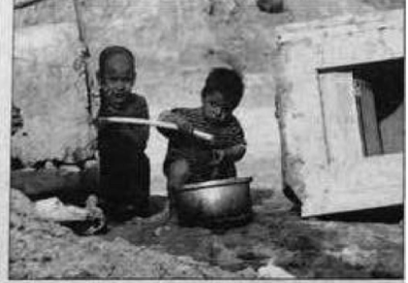
Why is clean water so important to developing countries? A recent report shows that about 80 percent of diseases in developing countries are caused by poor water and low sanitation（卫生）conditions. In those countries, women and girls spend several hours collecting water, but often polluted, far away from their families. The polluted water more or less influences their health. In this case , there is an urgent（迫切的）need for people in developing countries to have access to （有机会或权利使用）clean water to improve their health.
Here is a short story about Hadjara Zakari, a 12-year-old girl in Niger. Having access to clean water changed her life. She learned about the importance of hand-washing when the school first received clean water three years ago. That evening, she told to her father, “ You shouldn’t eat with me unless you clean your hands.” Her father was very angry and shouted at her ,”It’s not up to you to tell me what to do!” Stunned（目瞪口呆的），Hadjara sat in silence. But she knew she was right. In Protest , Hadjara refused to eat dinner that night. After her father questioned Hadiara’s head teacher, he understood the importance of hand-washing and his daughter’s intention（目的）. The girl really wanted her family to live longer and healthier life.
For person in developing countries, clean water can change many things, especially improve their health. So ,from now on, let’s avoid wasting water and take action to save water, which is important to people all over the world.
- According to the recent report, poor water and low sanitation conditions can cause.
A. Traffic problems B. Forest fires C. Many illnesses
52. The key to improve people’s health in developing countries is _______ in Paragraph 1.
A. To get clean water B. To exercise often C. To refuse drugs
53. What can we infer（推断）from Paragraph 2?
A. Hadjara laughed at her father’s foolishness.
B. Hadjara refused to eat dinner that night in order to lose weight.
C. Hadjara’s father understood his daughter’s love and care for him later.
- The underlined word”protest” in this passage means.
A. 抗议 B. 保护 C. 节约

55. The purpose of the writer is to .
A. Teach people how to wash hands
B. Call on people all over the world to save water.
C. Show developing countries rich in clean water.
C
It was a Christmas night. I was an unlucky nurse who had to work on a beautiful festival when I was complaining（抱怨）about it , three people appeared at my desk-a tired woman and two children.
“Are you all sick?” I asked doubtfully because they seemed all right.
“Yes,” the woman answered weakly and lowered her head.
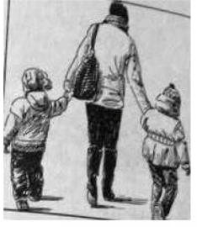
But when they started to present their problems, things became unclear. One child had a fever, but she could not tell me which ear hurt. It seemed that the mother was pretending（假装） to cough.
Something was wrong. But I only explained that it might take a while before a doctor meet them. “Take your time, please.”said the mother. I checked their charts-no address. Suddenly I knew, they were homeless while the hospital was warm.
The family huddled（蜷缩）together under the Christmas tree, smiling and talking with each other sweetly. Quietly, I went back to the nurses’ station and told them what happened in the waiting room. It was just like God sending us a gift on Christmas Day. The nurses’ station suddenly came back to life. All the nurses went into action for “a Christmas emergency（急诊）”.
We took out our meals for our Christmas “patients”, We also put together oranges and apples as presents. We tried to exceed the needs of a family who only wanted a warm place on Christmas night. Later, the little girl kissed me and said,”Thanks for being our angle（天使）.”
56. Before the family appeared in the hospital, the writer was very _______ .
A. Proud B. Hospital C. Pleases
57. The family came to the hospital because ________ .
A. They came to visit a patient B. They were all sick C. They were homeless
58. The nurses offered the family meals and gifts in order to _______ .
A. Make them feel at home B. Make the leave C. Make them feel upset
59. What does the underlined word “exceed” in this passage mean?
A. 降低 B. 超出 C. 拒绝
60. From the story, we learn that _______ .
A. Homeless people often tell lies
B. A hospital is a good place to spend Christmas night.
C. We should always be friendly and kind to those in need.

- 阅读表达 阅读下面的短文，然后根据短文内容回答问题。（共5小题，计10分）
France is well known for its fine art, tasty food and romantic scenery（风景）. About 75 million visitors come here every year.
France is the largest country in Western Europe. It has a population of over 66 million. The country is home to many famous places of interest, like the River Seine as well as the Eiffel Tower.
Many visitors also come for the country’s art. Sculptor（雕刻家）Auguste Rodin and painter Claude Monet once created their great works here. If you visit France today, it is not a surprise to meet street artists in the city or come across a singer in the subway.
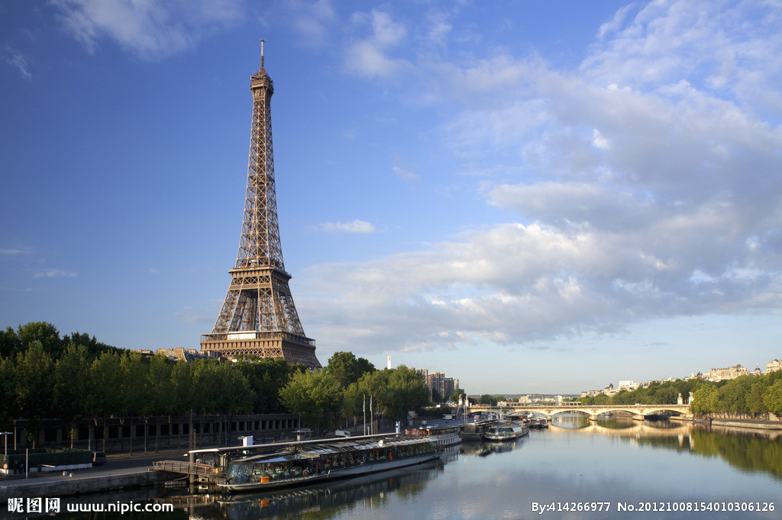
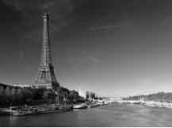
No visit to Paris without a trip to Louvre, one of the largest and most famous museums in the world. Inside, there are 35,000 works of art, such as the painting Mona Lisa by Da Vinci and the statue（雕塑）David by Michelangelo. It would take nine months to enjoy all the pieces.
Besides , French food is world famous. Bread is very important in France. The best known French bread is called a baguette（法棍面包）. They are long, delicious and taste salty. Snails（蜗牛）are also a must-have here. French people eat 40,000 tons of snails every year.
But French is not always good. Paris ,the city of the light, may also show its dark side to visitors. Chinese visitors feel sorry about the crowded subway in Paris.
- How many visitors come to France every year?
- Is it common to meet street artist in the city?
- Who created the famous painting Mona Lisa?
- Besides bread, what food is also a must-have for French people?
- Why do Chinese visitors feel sorry about the subway in Paris?

Ⅳ. 写作技能（三部分. 共11小题，计30分）
- 语篇翻译 阅读下面的短文，将划线部分译成英文或中文。（共5小题，计10分）
Reading an English newspaper is a good way to improve a student’s language ability. As there are many useful common words in an English newspaper, it may help students increase their vocabulary（词汇量）as well as improve their reading skills.66.他们可以从报纸上学到新的知识。 But what is the proper way to read an English newspaper? Do students need to look over all the content（内容）of the newspaper?
The first step is to choose a right newspaper with good language. Then turn to the front page and read the headlines（标题）to know what has happened. As the most important things are put on the front pages , it’s easy to find out what you’re interested in and then turn to the page to read it completely. 67. There is no need to go through all the article.
Secondly, read newspapers every day. Remember words through context（上下文）, in which these words may appear repeatedly. 68. Once they appear several times, you will remember them easily. Don’t look up every unknown word in your dictionary. You can try to guess the meaning between sentences. 69. 如果你的猜测错了，不要放弃。Keep reading, and you will become familiar with the words after reading them several time in different texts.
Reading English newspapers makes us knowledgeable. 70. It can not only help us know what is happening in the world but also improve our language.
- ______________________________________________________

- _______________________________________________________

- ________________________________________________________

- ________________________________________________________

- _________________________________________________________

- 情景交际 通读下面的对话，根据上下文补全对话。（共5小题，计10分）
A：Hey, Peter! You look tired._____________71_______________________?
B：I didn’t get enough sleep last night.
A: Were you just doing your homework last night?
B: ______________72______________. Mountains of homework,math, chemistry, Chinese.... I didn’t finish it until midnight.
A: Poor guy! No wonder you don’t look well.
B: You know, less sleep is bad for my health. I am not as energetic before.____________73____ ?
A: Sure. I advise you to make a plan before doing your homework. First things first. And you’d better do some outdoor sports.
B: _________________74____________. I am going to follow your advice. Thank you.
A: Um... If you are too busy on weekdays,just relax yourself at weekends.
B: Weekends? No kidding. I have to take after-school classes at weekends.
A: You do ? _______________75____________ ？
B: Because my parents want me to get into a good high school.
A: Yes. I guess that is a reason. Perhaps you should talk to them and explain that health is the most important.
B: You are right. Thanks for all the good advice. I’ll try to talk to them

- 书面表达（计10分）
- 假如你是李华，你的好朋友Lisa不久前参加达人秀节目被淘汰了，她为这次失败困扰，无心学习。请你给她写一封电子邮件，建议她正确看待达人秀节目，享受参与的过程而不必太在意结果；提醒她实现梦想的途径有很多，只有努力才能获得成功；鼓励她好好学习，也不要放弃个人爱好，开心的度过每一天。
要求：（1）包含以上所有要点，可适当增加细节，以使行文连贯：
（2）字数：68-80词（信的开头和结尾已经给出，不计入总词数）：
（3）信中不得出现你的真实姓名、学校名和地名。

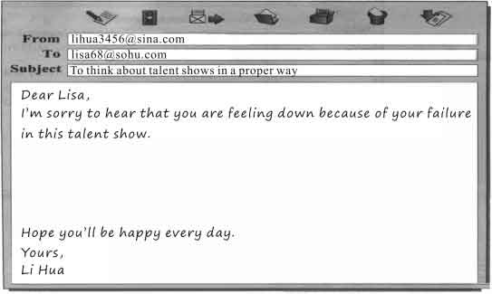

2016年长沙市初中毕业学业水平考试试卷
英语参考答案及评分标准

一、参考答案
I．听力技能
1—5 BACBA 6—10 ACACC 11—15 ACBBB
16．fruit and vegetables 17．Education 18．take exams
19．fewer hours 20．hard
II．知识运用
第一节 语法填空
21—25 BCACC 26—30 BBCAA
第二节 词语填空
31—35 BBAAC 36—40 AACBC
III．阅读技能
第一节 图表理解
41—45 CBAAB
第二节 短文理解
46—50 BACBC 51—55 CACAB 56—60 BCABC
第三节 阅读表达
61．About 75 million.
62．Yes, it is.
63．Da Vinci.
64．Snails.
65．Because it is crowded.

IV．写作技能
第一节 语篇翻译
66．They can learn new knowledge from newspapers.
67．没有必要浏览完所有的文章。
68．一旦这些词出现多次，你就能轻而易举地记住它们了。
69．If your guess is wrong, don’t give up.
70．读报不仅能帮助我们了解时事，而且还能提高我们的语言水平。

[来源:学科网]
第二节 情景交际
71．What’s up?
72．Yes, I was.
73．Can you give me some advice?
74．Sounds great.
75．Why do you have to take after-school classes?

第三节 书面表达
76．
Dear Lisa,
I’m sorry to hear that you are feeling down because of your failure in this talent show. I’d like to share with you my thoughts on this matter.
Yes, talent shows may change one’s future. They offer the opportunity to show one’s talents, and give people a way to make their dreams come true. Since only some people are truly talented, there is no need to take the result too seriously. It may not be good for us teenagers to become famous overnight. So just enjoy the process.
In addition, there are many ways to success, and only by working hard can you achieve your goals. As a teenager, you should spare no efforts to study and develop your interests at the same time, which, without doubt, will enrich your future life.
Hope you’ll be happy every day.
Yours,
Li Hua

二、评分标准
1．第1小题到第20小题和第21小题到第40小题，每题1分。
2．第41小题到第60小题，每题2分。
3．书面表达的评分标准
A档（10-9分）能够围绕话题进行表述，语言基本无误，行文连贯，表达清楚。
B档（8-7分） 能够围绕话题进行表述，语言有少量错误，表达基本连贯、清楚。
C档（6-5分） 能够基本围绕话题进行表述，语言表达有些错误，行文很不连贯，
但不影响句意理解。
D档（4-3分） 尚能围绕话题进行表述，语言错误较多，影响意思表达。
E档（2-0分） 只能写出与话题相关的一些单词或一两个句子，只有个别句子可懂。
4．第16小题到第20小题和第61小题到第76小题，除参考答案之外的可接受答案，均可酌情给分。

