**Task 1 Test scenarios for online check-in services**

**Functional Verification:**

1. Verify if the user is able to launch the Limehome online check in service page successfully.
2. Verify if the user is able to see the fields like- Last Name and Booking Reference number.
3. Verify if the user is able to view the Bilingual option: English/German at the top right corner.
4. Verify if the guest is able to retrieve the booking details on entering Valid Last Name and Reservation details.
5. Verify that the guest is not able to retrieve the booking details on entering Invalid Last Name and Booking Reference id.
6. Verify that the validation message is displayed in case user leaves Last Name and Booking reference id.
7. Verify the tab functionality is working properly.
8. Verify that Enter/Tab works as a substitute for the submit button.
9. Check all the fields for Special character
10. Verify that there is a limit on the total number of unsuccessful login attempts (No of valid attempts depends on the Business Logic)
11. Verify that validation message is displayed in case of exceeding character limit for Last Name, Booking Reference id.
12. Verify the timeout of each session.
13. Verify that the validation message is displayed when the mandatory fields are left blank.
14. Verify if the Date of Birth for the guest is not in future.
15. Verify that on clicking the date field a calendar widget should open.
16. Verify that the default width of the calendar should be displayed as per the specification.
17. Verify that user can select a date in the calendar and after selecting the date the same gets displayed in the date field.
18. Verify that by default current month's calendar should be displayed.
19. Verify that user can move to previous and next month's calendar by choosing the left and right icon over the calendar.
20. Verify that user enter date manually in the date following the date format.
21. Verify that user can edit a date set by choosing the one selected from the calendar.
22. Verify that values other than Numerics should not be allowed in the date field (apart from the characters used in the date format like '/' or '-'.
23. Verify that invalid dates are not allowed in the date field (like date value exceeding 31, month value exceeding 12 etc.).
24. Verify Passport field is displayed when the Nationality filed has any values other than GERMAN(DE).
25. Verify if there are no duplicate values on the drop down for Country, Nationality and Type.
26. Passport Id number validation based on the country Name selected.
27. Ensure that the drop-down Country and Nationality is aligned with the other fields.
28. Default values should be displayed on the drop-down when the user visits the page first time.
29. Selected items on the drop-down should be highlighted.
30. Loading time of the drop- down list should not take much time to load.
31. If the list of Nationality drop-down values is controlled by country, then the correctness of the items Country listed items should be proper.
32. When the keyboard alphabets are pressed, Items starting with the respective alphabet must be displayed.
33. Design of the drop-down may change on various browsers which is common problem, browser compatibility of the drop-down should be consistent in all browser.
34. Verify that after clicking upload button – File selection window should open
35. Verify whether after clicking the Cancel button of selection window the window should be closed.
36. Verify that select any file for upload and in between uploading process, Cancel the task. No file or file parts should be uploaded.
37. Verify that in between uploading process, click on upload button should be disabled.
38. Verify if the image shown in preview during picture upload is being displayed as passport picture after image upload.
39. Verify if the user is able to upload a file which is selected in windows dialog box and the file name is changed in the dialog box before selecting open in dialog box
40. Test if only particular file types can be uploaded: For instance, doc or pdf or images like .png, jpeg, bmp etc.
41. Verify uploaded file size cannot exceed certain size, for example uploaded file cannot be more than 2MB Size, if uploaded validate with a proper error message.
42. Verify the uploading size of the file with Greater, lesser and equal size of maximum mb size.
43. Verify to upload the image from different browsers.
44. Verify to upload a GIF file using Upload Image button.
45. Verify to upload an image which is corrupted (wrong encrypted file)
46. Verify the profile picture upload process result if the browser is closed while uploading
47. Verify to upload the video using Upload Image button.
48. Verify if there is a progress bar getting displayed if the size of the image is large and taking longer time to upload
49. Verify to upload a text file by changing its format to jpg.
50. Verify the test timeout function is working properly, for example upload should be cancelled automatically, let’s say after 3minutes.
51. Verify if the Upload process is resumed, In case of network connectivity problem.
52. Verify drag and drop option, instead of traditional way of uploading the file.
53. Verify that check for compressed/Read-only/Archived file uploads.
54. Check without selecting any file and enter path like: C:/Test.doc file.

**Database Testing Test Scenarios:**

1. Check if the correct data is getting saved upon successful page submit.
2. Check for values which are not accepting Null values.
3. Ensure that Tables have primary key column.
4. No Null values should be allowed for Primary key.
5. Check if the Pulldown values from Country, Nationality and Type of Reservation values are saved properly in the database.
6. Required table Indexes should be created.
7. Verify if the database fields are designed with correct data type and data length.
8. Check Numeric fields with Minimum, Maximum and float values.

**Performance Testing Test Scenarios**:

1. Check if the response time of the page is within the acceptable range.
2. Check page load time of the page with slow connectivity.
3. Check the response time for any particular modules like: Business critical scenarios, Heavy load condition etc.
4. Check for load, stress test of the application under test.
5. Check the performance of the database, stored procedures and trigger.
6. Check for memory and CPU under peak load conditions.

For Performance testing, I have used Jmeter as the tool to check the response time of the application. And for UI performance, I have used google’s page speed which will report the performance of a page on both mobile and desktop devices, and also provide us suggestions on how we can improve this.

(<https://developers.google.com/speed/pagespeed/insights/?url=https%3A%2F%2Flimehome-qa-task.herokuapp.com%2F&tab=desktop>)

**Security Testing Test Scenarios**

1. Online check in service Page should not reveal any security information in the view Page source mode.
2. Check in page should not be Vulnerable to SQL Injection.
3. There must be minimum length Booking Reference id.
4. XSS Scripts should not affect the system and user should not be allowed to login.
5. Check for URL Manipulation.
6. Page crash should not reveal any sensitive information’s of the application.
7. Test for memory Leaks.
8. Any error messages should not reveal any sensitive information of the application.

**Task 2** **Finding Defects**

The test cases for all the functional verifications are listed in the document

**Manual QA Test 1- Limehome_Testcases**, listing all the details of the test executions.

**Task 3** **Defect Reporting**

Defect Report is a document that identifies and describes a defect detected by a tester. The Main purpose of this document is to state the problem as clearly as possible so that a developer can easily reproduce the defect and fix it.

**Defect Report**

|  |  |
| --- | --- |
| **ID** | 1 (*Unique identifier given to the defect*) |
| **Project** | Limehome_Automation (*Name of the project*) |
| **Product** | Limehome_Online _checkin_Service (*Name of the product*) |
| **Release version** | 1.1 (*Name of the version release*) |
| **Module** | Limehome_Online _checkin_Service_1.1 (*Name of the specific Product module where the defect was detected)* |
| **Detected Build version** | 1.1 (Build version of the product where the defected was found) |
| **Summary** | Verify if the user is able to upload a file which has the special characters in the file name  (*Summary of the defect with clear steps*) |
| **Description** | This test is Verify that the user is able to Upload a file which is having special characters in its file name  (*Detailed descriptions of the defect, Explaining the exact steps with simple terms without repeating any steps*) |
| **Steps to replicate** | 1. Type the Url https://limehome-qa-task.herokuapp.com/ in the browser and click enter.  2. Online check in page with input fields should be displayed  3. Enter Last Name as "Ranjita"  4. Enter Booking Reference id as "123456"  5. Check if the page contains both English/German language option at the top right corner  6. Click Submit button 7. A New screen is loaded with all the Reservation details including: Last Name, First Name, Booking Reference Id, Street address, etc  8. Select Indian (IN) as Nationality and Passport tab should be loaded.  9. Enter Passport id as: M0135568  10.Click on Upload button  (*Step by step description of the way to reproduce the defect*) |
| **Actual Results** | 1. Type the Url https://limehome-qa-task.herokuapp.com/ in the browser and click enter.  2. Online check in page with input fields should be displayed  3. Enter Last Name as "Ranjita"  4. Enter Booking Reference id as "123456"  5. Check if the page contains both English/German language option at the top right corner  6. Click Submit button 7. A New screen is loaded with all the Reservation details including: Last Name: Ranjita, First Name, Booking Reference Id: 123456 Street address, country: Germany (DE), Postal code: 80331, City: Munich  8. Select Indian (IN) as Nationality and Passport tab should be loaded.  9. Enter Passport id as: M0135568  10. Click on upload button.  11. User tries to upload a file having filename as a special character.  12.User will be able to upload the image, but the image is not loaded  (*Define the steps which yields the actual results when followed the steps correctly*) |
| **Expected Results** | 1. Type the Url https://limehome-qa-task.herokuapp.com/ in the browser and click enter.  2. Online check in page with input fields should be displayed  3. Enter Last Name as "Ranjita"  4. Enter Booking Reference id as "123456"  5. Check if the page contains both English/German language option at the top right corner  6. Click Submit button 7. A New screen is loaded with all the Reservation details including: Last Name, First Name, Booking Reference Id, Street address, etc  8. Select Indian (IN) as Nationality and Passport tab should be loaded.  9. Enter Passport id as: M0135568  10. Click on upload button.  11. Users are not able to see any information about which file types are being supported.  12. Display an error message saying: Please upload only valid images  (*Step by step description of Expected Results*) |
| **Attachments** | **Please find the screenshots attached below (Attach any logs or screenshots as a proof for the defect)** |
| **Remarks** | Ideally it should show the supported file formats in the windows dialog list so that user will be aware of what all files it is supported to upload.  (*Add if there are any additional remarks or comments here*) |
| **Defect severity** | Major  (*Define the Severity of the defect, usually either one of the severities is assigned (Critical, Major, Medium, Low*) |
| **Defect Priority** | High  (Define the Priority of the defect, usually either one of the priorities is assigned (Low, Medium, High). |
| **Reported by and Date** | Ranjita Kukundur, 24-08-2019  (*Name of the Person who reported the defect*) |
| **Assigned To** | Developer Name: Alex  (*Name of the Person who will analyze/fix the defect*) |
| **Status** | Open  (*The status of the bug (New, assigned, Open, Rejected, Duplicate, Fixed, Completed, Reassigned, Resolved, Reopened, verified, closed*). |
| **Fixed Build version** | 1.2  *(Build version of the Product where the defect was fixed)* |

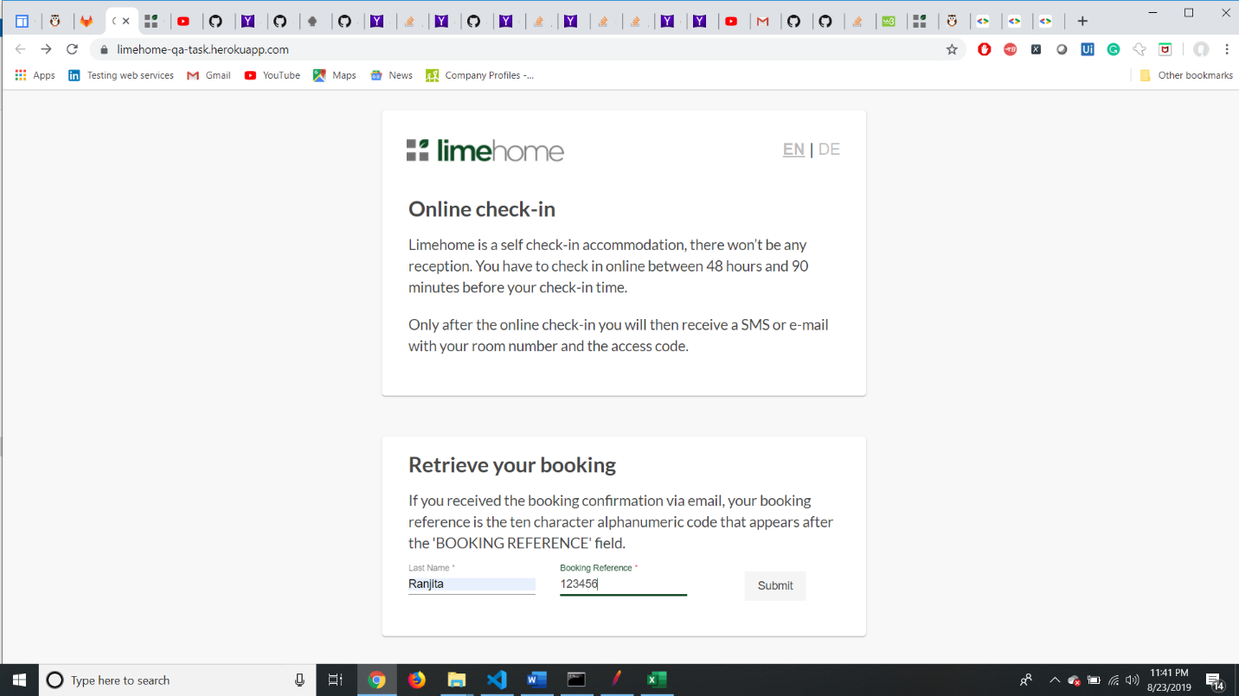

Image1: Enter Last Name: Ranjita; Booking Reference id: 123456, click Submit

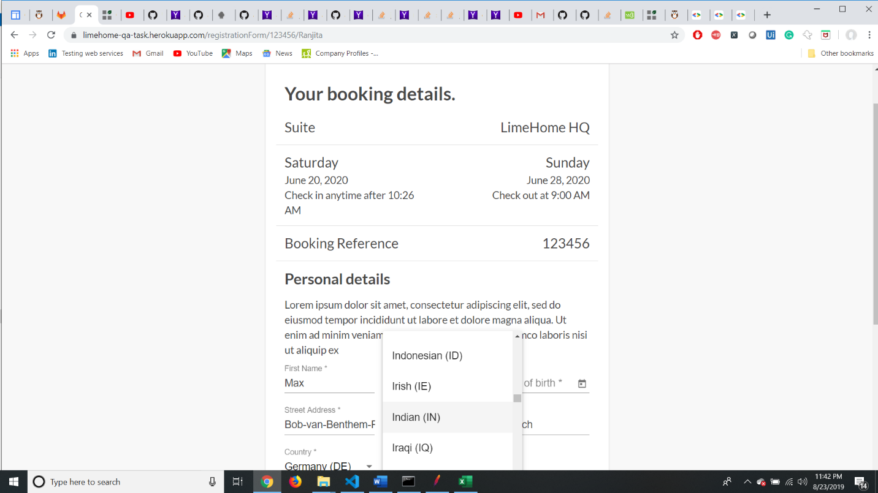

Image2:Next screen is loaded with all details including Last Name, Booking Reference id, Street,Postal code, City,Country,Select Nationality as : INDIAN(IN)

Image3: Passport tab is loaded, enter Passport Id: MO135568 and click Upload button

Image 4:On click of Upload, Pop up windows is opened, try to upload a pdf file having special character in the filename, Although the files gets uploaded here.

(Ideally it should show the supported file formats in the windows dialog list so that user will be aware of what all files it is supported to upload. but when trying to upload a ppt or doc file it is not uploading that file but however accepting such files)

Image5: Here you can see ,all though the user has been able to upload the image, theimage does not get uploaded here, which is an error. As there is no information displaying the supported file types