Software needed for the wrangling genomics session
MobaXterm provides a terminal emulator that can be used on the windows laptop to run Unix commands.

Installation guide for MobaXterm
Visit the website:
https://mobaxterm.mobatek.net/download-home-edition.html (shown below)

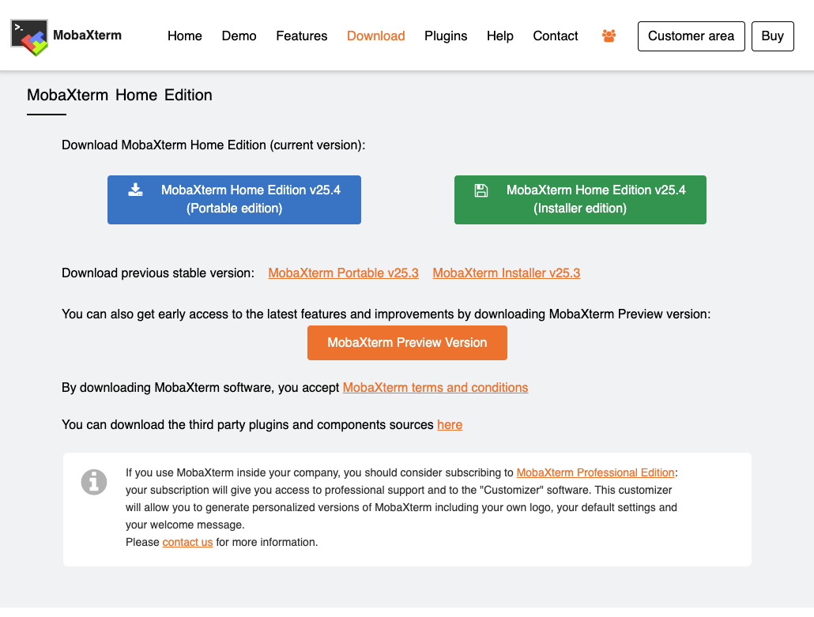

Click on the Portable edition (Blue) to download the software. A zipped document will have been downloaded.
Open the downloaded file zipped file. Click on the MobaXterm_Personal_25.4 then extract all the files.
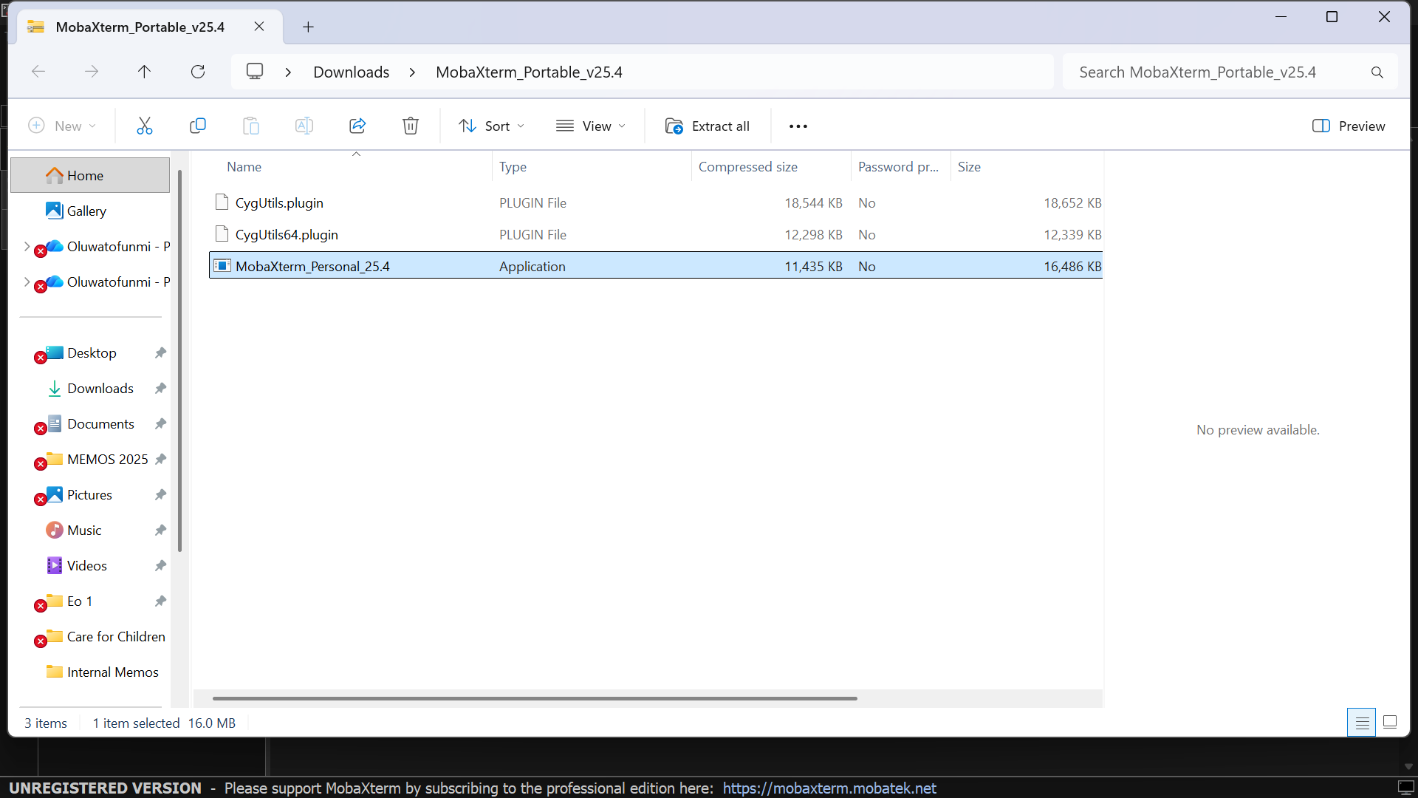

You’ll see an extracted page with similar files as the folder you previously opened (shown below). Open the MobaXterm_Personal_25.4 then follow the prompt.
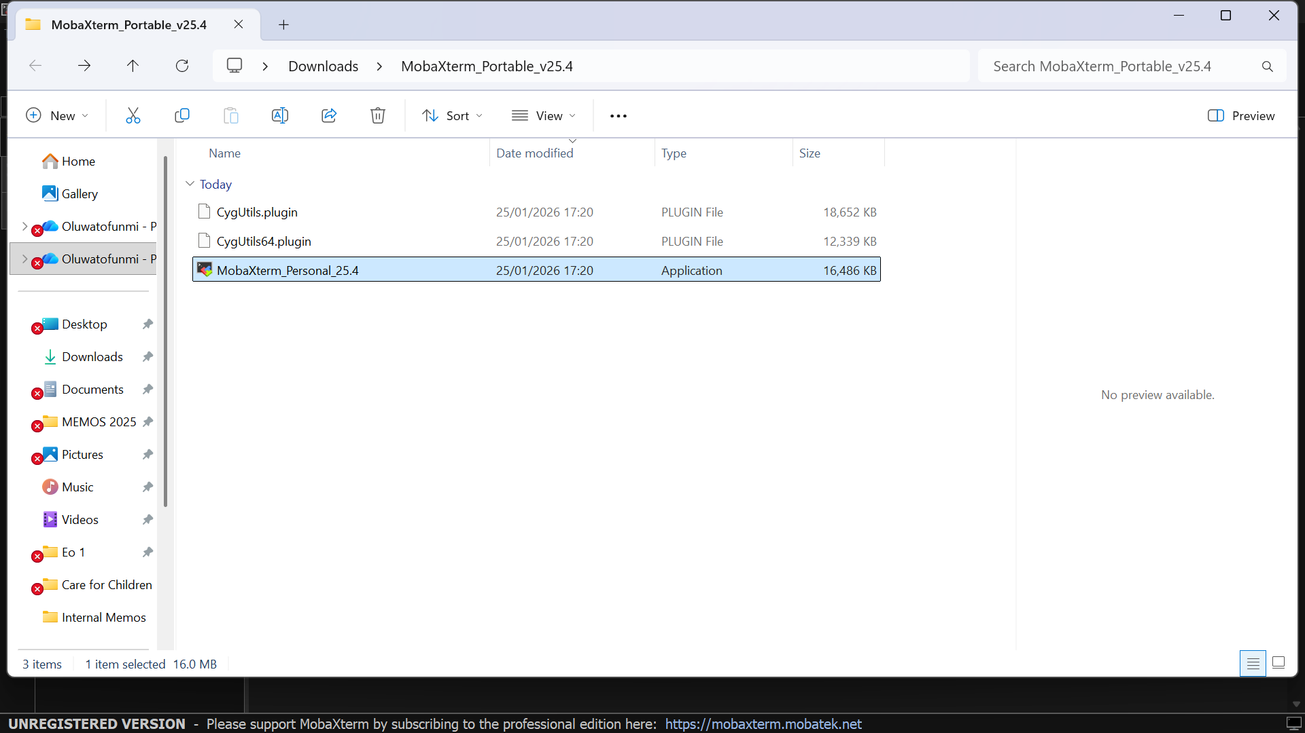

Yeyyy, the installation is complete .

You can either choose a light or dark interface depending on your preference.
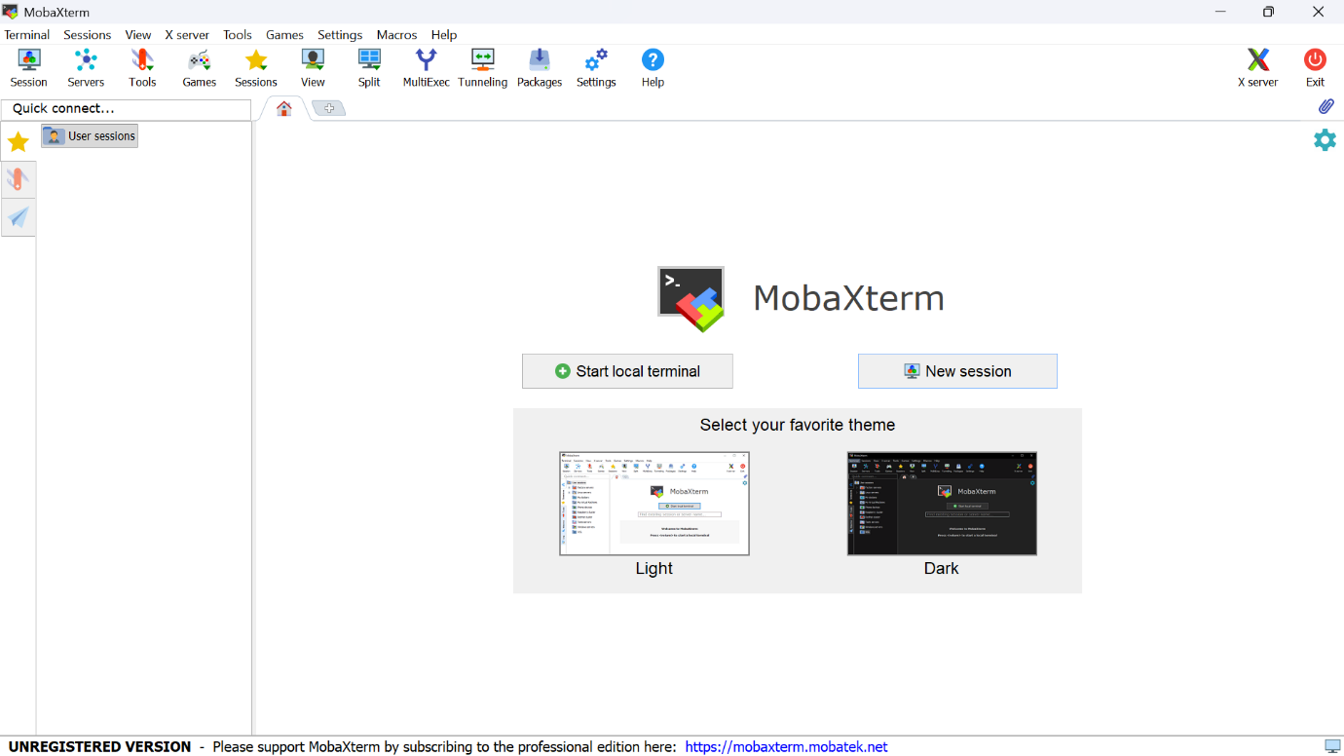

Click on the local terminal to see an interface.
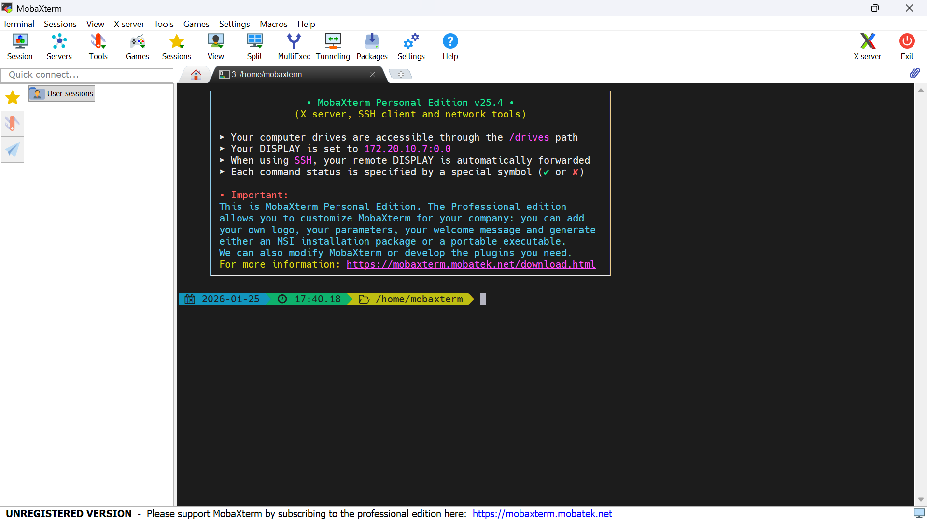

Congratulations you are ready for the bioinformatics session

