Home cuisine Islamic Restaurant

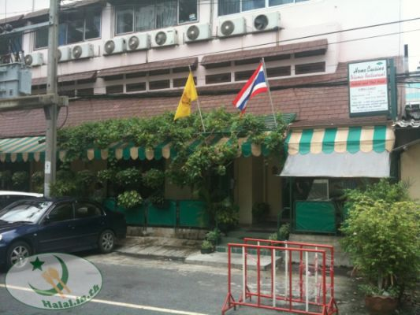

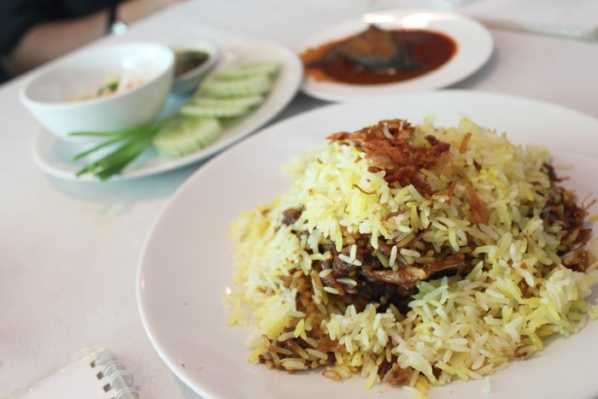

This Southern Indian style Halal restaurant can be or known as “Green restaurant” because the outside area of ​​the restaurant is made with green material. It is easy to recognize this restaurant by the symbol of grapevine on the roof. There are more than 70 foods in this restaurant, such as salad, fried rice or noodle. Moreover, there is a special menu that changes everyday. The recommended dish is Goat meat Biryani that will give you a taste of Southern India.

Price: 50 THB+

### Location: 186 Soi Charoen Krung 40, opposite to Embassy of France

Opening hours: Monday-Saturday 11.00-22.00/ Sunday 18.00- 22.00

Tip Hoy Tod Phu Khao Fai

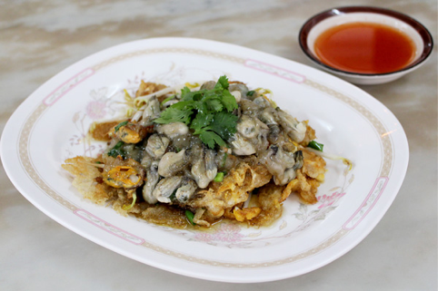

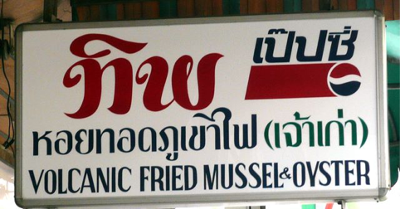

The former restaurant in Bangrak over 44 years, this restaurant guarantees the freshness of all shellfish, because they direct orders from Chonburi day to day. The menu is not to be missed is “Hoi Tup Hoi” that they will bring fried mussels over the fried oysters. Big size, Freshness and delicious food are the motto for this restaurant that you can proof from the crispy fried mussel and soft oyster omelet with large quantities of them.

Price: 80-100 THB

Location: 3 Soi Charoen Krung 50, next to Robinson BangRak

Opening hours: Monday-Saturday 10.00-20.30/ Closed on Sunday

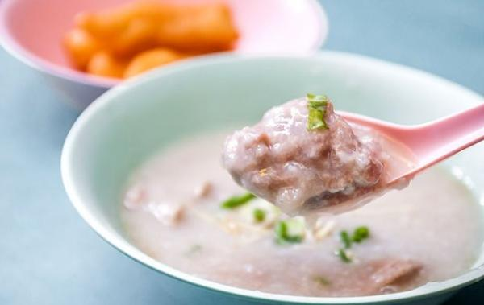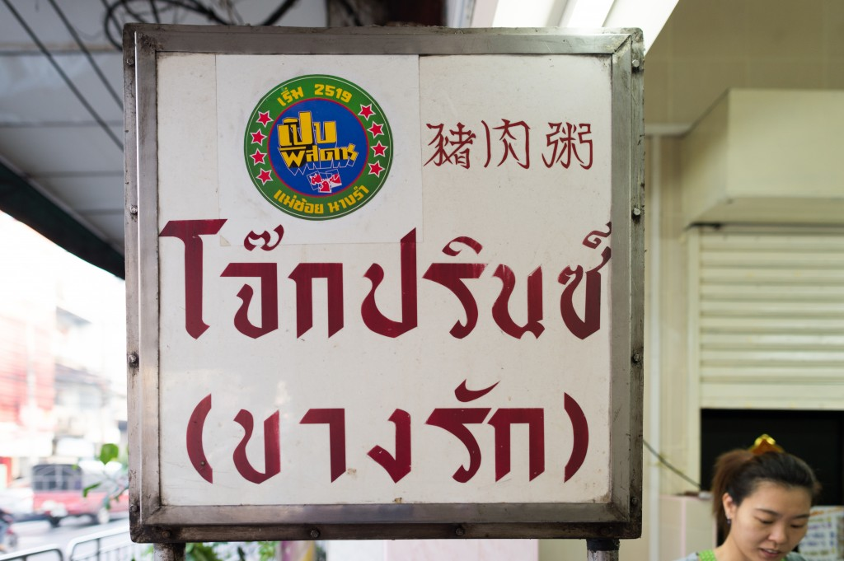Jok Prince

Jok Prince is simple rice soup porridge with small minced pork that has served for more than 50 years. The name Prince is from the location that located near old movie theater called Prince. We recommended you to have with a side of Chinese crullers or Pa Thong Ko. (Additional cost)

Price: 40-60 THB

Location: 1391 Opposite Robinson BangRak, Charoen Krung Road

Opening hours: Monday-Sunday 06.00-12.00/ 17.00-21.00

Yan Wo Yun Bangrak 2427

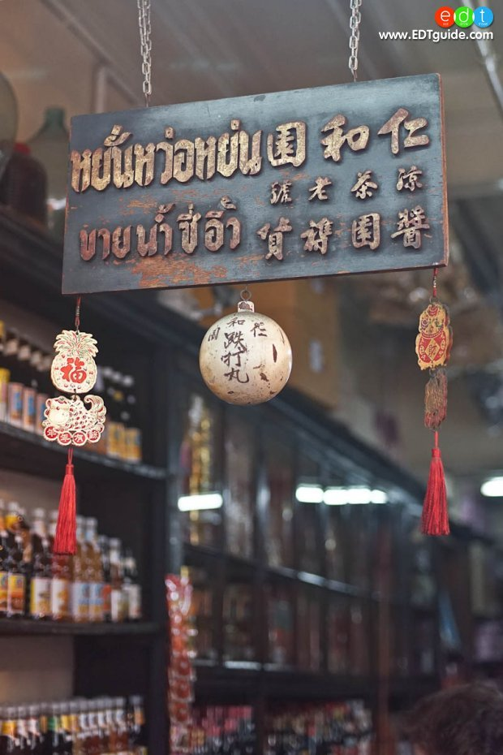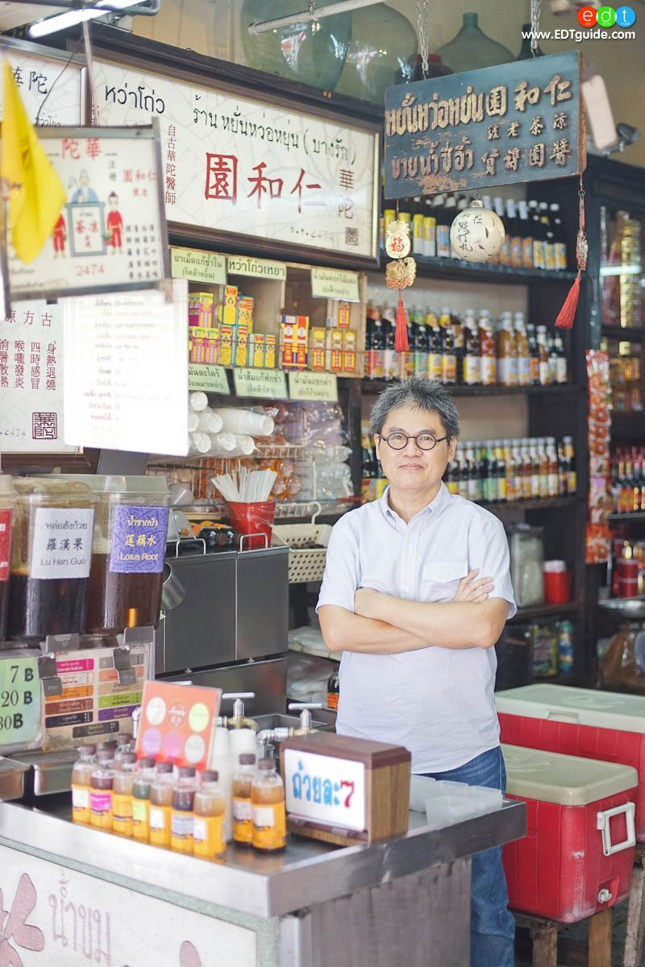

With a very hot weather in Thailand, it might be a good choice if you have something to quench your thirst. Yan Wo Yun is a small drinks shop that will serve you in a cup of ice or cool drink bottle and the famous for drink is “Bitter dinks.” This shop has sold Thai and Chinese herbal drinks, which is not only quenching your thirst, but also serving you the benefits of herbals over 84 years.

Price: 7-20 THB

Location: Opposite to Robinson Bangrak, Charoen Krung Road

Opening hours: Monday-Saturday 08.00-21.30

Jae Lee

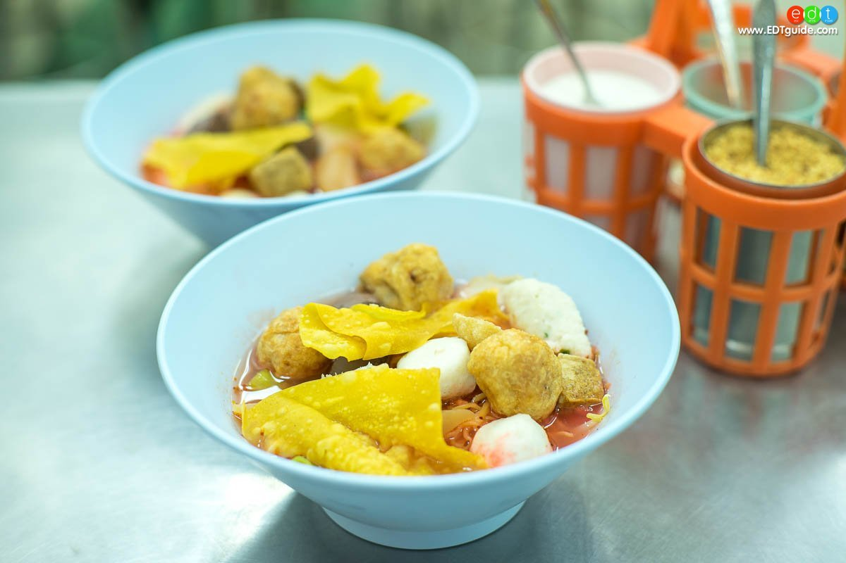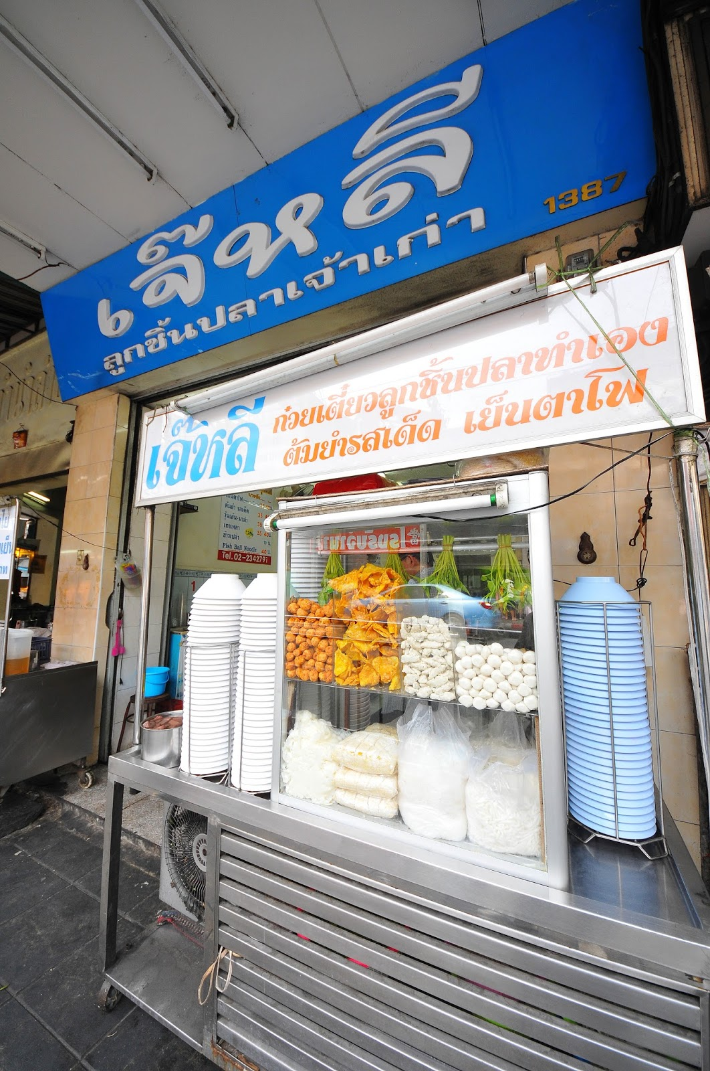

The special noodle from Jae Lee is Yen Ta Fo or Noodle with seafood soup and red sauce. The specialty of the sweet sauce is the recipe of the restaurant itself by using the ketchup as the main ingredients. Moreover, the restaurant itself originally makes the fish balls, so you will give a taste of real fish with less dough. Not only the Yen Ta Fo, but also other noodles are good with large quantities of them.

Price: 35-40 THB

Location: 1387 Charoen Krung Road, Bangrak

Opening hours: Open daily 7.30-21.30

Charoen Saeng Silom

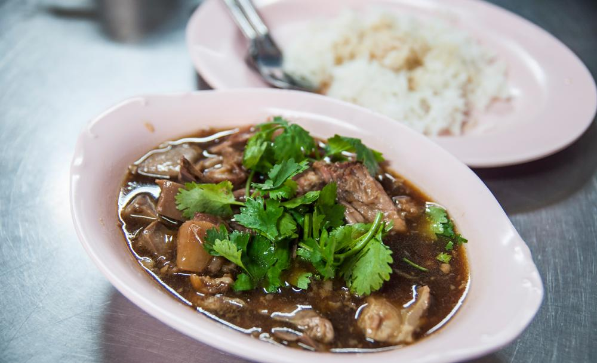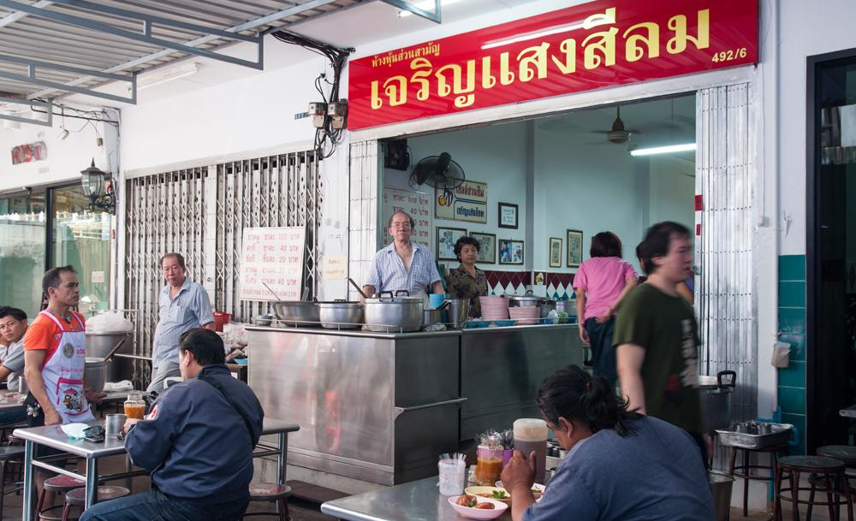

One of the best pork legs in Bangrak, Charoen Saeng Silom. The highlight of the restaurant is the soft-boiled pork legs that used in the front legs because they have less fat than the front legs. The taste of pork leg is good with a variety of Chinese herbs; it is not too salty or too greasy. Moreover, if you pour vinegar, the taste will be the spice up. Serving with rice and a little bit sweet pickles will make you love this dish.

Price: 40 THB+

Location: 492/6 Soi Charoen Krung 49, Bangrak

Opening hours: Open daily 8.30-13.30

Prachak

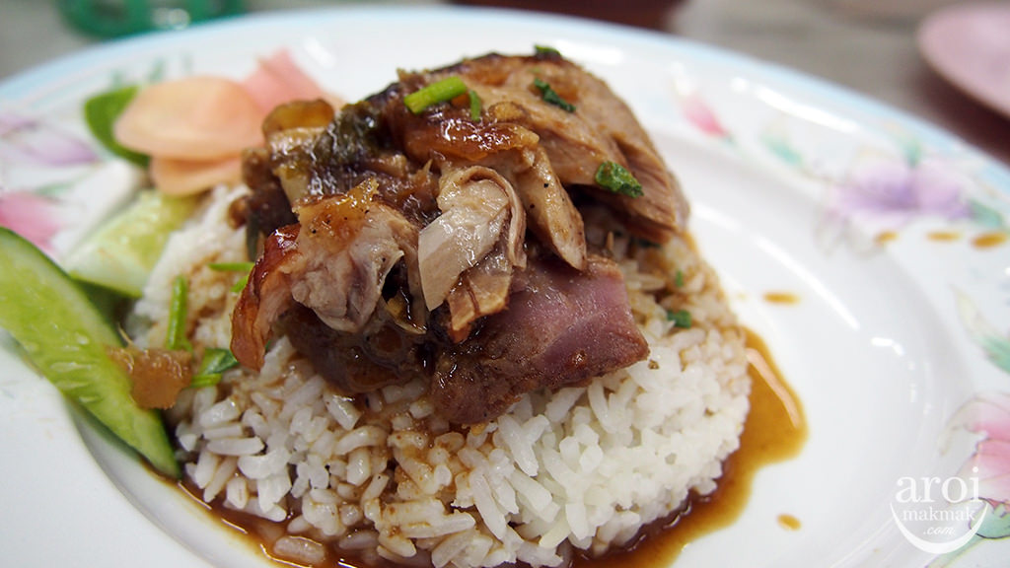

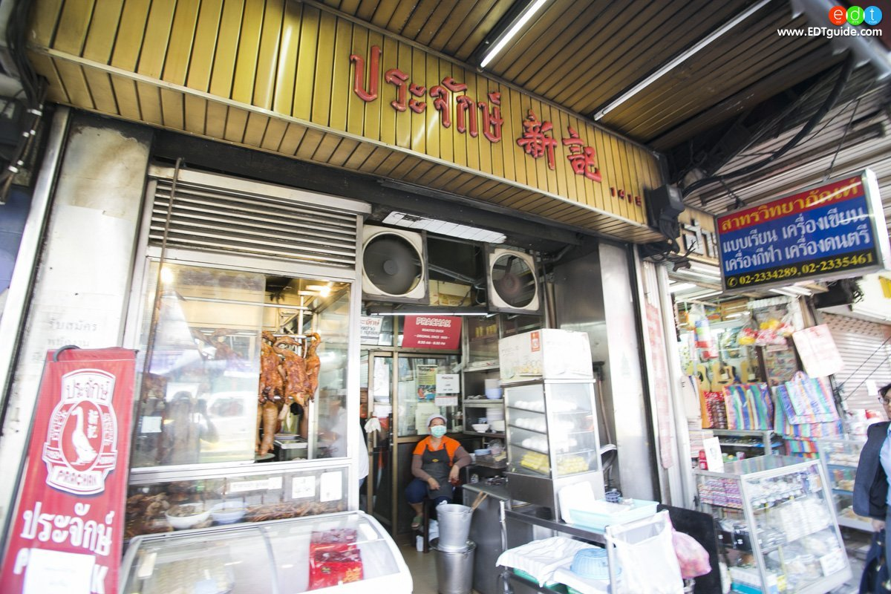

The restaurant that has lasted over 103 years, where the famous dish known for roasted duck. The unique roasted duck flavor is soft, crispy skin and topped with the special sauce from the restaurant. It is good with rice or another choice as egg noodle and big pieces of wontons. Additionally, the menu has more than 80 menus, desserts, steamed buns with selected ingredients as well.

Price: 50-100 THB

Location: 1415 Charoen Krung Road, Bangrak

Opening hours: Open daily 8.30-20.30

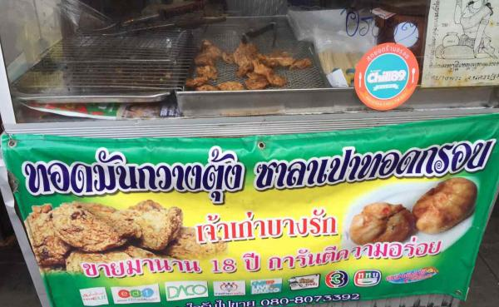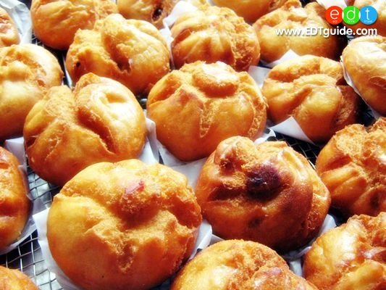Thotman-Kwangtung

The popular menu is Thotman-Kwantung with a special Cantonese recipe. The traditional recipe is delicious without sauce to have with. Moreover, there is thin dough steamed filling with crunchy pork, minced pork, pork ribs, fried mushroom stuffed with cabbage, and cream. This is one of the street food in Bangrak that you should have a taste.

Price: 25 THB each

Location: 1447 Charoen Krung Road, Opposite to Robinson Bangrak, Bangrak

Opening hours: Open daily 09.00-19.00

Boonsap Thai Dessert

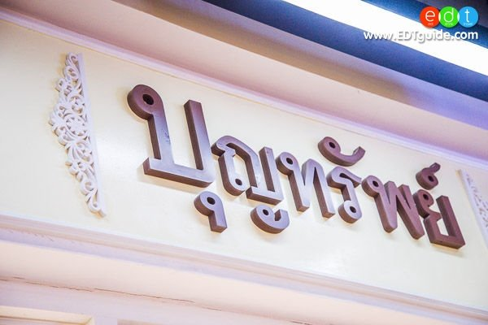

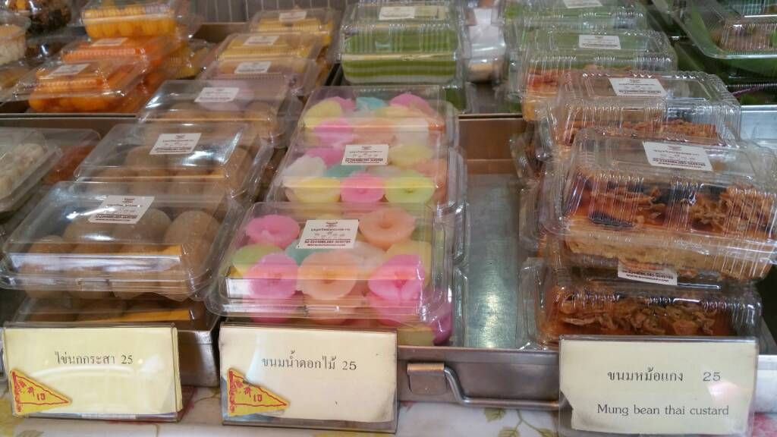

Boonsap Thai Dessert or known as Khun Luang has a lot kinds of Thai desserts in the shop. The taste of soft sticky rice get along well with sweet taste of coconut milk that is perfectly compatible. The taste of old Thai traditional dessert that you will be gets with the selected ingredients. The most well known dessert that we recommended you to try is the sweet sticky rice serving with ripe mango or shrimp and egg custard. Moreover, you can buy as the souvenir as well.

Price: 25 THB +

Location: 1478 Soi Charoen Krung 44

Opening hours: Open daily 7.00-17.00

Panlee Bakery

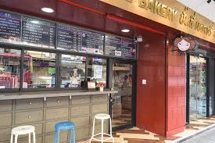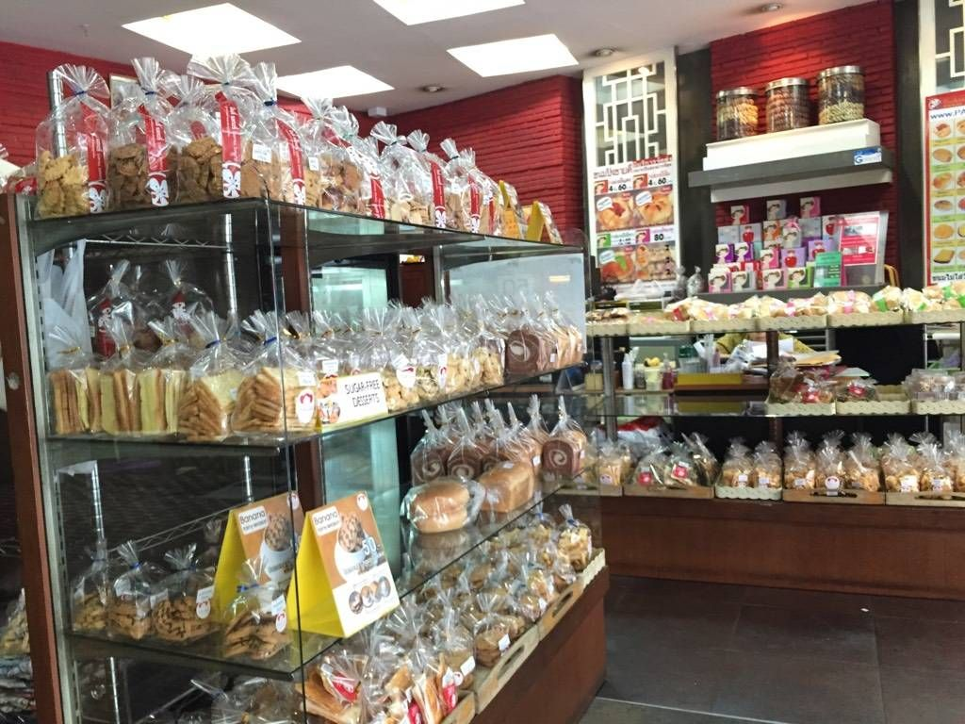

The red decorated front door, where you can see the desserts inside by the mirror. There are various kinds of desserts that well known in this area because of the soft delicious bread and cheap price. The shop I opened more than 60 years. The bread menu flavors that recommended are Pork Ham, Shredded Pork Ham and Custard. Additionally, the special cookies that sold only Panlee Bakery are dried-shrimp cookies. There is also a small coffee corner for you to have a cup of coffee with a delicious bakery.

Price: 10 THB +

Location: 337 Charoen Krung Road, Bangrak

Opening hours: Monday-Friday 06.00-20.00/ Saturday-Sunday 07.00-19.00