Blackout Ridge
Act 3 developer handoff
Field Deployment Planning
Revised draft 0.5 | 22 September 2026
Act 3 is an 8-minute collaborative planning game. The crew chooses two of four offline external installations, works out a viable order, selects two repair tools and one support item, adds three pre-calculated filter costs, and commits one deployment. The outside run and both repair puzzles occur in Act 4.
IMPLEMENTATION BOUNDARY The opening video sits outside the 8-minute planning window. Act 3 ends when the deployment is resolved and one runner is nominated. There are no field-repair puzzles in Act 3.
1. Opening video
Act 3 opens immediately after Act 2 and carries forward the actual end-of-Act-2 state. Successful cabin repairs remain successful; unrepaired local systems remain faulty.
A separate failure then occurs outside the cabin. A surge or cascading power-distribution fault takes four complete external systems offline:
• inbound communications;
• human outbound communications;
• Lower Road monitoring;
• Upper Ridge ventilation/purge.
The video does not reveal which field installation restores which failed function.
An automated environmental warning reports that the contaminated air released at Calder Vale is continuing to move upslope and spread further across the ridge. This warning is contextual only; the video does not explain route planning, stage filter costs or the two-location rule.
The automatic station heartbeat remains active and continues to report OPERATIONAL / NO ACTIVE DISTRESS. The video ends on the four external systems offline before transition to planning.
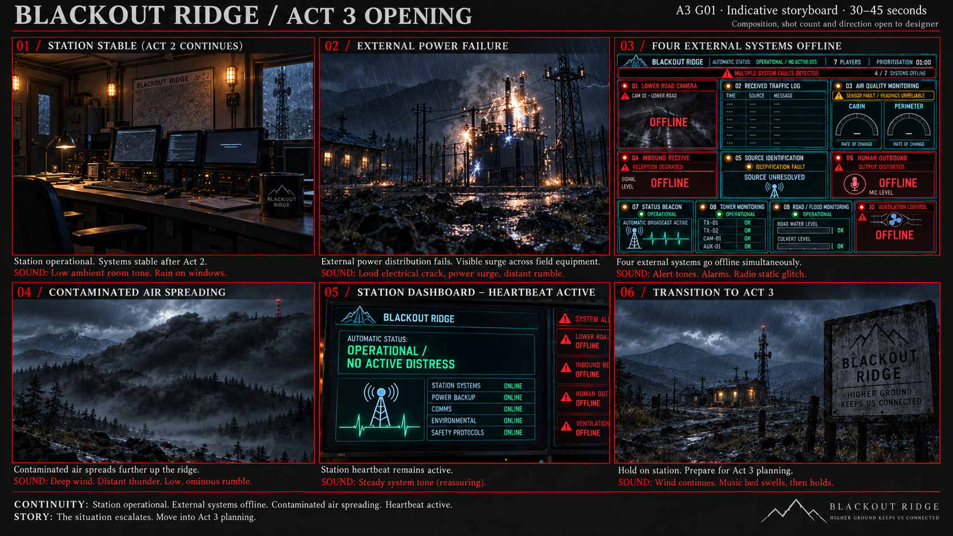
A3 G01. Indicative storyboard for the Act 3 opening video. Carries forward the actual end-of-Act-2 station state, introduces the separate external power/distribution failure, shows the four external systems dropping offline, establishes the contaminated air continuing to spread upslope, and ends on the still-active OPERATIONAL / NO ACTIVE DISTRESS heartbeat before planning begins.

ACT 2 DEPENDENCY Revise the two Act 2 respiratory advisories to 33 minutes under rated conditions and 20 minutes in severe Calder Vale gas. These numbers provide context only; Act 3 performs route planning in filter units.
2. How Act 3 plays
After the opening video, the facilitator tells the crew that four external systems are offline and that they have 8 minutes to plan one field deployment. The crew can attempt two repair locations.
The planned journey is: Cabin → first repair location → second repair location → Cabin
At the start of the planning window, all players receive the same three planning resources and assemble one deployment plan together.
• identify what each repair location restores;
• choose two locations and their order;
• select one repair tool for each location;
• select one support item;
• calculate filter use for the complete route;
• submit the deployment plan.
The Navigation Resource reduces the route calculation to three filter-cost stages: Cabin → first location and Repair 1; first location → second location and Repair 2; second location → Cabin. Players add the three published costs and compare the total with available filter capacity. They do not calculate contamination rates or model plume movement.
During planning, the facilitator triggers the Impossible Voice once. It is a story interruption only and does not provide planning evidence or change the route calculation.
A correct submission gives 5 minutes for each Act 4 repair. Any error in an otherwise viable submission is corrected automatically and reduces both repair windows to 4 minutes; the penalty applies once and does not stack.
CAM-01 + AUX-01 cannot be attempted together because they require different specialist support items and the runner may carry only one. If selected, the facilitator asks the crew to choose another pair.
When the 8-minute window expires, the facilitator asks for an immediate final submission. If the crew still cannot commit, a valid deployment is assigned at random with correct equipment and 4-minute repair windows.
Act 3 ends once the final deployment is resolved and one crew member is nominated as runner. The 8-minute value remains provisional until playtest.
3. Player materials
All players receive the same three planning resources: Navigation Resource, Field Systems Service Manual and Field Equipment Catalogue. The crew may divide the work however it chooses and communicate freely.
The shared Blackout Ridge dashboard remains visible throughout planning. Four external systems are offline in red; every other panel inherits its actual session state from Act 2. Tower Monitoring, if repaired, remains supplementary only and is not required to solve Act 3.
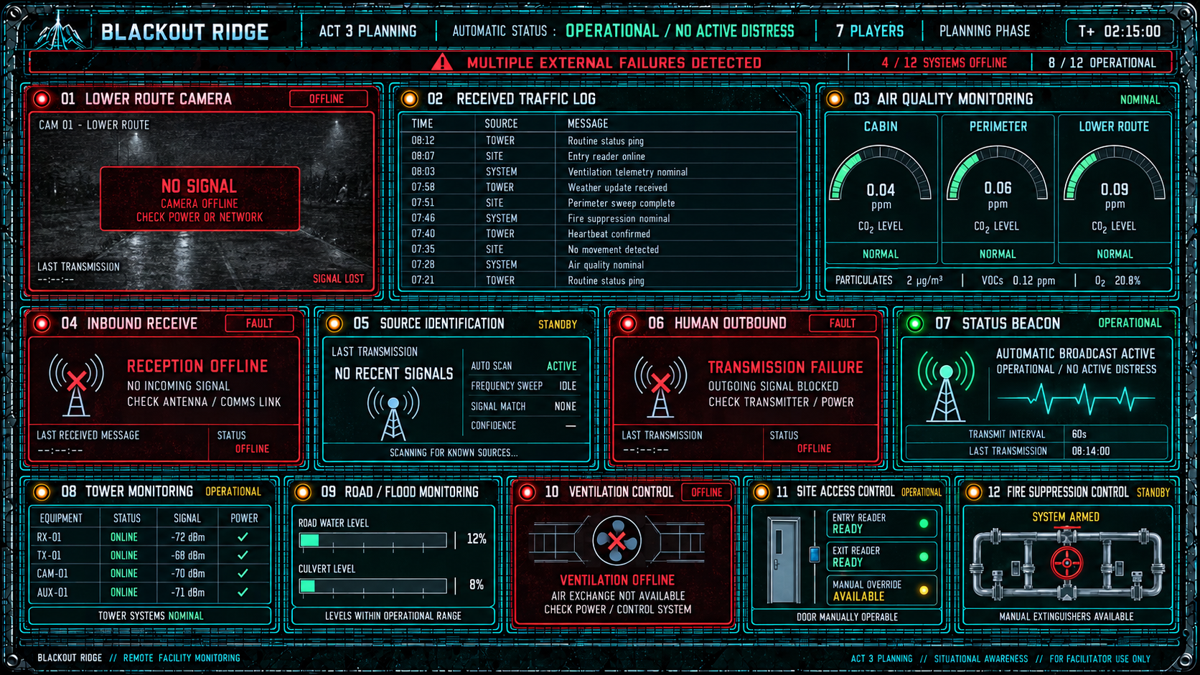
A3 G02. Example crew-facing Act 3 dashboard state. Lower Road Camera, Inbound Receive, Human Outbound and Ventilation Control are always offline in red following the external infrastructure failure. Every other panel inherits its actual session state from Act 2. The 7-player count, displayed time and other panel states shown here are illustrative rather than fixed outcomes.
Navigation Resource
Provides one terrain map and the three filter-cost lookups used to plan a deployment. Stage 1 gives the cost to reach and repair the first location; Stage 2 gives the cost to move to and repair the second location; Stage 3 gives the cost to return to the Cabin. CAM-01 is explicitly marked with standing water at the service platform, providing the evidence that water-access equipment is required.
Total filter use = Stage 1 + Stage 2 + Stage 3.
Standard filter capacity is 100 units. The Emergency Filter Cartridge adds 15 units, giving a maximum capacity of 115 units. The map shows the environmental context; the published stage costs are the authoritative player values for filter use.
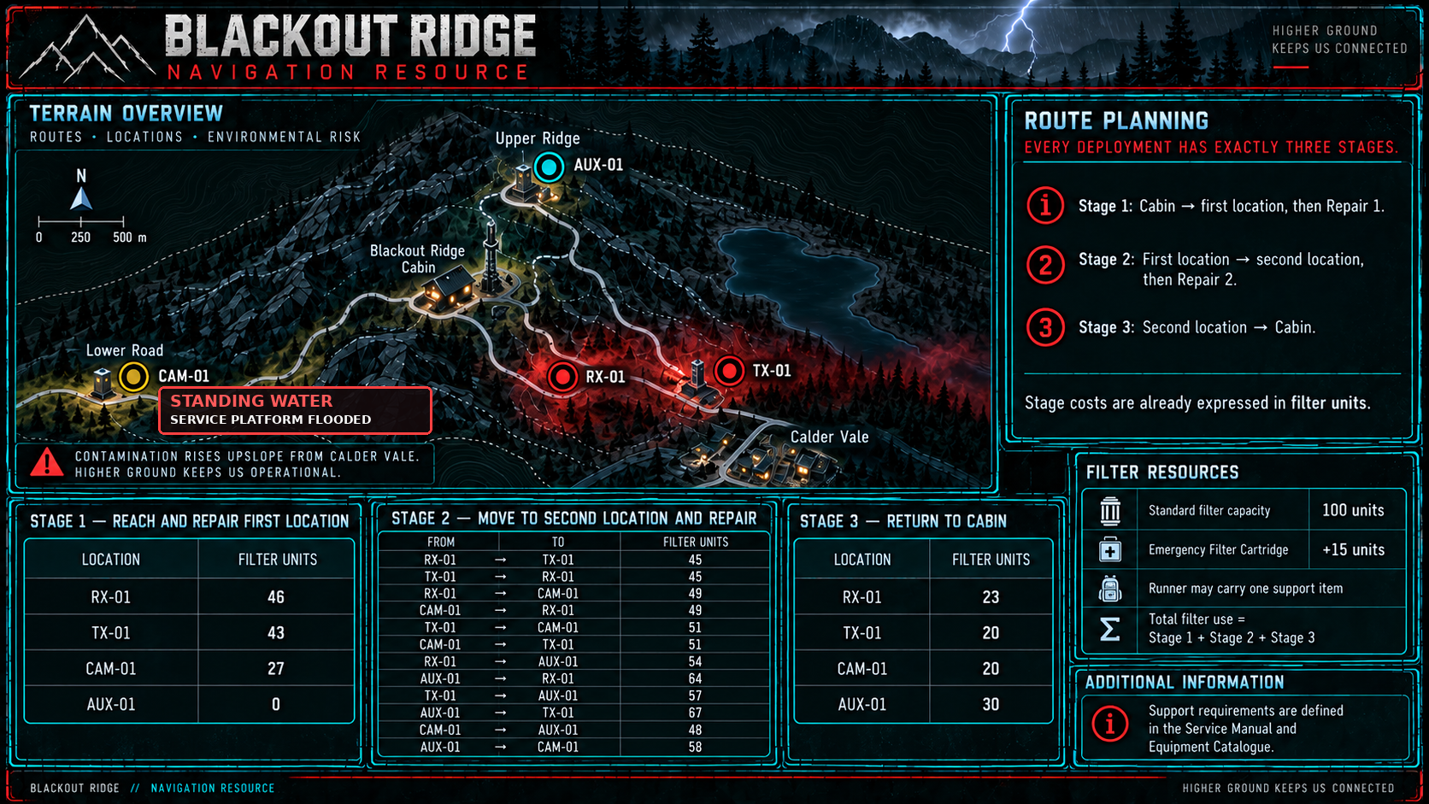
A3 G03. Player-facing Navigation Resource. A single terrain map provides spatial context while three stage-cost tables reduce every deployment to one three-number filter calculation. CAM-01 is explicitly marked SERVICE PLATFORM FLOODED. Players add Stage 1, Stage 2 and Stage 3 and compare the total with 100 units, or 115 units when carrying the Emergency Filter Cartridge. Generated artwork is a layout reference; implementation values must match the approved stage costs and developer answer key.
Field Systems Service Manual
Explains what RX-01, TX-01, CAM-01 and AUX-01 do, how each is restored, and whether specialist access equipment is required. It does not recommend which systems to prioritise.
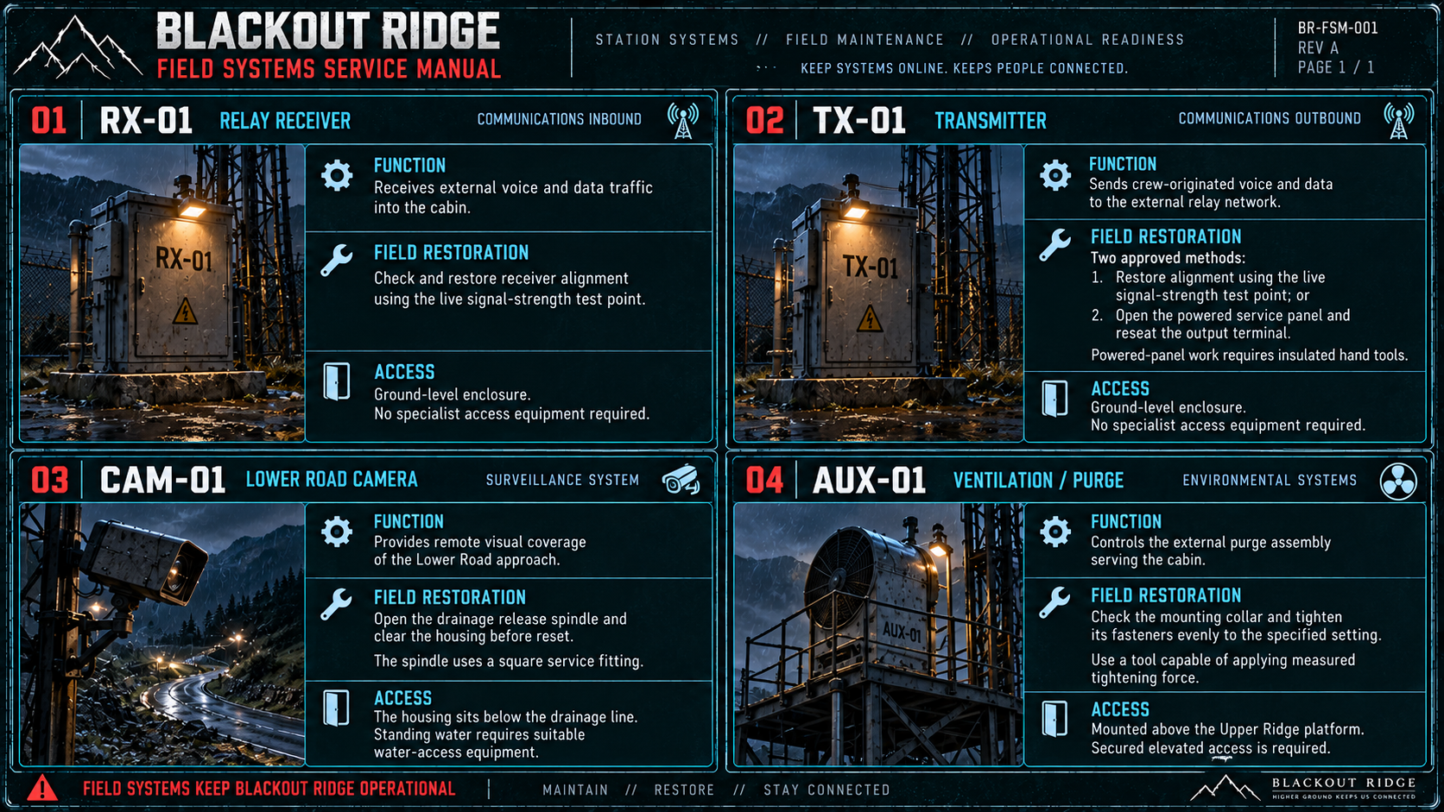
A3 G04. Player-facing Field Systems Service Manual. Each entry gives only the function, field-restoration requirement and access condition needed to select suitable equipment.
Field Equipment Catalogue
Contains four repair tools — Signal Meter, Insulated Driver Set, Valve Wrench and Torque Wrench — and three support items — Emergency Filter Cartridge, Flood Kit and Climbing Kit. The runner carries two repair tools and one support item.
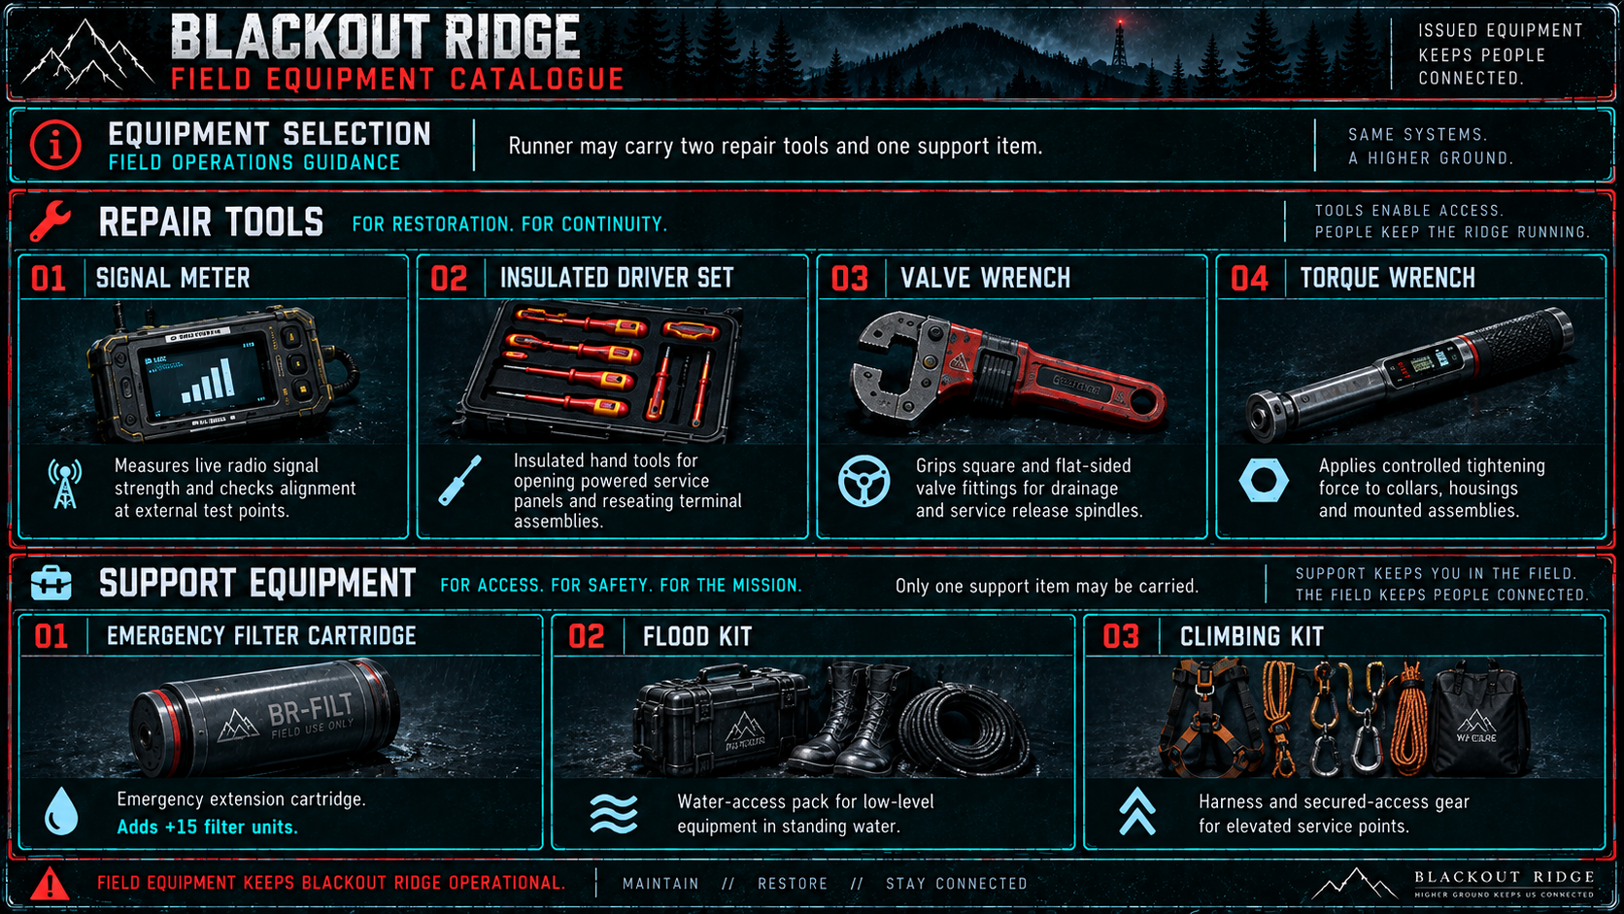
A3 G05. Player-facing Field Equipment Catalogue. The four repair tools and three support items are described by capability rather than destination.
These three resources contain all information required to solve Act 3. No Act 2 repair outcome is required to construct a valid deployment plan.
4. Developer answer key
Use the six valid ordered deployments below as the source of truth for submission validation. Each filter total is Stage 1 + Stage 2 + Stage 3 from A3 G03. Standard capacity is 100 units; the Emergency Filter Cartridge raises it to 115 units.
Valid deployment | Filter use | Support item | Tool 1 | Tool 2
RX-01 → TX-01 | 111 | Emergency Filter Cartridge | Signal Meter | Signal Meter or Insulated Driver Set
TX-01 → RX-01 | 111 | Emergency Filter Cartridge | Signal Meter or Insulated Driver Set | Signal Meter
CAM-01 → RX-01 | 99 | Flood Kit | Valve Wrench | Signal Meter
CAM-01 → TX-01 | 98 | Flood Kit | Valve Wrench | Signal Meter or Insulated Driver Set
AUX-01 → RX-01 | 87 | Climbing Kit | Torque Wrench | Signal Meter
AUX-01 → TX-01 | 87 | Climbing Kit | Torque Wrench | Signal Meter or Insulated Driver Set

Invalid route logic:
• RX-01 → CAM-01 and TX-01 → CAM-01 require both the Flood Kit and Emergency Filter Cartridge.
• RX-01 → AUX-01 and TX-01 → AUX-01 exceed the available filter capacity.
• CAM-01 + AUX-01 has no valid order because both locations require different specialist support items.
Successful repair consequences
• RX-01: restores inbound communications.
• TX-01: restores human outbound communications.
• CAM-01: restores the Lower Road camera and makes the recovered Mara footage available.
• AUX-01: restores ventilation/purge.
A selected system returns online only if its Act 4 repair succeeds. The two systems not selected are never visited and remain offline.
5. The Impossible Voice
During the 8-minute planning window, the facilitator triggers one impossible audio event: a distorted human voice cuts through the cabin audio despite Inbound Receive being offline.
The voice should plausibly be Mara, but the crew is not given a reliable identification. It remains recognisably human while sounding physically wrong — unstable, alien and unlike an ordinary damaged radio transmission.
A3 S01 — IMPOSSIBLE VOICE Spoken line: “Can anyone hear me?” Audio treatment: recognisably human and plausibly Mara, but distorted, unstable and alien in character; too close and intimate for a normal radio transmission. Play once during active planning. The 8-minute clock does not pause.
• It does not depend on RX-01.
• No source appears in Source Identification.
• Tower Monitoring does not explain it.
• No entry appears in the Received Traffic Log, and the event cannot be replayed.
• It does not alter any route, filter or equipment calculation.
Inbound Receive remains visibly offline afterwards. Trigger the voice once the crew is actively planning; if the crew is close to submitting early, play it before accepting the submission. The 8-minute clock does not pause.
6. Submission and facilitator behaviour
The crew submits one deployment plan containing:
• first repair location;
• second repair location;
• repair tool for each location;
• one support item;
• calculated filter use (Stage 1 + Stage 2 + Stage 3).
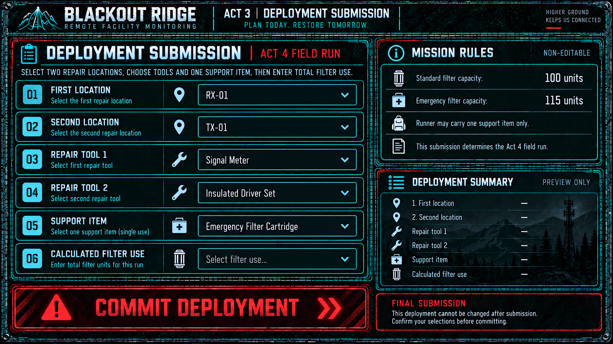
A3 G06. Player-facing Deployment Submission screen. The crew commits the first and second repair locations, one repair tool for each location, one support item and the calculated Stage 1 + Stage 2 + Stage 3 filter total. Standard and extended filter capacities are shown as reference; COMMIT DEPLOYMENT makes the final commitment explicit.
Resolution
Submission | Facilitator / system behaviour | Act 4 allowance
Correct | Accept the submitted deployment. | 5 minutes per repair
Viable pair, any planning error | Correct route/equipment automatically. Apply one non-stacking planning penalty. Preserve the crew’s chosen pair. | 4 minutes per repair
CAM-01 + AUX-01 during active planning | Reject as exceeding support capacity and return the crew for immediate reselection. No penalty. | —
CAM-01 + AUX-01 at expiry final call | Treat as no valid commitment. Assign one of the six valid ordered deployments at random with correct equipment. | 4 minutes per repair
No commitment after expiry final call | Assign one of the six valid ordered deployments at random with correct equipment. | 4 minutes per repair

The 4-minute penalty changes only the real-world Act 4 puzzle window. It does not change the fictional repair duration, the route, or the filter-use total calculated in Act 3.
At expiry, the facilitator asks for an immediate final submission. The final call does not create another planning period. A final CAM-01 + AUX-01 submission is treated as no valid commitment and triggers a random valid deployment with 4-minute repair windows.
7. Act 4 handoff
Act 3 ends once the deployment is resolved and the crew nominates one runner. Pass the following state into Act 4:
State | Passed forward
Runner | Crew-nominated player
First destination | Final confirmed/corrected location
Second destination | Final confirmed/corrected location
Repair tool 1 | Final confirmed/corrected tool
Repair tool 2 | Final confirmed/corrected tool
Support item | Final confirmed/corrected item
Repair allowance | 5 minutes per repair, or 4 minutes after a planning penalty/random assignment

The route and equipment are fixed when Act 4 begins. Act 4 executes the outside run and two repair puzzles; the Act 3 route calculation is not repeated.
8. Production assets and remaining work
Asset / task | Status / requirement
A3 G01 — Opening storyboard | Reference artwork complete; produce final opening video and environmental-warning audio.
A3 G02 — Shared dashboard | Reference artwork complete; implementation must inherit actual Act 2 session state outside the four forced external outages. Example player count/time are illustrative.
A3 G03 — Navigation Resource | Reference artwork complete; includes CAM-01 standing-water evidence. Final UI must use the approved single-map, three-stage filter-cost values.
A3 G04 — Service Manual | Reference artwork complete.
A3 G05 — Equipment Catalogue | Reference artwork complete.
Impossible Voice | Script locked as “Can anyone hear me?”. Produce audio using the treatment in Section 5 and provide a facilitator trigger.
A3 G06 — Deployment Submission | Reference artwork complete; build the player-facing submission interface from G06.
Submission result states | Build accepted, corrected and expiry/random-assignment states.
Facilitator controls | Provide Impossible Voice trigger and final deployment resolution/assignment controls.
Act 4 integration | Pass final deployment, equipment, runner and repair allowance into the Act 4 sequence.

Reference graphics illustrate the intended player experience and layout. Implement game logic from the editable rules and answer key in this handoff rather than relying on generated image text where the two differ.

