Blackout Ridge
Act 4 developer handoff
FIELD DEPLOYMENT EXECUTION | REVISED DRAFT v0.4 | 4 OCTOBER 2026

IMPLEMENTATION BOUNDARY The opening video sits outside the repair clocks. First stop always uses Repair Board 1; second stop always uses Repair Board 2, regardless of destination. Act 3 tools/support items do not branch Act 4 puzzle logic. Current working allowance is 6 minutes per repair, or 5 minutes after a planning penalty/random deployment. Timeout is the repair failure condition.

Act 4 executes the deployment committed in Act 3. One nominated runner leaves the cabin, reaches two fixed field installations in order, and attempts one six-module asymmetric repair at each while the remaining crew use private service procedures. The intended experience is organised chaos: a coordinated team can prepare procedures in parallel; a disorganised team loses time naturally.
This draft consolidates the two locked repair modules, their current player-facing references, and the developer interaction rules agreed during the design pass. Generated artwork remains reference material; the editable mechanics and developer notes in this document are authoritative if image text differs.

Document map
Section | Contents
1–6 | Authority, opening, state, act flow, screens and shared display
7–9 | Common interaction rules and Repair Board 1
10 | Repair Board 2
11–14 | Timing, travel, destination consequences and Mara footage
15–17 | Close, persistent state, production assets and acceptance

1. Authority and current changes
• This v0.4 supersedes Act 4 Draft v0.3 for the twelve repair-game mechanics and their implementation notes. The Revised Design Brief remains the continuity source where this document does not explicitly revise it.
• The four fictional field installations do not require four puzzle sets. Destination affects fiction and downstream consequences; stop order selects Repair Board 1 then Repair Board 2.
• Cabin procedures are professional field references. They contain the rule or lookup required to solve the apparatus; they do not script what players should ask one another.
• Act 3 repair tools and support items remain meaningful in planning only. Act 4 may acknowledge them visually, but they do not branch the repair games.
• Current working timing is 6 minutes per repair, or 5 minutes after penalty/random assignment. The current Act 3 handoff still contains 5/4-minute references and must be reconciled before canonical sign-off.

2. Opening video — Outside
Target duration: approximately 30–40 seconds. The sequence turns the Act 3 deployment decision into a physical survival-horror event before any repair timer begins.
• Deployment lock: confirmed runner and both selected destinations; no success judgement and no re-explanation of planning rules.
• Preparation: respirator cartridge fitted, straps tightened, gloves, radio and sealed service bag. Breathing becomes the dominant sound.
• Seal check: the runner briefly blocks the filter inlet; breathing stops for an uncomfortable beat and returns sharply.
• Heartbeat contradiction: BLACKOUT RIDGE — OPERATIONAL / NO ACTIVE DISTRESS continues while exterior conditions visibly deteriorate.
• Threshold: door caught by violent wind; local radio established; cabin ambience gives way to rain, wind and close respirator breathing.
• Outside: torch catches contaminated air moving across the ground; runner disappears into darkness. End on FIELD DEPLOYMENT ACTIVE / LOCAL RADIO CONNECTED.
• Do not show fictional crew debate over who should go outside.
• Do not explain the impossible voice, Mara, R-12, Lark Shift material or a monster.
• Do not re-open filter arithmetic, route planning or equipment selection.
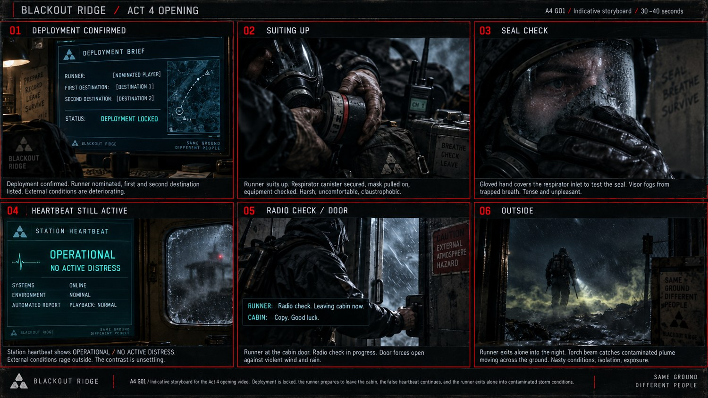
A4 G01 — current opening storyboard reference. Produce final video from the sequence above; identity/gender should remain obscured by POV/rear framing, hood, respirator and gloves.

3. State entering Act 4
State | Passed forward
Runner | Crew-nominated player
First destination | Final confirmed/corrected Act 3 location
Second destination | Final confirmed/corrected Act 3 location
Repair tools | Final Act 3 choices; no Act 4 branch
Support item | Final Act 3 choice; no Act 4 branch
Repair allowance | 6 minutes, or 5 minutes after penalty/random assignment

RX-01, TX-01, CAM-01 and AUX-01 begin Act 4 externally offline. Persistent Act 2 local-system states remain separate: restoring an external path does not retroactively repair a faulty local chain.

4. Act flow
Step | Behaviour
1 | Opening video; no repair clock.
2 | Atmospheric travel to first locked destination; no route choice or filter calculation.
3 | Repair Board 1 opens; all six modules available concurrently.
4 | Success applies destination consequence immediately; timeout leaves destination offline.
5 | Travel to second locked destination even if Repair 1 failed.
6 | Repair Board 2 opens with rebalanced cabin-procedure allocation.
7 | Resolve second destination, return to cabin, hand concrete field-service states into Act 5.

5. Participant and screen model
Audience | Screen | Purpose
Runner | Private runner screen | Manipulates the six-module board. Cabin players must not see it.
Cabin players | Private procedure tabs | Each player sees only assigned procedure(s) for the active repair.
Whole crew | Shared Act 4 display | Travel/repair status, timer, runner, destination order, six-module progress, radio and external systems. No answers.
Facilitator | Private administration | Phase, deadline, allocations, seeded/current module state, result and recovery controls. Never shared.

Remote play uses the existing call audio. For co-located play, separate sightlines so cabin players cannot see the runner board. There is no additional radio-management mechanic.

5.1 Cabin procedure allocation
Total players | Cabin players | Per-repair allocation | Repair 2 balancing
4 | 3 | 2 / 2 / 2 | Keep two each; vary pairings where useful.
5 | 4 | 2 / 2 / 1 / 1 | Players with one in Repair 1 receive two in Repair 2.
6 | 5 | 2 / 1 / 1 / 1 / 1 | Move the double allocation to another player.
7 | 6 | 1 / 1 / 1 / 1 / 1 / 1 | One procedure each again.

• Procedure ownership is private; players cannot browse one another’s tabs.
• All assigned tabs are available from the start so players can prepare while another game is active.
• Runner modules remain available in any order. The software does not organise the team for them.

6. Shared display and facilitator behaviour
Shared mode | Must show
EN ROUTE | Runner, destination order/current destination, local radio connected, four external states.
REPAIR ACTIVE | Above plus one repair countdown and six neutral COMPLETE / INCOMPLETE indicators.
REPAIR RESOLVED | RESTORED / NOT RESTORED, updated external state, next destination or return.
RETURNING | Runner returning; current field outcomes; no further decisions.

Facilitator administration additionally shows timing class, cabin allocation, seeded/current module state and repair result. Refresh/reconnect restores the existing deadline and state; it must not reroll a game or restart a timer.
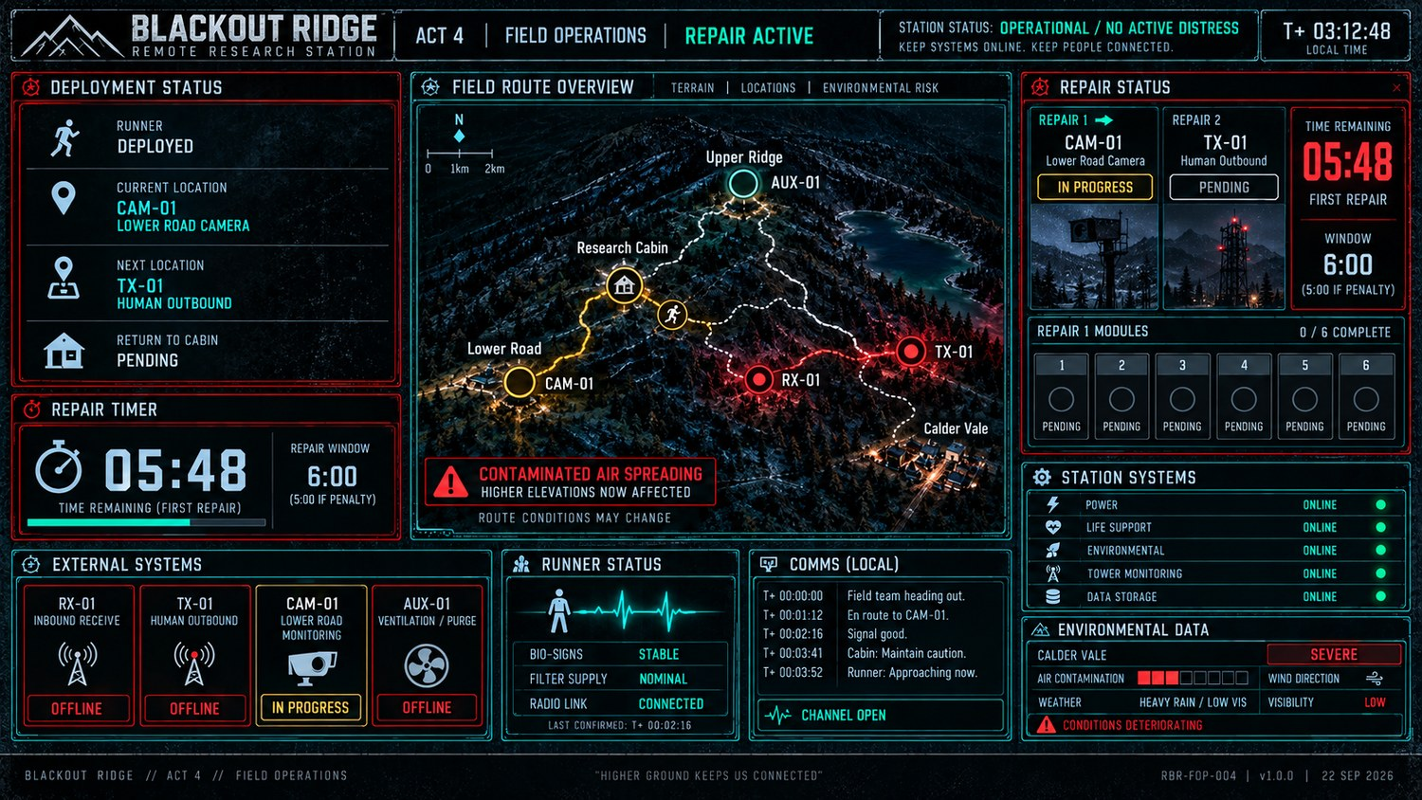
A4 G02 — shared Act 4 display reference. The map/progress/status composition is the current visual anchor; exact displayed values are illustrative.

7. Common cooperative-repair rules
CORE LOOP RUNNER OBSERVES → CABIN INTERPRETS → CABIN INSTRUCTS → RUNNER ACTS

• All six modules are visible and usable from the start. The runner chooses order; cabin players can prepare in parallel.
• Difficulty should come from accurate observation, translation and organisation under pressure, not specialist engineering knowledge or Act 2-style deduction.
• Where a game uses VERIFY / EXECUTE, validate the whole submitted state or sequence. Do not reveal which individual element was correct.
• Incorrect actions are recoverable while time remains. Avoid irreversible strikes, artificial wait penalties and precision-timing mechanics.
• Completed modules lock COMPLETE and cannot be altered. Repair succeeds only when all six complete before the shared deadline.
• Refresh/reconnect preserves countdown, seeds, current configuration and completed modules.
• Player-facing language stays diegetic: procedure, service, test, repair, module. Do not display GAME 1 / GAME 2 or developer asset IDs.
ARTWORK AUTHORITY Generated screens are visual references. If an image conflicts with an editable rule, answer key or interaction note below, implement the editable rule. Regenerate the reference artwork rather than changing the mechanic to match generated text.

8. Cabin instruction-screen standard
The procedure is the main content. Use the established Blackout Ridge dark/cyan house style for now: small header, large PROCEDURE title, direct numbered instructions and compact lookup tables. No generic white-paper layout, coaching language, examples unless indispensable, or duplicated diagrams of apparatus already visible to the runner.

9. Repair Board 1 — first selected destination
The first selected destination always uses this board. Destination appears only in the wrapper/header and determines downstream consequence, not the six game rules.
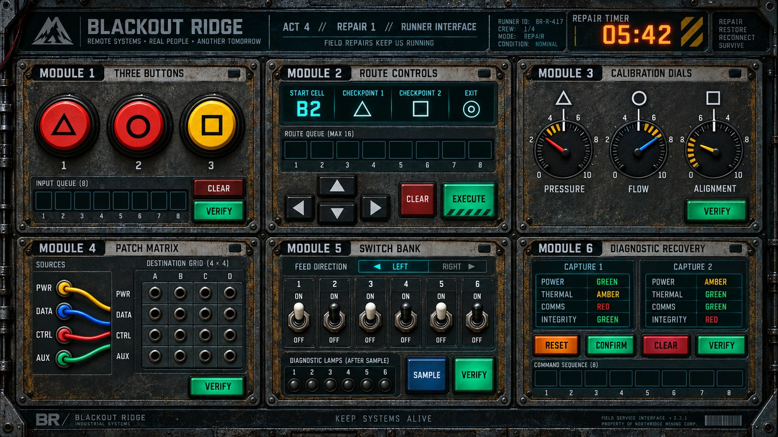
A4 G03 — Repair Board 1 runner reference. Six modules are available concurrently; the runner may tackle them in any order.

9.1–9.2 Repair Board 1 developer rules

9.1 Three Buttons
TASK Derive X/Y/Z from the physical buttons, then translate the selected eight-role sequence into actual button presses.
Runner state. Three left-to-right buttons. Exactly two share a colour; all three carry different symbols (triangle, circle, square). No X/Y/Z labels are shown.
Cabin rule. If the matching-colour pair is adjacent, X is the uniquely coloured button. If the pair is separated, X is the left-hand button of the matching pair. Of the two remaining buttons, Y is whichever symbol appears earlier in Triangle → Circle → Square; the last is Z. Select the 8-role sequence using the symbol on X and X’s physical position.
Symbol on X | X left | X centre | X right
Triangle | X Y Z X Z Y Y X | Z X Y Z Y X X Y | Y Z X X Y Z Y X
Circle | Y X Z Z X Y X Z | X Z Y X Y Z Z X | Z Y X Y X Z X Y
Square | Z Y X Z X Y Z X | Y Z X Y Z X X Z | X Y Z Z Y X Z Y

Interaction. Each physical-button click appends one entry to an eight-position queue. CLEAR may reset before submission. No extra status-light branch is used.
Validation / recovery. Validate only when eight presses have been entered / VERIFY is pressed. Wrong sequence clears the whole entry; button colours/symbols remain unchanged.
SEED / EDGE CONSTRAINTS Seed exactly one duplicated colour and three distinct symbols. Avoid combinations that violate the role rules.

9.2 Route Controls
TASK Transmit a full route through two ordered checkpoints to the exit using only directional commands.
Runner state. Runner sees the seeded START cell, required checkpoint symbols/order, arrow controls, route queue, CLEAR and EXECUTE. Runner does not see the cabin maze.
Cabin rule. Cabin sees the full 6×6 node-and-edge maze. Route must satisfy START → CHECKPOINT 1 → CHECKPOINT 2 → EXIT in that order. Current design intentionally allows waypoint detours rather than relying on sheer maze size.
Interaction. Arrow clicks append to a route queue. V1 does not require a generic maze engine: the developer may store one canonical accepted sequence, or a very small whitelist, for each seeded start/maze state.
Validation / recovery. EXECUTE validates the full route only. Invalid submission clears the route and gives no wrong-step position. No movement is enacted incrementally on the runner screen.
SEED / EDGE CONSTRAINTS Current reference uses a compact 6×6 layout; checkpoint placement is a design asset and must match the approved maze art. If multiple starts are seeded, store the accepted sequence per seed. Do not use maze size as the main difficulty lever.

Repair Board 1 — player procedure references 1–2
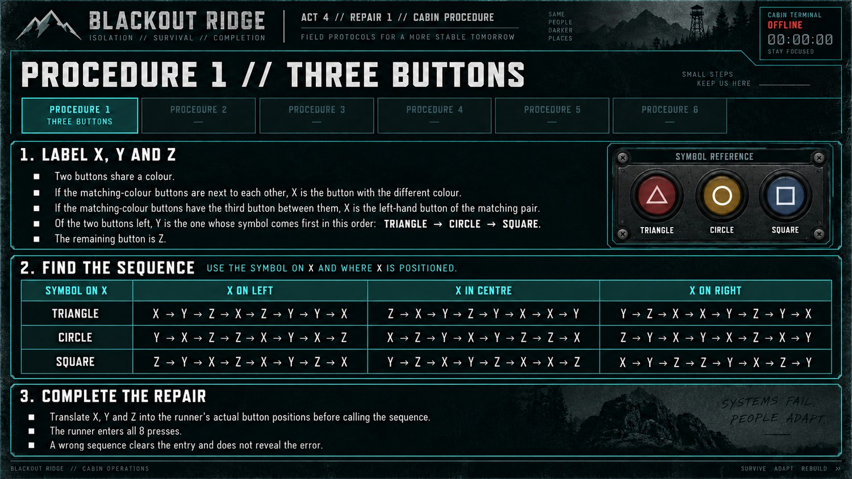
Procedure 1 — Three Buttons. Current reference; editable rule above is authoritative.
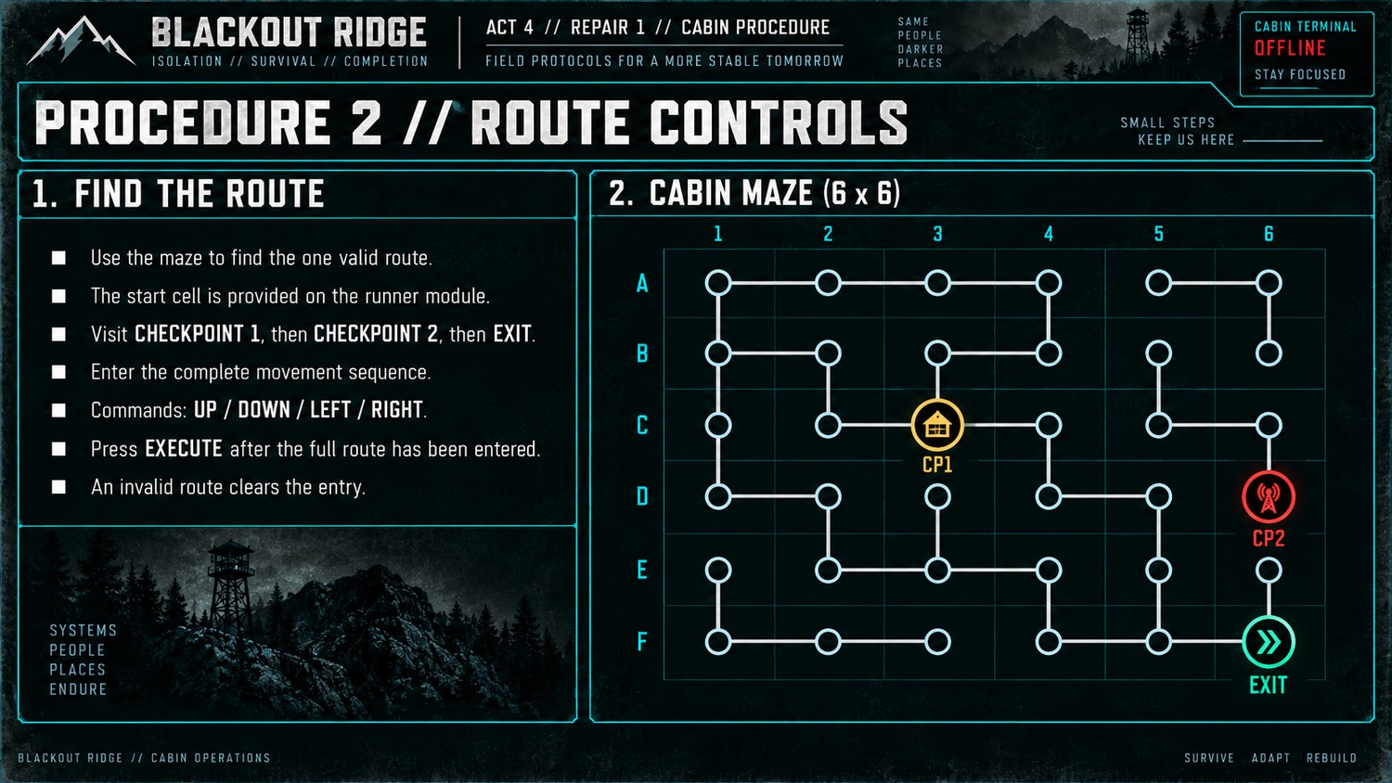
Procedure 2 — Route Controls. Current reference; final maze topology/waypoint coordinates must be kept consistent with implementation.

9.3–9.4 Repair Board 1 developer rules

9.3 Calibration Dials
TASK Use fixed calibration marks and the side of the marked striped sector to derive three target dial values.
Runner state. Pressure, Flow and Alignment dials. Each has a symbol, a fixed white calibration line, an adjacent striped sector lying immediately clockwise or anticlockwise of that line, and a separately movable setting.
Cabin rule. For each dial, use symbol + striped-side relation. Circle: anticlockwise +2, clockwise −1. Triangle: anticlockwise +1, clockwise −2. Square: anticlockwise +3, clockwise −3. Values wrap around 0–9.
Symbol | Striped sector anticlockwise | Striped sector clockwise
Circle | Set 2 higher | Set 1 lower
Triangle | Set 1 higher | Set 2 lower
Square | Set 3 higher | Set 3 lower

Interaction. Dials use discrete integer positions 0–9. The white calibration line and striped sector are fixed evidence and never move with the adjustable setting.
Validation / recovery. VERIFY checks all three targets together. No per-dial correctness indicators.
SEED / EDGE CONSTRAINTS Seed reference values/sector placements so every relation is unambiguous. Artwork must show the striped sector touching the white line, making clockwise vs anticlockwise visually meaningful.

9.4 Patch Matrix
TASK Route four coloured source leads to coordinate sockets using SOURCE + COLOUR lookup.
Runner state. Fixed source anchors PWR / DATA / CTRL / AUX. Each has one coloured lead. Destination grid has rows PWR / DATA / CTRL / AUX and columns A–D.
Cabin rule. For each lead, use its SOURCE and COLOUR to find the destination socket.
Source | Red | Blue | Yellow | Green
PWR | AUX-B | CTRL-C | CTRL-A | PWR-C
DATA | AUX-C | AUX-D | CTRL-B | PWR-A
CTRL | PWR-B | DATA-A | DATA-B | DATA-D
AUX | PWR-D | CTRL-D | AUX-A | DATA-C

Interaction. Use click-to-connect, not freehand dragging: click a source lead, then a destination socket. The UI may draw the wire automatically or show a connection state. Connections can be changed before VERIFY.
Validation / recovery. After four connections, VERIFY checks the complete routing. Wrong submission gives generic rejection with no correct-wire highlighting.
SEED / EDGE CONSTRAINTS Use a non-diagonal colour assignment; do not seed PWR=red / DATA=blue / CTRL=yellow / AUX=green as a shortcut. Current recommended example seed: PWR yellow, DATA blue, CTRL red, AUX green.

Repair Board 1 — player procedure references 3–4
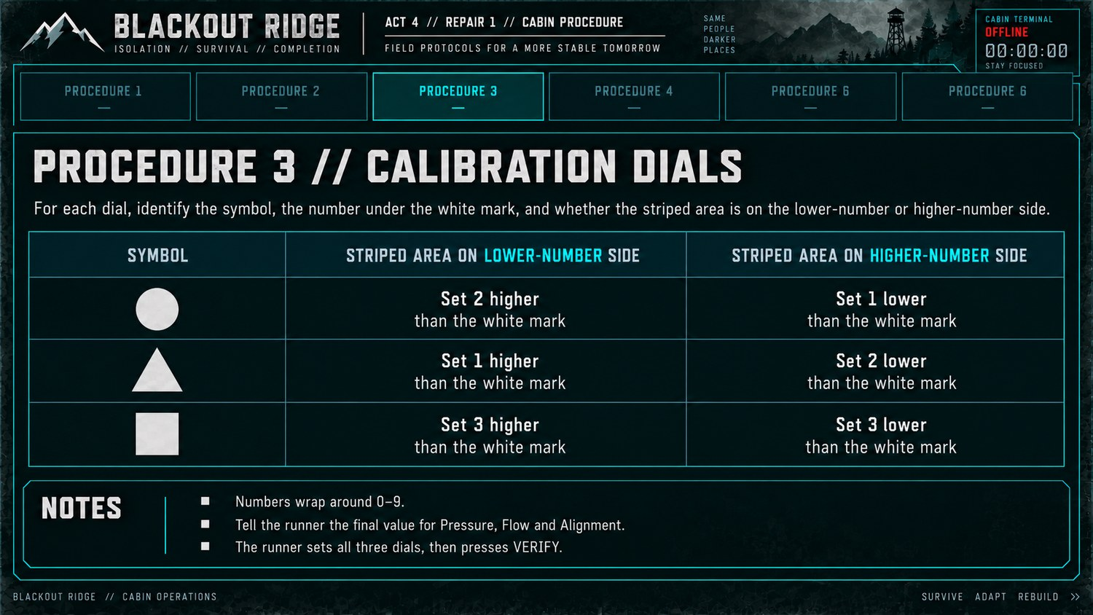
Procedure 3 — Calibration Dials. The clockwise / anticlockwise relation to the fixed white line is the authoritative reading rule.
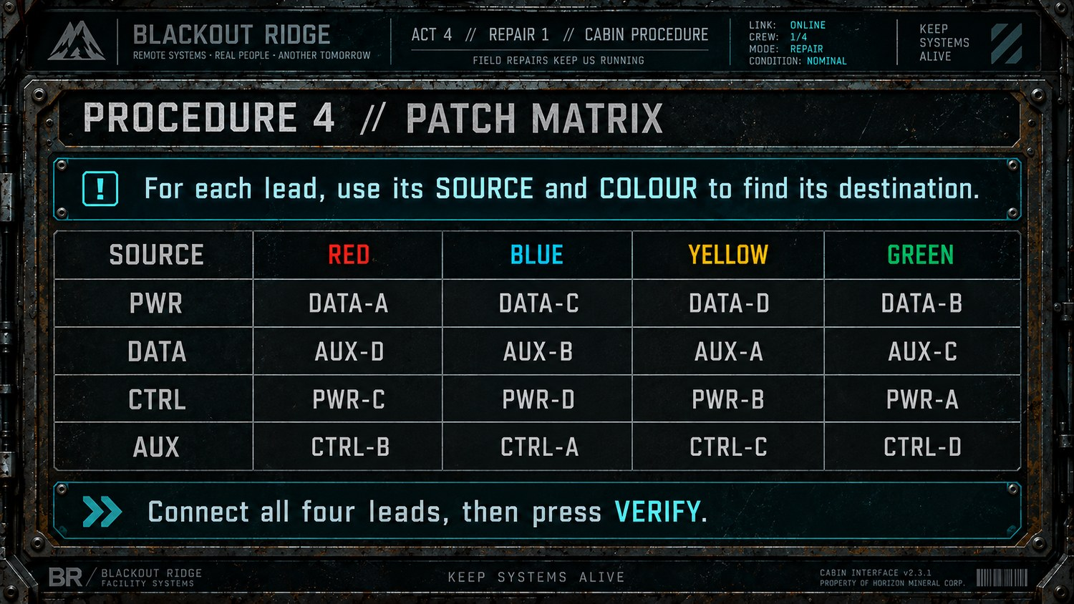
Procedure 4 — Patch Matrix. Current artwork is a reference; implement the revised non-diagonal matrix in Section 9.4 if the image differs.

9.5–9.6 Repair Board 1 developer rules

9.5 Switch Bank
TASK Set a diagnostic test configuration, sample a latched lamp response, then derive the final switch configuration.
Runner state. Six numbered switches with fixed white/black cap markings, feed direction LEFT/RIGHT, six response lamps, SAMPLE and VERIFY.
Cabin rule. Stage 1: feed direction selects the six-switch test pattern. LEFT = U D U D D U. RIGHT = D U D U U D. Press SAMPLE. If the test pattern is correct, SAMPLE returns green and reveals a fixed six-lamp pattern. If wrong, SAMPLE returns red and no lamps appear. Stage 2: white cap uses lamp state directly (ON→UP, OFF→DOWN); black cap inverts it (ON→DOWN, OFF→UP).
Feed | 1 | 2 | 3 | 4 | 5 | 6
LEFT | UP | DOWN | UP | DOWN | DOWN | UP
RIGHT | DOWN | UP | DOWN | UP | UP | DOWN

Interaction. Switches are binary toggles. SAMPLE is a pressed action, not a passive light. After a successful sample, latch the lamp pattern while the switches are changed for stage 2.
Validation / recovery. VERIFY checks the final six-switch configuration. Wrong final state returns red but leaves the latched lamp pattern visible for correction.
SEED / EDGE CONSTRAINTS Lamp pattern is seeded independently of the test switch positions; it must not simply mirror UP/DOWN. Cap colours must be clearly visible before and after sampling.
Cap | Lamp ON | Lamp OFF
WHITE | UP | DOWN
BLACK | DOWN | UP

9.6 Diagnostic Recovery
TASK Compare two saved diagnostic captures, translate four changes into command pairs, then submit one eight-key recovery sequence.
Runner state. Two simultaneous/switchable captures for POWER, THERMAL, COMMS and INTEGRITY, each GREEN / AMBER / RED. RESET and CONFIRM are command keys; CLEAR edits the queue; VERIFY submits.
Cabin rule. Compare Capture 1 with Capture 2 using severity GREEN → AMBER → RED. Improved = CONFIRM→RESET. Worsened = RESET→CONFIRM. Stayed GREEN = CONFIRM→CONFIRM. Stayed AMBER/RED = RESET→RESET. Concatenate pairs in service order POWER → THERMAL → COMMS → INTEGRITY.
Change between captures | Command pair
Improved | CONFIRM → RESET
Worsened | RESET → CONFIRM
Stayed GREEN | CONFIRM → CONFIRM
Stayed AMBER or RED | RESET → RESET

Interaction. RESET/CONFIRM clicks append to an eight-position queue. Captures remain available while entering the sequence; CLEAR removes the queue without changing captures.
Validation / recovery. VERIFY validates all eight commands together. Wrong sequence clears the queue and preserves both captures; no pair-specific feedback.
SEED / EDGE CONSTRAINTS At least one changed system should be present. Capture values are seeded once at repair start and survive refresh/reconnect.

Repair Board 1 — player procedure references 5–6
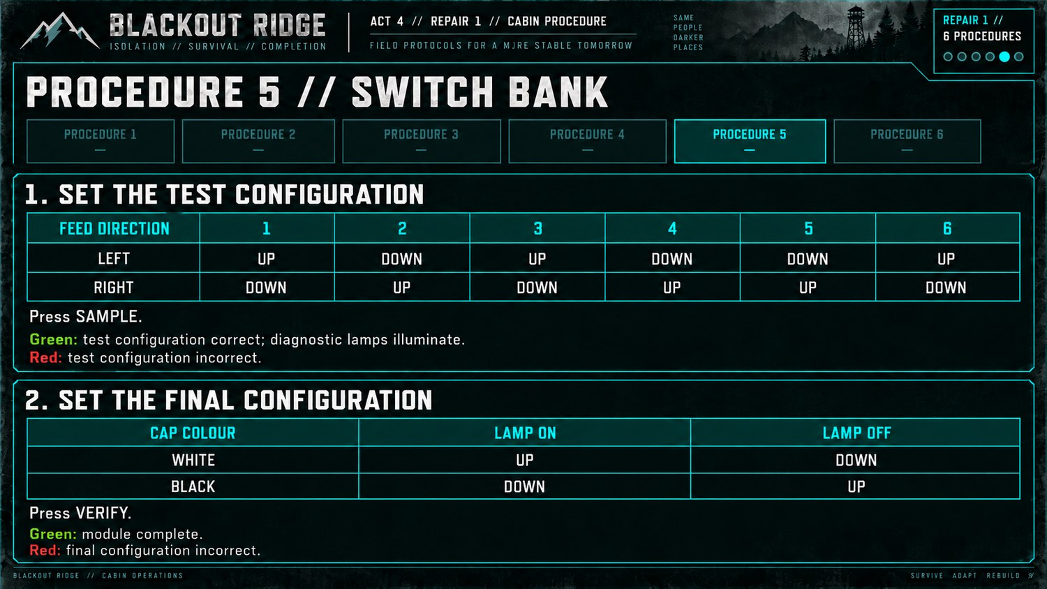
Procedure 5 — Switch Bank. Two-stage SAMPLE / VERIFY behaviour is authoritative.
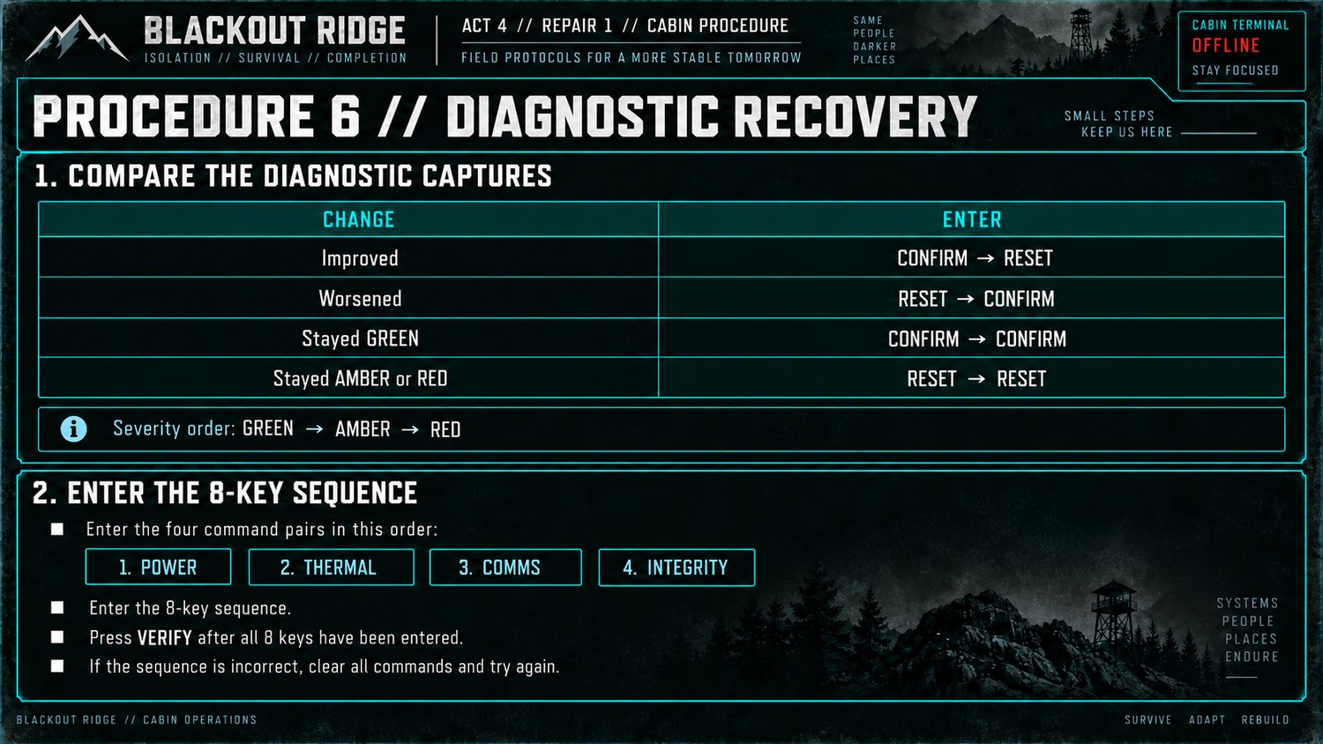
Procedure 6 — Diagnostic Recovery. Enter the eight-key sequence in POWER → THERMAL → COMMS → INTEGRITY order.

10. Repair Board 2 — second selected destination
The second selected destination always uses this board. Cabin procedures are redistributed before release so the heavier allocations move where possible.
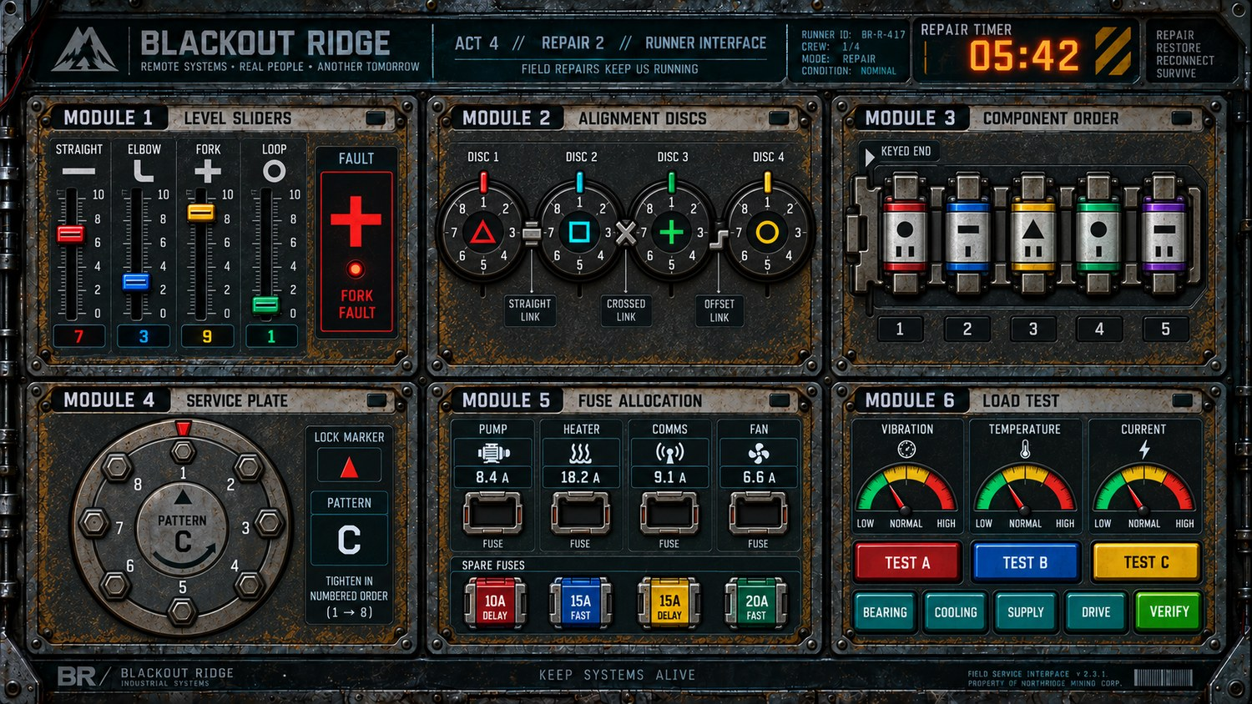
A4 G04 — consolidated Repair Board 2 runner reference: Level Sliders, Alignment Discs, Component Order, Service Plate, Fuse Allocation and Load Test.

10.1–10.2 Repair Board 2 developer rules

10.1 Level Sliders
TASK Use the faulted pipe shape and its rank among four live slider values to select a full target profile.
Runner state. Four sliders, each attached to one pipe shape: Straight / Elbow / Fork / Loop. Each has a current integer value. Exactly one pipe is marked FAULT.
Cabin rule. Identify the fault pipe, determine whether its current value is HIGHEST / 2ND HIGHEST / 2ND LOWEST / LOWEST, then select that row within the matching fault table. Apply the resulting four values to pipe shapes, not channel numbers.
Rank | Straight fault | Elbow fault | Fork fault | Loop fault
HIGHEST | 6 / 3 / 8 / 4 | 4 / 8 / 5 / 2 | 4 / 8 / 6 / 2 | 8 / 4 / 2 / 6
2ND HIGHEST | 5 / 7 / 4 / 2 | 7 / 6 / 3 / 5 | 7 / 3 / 5 / 9 | 5 / 7 / 3 / 4
2ND LOWEST | 8 / 4 / 2 / 6 | 2 / 7 / 8 / 4 | 6 / 2 / 7 / 4 | 2 / 6 / 8 / 5
LOWEST | 7 / 5 / 3 / 9 | 5 / 9 / 4 / 1 | 3 / 9 / 4 / 8 | 7 / 1 / 4 / 9

Interaction. Sliders use discrete integer values. Moving a slider updates only its current setting; pipe identity and FAULT marker are fixed.
Validation / recovery. VERIFY checks all four target values together. No channel-specific feedback.
SEED / EDGE CONSTRAINTS Seed four distinct current values so rank is unambiguous. Values in the target table are ordered Straight / Elbow / Fork / Loop.

10.2 Alignment Discs
TASK Propagate positions around four linked discs using each disc symbol and the link immediately before it.
Runner state. Four discs arranged clockwise as Triangle → Square → Plus → Circle. Each disc has positions 1–8. Links between discs are visually one of: straight, crossed, offset.
Cabin rule. Set Disc 1 to Position 1. Moving clockwise, for each following disc add the offset selected by that disc’s symbol and the link immediately before it. Positions wrap 1–8.
Disc symbol | Straight link | Crossed link | Offset link
Triangle | +0 | +3 | +5
Square | +1 | +4 | +6
Circle | +2 | +5 | +7
Plus | +3 | +6 | +0

Interaction. Discs step through eight discrete positions. Links are static visual evidence. Do not simulate real gear ratios or coupled motion.
Validation / recovery. VERIFY checks all four positions together. Wrong submission gives generic rejection and remains editable.
SEED / EDGE CONSTRAINTS V1 may keep this displayed symbol/link arrangement fixed. If variants are added later, cabin procedure and runner layout must be seeded as one state.

Repair Board 2 — player procedure references 1–2
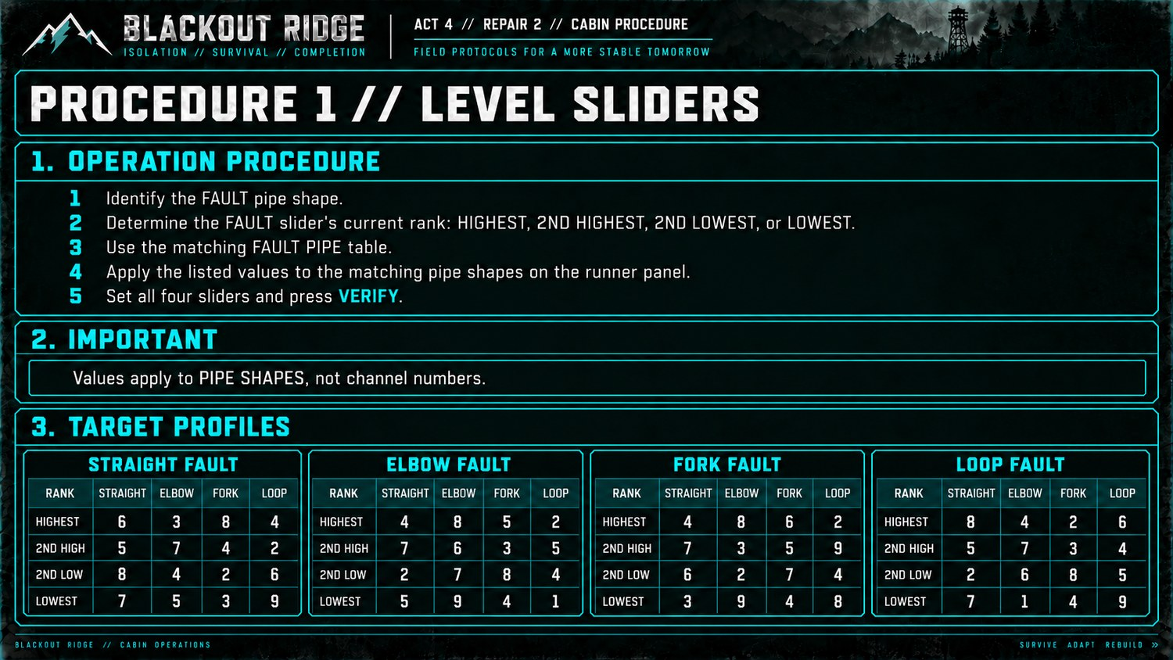
Procedure 1 — Level Sliders. Pipe shape + FAULT rank selects the target profile.
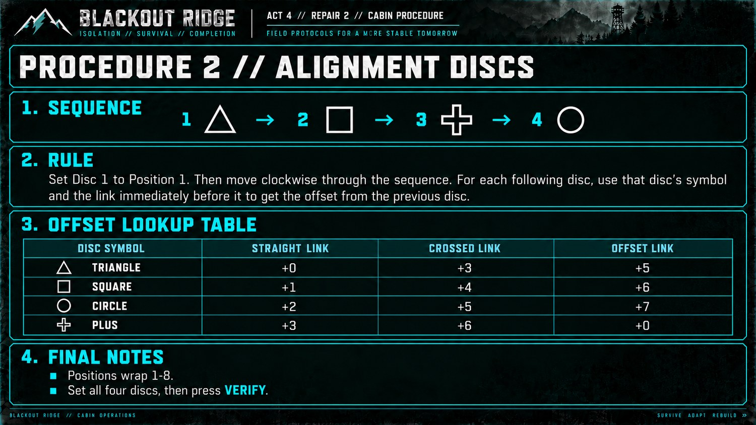
Procedure 2 — Alignment Discs. The sequence and offset table are the complete cabin reference.

10.3–10.4 Repair Board 2 developer rules

10.3 Component Order
TASK Arrange five marked components from the keyed end of the assembly rail.
Runner state. Five components each show a small marking (dot / bar / triangle) plus one or two notches. The rail has a visibly keyed end on the left or right.
Cabin rule. From the keyed end, required order is: 1 Dot+2 notches; 2 Bar+1; 3 Triangle+2; 4 Dot+1; 5 Bar+2.
Position from keyed end | Required marking
1 | Dot + two notches
2 | Bar + one notch
3 | Triangle + two notches
4 | Dot + one notch
5 | Bar + two notches

Interaction. Do not implement drag/drop. Click one component to select it, then click a second component to swap their positions. Highlight the selected first component. There is no empty holding slot.
Validation / recovery. VERIFY checks the complete five-component arrangement. Failed verify leaves the current arrangement in place so it can be corrected.
SEED / EDGE CONSTRAINTS If key is on the right, “position 1” is the rightmost slot and the required order runs right-to-left. Marking/notch combination must uniquely identify each component.

10.4 Service Plate
TASK Tighten eight bolts in a prescribed balancing sequence using the physical lock marker and stamped direction.
Runner state. Circular service plate with eight unnumbered clickable bolts, one lock marker, one stamped direction arrow and visible procedure pattern C.
Cabin rule. Pattern C / Skip Two: start with the bolt nearest the lock marker; skip two bolts in the stamped direction and tighten the next; tighten its opposite; tighten the bolt opposite the starting bolt; tighten the next unused bolt in the stamped direction; tighten its opposite; tighten the final unused bolt; tighten its opposite.
Interaction. Bolts are unnumbered to players but may use hidden 0–7 / 1–8 IDs internally. Clicking tightens a bolt and disables that bolt from repeat clicks. CLEAR restores all bolts. The expected sequence can be precomputed from start index + direction.
Validation / recovery. After all eight are clicked, VERIFY compares the whole sequence. Wrong order returns generic red feedback and resets/clears the plate; do not reveal the first wrong bolt.
SEED / EDGE CONSTRAINTS V1 uses Pattern C. Additional procedure variants may be added later, but only one matching procedure should ever be shown to a cabin player for a given seeded plate.

Repair Board 2 — player procedure references 3–4
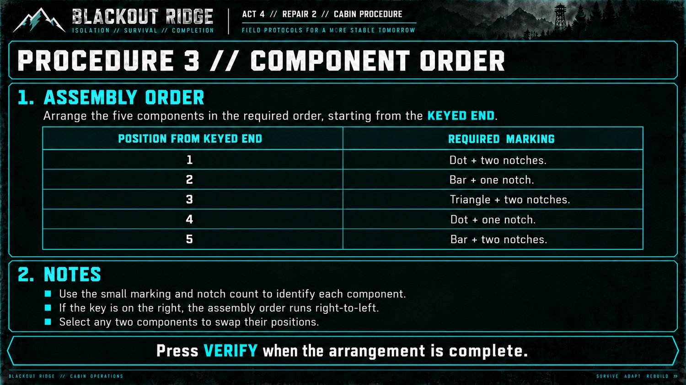
Procedure 3 — Component Order. Interaction is click-two-to-swap; no drag/drop.
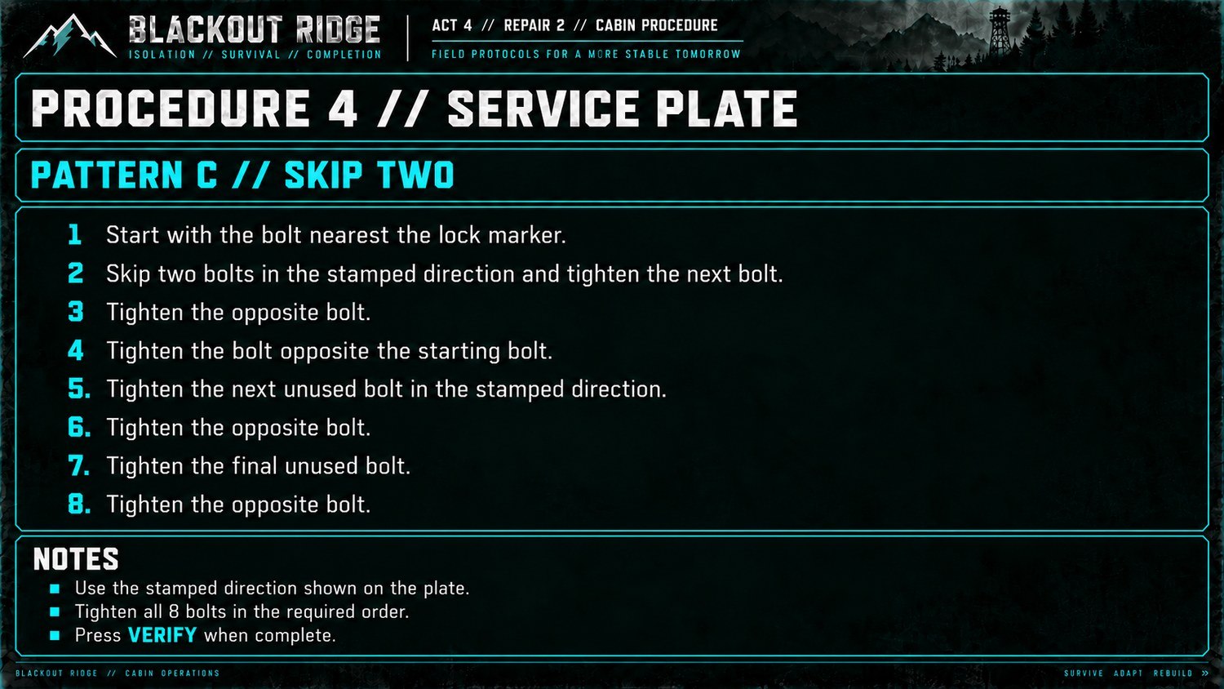
Procedure 4 — Service Plate, Pattern C / Skip Two. Bolts are unnumbered on the runner screen; internal IDs are developer-only.

10.5–10.6 Repair Board 2 developer rules

10.5 Fuse Allocation
TASK Allocate four physical fuses by adjusted load and required FAST / DELAY type.
Runner state. Four circuits: Pump, Heater, Comms, Fan. Each displays a measured current. Four empty circuit fuse slots and four one-use spare fuses: 10A DELAY, 15A FAST, 15A DELAY, 20A FAST.
Cabin rule. Circuit requirements: Pump DELAY +4A; Heater FAST +1A; Comms FAST +2A; Fan DELAY +3A. Add allowance to measured load, then choose the smallest available rating at or above the adjusted load with the required type.
Circuit | Required type | Add to measured current
Pump | DELAY | +4 A
Heater | FAST | +1 A
Comms | FAST | +2 A
Fan | DELAY | +3 A

Interaction. Click a spare fuse, then a circuit slot to assign it. A physical fuse can occupy only one slot. Allow reassignment/swapping before VERIFY rather than drag/drop.
Validation / recovery. VERIFY checks all four assignments together. Wrong submission gives no circuit-specific feedback.
SEED / EDGE CONSTRAINTS Seed measured loads near rating thresholds so the allowance materially changes the answer. Recommended reference state: Pump 8.4A → 15A DELAY; Heater 18.2A → 20A FAST; Comms 9.1A → 15A FAST; Fan 6.6A → 10A DELAY. Do not seed adjusted loads above the available fuse set.

10.6 Load Test
TASK Perform one initial diagnostic, choose the relevant follow-up test, identify the fault from current draw, then apply the matching repair.
Runner state. Three meters: VIBRATION / TEMPERATURE / CURRENT, each LOW / NORMAL / HIGH. Buttons TEST A / TEST B / TEST C. Repair actions: BEARING / COOLING / SUPPLY / DRIVE, then VERIFY.
Cabin rule. Run TEST A. If VIBRATION is HIGH, run TEST B. If TEMPERATURE is HIGH, run TEST C. Exactly one branch condition occurs. Follow-up diagnosis: B + CURRENT LOW = BEARING; B + CURRENT HIGH = DRIVE; C + CURRENT HIGH = COOLING; C + CURRENT LOW = SUPPLY.
Follow-up test | Current reading | Fault
TEST B | LOW | BEARING
TEST B | HIGH | DRIVE
TEST C | HIGH | COOLING
TEST C | LOW | SUPPLY

Interaction. Test buttons update the three displayed meter states from a deterministic seeded fault model. Tests may be repeated. Selecting a repair action highlights it; VERIFY is a separate commit.
Validation / recovery. Correct repair + VERIFY completes. Wrong repair returns generic rejection and remains retryable; tests can be rerun.
SEED / EDGE CONSTRAINTS Seed exactly four fault states. TEST A must always produce exactly one of VIBRATION HIGH or TEMPERATURE HIGH, never both/neither. Follow-up CURRENT must be LOW or HIGH as required; NORMAL is not used as the deciding follow-up value.

Repair Board 2 — player procedure references 5–6
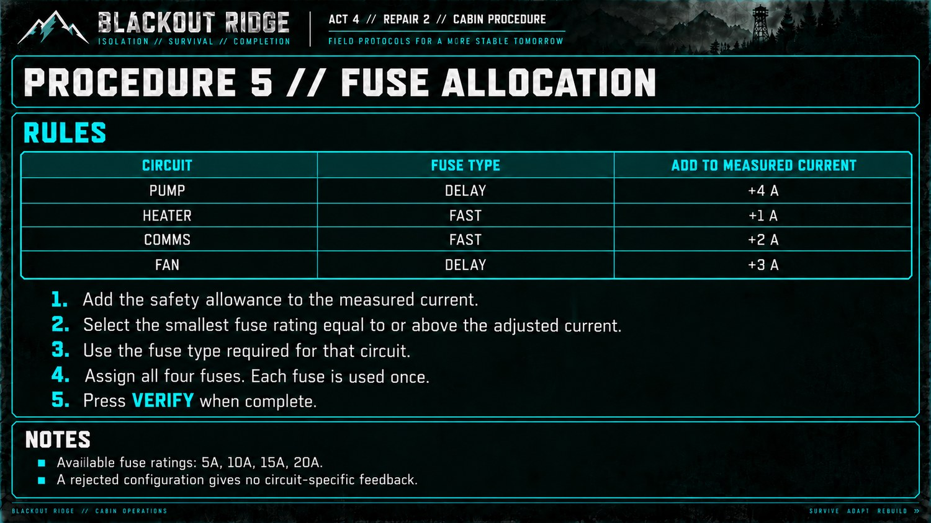
Procedure 5 — Fuse Allocation. Both adjusted rating and FAST/DELAY type are required.
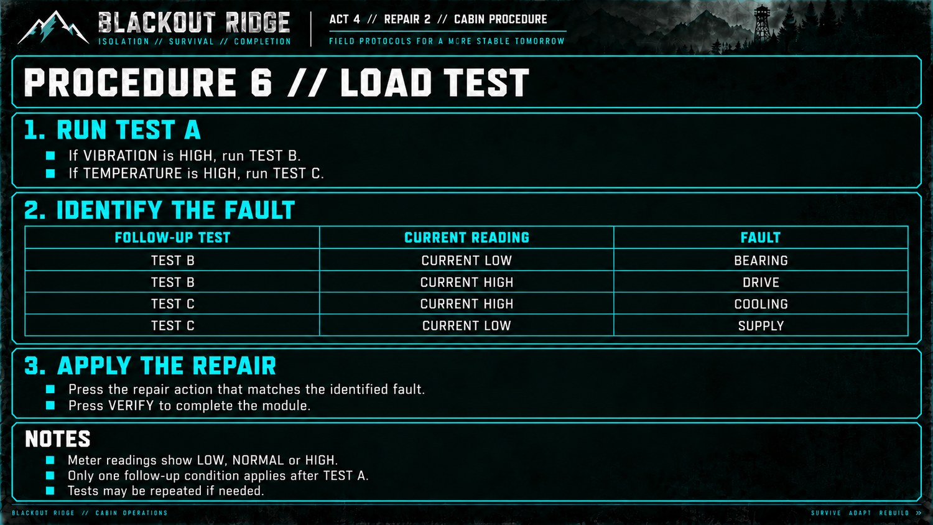
Procedure 6 — Load Test. TEST A explicitly determines whether TEST B or TEST C is the follow-up.

11. Timing and playtest target
The 6-minute standard / 5-minute penalised allowance is a design target, not yet a playtest result. Cabin players can prepare in parallel, so isolated solve times do not sum directly to board time.
• Playtest at 4, 5, 6 and 7 total players; communication overhead changes substantially with cabin size.
• Record time spent identifying the apparatus, interpreting the reference, communicating, manipulating controls and recovering from error.
• A coordinated team should have a credible route through a board inside 6 minutes; 5 minutes should feel meaningfully pressured but not arbitrary.
• Revise weak rules before adding implementation complexity. Dynamism/randomised layouts are V2 properties unless they are almost free to seed.
PLAYTEST REQUIRED Both complete boards need whole-team timing before canonical sign-off. The individual mechanics are now implementation-ready enough to prototype; difficulty is not yet empirically locked.

12. Travel and field transitions
• Travel is connective survival-horror presentation, not another navigation or gas-management game.
• Use the shared EN ROUTE state plus location-appropriate sound/visual treatment; do not ask players to recalculate filter use, select equipment again or change the locked route.
• Communicate distance, worsening weather, contaminated air, Lower Road flooding, Upper Ridge climb and runner isolation where relevant.
• Failure at Repair 1 does not stop travel to Repair 2. The runner cannot substitute a different destination after discovering a repair board.

13. Destination consequences
Destination | Successful repair | Timeout / unvisited
RX-01 | External inbound path RESTORED. Inbound Receive returns to its underlying Act 2 local state: green if the local chain works, amber/degraded if still faulty. | External inbound path NOT_RESTORED; Inbound remains red OFFLINE.
TX-01 | External outbound path RESTORED. Human Outbound returns to its underlying Act 2 local state. | External outbound path NOT_RESTORED; Human Outbound remains red OFFLINE.
CAM-01 | Lower Road Camera RESTORED; recovered Mara footage becomes available. | Camera NOT_RESTORED; recovered footage unavailable.
AUX-01 | External ventilation/purge infrastructure RESTORED. Do not explain later R-12 relationship or historical significance. | Upper Ridge service NOT_RESTORED.

14. CAM-01 recovered Mara footage
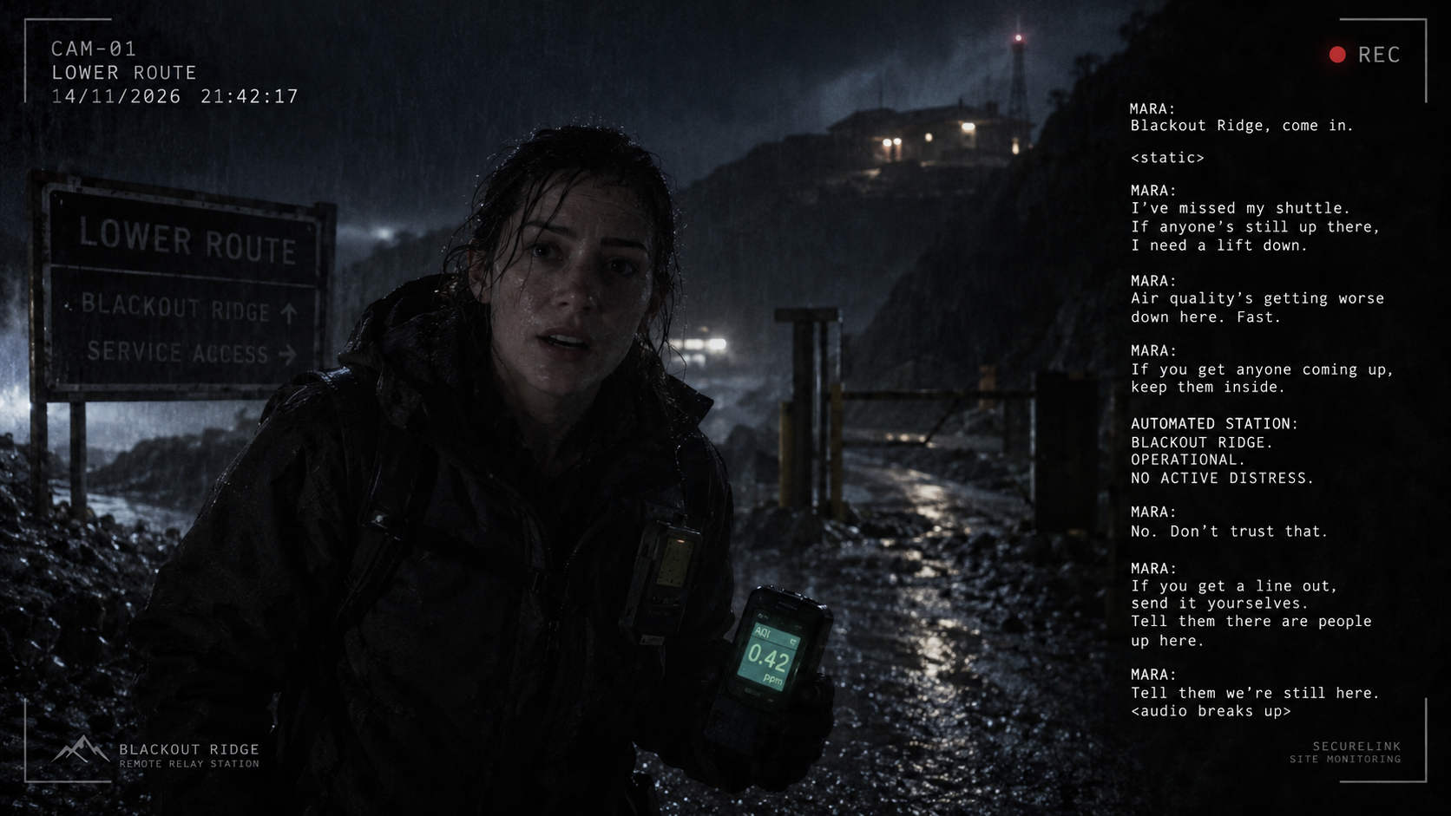
Successful CAM-01 service triggers a horror/story payoff video. Recovered Lower Road footage shows Mara returning toward Blackout Ridge, frightened/agitated or paranoid, reacting to something the camera does not show. It must not reveal her present location, R-12, the Lark Shift, hidden infrastructure beneath the cabin or the later meaning of the purge system. Act 5 must remain understandable if CAM-01 is not selected or times out.

A4 G06 — Recovered CAM-01 footage: Mara warns that Lower Road air quality is deteriorating and that Blackout Ridge’s automatic “NO ACTIVE DISTRESS” status cannot be trusted..

15. Repair resolution and Act 4 close

15.1 Success
• Mark current destination RESTORED and apply its consequence immediately.
• Lock the runner board.
• Update shared display and move to next travel state or RETURNING.

15.2 Timeout
• Freeze the board and mark destination NOT_RESTORED.
• Do not award partial restoration from completed individual modules.
• Repair 1 timeout still proceeds to Repair 2. Repair 2 timeout still returns the runner to the cabin.

15.3 Return
V1 requires no separate return cinematic. Use the shared RETURNING state, exterior/radio ambience and a short transition into Act 5. A later return shot can be added without changing mechanics.

16. Persistent state handed forward
State | Values | Meaning
EXTERNAL_INBOUND_PATH | RESTORED / NOT_RESTORED | Whether RX-01 service succeeded.
EXTERNAL_OUTBOUND_PATH | RESTORED / NOT_RESTORED | Whether TX-01 service succeeded.
LOWER_ROAD_CAMERA_SERVICE | RESTORED / NOT_RESTORED | Whether CAM-01 service succeeded.
UPPER_RIDGE_SERVICE | RESTORED / NOT_RESTORED | Whether AUX-01 service succeeded.

NOT_RESTORED does not need to distinguish unvisited from selected-but-timed-out. Retain Act 2 local states separately. No persistent state is required for travel time, filter consumption, runner health, module-level completion or player interpretation of the Mara footage. Do not calculate a hidden aggregate Act 4 score.

17. Production assets and remaining work
Asset / task | v0.4 status / requirement
A4 G01 — Opening storyboard | Reference artwork present; produce final video/audio treatment.
A4 G02 — Shared Act 4 screen | Reference artwork present; derive EN ROUTE / REPAIR ACTIVE / RESOLVED / RETURNING states in implementation.
A4 G03 — Repair Board 1 | Reference artwork present. Editable rules in Section 9 are authoritative where image text differs.
Repair 1 cabin procedures | Six reference screens present. Regenerate any stale table/value text before canonical visual sign-off.
A4 G04 — Repair Board 2 | Consolidated reference artwork present for the six current games.
Repair 2 cabin procedures | Six current reference screens present in the agreed temporary house style.
A4 G06 — Mara footage | Storyboard outstanding; placeholder retained in this draft.
Facilitator administration | No dedicated art required unless implementation review shows a need.
Act 3 dependency | Update every 5/4-minute reference to 6/5 if this working timing is confirmed.
Module playtest | Validate difficulty, ambiguity, recovery behaviour and 4–7-player whole-board timing.

18. Acceptance checklist
• Opening video does not start a repair clock or reveal later-story information.
• First selected destination always uses Repair Board 1; second always uses Repair Board 2.
• All twelve modules can be completed without cabin players seeing the runner screen or runner seeing private procedure tabs.
• All interaction patterns match the developer notes above: click-to-connect Patch Matrix, click-two-to-swap Component Order, hidden bolt IDs for Service Plate, one-use fuse allocation, latched SAMPLE response, and deterministic Load Test branches.
• Wrong submissions remain recoverable and do not leak partial correctness unless explicitly stated.
• Repair succeeds only when all six modules complete before the shared deadline; timeout leaves the destination offline.
• Shared display never exposes private procedures or hidden module state; facilitator administration is never shared.
• Refresh/reconnect preserves countdown, seeded states, active configuration and completed modules.
• RX/TX external-path state remains distinct from underlying Act 2 local-system state.
• CAM/AUX fiction respects reveal limits. Act 5 remains understandable regardless of optional repair outcomes.
• Before canonical sign-off, regenerate any reference graphic that visibly contradicts the editable mechanics in this document.
NEXT REVIEW Prototype and playtest both complete boards with the interaction rules above. Then reconcile Act 3 timing, regenerate the few stale visual references, approve the Mara storyboard, and promote this handoff to canonical implementation specification.

