Blackout Ridge
  - Act 2 developer handoff
After the Strike
Revised assembly | 15 September 2026
Act 2 establishes what the damaged station can do. The crew has three minutes to prioritise repairs, followed by five minutes of independent repair play while external emergency traffic continues. This document defines the screen flow, live dashboard, transmissions and ten repair games, with the reference artwork embedded beside the relevant specification.
Implement the agreed behaviour below. Section 13 identifies the remaining production inputs and validation work. Reference screenshots illustrate individual states; their example clocks and player assignments are not additional scripted events. Exact rules, evidence and answer mappings are provided as editable text.

Implementation boundary
Confirmed decision | Implementation
Repair roster | Ten games. Site Access Control replaces Backup Power Balance.
Scarcity | N players receive N attempts; N+1 consequential systems and both decoys are faulty.
Timing | Three minute prioritisation, then a shared five minute repair window. Keep the full repair window even if all players finish early.
Independent repairs | One player per repair; no assistance. Everyone continues to hear incoming transmissions.
Unfilled assignments | The facilitator intervenes; outstanding repair choices are allocated randomly.

Each answer selection opens a confirmation popup. Only confirmation submits the attempt. The shared dashboard is observational, and the Received Traffic Log displays completed messages as text. There is no replay flow.

Document guide
Section | Contents
1–2 | Opening, roster and player-count scaling
3–5 | Screen flow, two-page manual and live dashboard behaviour
6–8 | Running order, transmission scripts and buffer recovery
9 | Ten repair packages and enlarged graphics
10 | Private confirmation, success, failure and timeout screens
11–13 | Later dependencies, state transfer and completion checks

This handoff supersedes earlier Act 2 instructions. The Act 1 handoff remains authoritative for Act 1. Later acts retain their own evidence and decision specifications.

1 Opening video and initial state
Play the 30–45 second opening immediately after Act 1. Neither Act 2 timer runs during the video. The storyboard is a visual treatment reference; the final footage is a separate production asset.

The strike
Night at the same small relay cabin. The camera crosses the parking area; one car remains in Bay 1. No close-up, identifying caption or spoken comment. Lightning hits the mast and station infrastructure.

The interruption
Power drops, normal lighting fails, and emergency lighting activates. Interior displays restart unevenly. Show a surviving backup supply, without introducing a selectable Backup Power repair.

The damaged console
The twelve-panel console loads. Fault states reflect player-count scaling. Site Access retains its pre-existing exit-reader fault; the strike did not create that mechanical misalignment. Lower Road Camera and Ventilation Control remain operational.

The heartbeat
The automatic status display reads BLACKOUT RIDGE: OPERATIONAL / NO ACTIVE DISTRESS. Leave the meaning unexplained. Normal external traffic remains physically possible through the damaged but functioning mast.

The assignment window
The console and Station Systems Manual become available. The three-minute prioritisation timer starts. Display the number of available repair assignments, equal to the player count.

Player instruction
Several station systems are faulty. You have three minutes to choose one repair for each crew member. Consult the Station Systems Manual and assign different faulty systems. You will then have five minutes to attempt your repairs independently. Choose an answer and confirm it to submit your only attempt. Unfilled assignments will be allocated randomly when planning ends.

Story constraints
Do not assume that the crew identified Mara in Act 1. No correctness reveal or branch uses their handover answers.
Do not introduce the anomalous voice, the Lark Shift, R-12, Mara’s current location or the eventual function of the Upper Ridge installation.
Do not explain what OPERATIONAL measures or suggest that repairing the beacon automatically raises distress.
Do not show the later external distribution failure here. That is the separate transition into Act 3.

Opening storyboard
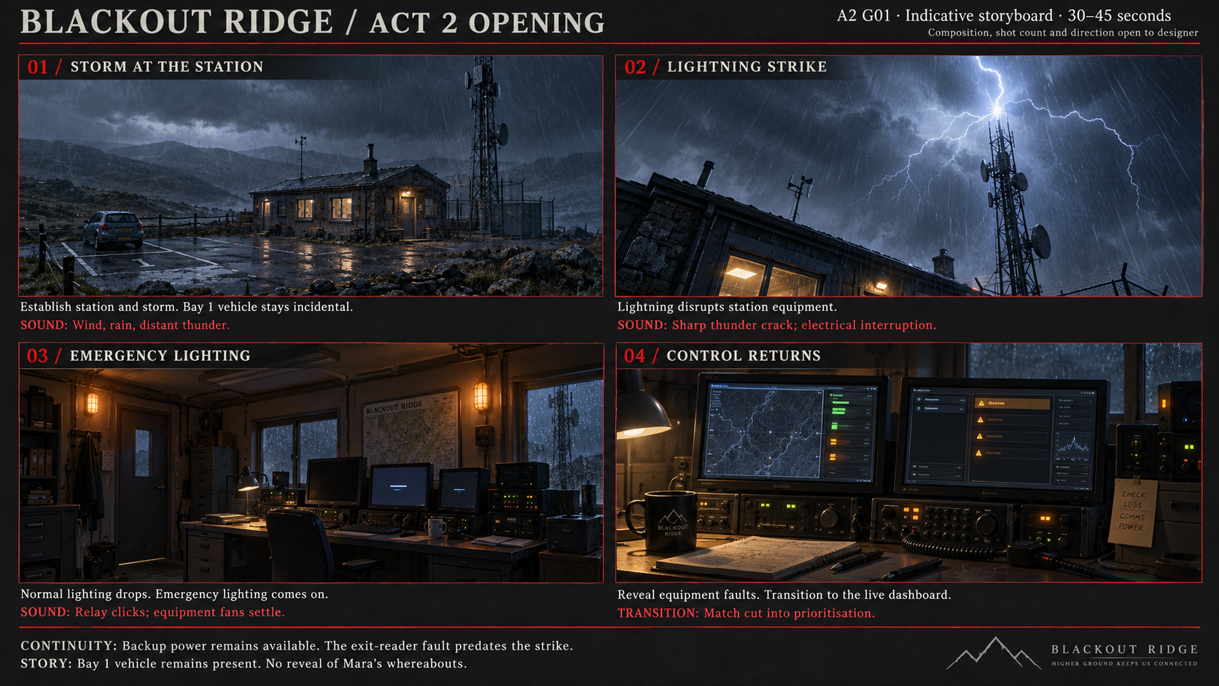
A2 G01. Production reference for the opening video, before either Act 2 timer starts. Bay 1 retains an unremarked vehicle. The board is not a player interface or a set of simultaneous screens.

2 System roster and scaling
Developer-only ranking. Never expose rank, consequential status or decoy status in the player interface. All twelve panels remain present at every player count. Systems outside the faulty set begin working.
Rank | System | Faulty at player counts | Role
1 | Inbound Receive | 4–7 | Consequential
2 | Human Outbound | 4–7 | Consequential
3 | Status Beacon | 4–7 | Consequential
4 | Tower Monitoring | 4–7 | Consequential
5 | Air Quality Monitoring | 4–7 | Consequential
6 | Received Traffic Log | 5–7 | Consequential
7 | Source Identification | 6–7 | Consequential
8 | Road / Flood Monitoring | 7 | Consequential
— | Site Access Control | 4–7 | Decoy; existing exit-reader fault
— | Fire Suppression Control | 4–7 | Decoy
— | Lower Road Camera | Never in Act 2 | Operational
— | Ventilation Control | Never in Act 2 | Operational

Players | Consequential faults | Decoy faults | Total faults | Repair attempts
4 | 5 | 2 | 7 | 4
5 | 6 | 2 | 8 | 5
6 | 7 | 2 | 9 | 6
7 | 8 | 2 | 10 | 7

Both decoy repairs genuinely work. Their capabilities simply have no material downstream payoff in this scenario. Give them the same visual quality and repair credibility as the other games.
Lower Road Camera and Ventilation Control always work throughout Act 2. At seven players there are ten faulty systems and seven attempts. Systems outside the scaled faulty set begin working; they still display the same information and participate in the same live updates.

Panel numbering
Use the dashboard panel IDs throughout the interface. Manual pages may group systems differently, but retain these IDs. Repair priority rank is a separate developer-only value.

3 Screens and repair flow

Who sees each screen
Audience | Display | Use
Everyone in the office | TV or shared office computer showing the facilitator’s Teams screen share | The station dashboard remains visible throughout Act 2. Shared incoming audio plays here.
Each player | Individual computer | Two-page manual during planning, assigned puzzle during repairs, confirmation popup, then result screen.
Facilitator only | Separate administration window or second monitor | Assignments and all players’ progress. Share only the station dashboard window through Teams.

The shared station dashboard and the facilitator’s administration screen are different interfaces. The facilitator monitors every player, not just the player whose example private screen appears in a figure. A second monitor makes this practical; a private administration window remains required if using one monitor.

Prioritisation
The crew discusses the console and manual. The facilitator records their assignments using one row per player and one distinct faulty system per row. Choices may be revised until the three minutes runs out. Prevent duplicate assignments and selection of working systems. Do not reveal puzzle contents during prioritisation.
Keep the full three-minute planning window even if every assignment is filled early. Player terminals show the two-page manual. The shared dashboard continues displaying live information. The facilitator can revise assignments until planning expires.

Assignment deadline
At the close of the first phase of the act, retain valid completed assignments and close further discussion. If any slots remain empty, the facilitator uses FILL REMAINING RANDOMLY. Draw without replacement from faulty systems not already assigned, giving each remaining system equal probability. Allocate one to each unassigned player. Do not weight consequential systems more highly.
The facilitator clicks once to fill all remaining assignments randomly. Once every player has received their assigned repair, start the shared five-minute timer. While assignments are being completed, players cannot continue planning or open their puzzles. Record whether each assignment was chosen by the crew or allocated randomly.
Dispatch the assigned puzzle to each terminal in a locked state. Open every puzzle and start the shared five-minute timer together once dispatch is complete. No player receives extra puzzle time during the administrative wait.

Submission and deadline
Selecting an answer opens the private confirmation popup without applying a repair. GO BACK closes the popup and permits a different selection. CONFIRM REPAIR submits the selected answer and consumes the player’s one attempt. The shared timer continues while the popup is open.
Accept confirmation only when received before the shared deadline. At 00:00, disable pending confirmations and close all unconfirmed attempts as timeouts, including a selection still displayed in a popup. Use the session clock to resolve competing confirmation and deadline events. An accepted confirmation fixes the result once; duplicate requests cannot alter it.
Correct confirmation changes the local system to working immediately. Incorrect confirmation leaves it faulty. Show the corresponding private result screen and update the facilitator’s progress row. Opening the popup alone changes neither the system nor the attempt outcome.

Independent work and early finishers
Players do not share answers or assist unfinished repairs. Each completed player stays on their private result screen while the shared repair window continues. No second repair, dashboard navigation or return-to-manual flow is available on that screen. The station dashboard remains visible on the room display. Personal notes are allowed.
Incoming audio plays once through the shared Teams room setup. Private terminals retain matching incoming captions; do not create competing audio playback on every player computer. Live traffic takes priority over repair animations and result sounds. Finishing every attempt early does not end the five-minute window.

Facilitator progress
Show all player rows, assigned system, crew-chosen or random assignment, and attempt state. Use ASSIGNED, IN_PROGRESS, SUCCEEDED, FAILED and TIMED_OUT. Keep these separate from the system’s working or faulty condition. Show completion totals without exposing consequential ranks or an optimal-repair score.

Assignments during prioritisation
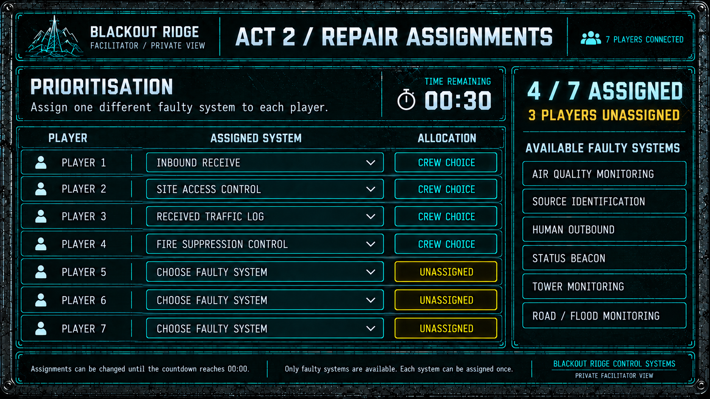
A2 G03a. Facilitator only, planning still open. Seven-player example with four crew choices and three unassigned rows. The timer is time remaining.

Unfilled assignments at the deadline
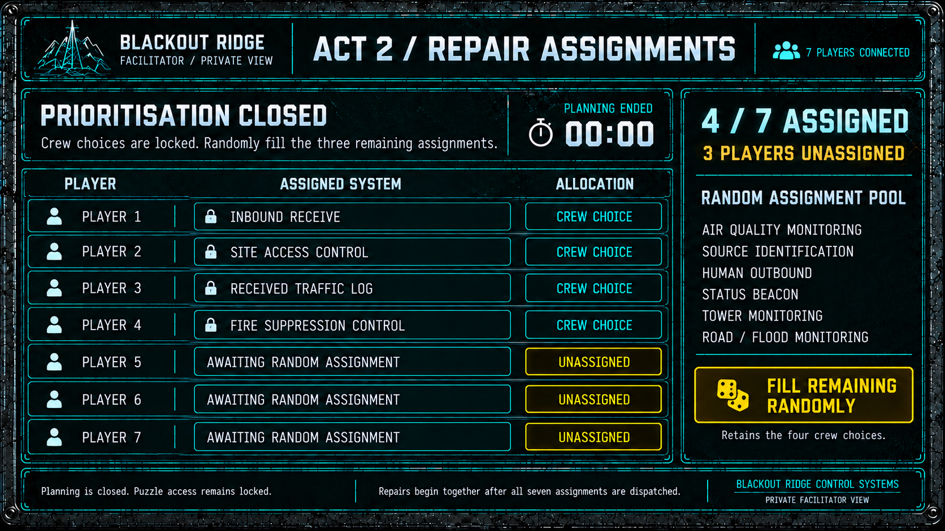
A2 G03b. Facilitator only, planning closed. Keep four existing choices; FILL REMAINING RANDOMLY allocates the other three without replacement. This screen precedes dispatch and the repair timer.

All player repair progress
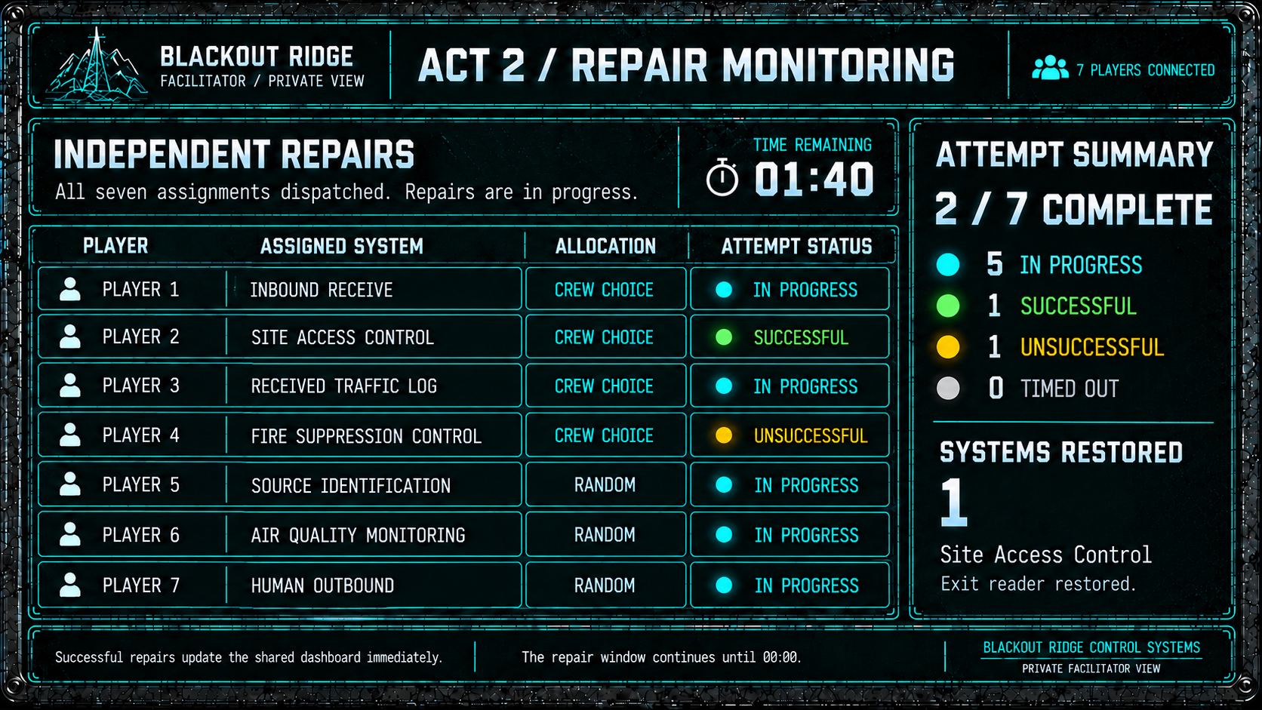
A2 G03c. Facilitator only, repair window at 01:40 remaining. Seven rows show five attempts in progress, one success and one failure. Player 2 has repaired Site Access; the screen is not shared with the crew.

4 Station Systems Manual
Use exactly two player screens with six system entries each. Every player can switch pages during the three-minute prioritisation phase. Show the planning countdown on both pages. The facilitator may consult the same content privately. Keep the manual identical at every player count.
The manual explains system functions and dependencies. It contains no repair ranking, scenario payoff, live readings, route travel times, field service times, filter calculation, 22-minute incident budget or specialist-equipment requirement. There is no Act 2 field-reference page.
The manual closes when planning ends. It is not reopened from a puzzle or result screen. PAGE 1 and PAGE 2 tabs or next/previous page buttons are allowed here; the shared dashboard has no controls.

Page 1 copy
04 Inbound Receive
Receives external voice and data traffic through the relay mast. Feeds the cabin speakers and the Received Traffic Log. Depends on the mast feed and receiver chain.
06 Human Outbound
Transmits crew voice and data to external stations. Depends on the outbound amplifier and mast feed. Its signal path is separate from Inbound Receive.
07 Status Beacon
Sends the station’s configured automatic status report at fixed intervals on a reserved channel. Depends on the dedicated beacon transmitter; does not use the outbound amplifier.
08 Tower Monitoring
Collects fault codes from mast-mounted and external equipment. Reports equipment ID, fault code and time. Does not identify the equipment’s physical location.
03 Air Quality Monitoring
Samples cabin and perimeter air. Reports current readings and how quickly they are changing.
02 Received Traffic Log
Displays the time, source and message text for completed incoming transmissions. A temporary buffer holds traffic during a recorder fault. Repair recovers buffered messages as received. Earlier message text and source labels are not reprocessed.

Page 2 copy
05 Source Identification
Matches incoming transmissions against the station channel registry and labels them with the originating station. Labels appear beside incoming traffic and in stored messages. Earlier unidentified messages remain unidentified.
10 Ventilation Control
Manages cabin air exchange and operates the emergency purge cycle. Depends on the external intake assembly.
09 Road / Flood Monitoring
Receives data from roadside and culvert gauges on the local road network. Reports surface water depth and gauge state.
01 Lower Road Camera
Provides a continuous live view of the Lower Road approach.
11 Site Access Control
Operates the cabin entry and exit readers and records access events. Doors remain manually operable when a reader is unavailable.
12 Fire Suppression Control
Operates automatic fire suppression in the cabin and equipment enclosures. Manual extinguishers are unaffected by a control fault.

Station Systems Manual page 1
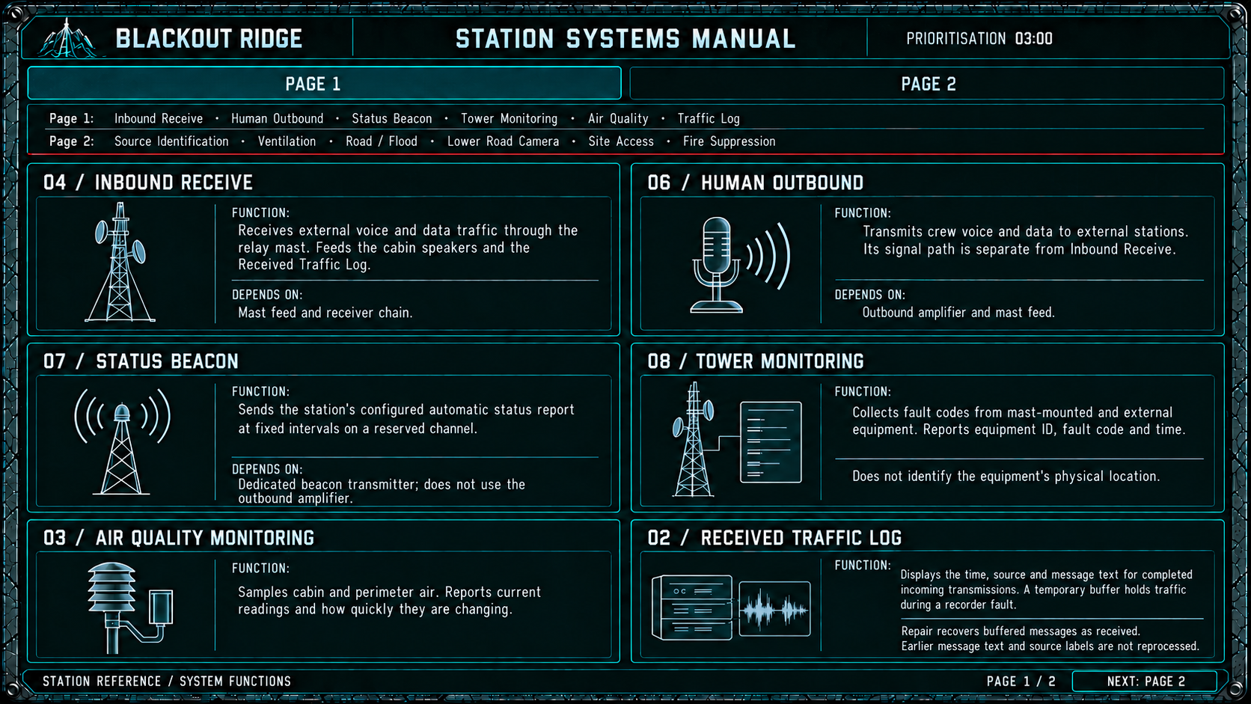
A2 G05a. Private player reference during prioritisation. Six system descriptions, with IDs matching the shared dashboard. PAGE 1 and PAGE 2 navigation changes only the manual page.

Station Systems Manual page 2
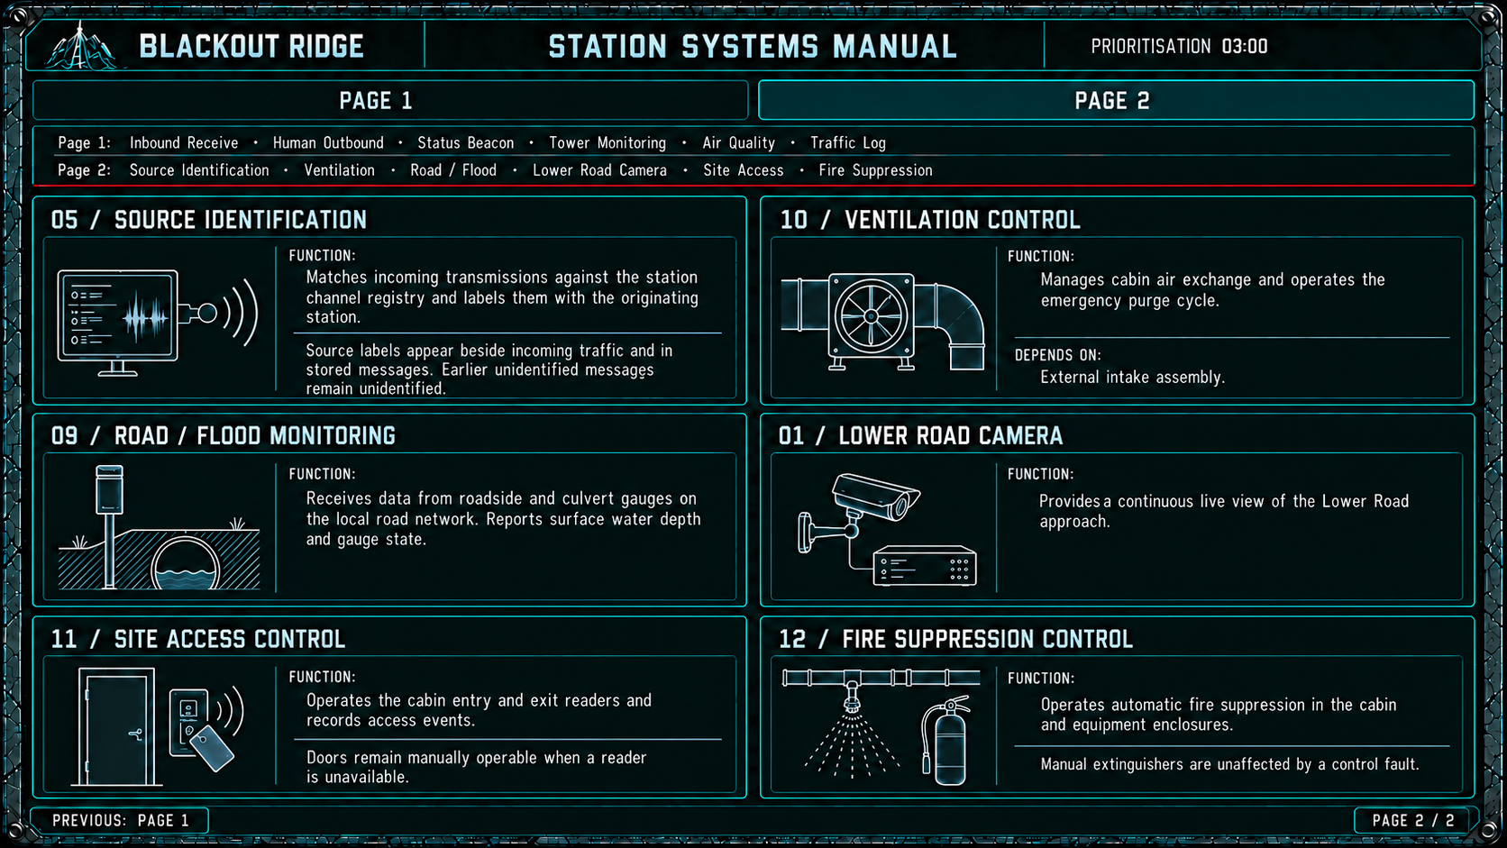
A2 G05b. Private player reference during prioritisation. Final manual page. No field-reference page or return-to-dashboard control.

5 Live dashboard behaviour
The dashboard is the players’ live view of the station, continuously shared on the office display. Give each component a recognisable instrument: a camera picture, message log, receiver waveform, readings or diagnostic report. Vary panel sizes to suit the information. These are live components, not twelve equal repair cards.
Use the established charcoal interface, slim header, off-white text, muted cyan diagrams and red section dividers. Green status lights mean working; amber means a local fault. Keep status text readable without colour. Red identifies the personnel warning. Working sensors do not mean safe air, roads or working external infrastructure.
There are no dashboard buttons, clickable repair cards, replay controls, PURGE, TRANSMIT or beacon controls in Act 2. The facilitator assigns repairs privately. Ventilation, outbound and beacon panels show state only; a repair does not operate their later-act controls.

Panel behaviour table

01 Lower Road Camera
Initial or faulty state | Live behaviour | Repair or later behaviour
Working throughout Act 2. Show the approved Lower Road feed. | Continuous video, independent of transmissions. No player playback controls. | Act 3 external failure stops the feed. Final footage and loop timing remain production inputs.

02 Received Traffic Log
Initial or faulty state | Live behaviour | Repair or later behaviour
Fault: LOG UNAVAILABLE; incoming messages held in receiver buffer. Working: TIME / SOURCE / MESSAGE. | Add a row as soon as a message completes. Display original receipt-start time and the captured source; message text matches what was received. | Repair restores completed buffered messages and existing archive text, then normal logging. Preserve ordering and readable automatic scrolling; no replay.

03 Air Quality Monitoring
Initial or faulty state | Live behaviour | Repair or later behaviour
Fault: SENSOR FAULT / READINGS UNRELIABLE; mask values and trends. Working: cabin and perimeter readings and rate of change. | Update from the conditions timeline independently of radio traffic. | Repair restores measurement, not air quality. Units, values and update cadence require supplied content.

04 Inbound Receive
Initial or faulty state | Live behaviour | Repair or later behaviour
Fault: RECEPTION DEGRADED. Working: clear reception. | Animate waveform during the live signal; progressively scroll decoded message text beneath it. Degraded text contains only surviving words and loss markers. | Idle waveform when no signal. Retain last received message until the next starts. Repair affects only transmissions starting afterwards.

05 Source Identification
Initial or faulty state | Live behaviour | Repair or later behaviour
Fault: SOURCE UNRESOLVED. Working: originating station from approved metadata. | Show current message details during reception, then retain the last transmission details. | Use the message-start snapshot. The same captured source is written to the log when the transmission ends. Do not manufacture callsigns or locations.

06 Human Outbound
Initial or faulty state | Live behaviour | Repair or later behaviour
Fault: OUTPUT DISTORTED. After repair: local transmission chain ready. | Idle meter during Act 2; no outgoing player message. | Repair does not send distress or extraction. External path and later finale actions remain separate dependencies.

07 Status Beacon
Initial or faulty state | Live behaviour | Repair or later behaviour
Fault: STATUS CONTROL FAULT; automatic broadcast remains active. After repair: manual control connection ready. | Automatic heartbeat continues displaying the configured OPERATIONAL / NO ACTIVE DISTRESS message. | Repair does not change that message or transmit distress. No Act 2 controls.

08 Tower Monitoring
Initial or faulty state | Live behaviour | Repair or later behaviour
Fault: DIAGNOSTIC FEED UNAVAILABLE. Working: equipment ID, fault code and time. | Rows RX-01, TX-01, CAM-01 and AUX-01 update when scripted diagnostic events occur. | Not a geographic map. Repair restores local labels and reporting. Act 3 fault-code evidence still needs its approved codes and timing.

09 Road / Flood Monitoring
Initial or faulty state | Live behaviour | Repair or later behaviour
Fault: reports unavailable or unreliable; mask readings. Working: road water level and culvert information. | Update with scripted road conditions; independent of radio traffic. | Act 2 gives general flooding evidence. Do not reveal Act 3 destination mapping, flood kit or service duration here.

10 Ventilation Control
Initial or faulty state | Live behaviour | Repair or later behaviour
Working throughout Act 2: AIR EXCHANGE ACTIVE. | A steady activity indication or fan animation shows operation. | No PURGE control. Act 3 external distribution failure can stop the intake infrastructure.

11 Site Access Control
Initial or faulty state | Live behaviour | Repair or later behaviour
Entry reader READY; exit reader FAULT; door manually operable. After repair: exit reader restored. | Record future valid exit events only if one actually occurs. | No invented scan animation, retroactive departure history, entry restriction or Mara resolution.

12 Fire Suppression Control
Initial or faulty state | Live behaviour | Repair or later behaviour
Fault: automatic suppression not ready. After repair: control ready. Manual extinguishers remain available. | Static readiness display unless an actual event is specified. | Repair does not discharge suppressant. There is no Act 2 fire event.

Persistent header and personnel area
Keep the automatic status line, personnel-status area, connected-player count and phase countdown visible. During prioritisation show assignments completed out of player count. During repairs show the appropriate progress state; do not label completed attempts as successful repairs.
Personnel escalation occurs automatically at the running-order times, without opening or selecting a panel. It persists alongside the configured automatic status report. Do not reproduce the Mara warning on private puzzles, results or facilitator administration screens.

Shared station dashboard
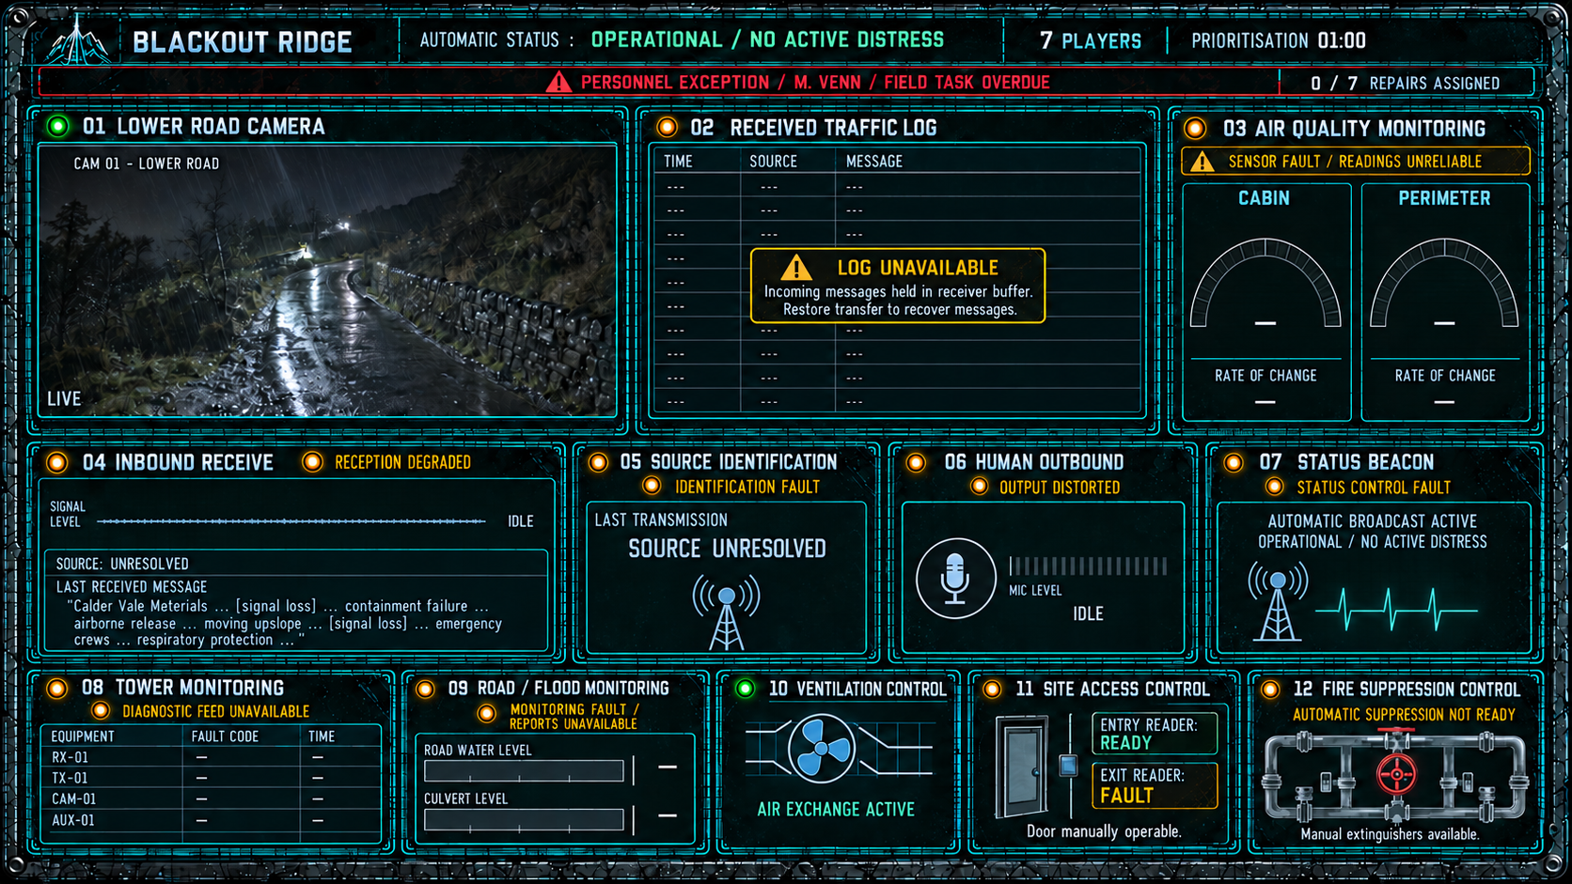
A2 G02. Crew-facing dashboard during seven-player prioritisation, with 01:00 remaining and 0/7 assignments. Ten local faults are amber; Camera and Ventilation work. The personnel exception is red. Instruments supply live information and have no controls.

6 Running order and personnel escalation
P is elapsed time since prioritisation starts; R is elapsed time since the shared repair window starts. Screen countdowns show remaining time. Use this running order for implementation and audio production; final audio durations and the absolute fiction-clock alignment are completion items in section 13.
Time | Event | Required behaviour
P 00:00 | Prioritisation opens | Start 03:00 timer; show faulty systems and assignments.
P 00:30 | COMM-01 | Always degraded: no repair puzzle is yet available.
P 01:00 | Mara task overdue | Personnel area changes to M. VENN / FIELD TASK OVERDUE.
P 02:00 | Personnel exception | PERSONNEL EXCEPTION RAISED / M. VENN / FIELD TASK OVERDUE.
P 03:00 | Assignments close | Facilitator fills gaps randomly; dispatch repairs.
R 00:00 | Repair window opens | Start shared 05:00 clock; independent work begins.
R 01:30 | COMM-02 | Lower Route flooding; reception state read at message start.
R 03:50 | COMM-03 | Upper Ridge incident; clear version carries high-access requirement.
R 04:15 | COMM-04A | Generic 35-minute canister advisory.
R 04:35 | COMM-04B | Incident-specific 22-minute advisory.
R 05:00 | Repair window ends | Close unresolved games; retain actual system and traffic state.

After R 05:00, hold the closed dashboard briefly without accepting further input, then begin the Act 3 transition. The proposed production hold is five seconds; its final duration remains to be confirmed against the transition footage.

Personnel story
The escalation occurs automatically; it is not caused by a player opening a panel. The personnel exception remains visible through the repair window and after repairs finish. The automatic OPERATIONAL / NO ACTIVE DISTRESS report continues alongside it. Use no explanatory connection between the two.
This establishes that the personnel threshold has now been crossed. It does not say the Act 1 system lied or mark a previous YES answer wrong. No family call, live message from Mara or search task is added in this act. Her car remains in Bay 1.
The opening may bridge elapsed story time after Act 1, but a specific absolute clock bridge is not fixed here. Reconcile any 24-hour timestamps with Act 1’s recorded times and task deadline before production. Do not silently reset the fiction clock or rewrite Act 1 answers.

Audio limits
The opening is outside both clocks. No two transmissions may overlap. Keep the full repair window after early submissions. A repair confirmed before 05:00 can recover the buffer but cannot improve any reception or attribution already captured.

Personnel task overdue
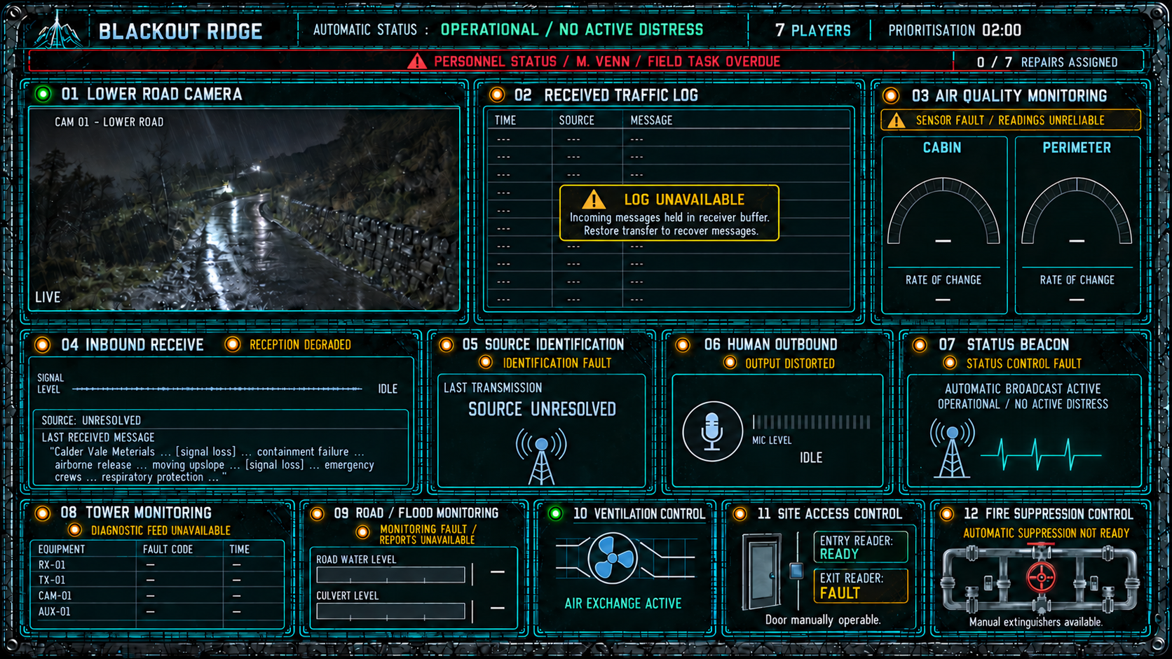
A2 G06. Crew-facing dashboard at P 01:00, with 02:00 planning time remaining. The first overdue warning appears automatically beside the continuing status heartbeat. The stronger exception appears at P 02:00, as shown in G02.

7 Incoming transmissions
All players hear the same scheduled audio through the shared room display and see matching captions. Square-bracketed directions are sound treatment, not spoken words. Caption text must preserve the audio’s information loss. Clear and degraded versions are whole-message assets selected from reception state at message start.

COMM 01 Containment failure
Source metadata: Calder Vale Materials. Starts P 00:30. Maximum asset duration 25 seconds. Always use the degraded version in Act 2; the clean text defines the underlying transmission for production.
Underlying clean transmission
“Calder Vale Materials to stations above the vale. We have a containment failure. An airborne release is moving upslope. Emergency crews in affected areas are using respiratory protection. Further information will follow.”
Required degraded playback
“Calder Vale Materials … [signal loss] … containment failure … airborne release … moving upslope … [signal loss] … emergency crews … respiratory protection …”
Preserve the incident, direction of movement and use of respiratory protection. Do not instruct the Blackout Ridge crew to put masks on. This message establishes the crisis, not a route, equipment choice or numerical filter budget.

COMM 02 Lower Route flooding
Source metadata: Calder Highways. Starts R 01:30. Maximum duration 25 seconds. Select clear or degraded playback from Inbound Receive state at message start.
Clear playback
“Calder Highways, road conditions update. Heavy runoff is overwhelming the culverts on the Lower Route. Standing water is spreading across the carriageway and access is deteriorating. Conditions are still worsening.”
Degraded playback
“Calder Highways … [signal loss] … Lower Route … culverts overwhelmed … water across the carriageway … [signal loss] … access deteriorating …”
Preserve flooding and worsening road access. Do not mention a field installation, flood kit, specialist equipment or service duration. Working road monitoring and the camera can independently corroborate general flooding. Nothing challenges the crew’s existing Lower Route / Lower Road interpretation.

COMM 03 Upper Ridge damage
Source metadata: Calder Mountain Rescue. Starts R 03:50. Maximum duration 20 seconds.
Clear playback
“Calder Mountain Rescue. Storm damage confirmed at the Blackout Ridge installation on Upper Ridge. The foot approach is unusable. Any service team will need a high-access kit to reach the equipment.”
Degraded playback
“Calder Mountain Rescue … storm damage confirmed … Blackout Ridge installation … Upper Ridge … [extended signal loss] … reach the equipment.”
The degraded asset must remove the high-access kit requirement and equivalent climbing or access clues. Retain the existence and general area of the incident. Do not explain the installation’s ventilation or R-12 function. In Act 3, its physical mapping to Location D comes from that act’s evidence, not an added destination label here.

COMM 04A Generic filter advisory
Source metadata: Emergency Control. Starts R 04:15. Maximum duration 16 seconds. Shared rebroadcast channel; no spoken source identification.
Clear playback
“Respiratory equipment advisory. Standard canister service life is thirty-five minutes under rated conditions. Use that figure for preliminary deployment planning. Further advisories will follow.”
Degraded playback
“Respiratory equipment advisory … [signal loss] … standard canister service life … thirty-five minutes … rated conditions … [signal loss] … preliminary planning.”

COMM 04B Incident atmosphere advisory
Source metadata: Calder Vale Materials site channel. Starts R 04:35. Maximum duration 20 seconds. Same shared rebroadcast channel; no spoken source identification.
Clear playback
“Respiratory equipment advisory. Under current exposure, filter media are degrading faster than rated. Assume twenty-two minutes of protected service life in this atmosphere, rather than the standard thirty-five.”
Degraded playback
“Respiratory equipment advisory … filter media … [signal loss] … degrading faster than rated … twenty-two minutes … protected service life … this atmosphere …”
Keep both numerical advisories intelligible even when reception is degraded. This preserves the attribution problem as distinct from the reception problem. The 22-minute advisory also gives a reason for the reduced life; players may reason about it even without a source label. Do not hard-code a wrong decision whenever Source Identification is broken.
Use equivalent rebroadcast sound treatment and avoid recognisable station-specific voice cues for the pair. Reliable origin labels come only from Source Identification. Do not label either advisory correct, authoritative, generic or superseded in player-facing UI beyond its spoken wording.

Attribution and presentation
When Source Identification works, show the originating station from metadata. Otherwise display SOURCE UNRESOLVED. Spoken source names in COMM-01 and COMM-02 may still be audible; do not pretend a missing metadata label erases speech. The conflicting advisories above deliberately contain no spoken station names.
No repair animation or result sound may drown out a live transmission. Provide captions with the same information loss as the audio. Captions must not expose the true source through speaker names, asset filenames or accessibility labels when attribution is unavailable.
The waveform moves with the live signal and the decoded text scrolls progressively. On completion, the receiver retains the last message; Source Identification retains its captured details. The Traffic Log receives the completed text and the same source label at that point if available. There is no player audio replay.

Clear attributed incoming transmission
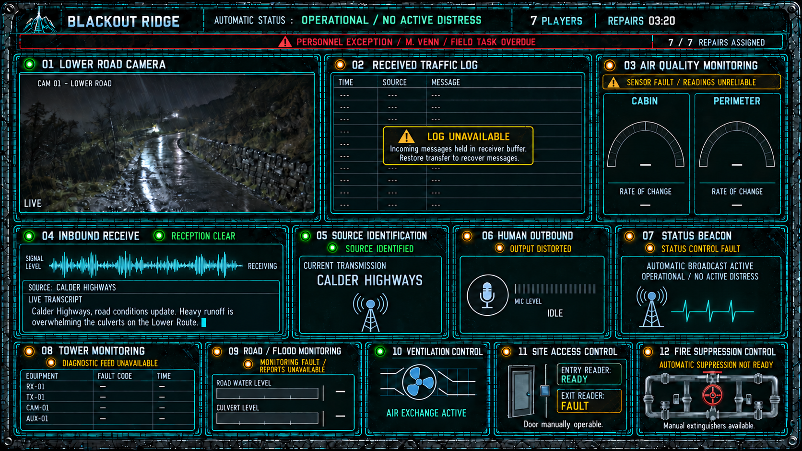
A2 G07a. Crew-facing dashboard during COMM 02 at R 01:40, with 03:20 repair time remaining. Receiver and Source Identification work; the log is still faulty. The transcript is in progress and has not yet been added as a completed row.

Degraded unresolved incoming transmission
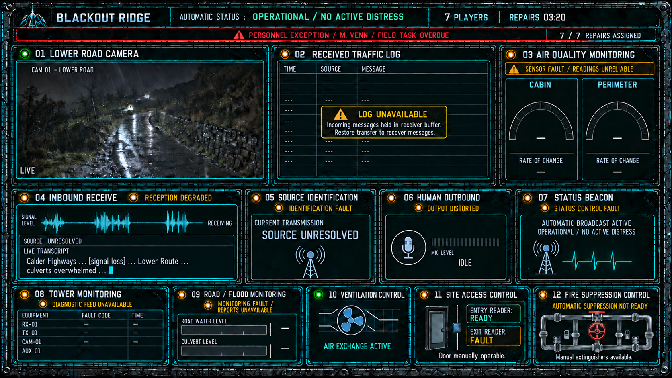
A2 G07b. Alternative state at the same point in COMM 02. Receiver and Source Identification remain faulty. Show surviving words and signal-loss markers only. An audible station name can remain in the message even though metadata is unresolved.

8 Reception and buffer recovery

Capture state at message start
At each message’s start, capture Inbound Receive and Source Identification state. Choose the entire audio/caption variant and origin label from that snapshot. A repair midway through playback does not switch the asset, fill a missing phrase or add a source label.
Receive | Source ID | Log availability | Player-visible result
Working | Working | Working | Clear audio; attributed; logged on completion.
Working | Faulty | Working | Clear audio; unresolved source; logged on completion.
Faulty | Working | Working | Degraded audio; attributed; logged on completion.
Faulty | Faulty | Working | Degraded audio; unresolved source; logged on completion.
Working | Working | Faulty | Clear audio; attributed; buffered on completion.
Working | Faulty | Faulty | Clear audio; unresolved source; buffered on completion.
Faulty | Working | Faulty | Degraded audio; attributed; buffered on completion.
Faulty | Faulty | Faulty | Degraded audio; unresolved source; buffered on completion.

Reception and source attribution are captured at message start. Log availability is evaluated when the completed message is stored. Repairing the log during a transmission changes where its completed entry is committed; it does not change its audio, transcript or source.

Recovery lifecycle
The receiver buffer holds every scheduled Act 2 message while the log is faulty and is not player-readable. Repair transfers completed buffered entries into the readable Traffic Log, preserving original receipt time, received text and source label. It also restores normal logging for future completions.
An in-progress transmission is committed once when it ends. If log repair occurs before that point, write its original captured content directly to the restored log. Do not create a partial recovered entry and then a duplicate completed entry.
If the log remains faulty at the repair deadline, unrecovered Act 2 buffer contents are lost and cannot be recovered in a later act. A confirmed successful log repair before the deadline protects the buffered traffic. Existing Act 1 history is unavailable while the log is faulty but is not erased by that fault. Restore only messages that actually occurred in Act 1.
Keep the original source as UNRESOLVED when appropriate. Subsequent receiver or source repairs never improve an earlier record. The readable archive is message text; neither it nor the camera provides player replay controls.

Persistent data
For each transmission store message ID, receipt-start time, completion time, selected audio and caption variant IDs, displayed transcript, captured reception state, captured source label, and storage state. Distinguish buffered, recovered and directly logged entries internally. Screen refreshes must not reevaluate old messages against current system states.
The later anomalous internal transmission is outside this normal external-traffic pipeline. Its special no-attribution and no-log behaviour remains governed by the Act 3 handoff.

Recovered Received Traffic Log
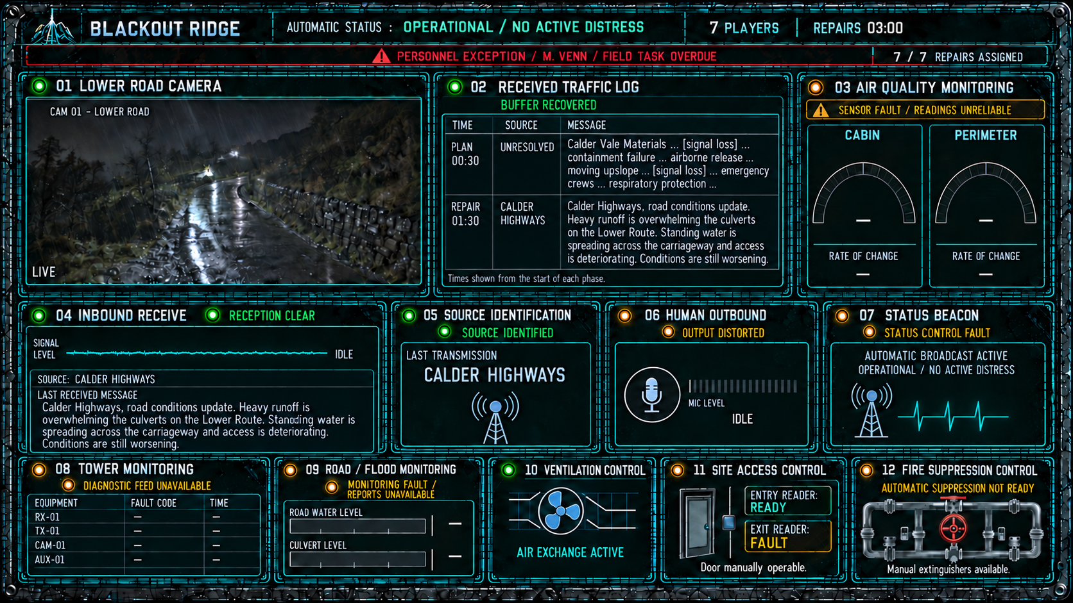
A2 G08. Crew-facing dashboard after a successful log repair. Buffered messages are visible exactly as received, including unresolved attribution and degraded text. The phase-relative TIME labels in this illustration are placeholders for the final receipt-time display; do not treat them as a settled fiction clock.

9 Repair packages
Each package contains the retained player rules, evidence, repair choices, answer and result behaviour. The following enlarged reference pages each show one private puzzle screen. Implement text and geometry as dependable UI, rather than relying on generated pixels to determine logic.
Use one screen per puzzle. All necessary clues stay visible. Aim for task comprehension within 90 seconds and roughly two to four minutes of solving inside the five-minute window. These are playtest targets, not enforced minimum times. Similar mechanics within Act 2 are permitted.
Every SELECT REPAIR button opens G04a with that choice’s wording. Beacon has four choices; the other games have five. Only confirmation submits. Apply the shared outcome and timeout behaviour in section 10. Do not highlight correct answers on player screens.
Keep the supplied answer order. No redistribution has been applied: any later reordering must update graphics, option IDs, keys and confirmation summaries together. The newly collated text is an implementation transcription, not a new puzzle redesign. The revised Site Access movement variant still needs its follow-up playtest.
Figure | System | Correct choice
G09 | Inbound Receive | C
G10 | Status Beacon | C
G11 | Tower Monitoring | C
G12 | Air Quality Monitoring | C
G13 | Received Traffic Log | C
G14 | Source Identification | C
G15 | Fire Suppression Control | B
G16 | Road / Flood Monitoring | C
G17 | Human Outbound | D
G18 | Site Access Control | D

9.1 Inbound Receive

Player task and rules
Automatic receive routing has failed. Exactly two modules have failed. Each grouped check tests three modules independently and reports only how many passed. Choose one working input, booster and filter, followed by the working receiver. Input B is hard-wired to Booster 2. During severe electrical activity, Booster 2 must connect to Filter 2. Select a filter mode that suppresses any interference band at 60 or above while keeping the transmission band open.

Evidence
Modules checked | Passed
Input A / Booster 1 / Filter 1 | 2 of 3
Input B / Booster 2 / Filter 1 | 2 of 3
Input B / Booster 1 / Filter 2 | 1 of 3

STANDARD suppresses LOW; SURGE suppresses HIGH. LOW interference 31; HIGH interference 78. Transmission band LOW. Weather SEVERE. Receiver self-test passes.

Repair choices
Option | Input | Booster | Filter | Mode
A | A | 1 | 2 | SURGE
B | A | 2 | 1 | SURGE
C | A | 2 | 2 | SURGE
D | A | 2 | 2 | STANDARD
E | B | 2 | 2 | SURGE

Designer solution
Correct choice C. Input B and Booster 1 are the failed modules. These are the only pair producing all three check totals. Input A and Booster 2 are working; severe weather requires Filter 2. HIGH interference must be suppressed, so use SURGE and leave LOW open.

Result behaviour
Restore the receiver chain and clear future normal transmissions starting after repair. Do not change a message already in progress or any stored text or source label. Incorrect confirmation leaves the system faulty and ends the attempt. No confirmation before the deadline applies no repair and records a timeout.

Inbound Receive repair screen
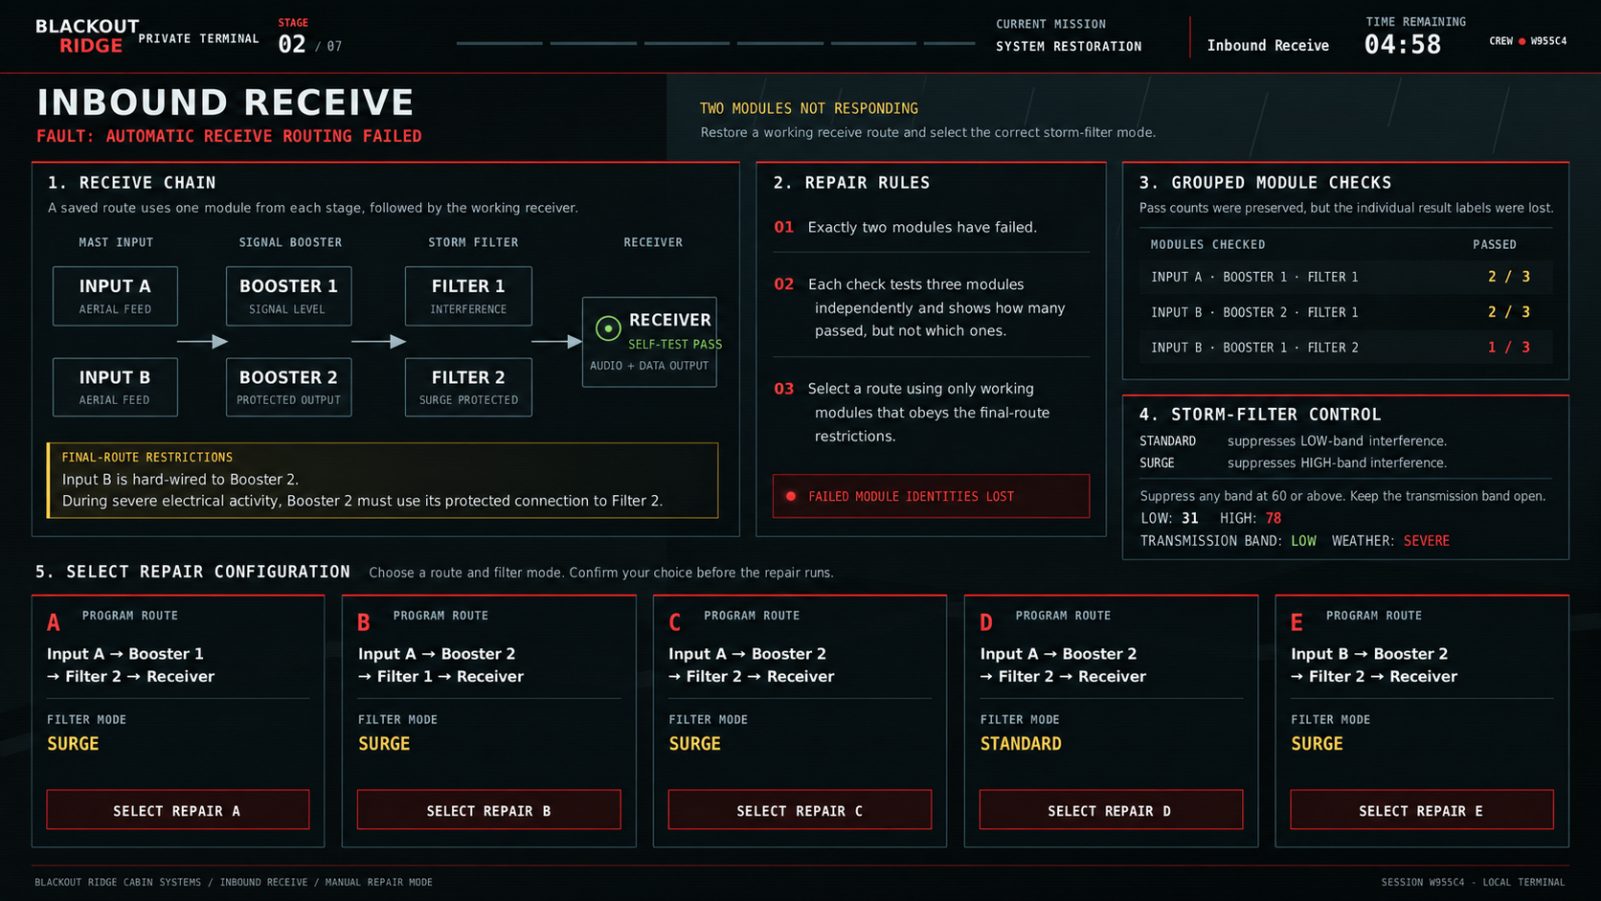
A2 G09. Private player puzzle during the shared repair window. The timer is illustrative time remaining. Selecting a repair opens the confirmation popup; it does not submit immediately.

9.2 Status Beacon

Player task and rules
The manual control connection is lost but the automatic broadcast remains active. Restore the connection settings. A command is accepted only if station number and access code each match, and command duration meets or exceeds the beacon’s minimum. Required settings remain unchanged throughout the saved tests.

Evidence
Possible station numbers: 6, 9, 12. Access codes: 24, 57, 81. Minimum durations: 2, 4, 6 seconds.
Test | Station | Code | Duration sec | Conditions met
1 | 6 | 24 | 4 | 1 of 3
2 | 6 | 57 | 2 | 1 of 3
3 | 6 | 57 | 4 | 2 of 3
4 | 9 | 24 | 2 | 1 of 3

Repair choices
Option | Station | Code | Duration sec
A | 9 | 24 | 4
B | 6 | 57 | 4
C | 9 | 57 | 4
D | 9 | 57 | 2

Designer solution
Correct choice C. Tests 2 and 3 differ only in duration, so 4 seconds passes and 2 fails: minimum 4. Test 3 then needs exactly one of station 6 and code 57. Test 1’s duration already supplies its one match, so station 6 and code 24 are wrong. Therefore code 57 is right. Test 4 then forces station 9.

Result behaviour
Restore manual control connectivity. Keep the automatic broadcast active and its configured OPERATIONAL / NO ACTIVE DISTRESS message unchanged. Repair sends no distress message. Incorrect confirmation leaves the system faulty and ends the attempt. No confirmation before the deadline applies no repair and records a timeout.

Status Beacon repair screen
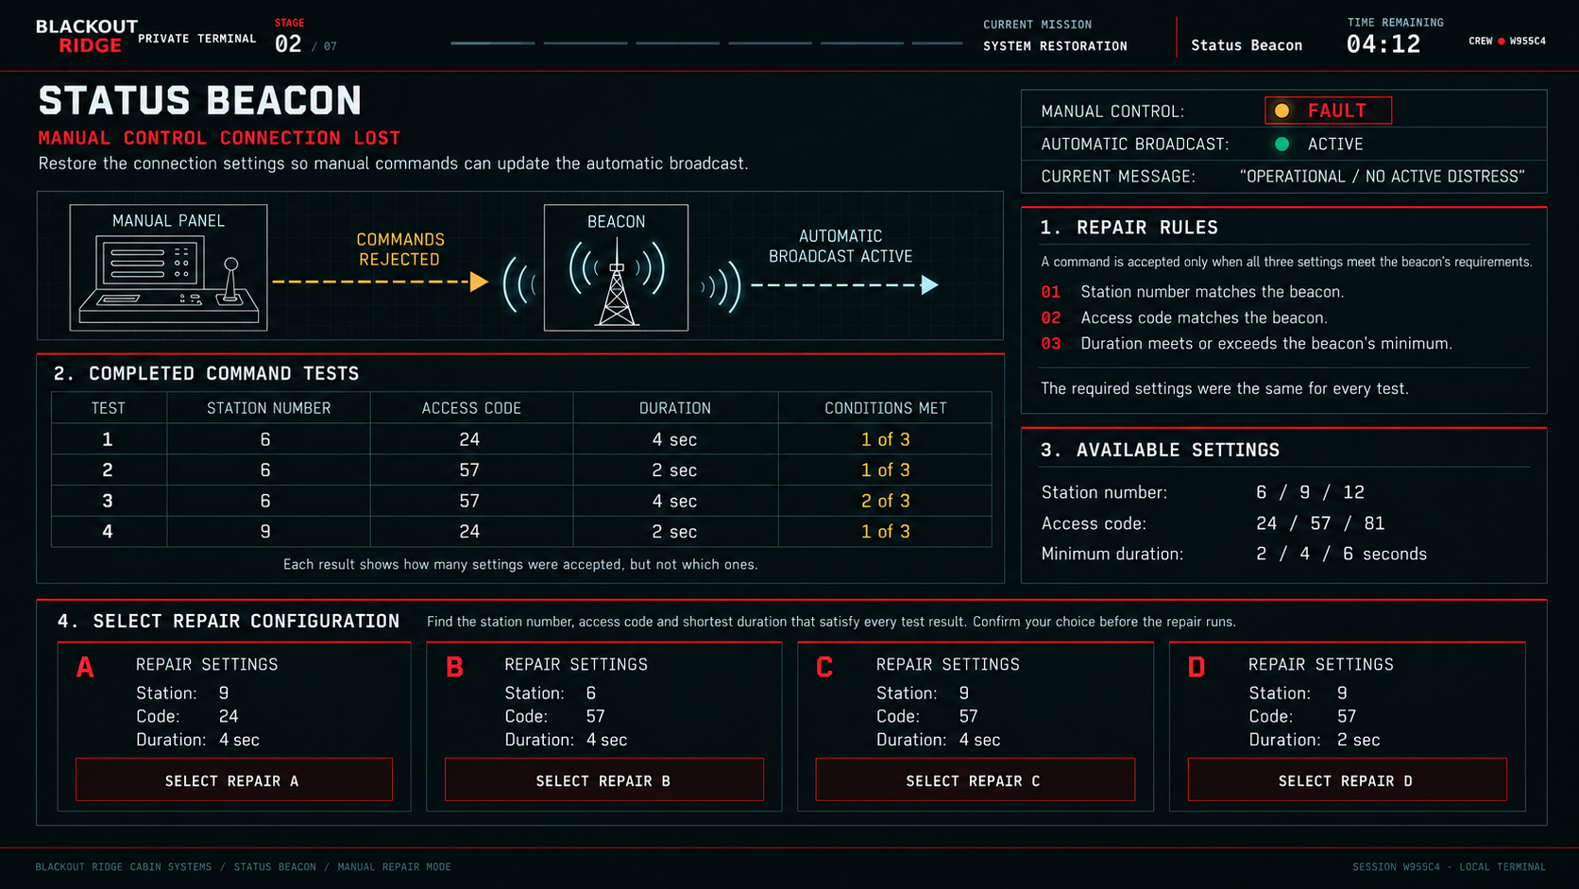
A2 G10. Private player puzzle during the shared repair window. The timer is illustrative time remaining. Selecting a repair opens the confirmation popup; it does not submit immediately.

9.3 Tower Monitoring

Player task and rules
The incoming channel label map is lost. Every channel A–D receives telemetry from exactly one equipment item, and each item belongs to exactly one channel. Saved tests temporarily assigned equipment labels. Only the total correct count survived. The true assignment did not change between tests. Restore the equipment labels.

Evidence
Test | Channel A | Channel B | Channel C | Channel D | Correct
1 | RX-01 | TX-01 | CAM-01 | AUX-01 | 2
2 | RX-01 | CAM-01 | TX-01 | AUX-01 | 1
3 | RX-01 | AUX-01 | CAM-01 | TX-01 | 1
4 | TX-01 | CAM-01 | RX-01 | AUX-01 | 0

Repair choices
Option | Channel A | Channel B | Channel C | Channel D
A | RX-01 | AUX-01 | CAM-01 | TX-01
B | TX-01 | RX-01 | CAM-01 | AUX-01
C | RX-01 | TX-01 | AUX-01 | CAM-01
D | CAM-01 | AUX-01 | TX-01 | RX-01
E | AUX-01 | TX-01 | CAM-01 | RX-01

Designer solution
Correct choice C. Test 4 excludes D=AUX-01. Test 1 therefore needs two of A=RX-01, B=TX-01 and C=CAM-01. Test 3 permits at most one of A=RX-01 and C=CAM-01, forcing B=TX-01. Test 2 then forces A=RX-01. Test 1 excludes C=CAM-01, leaving C=AUX-01 and D=CAM-01. This mapping yields totals 2, 1, 1, 0.

Result behaviour
Restore equipment-labelled diagnostic reports. Do not show geographic destinations. RX-01, TX-01, CAM-01 and AUX-01 remain equipment identifiers; mapping their later faults to field locations belongs to Act 3. Incorrect confirmation leaves the system faulty and ends the attempt. No confirmation before the deadline applies no repair and records a timeout.

Tower Monitoring repair screen
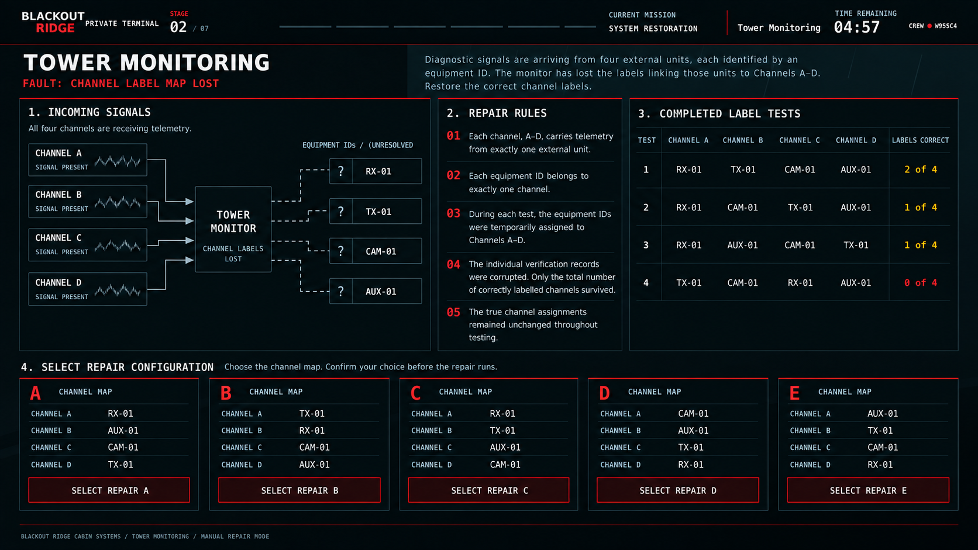
A2 G11. Private player puzzle during the shared repair window. The timer is illustrative time remaining. Selecting a repair opens the confirmation popup; it does not submit immediately.

9.4 Air Quality Monitoring

Player task and rules
All five sensors sample the same reference air during calibration. Exactly one reads high and one reads low by one calibration step each; the other three are correct. Pair tests report whether their average is high, low or balanced. Identify the high and low sensors and apply the corresponding downward and upward correction.

Evidence
A external intake; B main cabin; C equipment bay; D lower access; E ceiling return.
Sensor pair | Average result
A + B | BALANCED
A + C | HIGH
A + D | BALANCED
B + E | LOW

Repair choices
Option | Adjust down | Adjust up
A | A | B
B | C | B
C | C | E
D | A | E
E | D | B

Designer solution
Correct choice C. If A were high or low, both B and D would need the same opposite fault to balance their pairs, contradicting one high and one low. Thus A, B and D are correct. A+C high identifies C as high; B+E low identifies E as low.

Result behaviour
Restore trustworthy readings and trends. The repair changes calibration only; it neither purifies the air nor changes the current hazard. Incorrect confirmation leaves the system faulty and ends the attempt. No confirmation before the deadline applies no repair and records a timeout.

Air Quality Monitoring repair screen
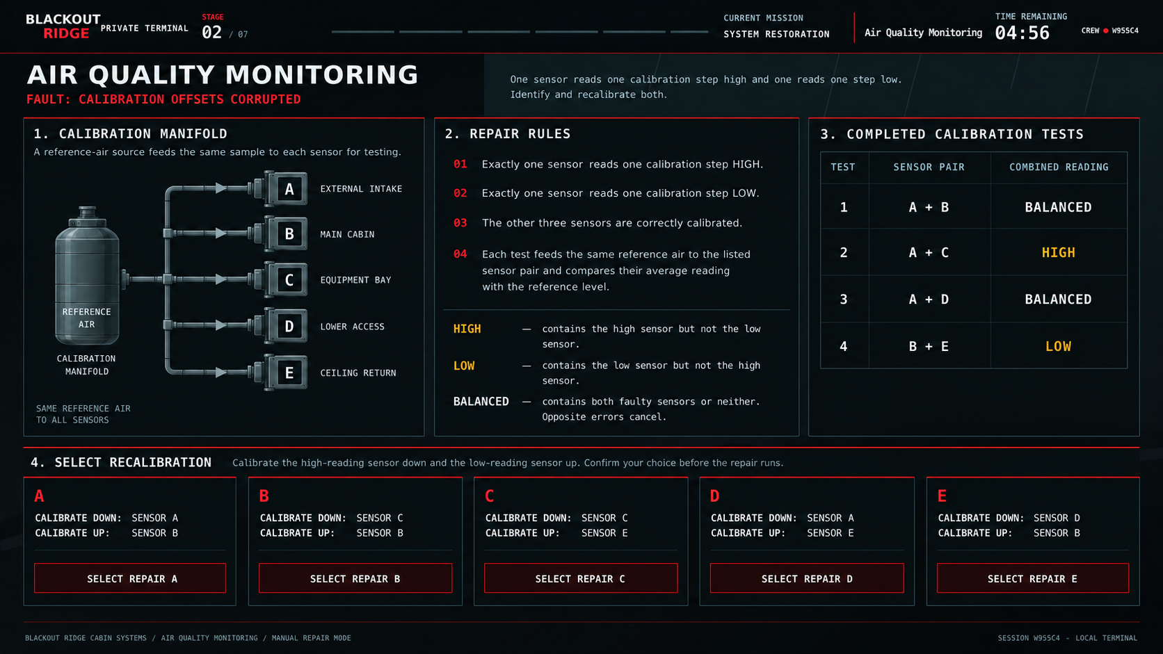
A2 G12. Private player puzzle during the shared repair window. The timer is illustrative time remaining. Selecting a repair opens the confirmation popup; it does not submit immediately.

9.5 Received Traffic Log

Player task and rules
The automatic changeover stopped with three switches in the wrong position. Signals move left to right through SW1 to SW6. Each switch affects only its two numbered lines. STRAIGHT keeps them on their current lines; CROSS exchanges them. Reverse three switches from the visible current positions so the route check and required backup inputs both match.

Evidence
Buffer lines 1–4: MESSAGE AUDIO / STATION TIME / RECORD COMMAND / SOURCE LABEL.
Switch | Controlled lines | Current
SW1 | 1 and 2 | STRAIGHT
SW2 | 1 and 3 | STRAIGHT
SW3 | 1 and 4 | STRAIGHT
SW4 | 2 and 3 | CROSS
SW5 | 2 and 4 | CROSS
SW6 | 3 and 4 | STRAIGHT

Route check immediately after SW3: line 2 STATION TIME; line 3 RECORD COMMAND. Required backup lines 1–4: SOURCE LABEL / RECORD COMMAND / MESSAGE AUDIO / STATION TIME.

Repair choices
Option | Reverse switches
A | SW4 / SW5 / SW6
B | SW3 / SW4 / SW5
C | SW3 / SW5 / SW6
D | SW2 / SW3 / SW4
E | SW1 / SW3 / SW5

Designer solution
Correct choice C. Final positions S S C C S C. After SW3 the order is SOURCE / TIME / RECORD / AUDIO. SW4 exchanges TIME and RECORD; SW5 stays straight; SW6 exchanges TIME and AUDIO. A, B and C pass the route check; C, D and E match final inputs. Only C satisfies both.

Result behaviour
Transfer buffered entries as received, display BUFFER TRANSFER COMPLETE and TRAFFIC LOG RESTORED, and enable later completed-message logging. Incorrect confirmation leaves the system faulty and ends the attempt. No confirmation before the deadline applies no repair and records a timeout.

Received Traffic Log repair screen
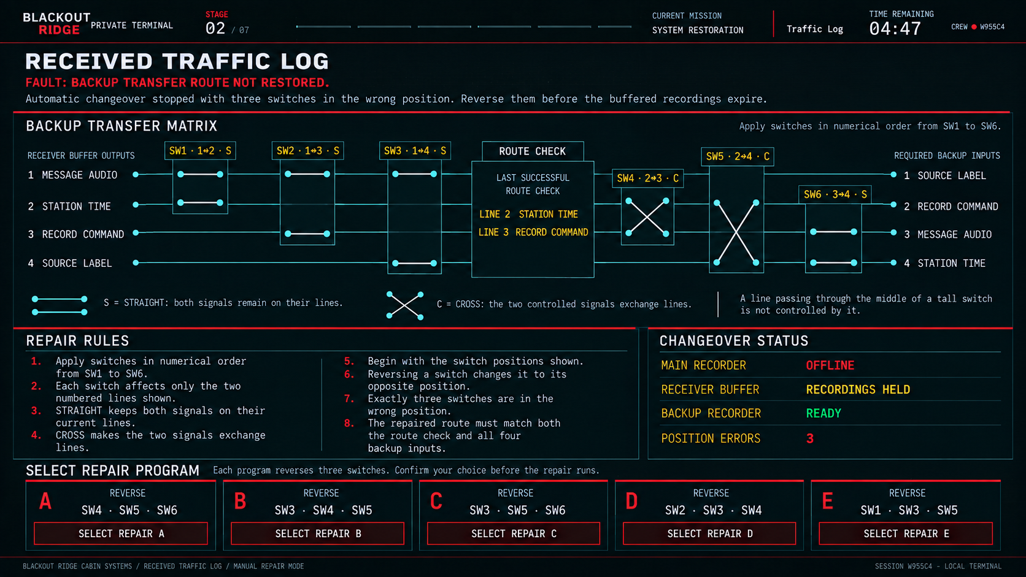
A2 G13. Private player puzzle during the shared repair window. The timer is illustrative time remaining. Selecting a repair opens the confirmation popup; it does not submit immediately. Geometry requirement: four terminals per switch only. Any intermediate line passes through untouched with no connection dot. Attach each switch label directly to its switch. The internal audio signal does not create a player replay feature.

9.6 Source Identification

Player task and rules
Each transmitter sends an identification code of eight binary digits, one after another. Every digit occupies an equal, contiguous time slot. The reader must sample halfway through each slot. Restore the first sample time and regular sampling interval using the saved diagnostic capture.

Evidence
All times are milliseconds after the test trigger. DIGIT 2 ENDS at 64 ms. DIGIT 7 BEGINS at 160 ms. The eight time slots have no gaps.
Current first sample 26 ms, interval 27 ms. Current samples: 26, 53, 80, 107, 134, 161, 188, 215 ms. Display a 0–220 ms axis, 20 ms major divisions and 10 ms minor divisions.

Repair choices
Option | First sample ms | Interval ms
A | 40 | 16
B | 16 | 24
C | 28 | 24
D | 16 | 32
E | 40 | 24

Designer solution
Correct choice C. The interval from the end of digit 2 to the beginning of digit 7 contains four complete slots, digits 3–6. Slot duration is (160−64)/4 = 24 ms. Digit 1 starts at 64−48 = 16 ms, so its midpoint is 28 ms. Subsequent samples are 52, 76, 100, 124, 148, 172 and 196 ms.

Result behaviour
Restore source decoding for subsequent transmissions. Earlier unresolved messages, including one currently in progress when repaired, remain unresolved. Incorrect confirmation leaves the system faulty and ends the attempt. No confirmation before the deadline applies no repair and records a timeout.

Source Identification repair screen
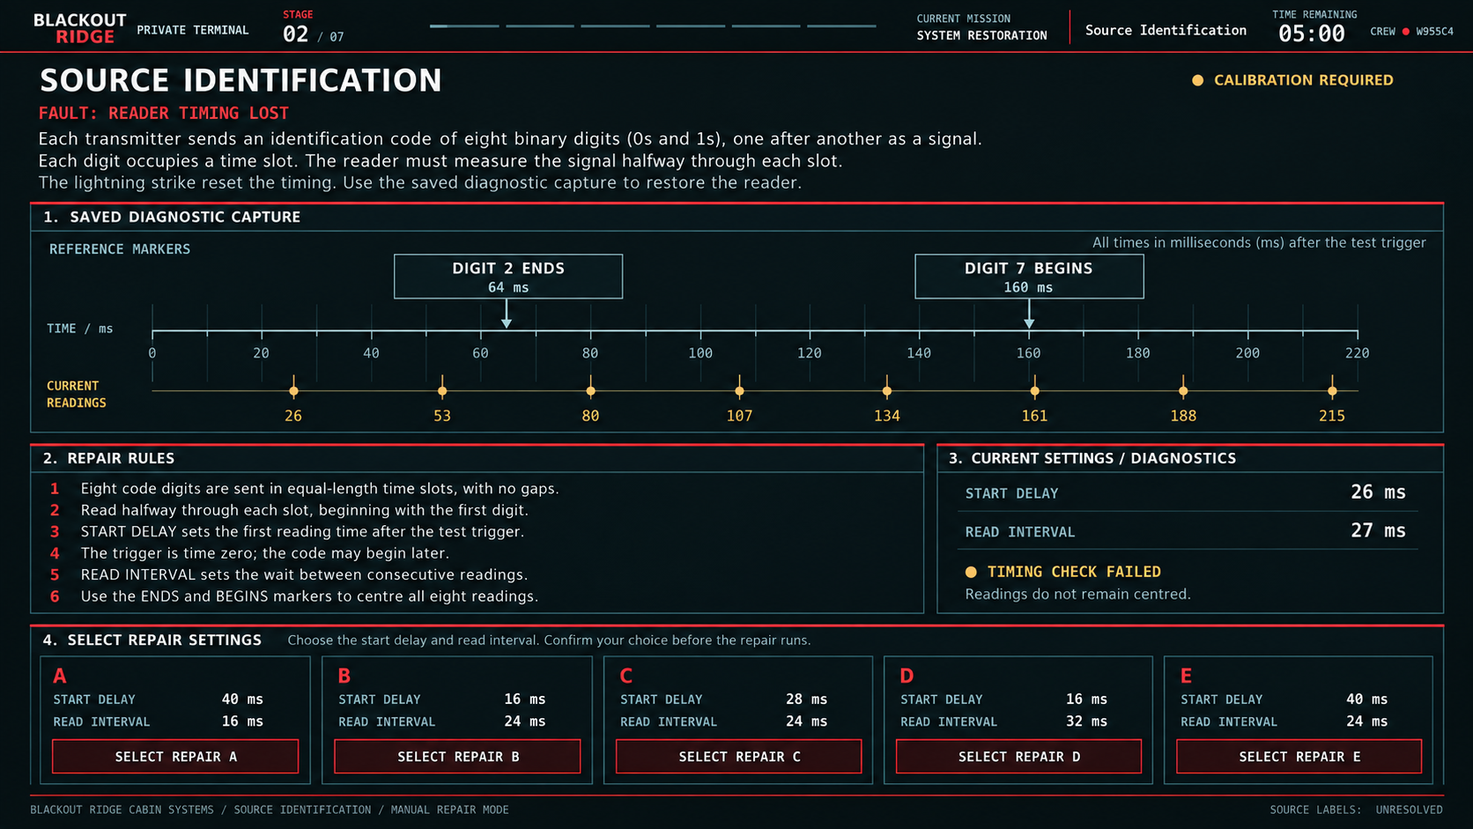
A2 G14. Private player puzzle during the shared repair window. The timer is illustrative time remaining. Selecting a repair opens the confirmation popup; it does not submit immediately.

9.7 Fire Suppression Control

Player task and rules
One valve is stuck open; all others obey commands. Chambers connect only through the shown pipes. Each test starts with all chambers pressurised and no new inflow. Draining a chamber lowers pressure in any chamber connected to it through open valves. Gauge B measures chamber B. Use the saved tests to identify the failed valve; the selected repair closes the working backup valve on that pipe.

Evidence
Chambers: A left, B above, C below, D right. V1 joins A–B; V2 joins B–C; V3 joins A–C; V4 joins B–D; V5 joins C–D.
Test | Commanded open | Commanded closed | Drained | Gauge B
1 | V1 | V2, V3, V4, V5 | C | DROPPED
2 | V2 | V1, V3, V4, V5 | A | UNCHANGED

Repair choices
Option | Pipe backup valve
A | V1
B | V2
C | V3
D | V4
E | V5

Designer solution
Correct choice B. Test 1 can connect B to drained C through stuck V2 directly or through V1 and stuck V3. Test 2 rules out V3: with V2 open, stuck V3 would connect B through C to drained A and drop the gauge. V2 stuck open fits both tests.

Result behaviour
Isolate the failed pipe through its backup valve and restore automatic suppression readiness. Do not discharge suppressant or invent a fire event. Manual extinguishers remain available. Incorrect confirmation leaves the system faulty and ends the attempt. No confirmation before the deadline applies no repair and records a timeout.

Fire Suppression Control repair screen
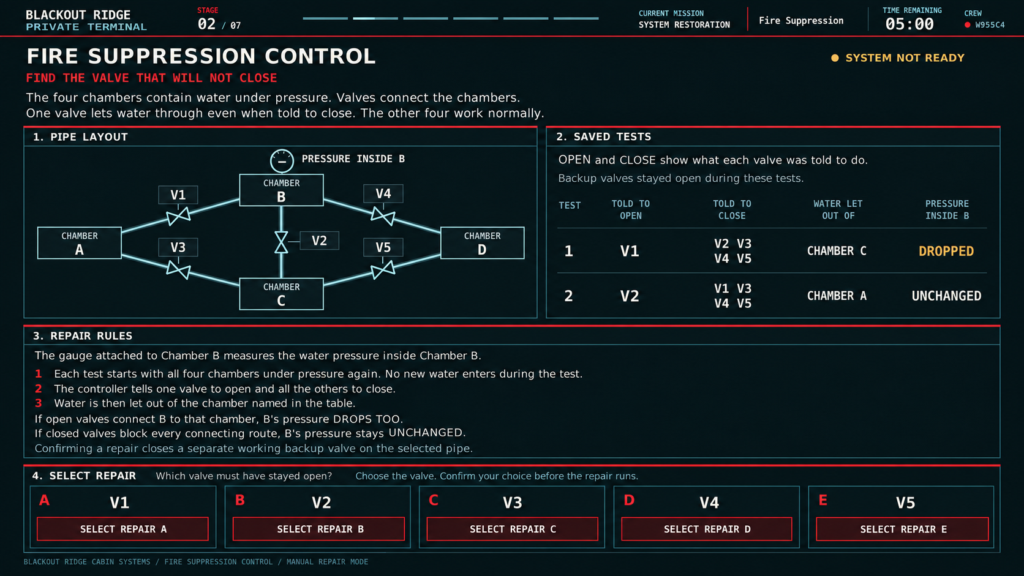
A2 G15. Private player puzzle during the shared repair window. The timer is illustrative time remaining. Selecting a repair opens the confirmation popup; it does not submit immediately.

9.8 Road and Flood Monitoring

Player task and rules
One warning relay is stuck open; the other four work normally. YES closes its controlled relay and NO opens it. The warning lamp lights only if an unbroken path reaches it from the power supply. Determine the failed relay from the saved conditions and lamp results, then switch to that relay’s spare.

Evidence
Circuit: power through parallel R1 or R2 to the middle junction; then parallel R3 or R4; then R5 in series to the warning lamp. R1 and R3 respond to WATER ON ROAD; R2 to UPSTREAM RISING; R4 to DRAINAGE OBSTRUCTED. A working R5 lights the lamp when power reaches it. Sensors and the lamp work normally.
Test | Water on road | Upstream rising | Drainage obstructed | Lamp
1 | YES | NO | YES | ON
2 | YES | YES | NO | OFF

Repair choices
Option | Use spare for
A | R1
B | R2
C | R3
D | R4
E | R5

Designer solution
Correct choice C. Test 1 needs R1 and R5, so both work. Its second stage can pass through R3 or R4. In Test 2 the first stage has a working R1 path, R5 is known working and R4 is commanded open. R3 must therefore be the stuck-open relay.

Result behaviour
Restore reliable warning reports and monitoring information. Actual water levels and later flood-equipment evidence come from the conditions content, not the relay test. Incorrect confirmation leaves the system faulty and ends the attempt. No confirmation before the deadline applies no repair and records a timeout.

Road and Flood Monitoring repair screen
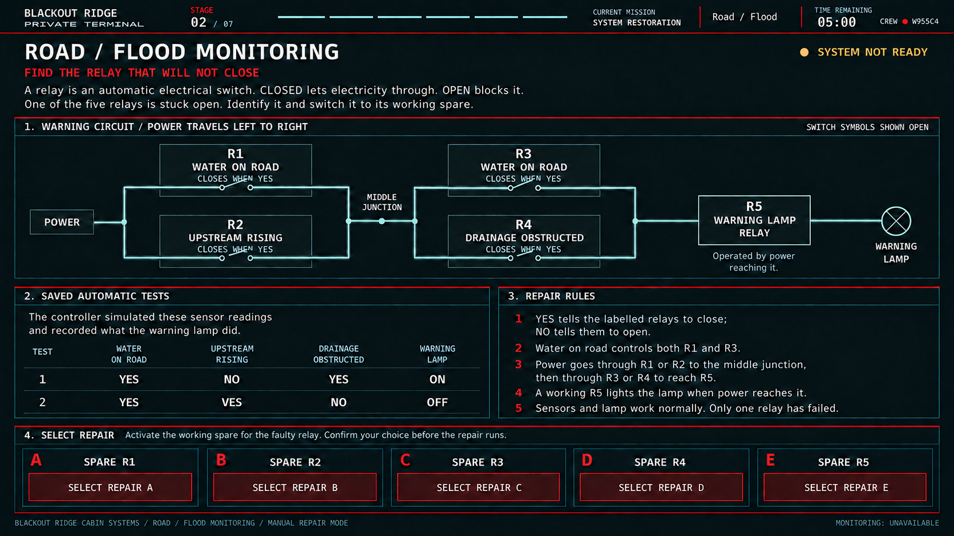
A2 G16. Private player puzzle during the shared repair window. The timer is illustrative time remaining. Selecting a repair opens the confirmation popup; it does not submit immediately.

9.9 Human Outbound

Player task and rules
The test signal passes through four operations in order: Input Shift, Amplifier, Limiter, Output Shift. A shift moves the signal up or down; each repair unit moves it by one vertical unit. The amplifier multiplies by 2. The limiter clips anything above +4 to +4 and below −4 to −4. One shift has drifted by an unknown constant; the other remains zero. Amplifier and limiter operate correctly. Select the change that makes both current outputs match the expected target outputs.

Evidence
Use six graphs: rows QUIET TEST and STRONG TEST; columns TEST SIGNAL, TARGET OUTPUT and CURRENT OUTPUT. Both tests traverse all four operations. Both input graphs show two sinusoidal cycles starting at zero and rising; use identical phase and time scale in each column. Each vertical square is one signal-level unit.
Test | Input peaks | Target peaks | Current output
Quiet | −1 to +1 | −2 to +2 | 0 to +4, centred on +2
Strong | −2 to +2 | −4 to +4 | −2 to +4, upper peaks clipped; starts at +2

Repair choices
Option | Change
A | Lower Input Shift by 2 units
B | Lower Output Shift by 2 units
C | Change amplifier from ×2 to ×1
D | Lower Input Shift by 1 unit
E | Lower Output Shift by 1 unit

Designer solution
Correct choice D. Quiet output is displaced upward by 2 after amplification. A +1 input shift or +2 output shift could explain that test alone. The strong test distinguishes them: +1 before amplification creates an upper peak of +6 which clips to +4, while the lower peak becomes −2. A +2 output shift would instead lift the already-limited upper peak to +6. Lower the input by 1 to restore both targets.

Result behaviour
Restore the local outbound signal chain. No message is transmitted during Act 2. Later outbound delivery still requires the external path and the correct finale message. Incorrect confirmation leaves the system faulty and ends the attempt. No confirmation before the deadline applies no repair and records a timeout.

Human Outbound repair screen
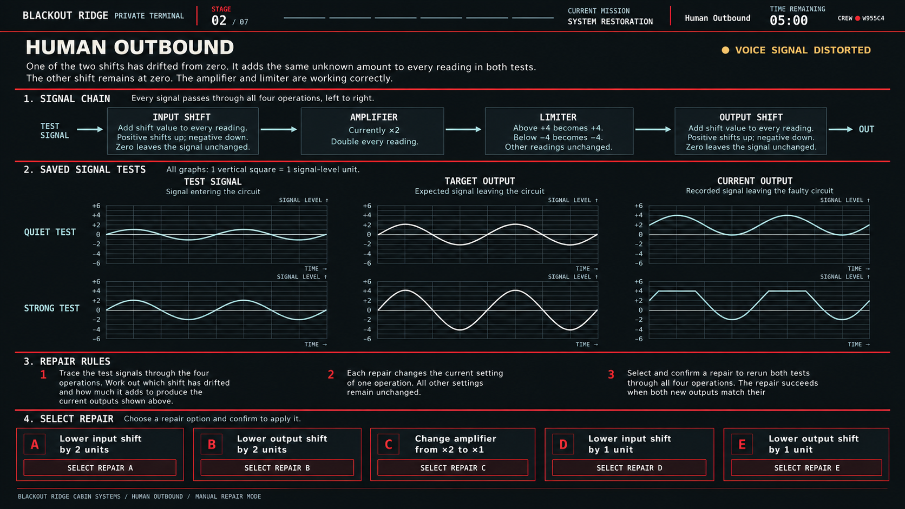
A2 G17. Private player puzzle during the shared repair window. The timer is illustrative time remaining. Selecting a repair opens the confirmation popup; it does not submit immediately.

9.10 Site Access Control

Player task and rules
The existing exit-reader sensor head is misaligned. Four sensors in a fixed 2×2 block each read black or white. Controls move the entire head by whole squares without rotation; it remains entirely on the card. Cards are fully inserted in the same orientation. The controller moved the head exactly one square RIGHT between Test 1 and Test 2. It has not moved since. Locate its current position and move it to the required position.

Evidence
Both cards have 5 rows and 7 columns. Read each string left to right, with rows top to bottom. B = black; W = white. Required head position covers rows 3–4, columns 4–5.
Row | Card 1 | Card 2
1 | WWWBWBW | BWBBWBW
2 | WBBBBWW | WWWWWWW
3 | WBWWBWW | BBBBWBB
4 | WBBWBBW | BBBBWWW
5 | BBBWWWB | WWBBBBW

Test 1 sensor reading: top row B W; bottom row B B. Test 2: top row W B; bottom row W W. Preserve their 2×2 arrangement.

Repair choices
Option | Move from position after Test 2
A | Down 2 squares
B | Right 1 square
C | Left 1 square
D | Down 2 squares and left 1 square
E | Down 2 squares and right 2 squares

Designer solution
Correct choice D. The pair of readings with the one-square rightward movement locates Test 1 at rows 1–2, columns 4–5, and Test 2 at rows 1–2, columns 5–6. The target is rows 3–4, columns 4–5, so move down 2 and left 1 from the current position.

Result behaviour
Restore exit-reader recognition and future exit-event recording. Entry readiness and manual door operation are unaffected. Do not reconstruct Mara’s departure. Incorrect confirmation leaves the system faulty and ends the attempt. No confirmation before the deadline applies no repair and records a timeout.

Site Access Control repair screen
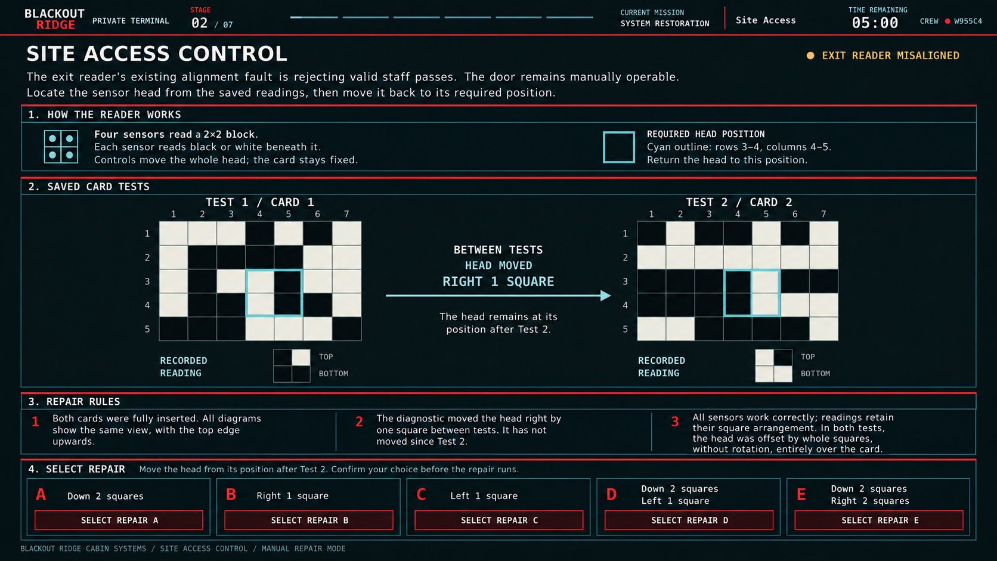
A2 G18. Private player puzzle during the shared repair window. The timer is illustrative time remaining. Selecting a repair opens the confirmation popup; it does not submit immediately. Validation still required: Peter playtested the earlier stationary-head version. The added rightward movement between tests is logically checked but still needs the follow-up user playtest.

10 Private confirmation and result screens
These are individual terminal screens, shown after answer selection or confirmation. The shared dashboard remains on the office display. Use the same layout across repairs, substituting the player, system, selected action and result text. The figures use Player 2 and Site Access as one example, not as a monitoring screen for the whole crew.

Confirmation
G04a overlays the current puzzle. Show the selected option and its exact repair action, GO BACK and CONFIRM REPAIR. State that confirmation submits the only attempt and the repair clock is still running. Do not imply success. Closing the popup permits another choice; expiry while it is open produces G04d.

Success and failure
G04b follows a confirmed correct answer; G04c follows a confirmed incorrect answer. Both retain the shared countdown and incoming captions. They contain no retry, return-to-dashboard, manual or replay controls. The player stays here until the repair window closes. At closure, replace the waiting sentence with REPAIR WINDOW CLOSED while preserving the actual success or failure result.

Timeout
G04d shows 00:00 when no confirmation was accepted before the deadline. No repair is applied. A previously accepted success or failure must not be relabelled as timeout. Keep the screen during the short closing hold, then transition with the session.

Private repair confirmation
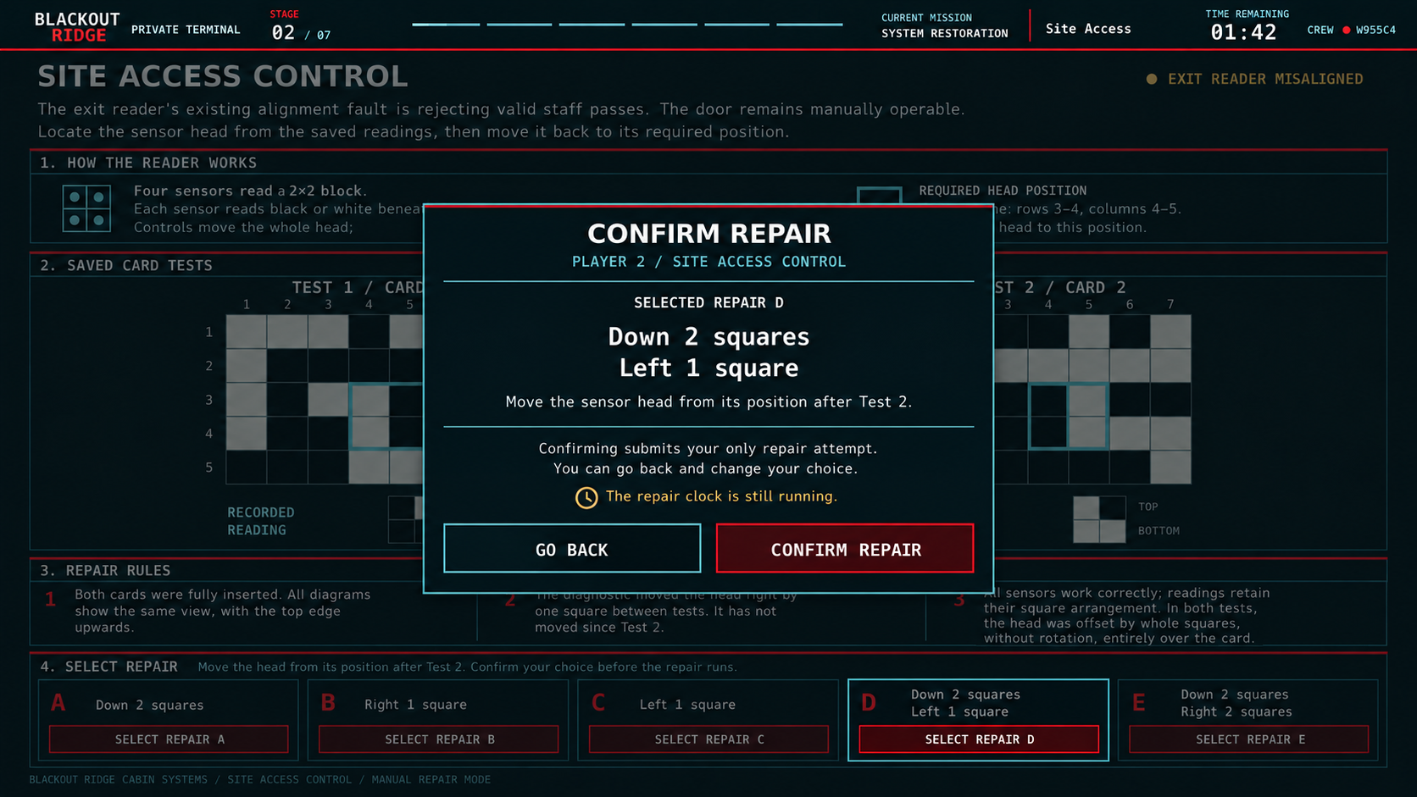
A2 G04a. Private player popup after selecting a repair and before submission. The selected repair is not yet applied. GO BACK permits a change; CONFIRM REPAIR consumes the attempt. The clock continues.

Private successful repair result
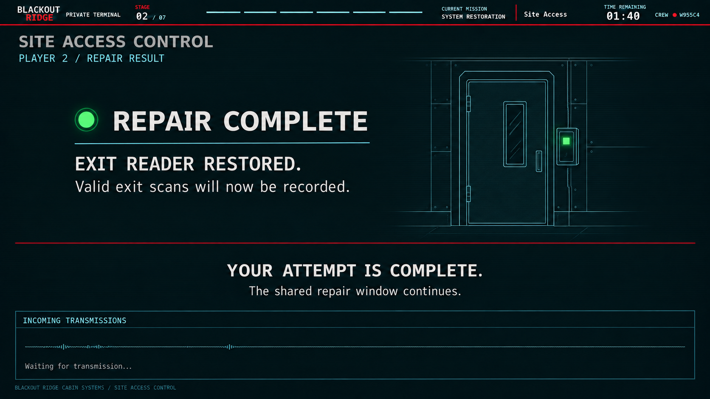
A2 G04b. Private player screen after a confirmed correct answer. The shared dashboard updates immediately. The player remains here with incoming captions available while the repair window continues.

Private unsuccessful repair result
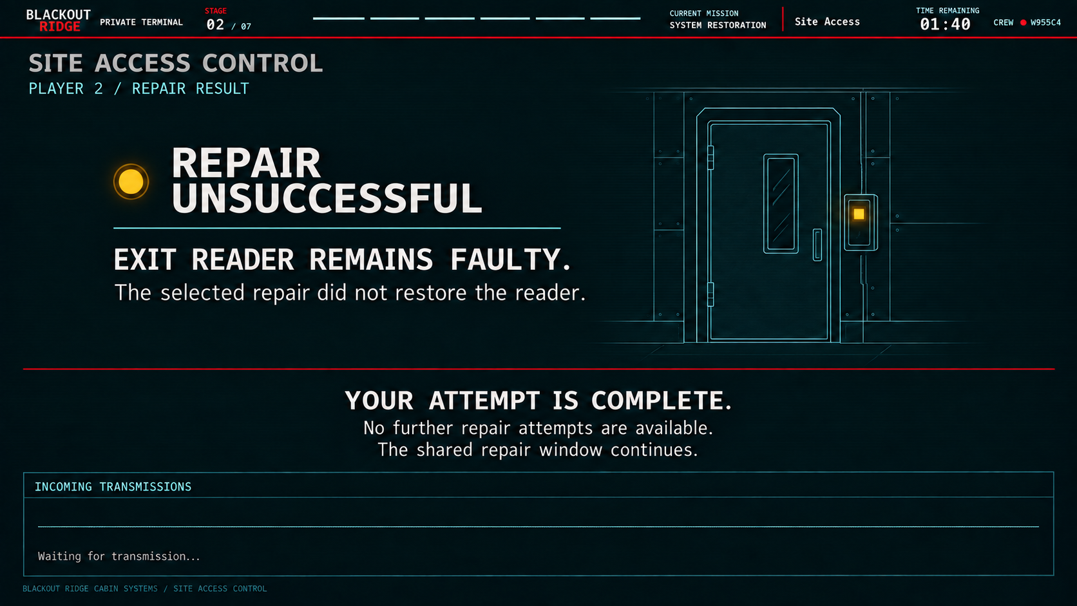
A2 G04c. Private player screen after a confirmed incorrect answer. The system remains faulty and no further attempt is available. Incoming captions remain available while the shared countdown continues.

Private timeout result
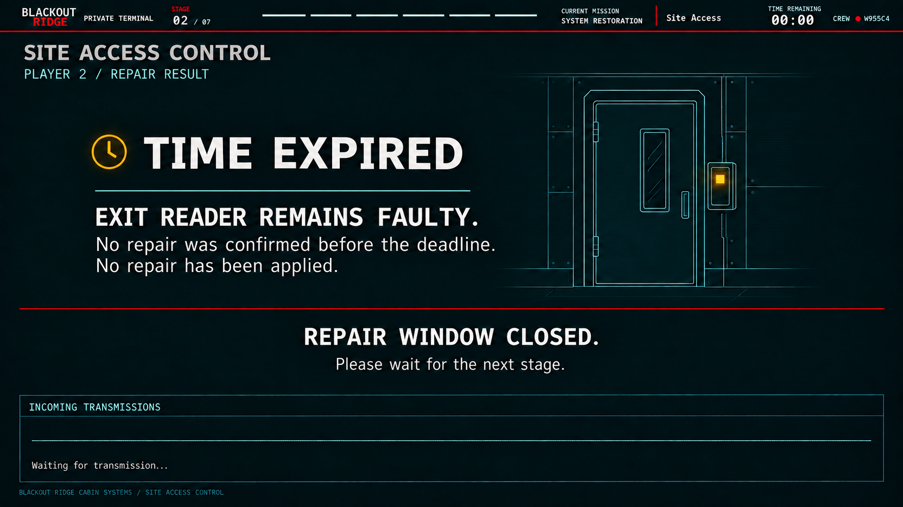
A2 G04d. Private player screen when no answer was confirmed before the deadline, including a selection left in the popup. No repair is applied and the system remains faulty. The shared repair window is closed.

11 System consequences and later acts
The following effects govern integration. They are developer information, not recommendations in the Station Systems Manual. A successful local repair changes capability; it does not guarantee the crew will use that capability or infer the right conclusion.
System | Immediate and downstream effect
Inbound Receive | Subsequent normal transmissions become clear. COMM-03 can convey the high-access requirement. Later, a restored external inbound path is also needed to receive the Act 6 responder broadcast.
Human Outbound | Restores the local voice/data transmission chain. Later extraction-message delivery also depends on the external outbound path and the finale’s message rules. Repair sends no automatic distress or extraction request.
Status Beacon | Restores the local manual control connection. The automatic heartbeat continues broadcasting its configured OPERATIONAL / NO ACTIVE DISTRESS message. Repair does not send distress; later distress control remains distinct from Human Outbound.
Tower Monitoring | Restores fault-code reporting, not physical destination labels. In Act 3, supplies the diagnostic evidence and unresolved legacy reference defined by that act. Do not reveal Upper Ridge’s eventual function.
Air Quality Monitoring | Restores trustworthy local readings and trends. Does not change the hazard. Later observability improves; the Act 3 Field Conditions panel remains available independently.
Received Traffic Log | Recovers buffered message text as received and logs subsequent completed transmissions. Stored text and captured source labels remain readable after external communications fail.
Source Identification | Labels subsequent normal traffic, including the two filter advisories. Does not update earlier labels or identify the anomalous internal transmission.
Road / Flood Monitoring | Provides detailed flood evidence. In Act 3 this supplies Location C’s flood-kit requirement and flooded service-time applicability. General camera footage does not duplicate that equipment evidence.
Site Access Control | Restores exit-reader pass recognition and future exit-event recording. Does not reconstruct departures, answer the Mara mystery or alter manual door operation.
Fire Suppression Control | Restores automatic suppression control. No later fire makes this repair material to the scenario. Manual extinguishers are unaffected.

Local faults and external failure
Act 2 repairs restore local processing, control, calibration or labelling. The mast still carries normal external traffic, although the receiver may degrade it. At the Act 3 transition a separate central external power or distribution failure removes the field paths for RX-01, TX-01, CAM-01 and AUX-01. It does not undo a successful local repair.
Tower Monitoring identifies equipment and reports fault codes. It does not know the equipment’s physical service location. Act 3 supplies the evidence connecting equipment faults and legacy references to the field map. AUX-01 is the ventilation-related infrastructure in the developer model; do not rename it VENT in player-facing Act 2 evidence.

Act 6 instruction and Act 7 extraction
Act 6 must include an inbound responder transmission giving the incident reference needed in the Human Outbound extraction message in Act 7. Hearing it requires a working local Inbound Receive chain and restored external inbound path. Sending the final message requires the local Human Outbound repair, a working external outbound path and the correct player action.
The Act 6 transmission is a separate event, not a new Act 2 message. Its exact incident reference, spoken instruction and the Act 7 accepted-message rubric remain owned by those later-act specifications. Do not invent an Act 2 reference or silently allow extraction without the information dependency.

12 End of act and state transfer

Close the repair window
At R 05:00, close unanswered repairs and finalise their timeout results. Keep working systems working and leave failed, ignored or timed-out systems faulty. Preserve the personnel exception. There is no crew score, optimal-choice reveal or explanation of which systems mattered.
At the shared deadline, reject new confirmations, close pending popups and record unanswered attempts as TIMED_OUT. Update private screens and the facilitator progress display. Complete buffer expiry rules, then hold the closed dashboard briefly before the separate Act 3 transition. The hold creates no further decision window.

State handed forward
Record | Required contents
Session | Player count; phase start and end times; event schedule.
System states | Working/faulty for all ten repair systems. Camera and Ventilation remain working at Act 2 close, before the Act 3 event.
Repair attempts | Player, system, assignment method, selected answer, confirmation receipt time, final outcome and resulting local system state. Retain one resolved result across refresh or reconnect.
Traffic | Only actual Act 1 history; Act 2 message-start snapshots, received transcript, source label, original receipt time, completion time, and recovered or directly logged state.
Personnel story | Mara task overdue and exception raised; no change to Act 1 recorded answers.
Later dependencies | Local comms capability separate from field-path availability; beacon control; monitoring, recording and attribution capabilities.

Do not calculate a rescue outcome in Act 2. The later acts combine these capabilities with field repairs and final player actions. Store concrete choices and results rather than an early hidden success score.

Reconnect behaviour
Restore the player’s current assignment, remaining shared time and resolved result from session state. Reconnecting does not restart a timer, permit a second repair or reprocess old messages. If the session deadline passed while disconnected, an unconfirmed attempt is a timeout. Preserve the shared event schedule and already-played messages.

13 Acceptance and outstanding work

Implementation acceptance
- For each supported player count 4–7, retain all twelve panels and the exact fault and attempt counts in section 2. Only faulty, unassigned systems can be allocated.
- Keep the complete three-minute planning and five-minute repair windows. Random completion preserves existing choices and draws only from remaining faulty systems without replacement.
- Share only the station dashboard to the room. The facilitator privately sees every player. The dashboard contains no controls; player terminals have only the controls appropriate to their phase.
- Every answer selection opens confirmation. A confirmation received before the deadline resolves once; an unconfirmed popup times out. Refresh and duplicate requests cannot produce another attempt.
- Receiver waveforms and scrolling captions respond to live transmissions. Source details persist after completion. A completed log row contains original receipt time, captured source and received message text.
- Repair during a message never changes its audio, text or attribution. A log repair recovers completed buffer entries and commits an in-progress message once, with no retrospective improvement.
- COMM 01 is degraded; COMM 03 degradation removes the high-access clue. Both numerical advisories remain intelligible under their masks. Private captions reveal no hidden source.
- Personnel escalation is independent of Act 1 answers and panel selection. Keep it beside the configured automatic status message, without a correctness reveal.
- Keep exactly two manual screens. Site Access does not block entry or manual door movement. Camera and Ventilation stay working until the separate Act 3 event.
- Keep Act 2 local repair states separate from later field availability. Preserve the Act 6 incident-reference to Act 7 extraction dependency.

Outstanding content and validation
The reference graphics are embedded. Remaining items below are production content or validation dependencies, not permission to redesign approved games.
Item | Required completion
Audio production | Record and time all clear/degraded assets and matching caption cues against section 6. Adjust delivery within the stated maxima; do not silently remove evidence.
Absolute story time | Reconcile the opening bridge, Act 1 end time and Mara task deadline. Set final receipt timestamps. G08 phase-relative labels are illustrative, not the final 24-hour display.
Closing hold | Confirm the proposed five-second hold against Act 3 transition footage. No repairs or decisions are allowed during it.
Conditions content | Supply cabin/perimeter air-quality values, units, trends and update cadence; road-water and culvert values and timing. No invented sensor numbers are added here.
Camera and opening footage | Produce final Lower Road video and opening footage from the approved visuals. Define playback duration, loop and transition timing. Dashboard artwork is a frame reference.
Tower diagnostic content | Supply the working Act 2 report values and the separate Act 3 equipment fault codes, event times and mapping evidence. RX-01/TX-01/CAM-01/AUX-01 are fixed display identifiers.
Puzzle build checks | Compare each built puzzle against the editable evidence and reference. Verify exact card cells, graph curves, line terminals and options. Run the revised Site Access rightward-movement playtest.
Later-act message | Finalise Act 6 incident-reference broadcast and Act 7 accepted extraction wording in those handoffs, retaining the dependency stated in section 11.

Graphics and authority
Use figure IDs as asset references; do not display them inside player screens. Each interface figure is one screen. G01 alone is a production storyboard, not a composite player interface. All three facilitator views are separate, and all private confirmation/results follow the puzzle section.
Source documents: Blackout Ridge Designer Specification Production; Blackout Ridge Act 1 Developer Implementation Handoff; Blackout Ridge Change Log and Open Decisions; the reviewed Act 2 draft and subsequent agreed screen and puzzle revisions. This assembly removes obsolete playback and return navigation instructions and retains the approved repair mechanics.

