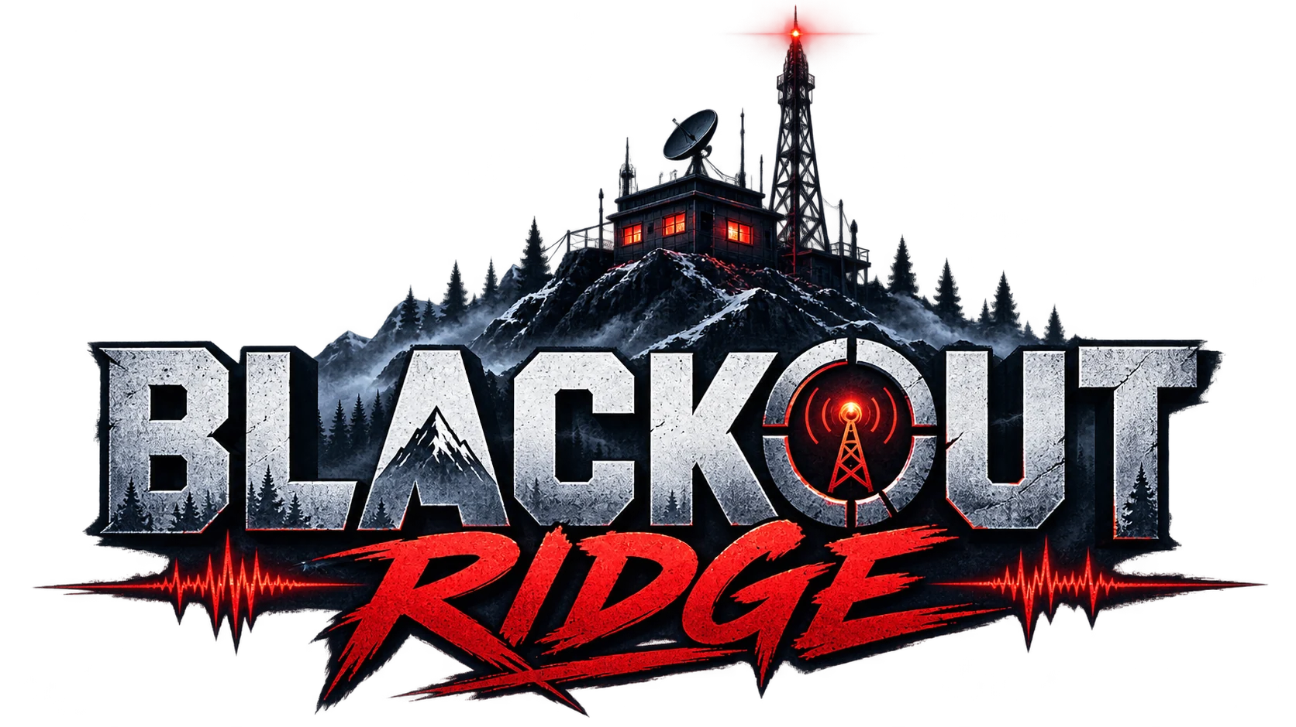

Complete Client, Facilitator
& New-Player Guide
How to prepare, host, play, explain, debrief, and support every Blackout Ridge session

CLIENT DELIVERY EDITION • VERSION 1.0
Prepared 07 September 2026

Current hosted build: http://151.243.217.9:4173/
Facilitator material includes story spoilers. Give participants only Sections 2–4 unless spoilers are acceptable.
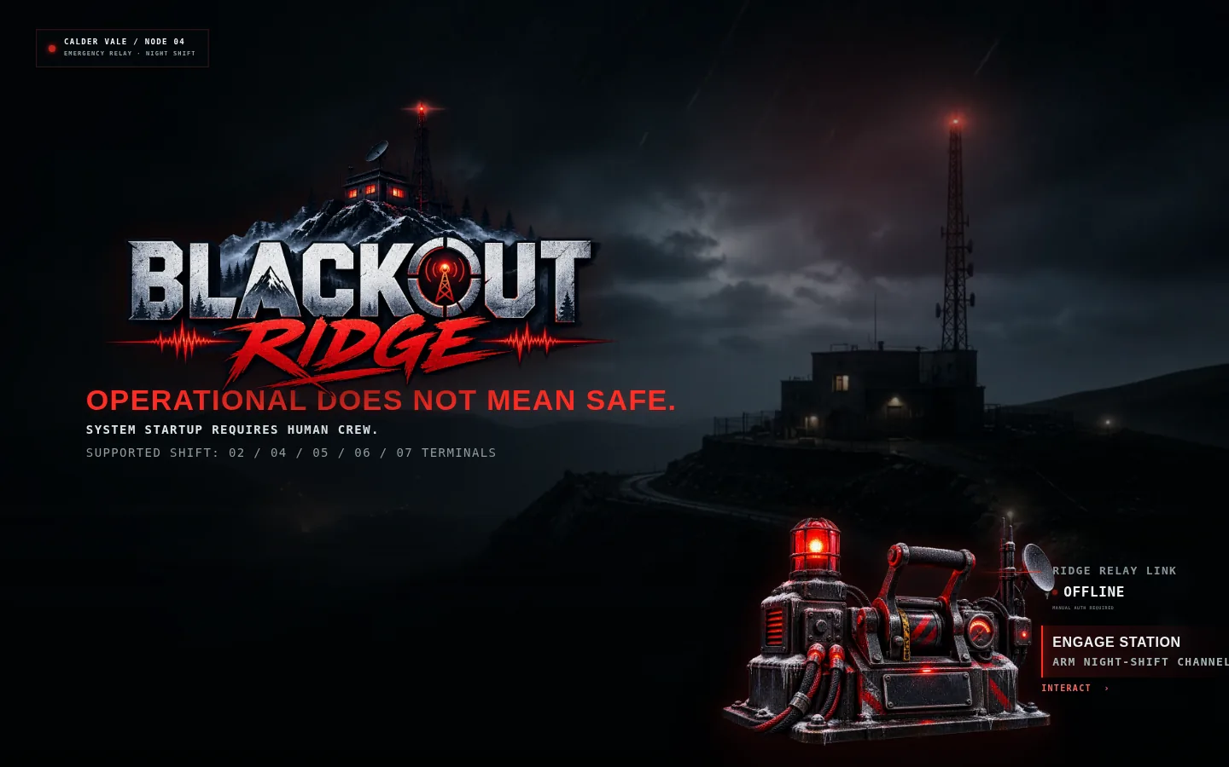
Figure 1. The in-world station boot screen participants see on entry.

Document control
Item | Value
Document | Blackout Ridge — Complete Client, Facilitator & New-Player Guide
Version | 1.0 / client delivery edition
Prepared | 07 September 2026
Runtime | Browser-based synchronized multiplayer game; Node server on port 4173
Supported crew sizes | 4, 5, 6, or 7 participants, plus one facilitator
Recommended duration | Approximately 70 minutes: 5-minute briefing, 43-minute play, 20–25-minute debrief
Primary audience | Client sponsors, workshop producers, facilitators, technical hosts, and new participants

SECURITY AND PRIVACY
Facilitator and player links contain bearer tokens. Treat them like private access links. The room-facing shared link is public/read-only. Crew Chat and debrief notes are stored with the session and appear in the facilitator export.

How to use this guide
Reader | Read first | Then use
Client sponsor | Sections 1 and 8 | Sections 5–7 for the full learning design
Technical host | Sections 2 and 9 | Appendix A preflight checklist
Facilitator | Sections 2, 5, 6, and 7 | Appendix B scripts and Appendix C recovery table
New participant | Sections 3 and 4 | Avoid Section 6 if you want a spoiler-free experience
Observer / evaluator | Sections 1, 5, 7, and 8 | Appendix D playtest evidence prompts

Contents
Section | Purpose
1. What Blackout Ridge is | Product intent, audience, learning model, and experience architecture
2. Quick start and technical setup | Launch, host, session creation, links, devices, and preflight
3. New-player guide | Join, claim a role, read evidence, communicate, recommend, and act
4. Screen-by-screen reference | Shared display, private terminal, facilitator console, chat, telemetry
5. Facilitator runbook | Care briefing, opening script, timing, controls, and room management
6. Seven-stage walkthrough (spoilers) | Exact objective, decisions, facilitation notes, and consequences
7. Endings and debrief | Ending logic, six-step debrief, first steps, and export
8. Explaining the game to a client | Value proposition, demo narrative, evidence, and success criteria
9. Troubleshooting and recovery | Network, browser, token, role, timer, mobile, and audio issues
Appendices | Checklists, scripts, controls, glossary, and one-page quick reference

SECTION 1

What Blackout Ridge is
A synchronized leadership simulation about challenging calm automated labels when human reality is incomplete.

1.1 Experience in one paragraph
Blackout Ridge is a live-facilitated, browser-based survival-horror leadership simulation. A storm has damaged a remote relay station, a colleague named Mara Venn is missing, and the station is producing plausible operational conclusions from incomplete data. Every participant receives a different private evidence lens. The group must speak, combine evidence, complete seven connected timed challenges, manage physical danger and external response, and then connect the experience to real AI-enabled workplace decisions.

1.2 What the game teaches
- Challenge the label, not only the number. A clean status can measure the wrong object. OPERATIONAL describes relay transmission, not human safety.
- Ask what evidence is missing. Players see different fragments and must reconstruct provenance, human context, dependencies, and guardrails.
- Act under uncertainty without pretending certainty. Every stage demands one bounded action; endless analysis allows defaults to harden.
- Keep people visible in system records. Mara and the former Lark Shift expose the danger of replacing named people with occupancy or status abstractions.
- Make corrections actionable to receivers. A warning succeeds only when an outside authority understands the invalid status, person, location, hazard, evidence, and requested action.

1.3 What it is not
- It is not a technical exam; roles are leadership perspectives, not professional certifications.
- It is not a hidden-information competition; players may read or paraphrase their private evidence.
- It is not a psychometric assessment; people receive no numerical score or personality diagnosis.
- It is not seven disconnected puzzles; decisions persist and change later evidence, safety, trust, and endings.
- It is not a generative-AI adjudicator; outcome logic is deterministic and testable.

1.4 Four coordinated views
View | Audience | Purpose | Contains private information?
Game start / join | Host and participants | Create a shift, enter a code, claim an available responsibility | No clues yet
Shared station | Room display or screen share | Common incident, clock, telemetry, evidence ledger, roster, consequence | No
Private role terminal | One participant | Role-specific evidence, recommendation, intervention, lead decision tools | Yes
Facilitator console | Facilitator only | Pacing, decisions, all reports, safety, recovery, ending preview, debrief | Yes—keep private

CORE LOOP
Story pressure → Private evidence → Crew discussion → Decision preview → Commitment → Cause-and-effect reveal. Every stage begins from the previous consequence, so the crew always knows why the new emergency is happening and what its current decision may preserve or put at risk.

1.5 The escalating story arc
Act | Stages | Escalation
Doubt the handover | 1–2 | Mara is absent; weak human evidence conflicts with calm defaults; lightning then forces the crew to sacrifice future capabilities.
Follow the contradiction | 3–5 | The disputed signal points away from the road, an exposed field test locates a route beneath the station, and the crew discovers Mara inside a legacy hold.
Learn and evacuate | 6–7 | The crew learns why the Lark Shift rescue arrived too late, then descends into R-12 while preserving air and preparing an actionable external extraction request.

SECTION 2

Quick start and technical setup
Everything a host needs to move from a stopped server to a ready room.

2.1 Minimum setup
Item | Minimum | Recommended
Facilitator | 1 laptop/browser | Laptop plus a second monitor
Participants | One browser per person | Laptop or tablet; phone supported when necessary
Shared display | Optional | TV/projector or a dedicated screen-shared tab
Voice | Same room or conference call | Teams/Zoom plus headphones where useful
Browser | Current Chrome/Edge/Firefox/Safari | Chrome or Edge on a stable connection
Server | Node.js runtime, port 4173 | Wired host, persistent terminal, firewall rule for the chosen network

2.2 Start the application
1. Open a terminal in the project folder.
2. Run: npm run dev
3. Wait for: Blackout Ridge running at http://localhost:4173
4. On the host machine, open http://localhost:4173/
5. For the current hosted build, open http://151.243.217.9:4173/
NETWORK NOTE
localhost works only on the server machine. Other devices need a reachable LAN or public address and access to TCP port 4173. If a link opens on the host but not on participant devices, check routing/firewall before changing the game.

2.3 Create a shift
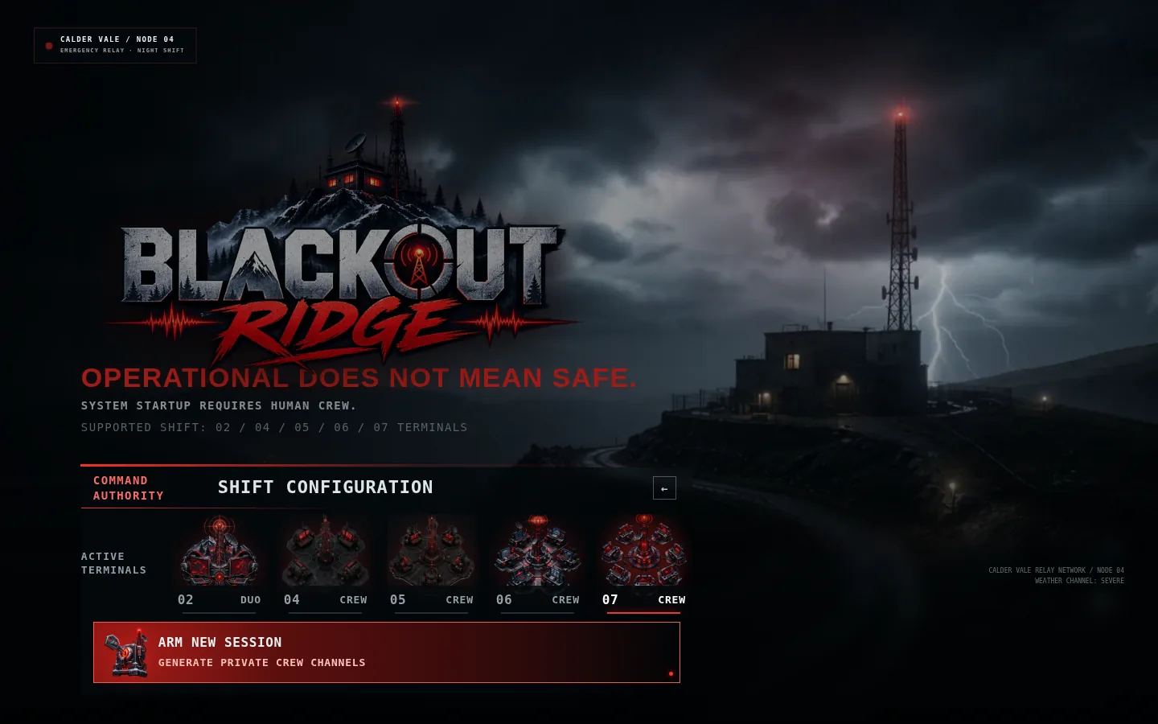
Figure 2. Command Authority chooses the number of participant terminals before arming the session.
1 Choose 4, 5, 6, or 7 players. | 2 The facilitator becomes Game Master; they are not counted as a player. | 3 Arm the shift to create the session code and private facilitator authority.

1. Engage the station from the opening screen.
2. Choose Command Authority / host mode.
3. Select the exact number of participants who will play roles.
4. Arm the shift. The application creates a six-character session code and private facilitator token.
5. Keep the facilitator tab private. Copy the crew link and open the Room Display in a separate tab.

2.4 Assemble the room
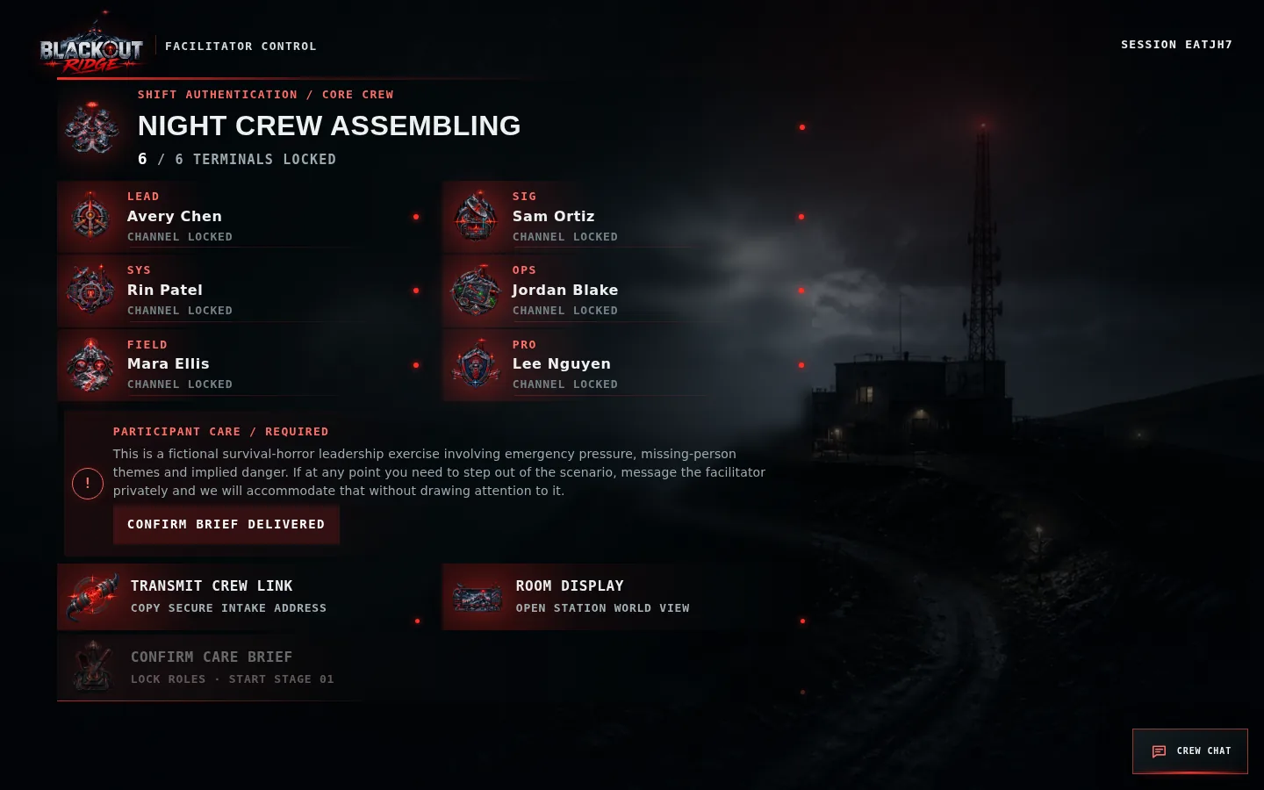
Figure 3. The facilitator assembly lobby shows connected terminals, the participant-care gate, crew link, room display, and start control.
1 Roster: each required terminal must be connected. | 2 Participant care: the facilitator must read and confirm the briefing. | 3 Start remains locked until both conditions are true.

Link handling
Link | Who receives it | Rule
Crew link | All participants | Safe to share with the intended cohort; players claim one open role
Player link | Only that participant | Contains a bearer token; do not paste into public chat or screenshots
Shared display | Room display / screen share | Read-only and intentionally excludes private evidence and Crew Chat
Facilitator link | Facilitator only | Contains full control and all recommendations; treat as confidential

2.5 Five-minute preflight
- Open the shared display at 100% browser zoom and full-screen it.
- Confirm every participant can see their name, role, and private evidence card.
- Ask players not to share their browser tab or player URL.
- Test voice communication; use Crew Chat as fallback, not as the only plan unless required.
- Confirm the facilitator can Pause, add 30 seconds, send a prompt, and activate Safety Pause.
- Explain that audio is opt-in and can remain off.
- Read the participant-care statement and confirm it in the lobby.
- Close unrelated notifications and avoid browser translation or aggressive content blockers.

SECTION 3

New-player guide
A spoiler-light explanation participants can follow without learning the answers.

3.1 Join and claim a responsibility
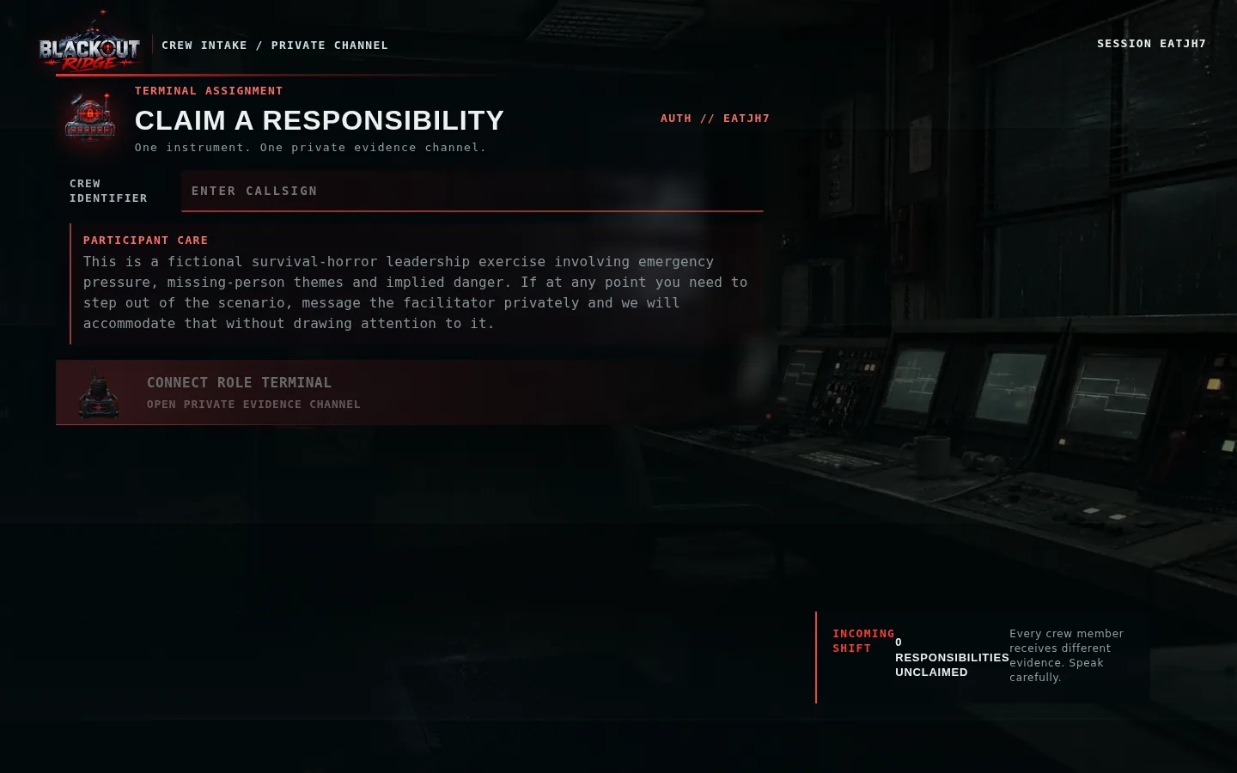
Figure 4. A new participant enters a callsign and claims an available role terminal.
1 Enter the name others should recognize. | 2 Read the participant-care notice before connecting. | 3 Only unclaimed roles can be selected; one browser becomes one private terminal.

1. Open the crew link from the facilitator.
2. Enter your display name or workshop callsign.
3. Choose one available responsibility. If a role disappears, another participant claimed it first.
4. Press Connect Role Terminal and keep that tab open.
5. If you refresh, return using the same player link or browser; the token restores your role.

3.2 The responsibilities
Role | What this role protects | Once-per-session override
Station Lead | Accountability, pace, unresolved disagreement, crew commitment | Hold the Clock
Signal Analyst | Source, timestamps, waveform meaning, preservation and replay | Recover Fragment
Systems Engineer | Dependencies and what a status actually measures | Trace Dependency
Operations Officer | Bounded action, route, equipment, timing, abort conditions | Controlled Test
Field Liaison | Mara, human context, staff practice, people missing from clean data | Human Check
Protocol Officer | Guardrails, uncertainty, receiver requirements, safety thresholds | Safety Condition
Comms Officer (7 players) | Receiver trust, message clarity, acknowledgement and readback | Request Readback

CREW SIZE AND COMBINED ROLES
Blackout Ridge is designed for four to seven players. Four-player games combine Command with Protocol and Operations with Field; five-player games combine Field with Protocol. Six-player games redistribute essential Comms evidence, while seven-player games use every responsibility as a separate terminal. Every supported crew size receives the evidence needed to complete all seven acts.

3.3 What to do in every stage
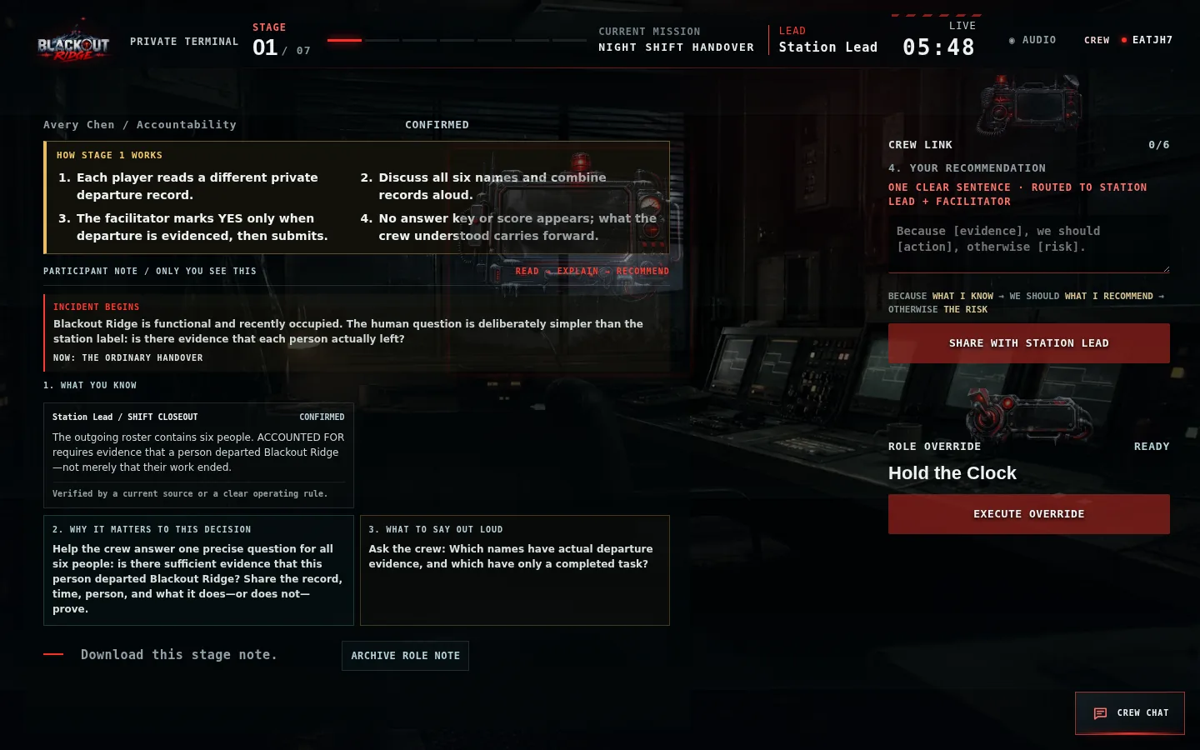
Figure 5. A player terminal now turns each private brief into four plain-language actions: understand the evidence, interpret its confidence, say what matters aloud, and make a recommendation.
1 WHAT YOU KNOW separates evidence from interpretation. | 2 WHY IT MATTERS connects that evidence to the current crew decision. | 3 WHAT TO SAY OUT LOUD gives a direct discussion prompt. | 4 The consequence preview names what the proposed decision preserves, costs, and still leaves unresolved.

- Read. Identify what your evidence actually proves and what remains an assumption.
- Speak. Share the evidence aloud or in Crew Chat. State its confidence: confirmed, likely, stale, unknown, or contradicted.
- Recommend. Complete the sentence: Because [evidence], we should [action], otherwise [risk]. Then choose Share with Station Lead. A visible confirmation shows it was routed.
- Question. Ask which source produced a clean label and what that source is authorized to claim.
- Commit. The Station Lead summarizes and submits the crew decision. The facilitator can also resolve when necessary.
- Observe consequence. Read what changed; earlier choices affect later clarity, safety, trust, and options.

3.4 Recommendations are not public chat
Channel | Who sees the text | Best use
Your Recommendation | You, Station Lead, and facilitator; peers see only that you submitted | Short stage assessment tied to your private evidence
Crew Chat | All authenticated players and facilitator | Discussion, remote fallback, coordination, accessibility
Voice | Everyone on the room/call | Primary discussion channel and fastest synthesis
Shared display | Anyone with shared URL | Common incident only; cannot read or post chat

3.5 Crew Chat
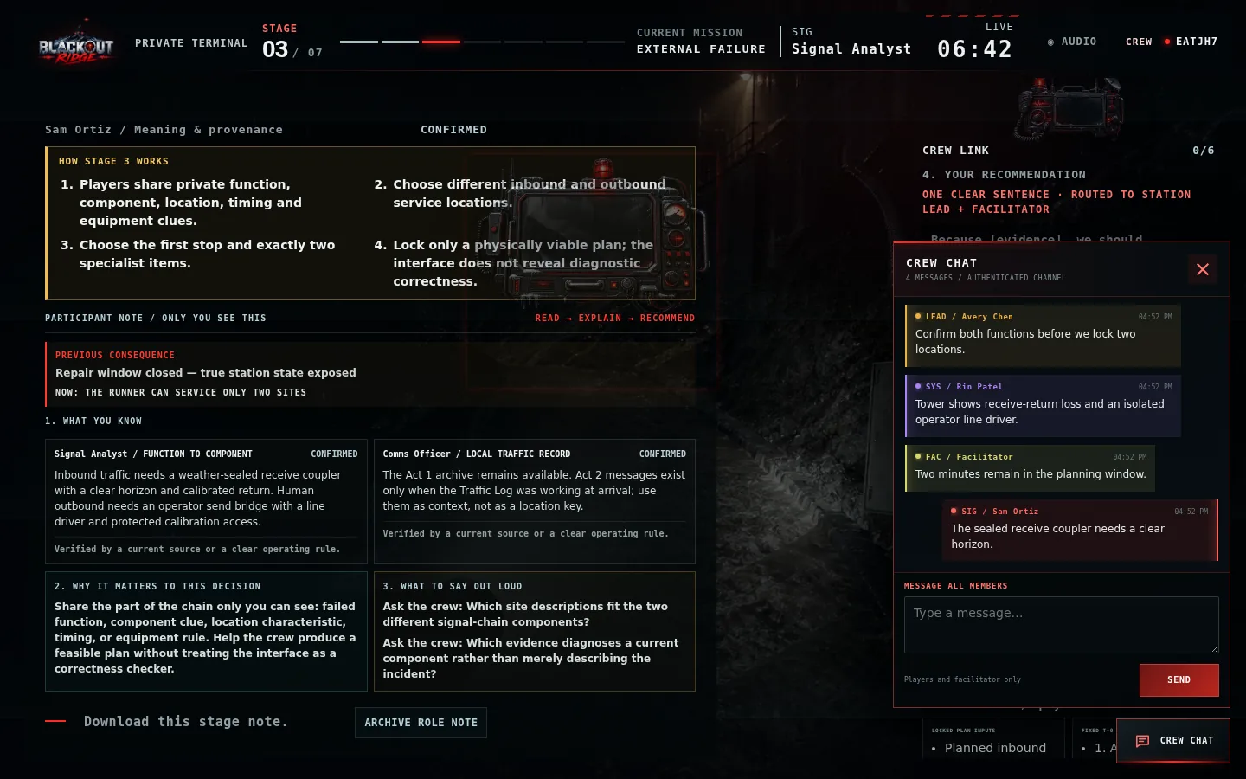
Figure 6. Crew Chat uses stable role colors so participants can distinguish senders quickly.
1 Other roles retain distinct colors by responsibility. | 2 Your own messages appear red and align right. | 3 Unread messages produce a badge and temporary alert; the shared display has no chat access.

- Open the lower-right Crew Chat button.
- Messages synchronize immediately to authenticated players and the facilitator.
- Lead is amber, Signal cyan, Systems violet, Operations green, Field rose, Protocol blue, Comms orange, Facilitator yellow; your own bubble is red.
- Messages are limited to 500 characters. The session retains the latest 100 messages.
- Do not use chat for sensitive personal disclosures; it is included in the facilitator’s exported record.

3.6 Mobile use
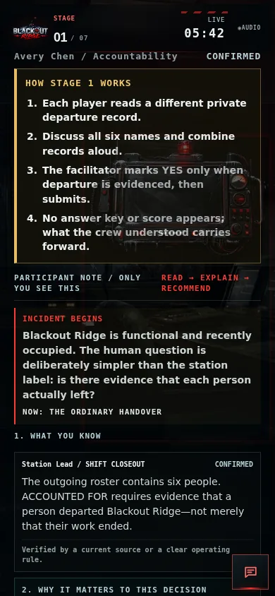 | 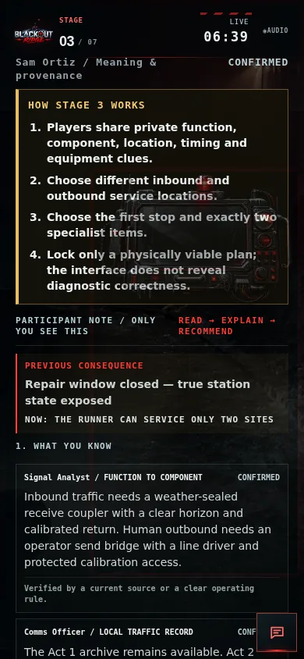
Figure 7. Structured participant note and decision preview on a phone. | Figure 8. Live private Signal terminal on a phone.

- Use portrait orientation for reading and chat; landscape can help with dense stage controls.
- Scroll within the page when the current control is below the evidence card.
- The chat button stays in the lower-right corner; close chat before using controls underneath it.
- Browser zoom should remain at 100%. Increase operating-system text size if accessibility requires it.

SECTION 4

Screen-by-screen reference
What each interface is showing and what the user should do with it.

4.1 Shared station
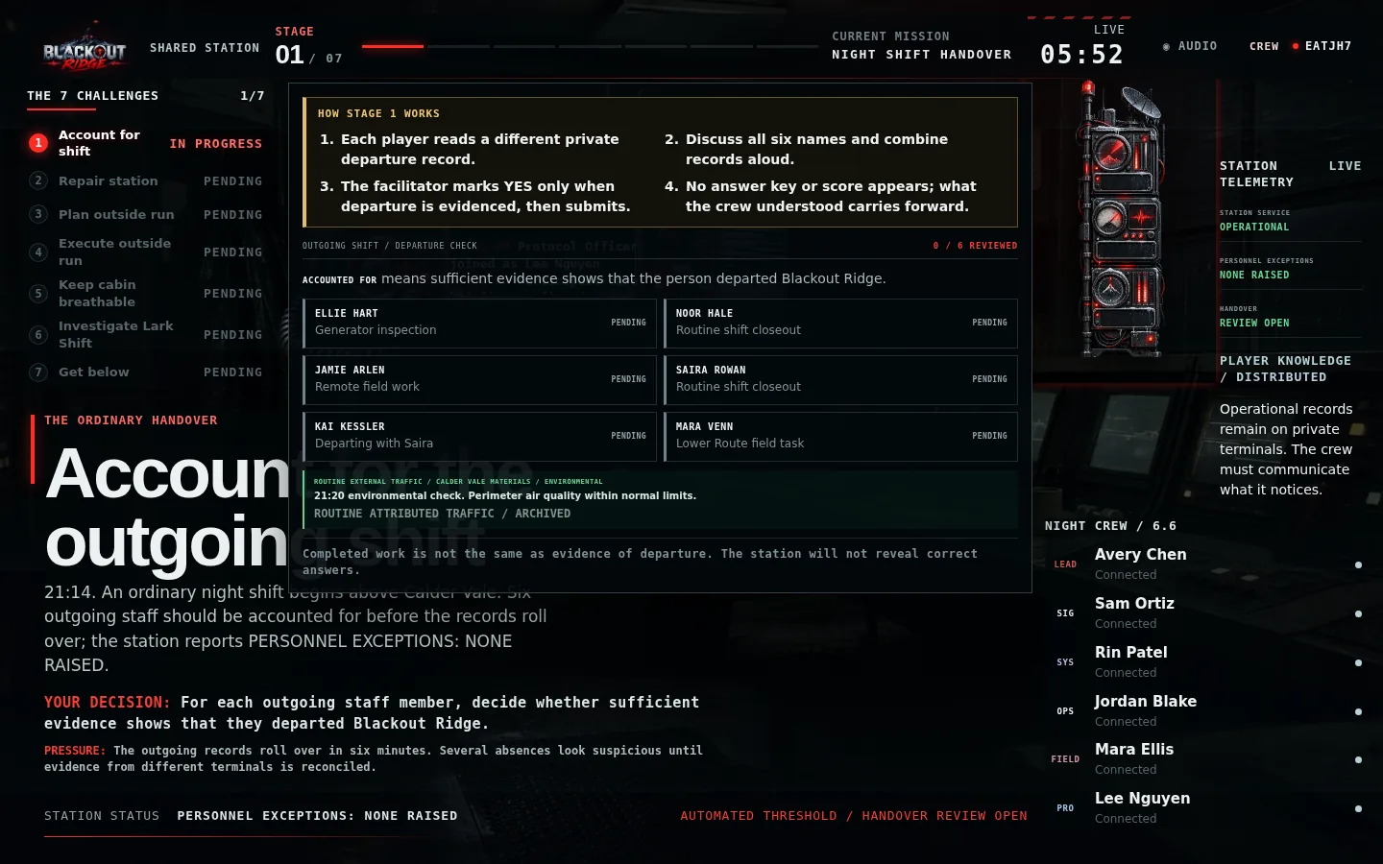
Figure 9. The shared Stage 1 station view keeps the incident, timer, challenge stack, signal, tracks, evidence, and roster in one common picture.
1 Mission and timer establish the current decision window. | 2 Incident pressures and three persistent tracks show compounding consequences. | 3 Verified evidence and roster are public; private cards remain hidden.

Persistent tracks
Track | Labels | Interpretation
Upper Air | Stable → Trace → Unsafe → Critical | Surface operating safety and remaining pressure margin
External Trust | Unverified → Heard → Credible | Whether Cordon Control will act on Ridge traffic
Official Status | Drafting → Repeating → Hardening → Filed | How close a false calm conclusion is to becoming authoritative

4.2 Private role terminal
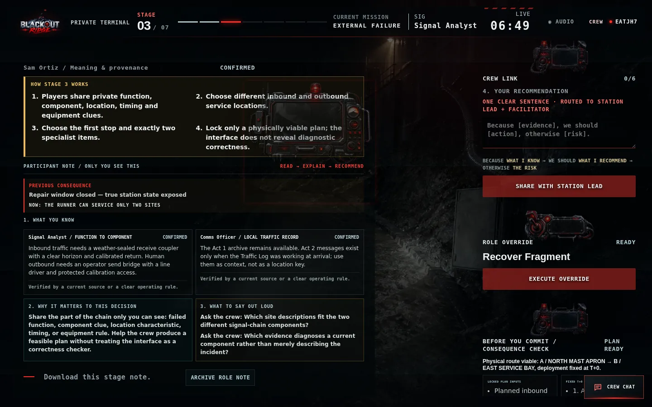
Figure 10. Signal Analyst sees a role-specific brief during the degraded-signal stage.
1 Private evidence is deliberately incomplete. | 2 The confidence label describes evidence quality, not whether the player is correct. | 3 Archive Role Brief downloads a text copy for remote or accessibility use.

How to read a Participant Note
Block | Meaning | Participant action
What you know | The role's private observation or record | Separate the evidence from your preferred action
Confidence | Why the evidence is confirmed, likely, stale, contradicted, or unknown | Say the confidence level when sharing it
Why it matters | The connection to this stage's exact decision | Name what changes if the crew ignores it
What to say out loud | A direct question or sentence starter | Use it to bring the evidence into discussion
Your recommendation | A private summary routed to Lead and facilitator | Link evidence, action, and risk in one concise statement

4.3 Facilitator console
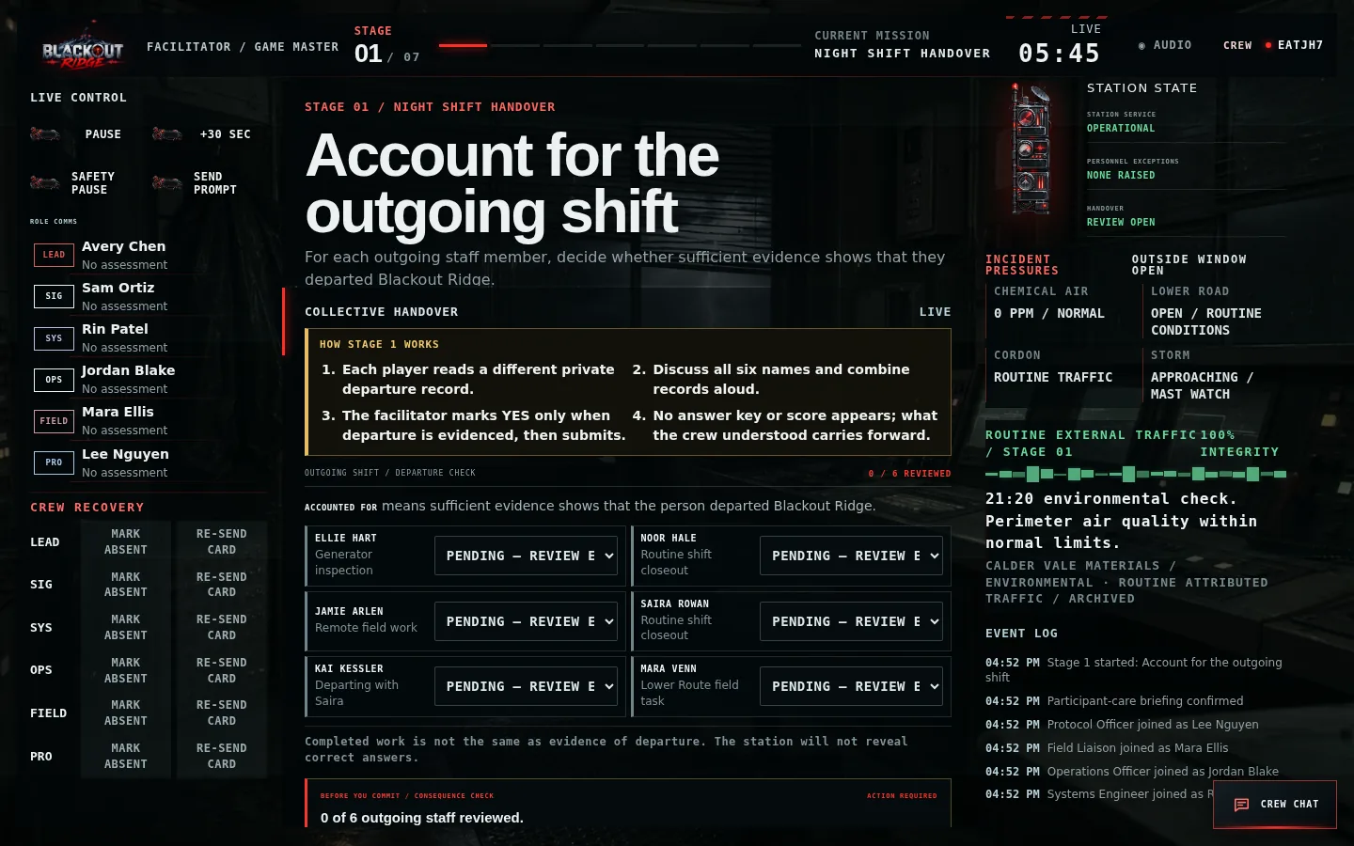
Figure 11. The facilitator console combines live control, all role submissions, decision controls, station state, signal, evidence, and event history.
1 Left: pace, safety, prompts, reports, and recovery. | 2 Center: current crew decision; facilitator can resolve if needed. | 3 Right: authoritative state, evidence, signal integrity, and audit history.

Controls and correct use
Control | Use when | Do not use to
Pause / Resume | Technical interruption, room management, necessary clarification | Remove normal decision pressure
+30 sec | Compensate for a connection or interface delay | Reward indecision or steer toward a better choice
Safety Pause | A participant needs intensity reduced or time out | Create dramatic effect
Send Prompt | The group is stuck on the rule or missing question | Reveal a private answer
Mark Absent | A player steps out; observer mode blocks game actions but leaves chat available | Punish non-participation
Re-send Card | A player lost or cannot locate their private evidence | Broadcast another role’s evidence
Reassign Role | A role must move to a connected participant | Change outcomes after seeing the preview
Resolve Decision | Facilitator is authorized to commit or recover the stage | Silently replace the crew’s actual choice

4.4 Consequence screens
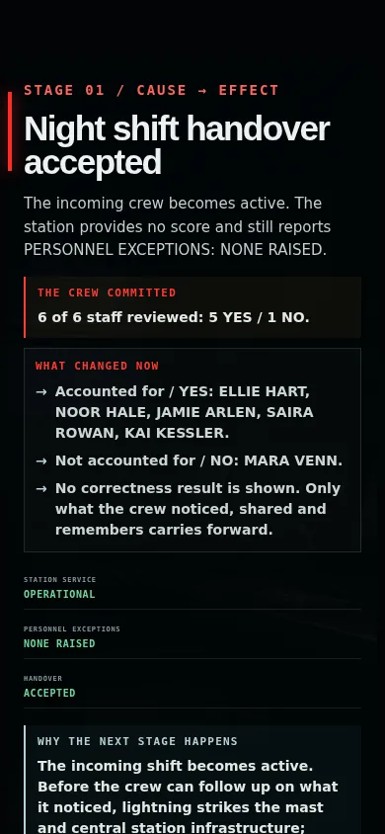
Figure 12. Every commitment opens a cause-and-effect reveal before the next stage can begin.
1 THE CREW COMMITTED repeats the exact choice. | 2 WHAT CHANGED NOW names immediate gains and costs. | 3 Persistent tracks show the updated pressure. | 4 WHY THE NEXT STAGE HAPPENS provides the narrative bridge into the escalating emergency.

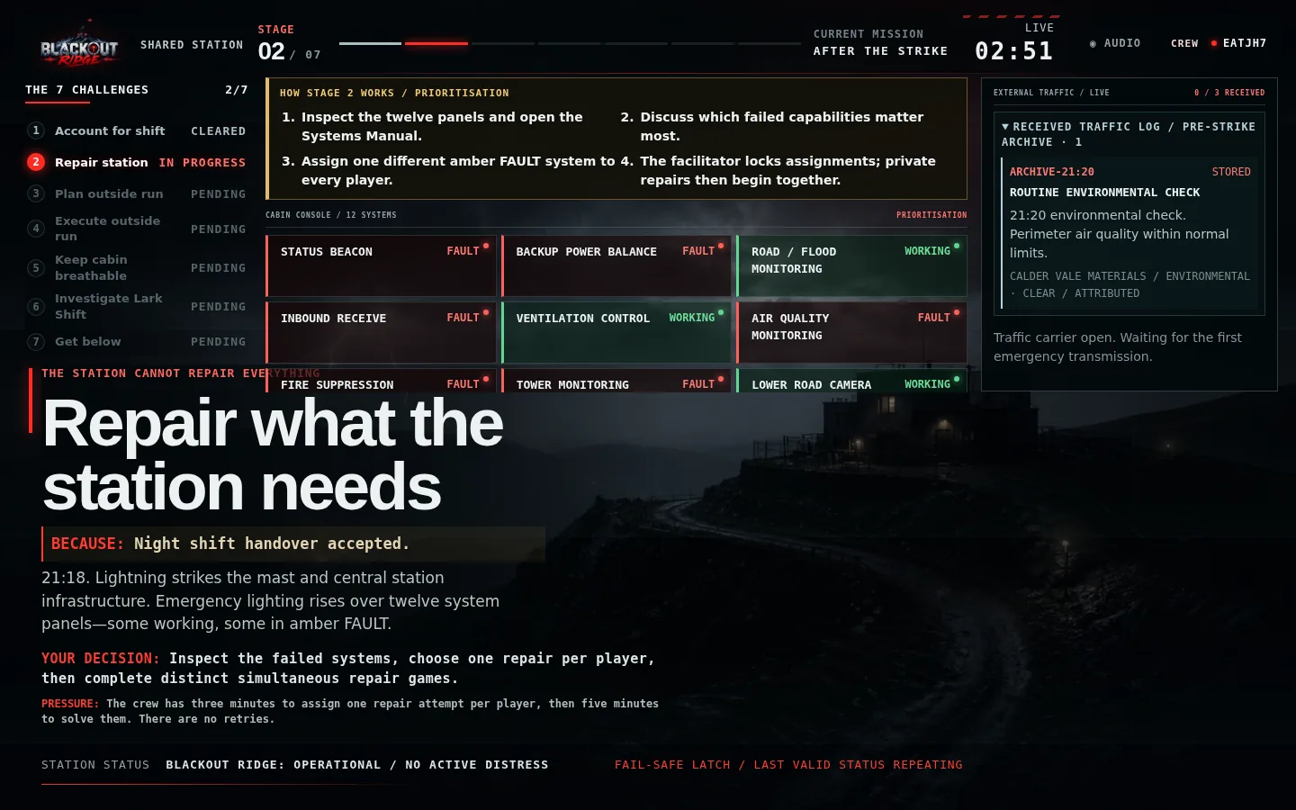
Figure 13. Stage 2 shared view: twelve equally weighted system panels show the station's true WORKING and FAULT state.
1 The crew chooses one failed system per player. | 2 Private repair games run simultaneously after assignments lock. | 3 External traffic changes according to what is working when each message arrives.

SECTION 5

Facilitator runbook
A practical, safe, and repeatable 70-minute delivery sequence.

5.1 Recommended timing
Block | Time | Facilitator goal
Arrival and technical check | Before start | Links, devices, voice, shared display, private tabs
Participant care and opening | 5 minutes | Consent, off-ramp, premise, interaction loop
Stages 1–7 | 43 minutes designed clocks | Keep decisions bounded; let consequences teach
Transition | 2 minutes | Let the ending land; separate system record from human reality
Debrief | 20–25 minutes | Reconstruct, map roles, diagnose hesitation, bridge to work, record first steps

5.2 Participant-care script
READ BEFORE STARTING
“This is a fictional survival-horror leadership exercise involving emergency pressure, missing-person themes and implied danger. If at any point you need to step out of the scenario, message me privately and I will accommodate that without drawing attention to it. You do not need to explain why.”

Only choose Confirm Brief Delivered after reading the statement. The game cannot start until every configured terminal is connected and the briefing is confirmed. Safety Pause freezes the clock and replaces active pressure with a neutral pause message on every screen.

5.3 Opening script
SUGGESTED WORDING
“You are the night crew at Blackout Ridge Signal Station. The storm has damaged the mast. Mara Venn is missing. The station is producing calm operational answers, but each of you can see different evidence. Share what matters, name what you are assuming, and make one crew decision before each window closes. You may be unable to save everything. Operational does not mean safe.”

5.4 Stage rhythm
1. Open with one sentence naming the current incident; stop talking within 30 seconds.
2. Give participants time to read their cards silently.
3. Listen for missing roles and ask, “Whose evidence have we not heard?” rather than asking for a specific clue.
4. At midpoint, name remaining time. At 30 seconds, ask the Station Lead to summarize and commit.
5. After commitment, read the consequence and ask one short noticing question. Do not debrief the full lesson mid-game.
6. Advance only when the group understands what changed operationally.

5.5 Facilitation boundaries
Do | Avoid
Ask what the output measures | Explain the central OPERATIONAL twist during play
Ask which role has not spoken | Read private cards for connected players
Protect participant choice and safety | Secretly alter the ending to make it nicer
Correct a proven interface/transcription error with an audit note | Override a choice because the group chose poorly
Let weak choices fail forward | Restart a stage to chase an ideal route
Keep the shared and human stakes separate | Reduce the result to winning, losing, or points

5.6 Before advancing to the next stage
- The committed decision shown on screen matches what the Station Lead intended.
- The room has read the consequence headline and can name the operational change.
- Any timer or connection loss has been handled transparently.
- No participant-care request is waiting for a private response.
- You have not explained the next reveal or interpreted the group’s behavior for them.
- The shared display, player terminals, and facilitator console all show the resolved state.

SECTION 6

Seven-stage walkthrough
FACILITATOR-ONLY SPOILERS: exact decisions, intended joins, risks, and stage-to-stage handoffs.
SPOILER BOUNDARY
Do not give this section to first-time participants unless the client explicitly wants an open-book demonstration. The learning depends on discovering that several calm labels describe system proxies rather than human reality.

Stage overview
Stage | Time | Question | Required crew decision
1. Account for the outgoing shift | 6 min | Did each outgoing staff member actually depart? | Record one collective YES/NO answer for each of 6 people
2. Repair what the station needs | 3 + 5 min | What can the damaged station still do? | Assign one different repair per player; complete simultaneous one-shot games
3. Build the outside plan | 7 min | Which two sites restore human communications? | Inbound site, outbound site, first target, exactly 2 specialist items
4. Execute the outside run | 8 min | Can the crew execute both locked field services? | Assign runner; complete 2 observation/instruction/action games
5. Keep the cabin breathable | 4 min | How long can the crew preserve breathable air as the plume worsens? | Rotating cabin controls; Act 6 time; R-12/Mara reveal
6. The Lark Shift | 3–6 min | Why did six people die after R-12 protected them? | Search history, then teach every player the R-12 operating procedure
7. Get Below | 8–10 min | Can everyone reach R-12 without repeating the Lark Shift? | Sequential transfers, shared purge and a solo surface procedure

6.1 Stage 1 — Account for the outgoing shift
Figure 14. Stage 1 facilitator view for recording the crew's six collective departure answers.
- Situation. An ordinary night shift begins while the station reports PERSONNEL EXCEPTIONS: NONE RAISED. Six outgoing staff members must be accounted for before rollover.
- Decision. For Ellie Hart, Noor Hale, Jamie Arlen, Saira Rowan, Kai Kessler and Mara Venn, decide whether the available evidence is sufficient to show that person departed Blackout Ridge.
- Information join. Departure, task, vehicle, badge and communications records sit on different private terminals. No participant—including the facilitator—has a complete privileged view.
- Designed false alarm. Noor's rover remains at Ridge and the loading-point scan proves only arrival there. Noor is accounted for only when the crew joins those records with Calder Vale's external shuttle readback.
- Crew-size safeguard. At four and five players, the absent Comms evidence is combined into the Signal terminal. At six players, explicit supplements preserve the same required joins.
- Facilitator watch. Ask participants to state what their record proves and what it merely suggests. Enter only the answer the crew agrees for each person.
- Resolution. Submission and timeout reveal no correctness score and create no later mechanical bonus or penalty.
- Handoff. The completed handover is interrupted by a lightning strike that damages station systems.
DO NOT REVEAL
Do not confirm correct answers. The purpose is to establish how the crew shares and tests incomplete operational records.

6.2 Stage 2 — Repair what the station needs
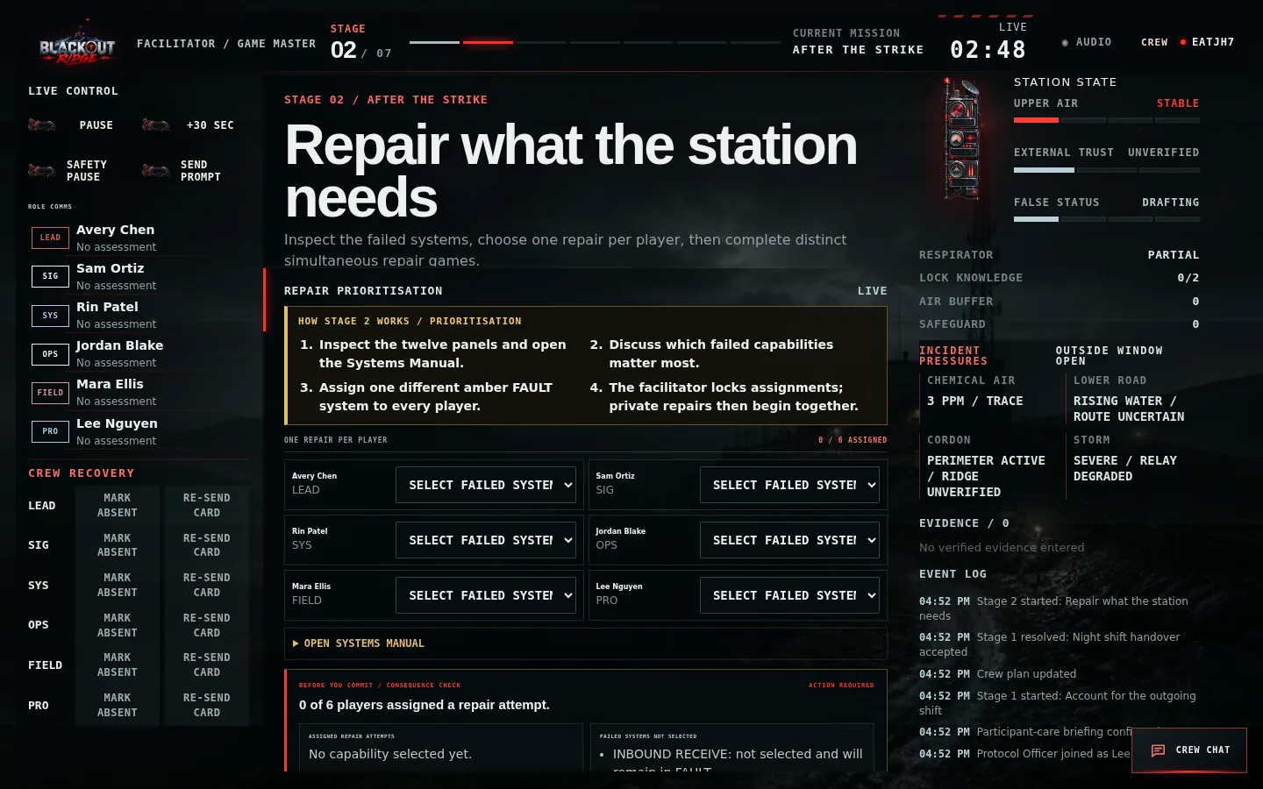
Figure 15. Stage 2 facilitator controls for assigning one distinct amber FAULT panel to every player.
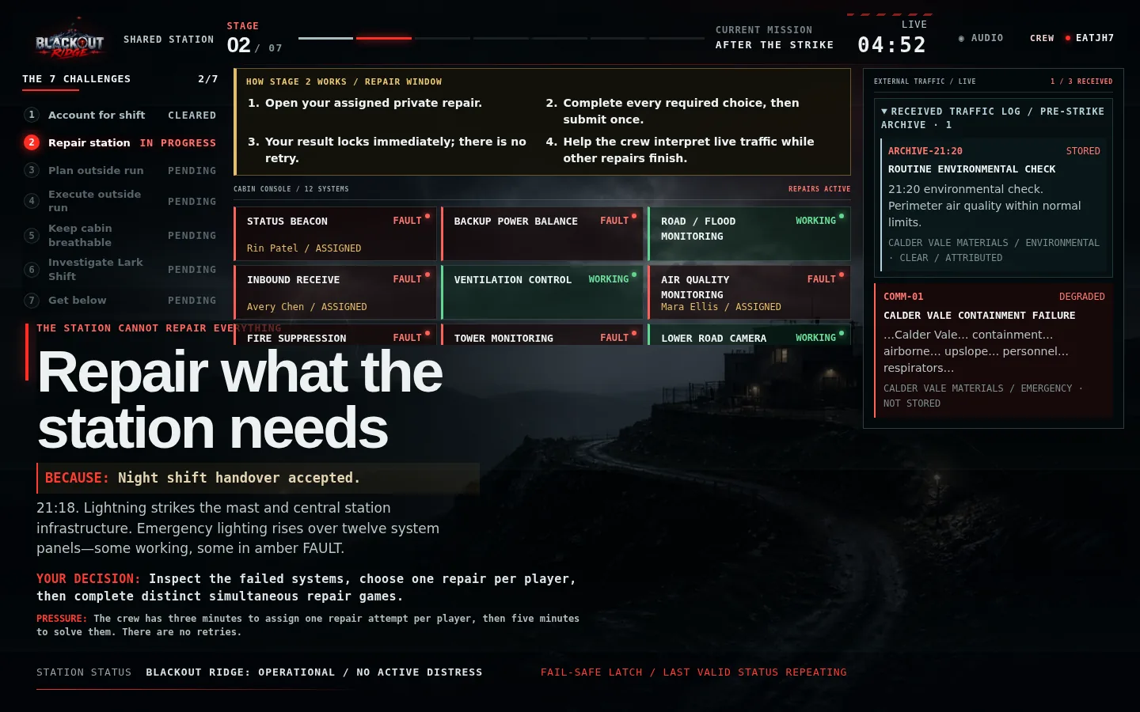
Figure 16. Once assignments lock, the shared console shows all active repairs and the first developing external transmission.
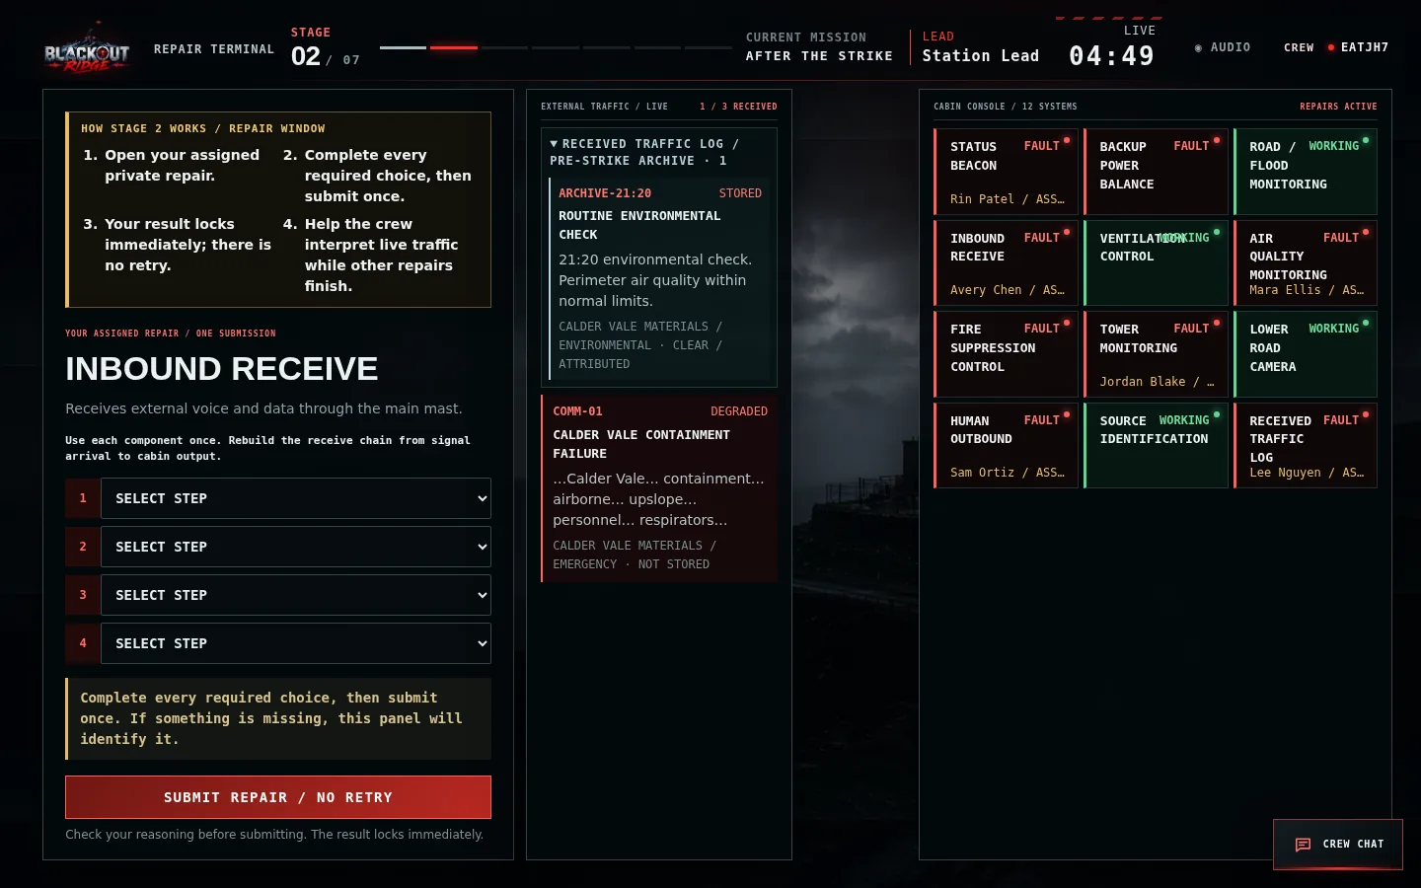
Figure 17. A private Inbound Receive repair uses a one-screen sequencing problem; its server-held solution is not visible to other terminals.
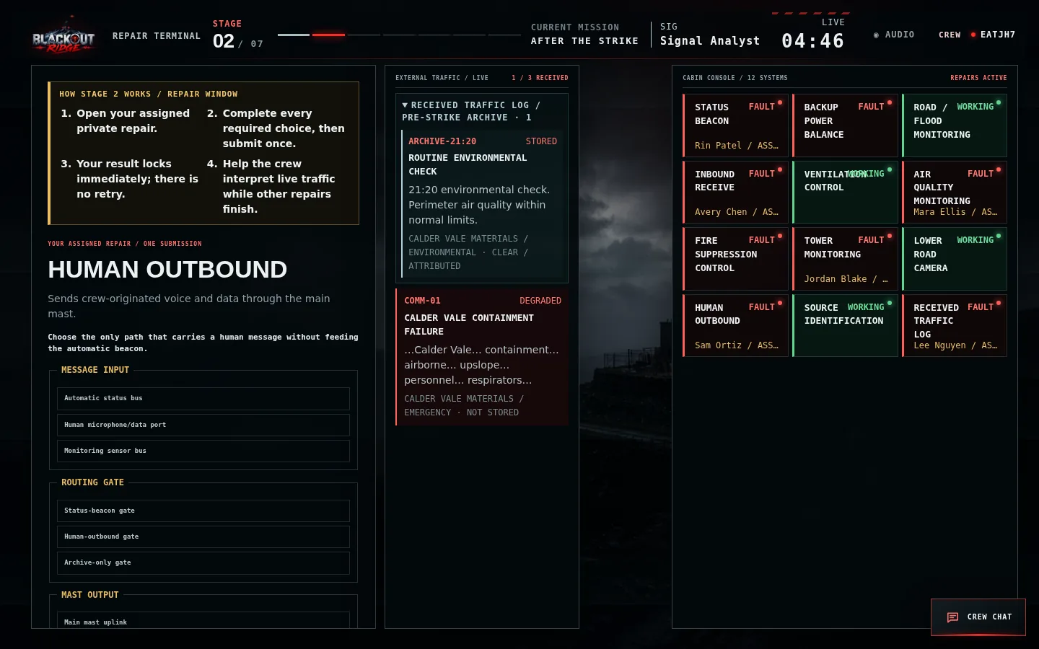
Figure 18. Human Outbound uses a different routing problem, separating human messages from automatic status traffic.
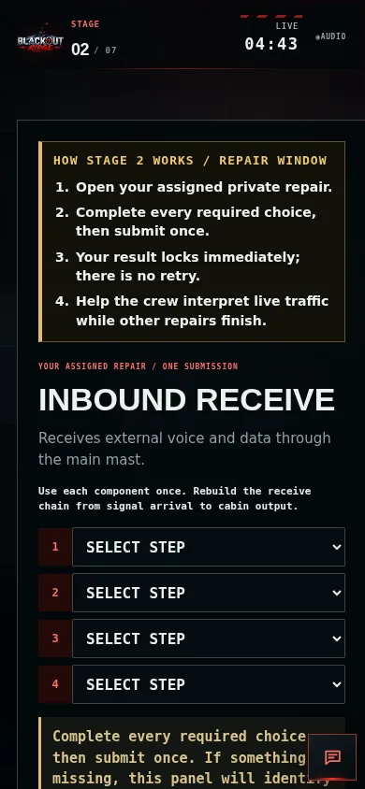
Figure 19. The private repair workflow remains readable and fully scrollable on a phone.
System group | What the crew sees | Rule
Seven consequential systems | Inbound Receive; Human Outbound; Status Beacon; Tower Monitoring; Air Quality Monitoring; Received Traffic Log; Source Identification | Only ranks 1–X begin broken for X players; ranking is hidden
Two credible alternatives | Backup Power Balance; Fire Suppression Control | Always begin broken and repair genuinely, but do not matter later in this scenario
Three surviving systems | Road/Flood Monitoring; Lower Road Camera; Ventilation Control | Remain WORKING and cannot be selected

- Allow about three minutes for the Systems Manual and prioritisation. Enter the team’s choices without advising them.
- Every player receives one different repair. The five-minute repair window runs simultaneously on private terminals.
- Each puzzle is a system-related reasoning task with one submission and no retry; success takes effect immediately.
- The twelve-panel layout interleaves consequential, alternative and surviving systems so position does not reproduce the hidden ranking.
- The Traffic Log area exposes the exact clear pre-strike Calder Vale baseline separately from live incident traffic.
- COMM-01 always arrives degraded. Later clarity, attribution and storage depend separately on Inbound Receive, Source Identification and Received Traffic Log.
- With shared-station audio enabled, recorded transmissions play in arrival order; the matching accessible transcript remains visible.
- Show the final true station state without a score or hint about which choices will matter later.
- Handoff: a central external distribution failure takes field infrastructure and Ventilation Control offline for Act 3.

6.3 Stage 3 — Build the outside plan
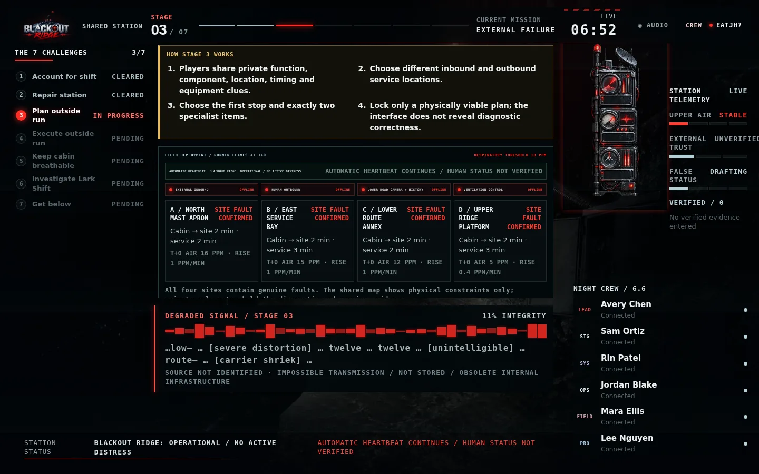
Figure 20. Stage 3 shared station: four red external outages, four genuine field faults and fixed T+0 route conditions.
Figure 21. Signal Analyst private evidence distinguishes the inbound receive coupler from the human-outbound send bridge.
- Decision. Enter one planned inbound location, one different human-outbound location, the first selected target, and exactly two items from Gas Mask, Flood Response Kit, High-Access Kit and Specialist Service Toolkit.
- Evidence join. Participants must connect failed FUNCTION to COMPONENT behavior and then to LOCATION characteristics. Every site has a genuine fault, so site labels cannot solve the problem.
- Physical check. The interface calculates arrival, service completion, plume exposure and required equipment from fixed runner deployment T+0. It checks feasibility only and never confirms the communications diagnosis.
- State-sensitive evidence. Working Tower Monitoring supplies two current component symptoms and one unresolved R-12 legacy reference. If it is broken, other role clues still make the plan fully solvable. Traffic Log contains only messages stored at arrival.
- Order consequence. C→D works with Flood Response + High-Access. D→C crosses the respiratory threshold at C and would also require a Gas Mask, making that reverse route impossible with two items.
- Horror interruption. The unidentified ‘twelve … twelve … route’ transmission is unstored obsolete-infrastructure traffic. It is atmosphere and future setup, not a plan answer.
- Handoff. The plan locks without correctness feedback and the runner leaves at T+0.
DO NOT REVEAL
Never say that a selected communications location is right or wrong. Give only practical feedback such as duplicate sites, missing equipment, route order or respiratory threshold.

6.4 Stage 4 — Execute the outside run
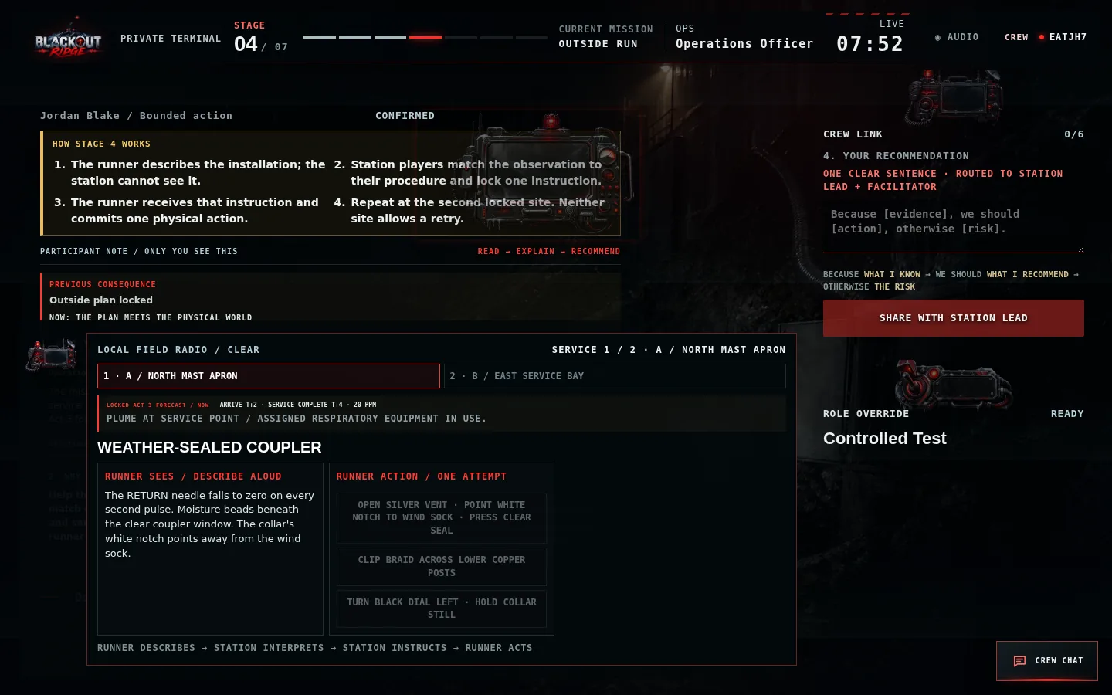
Figure 22. Runner terminal: physical observation and three possible one-shot actions, with no access to the station manual.
1 Describe every visible condition aloud. | 2 Wait for a station instruction. | 3 Commit one physical action; there is no retry.

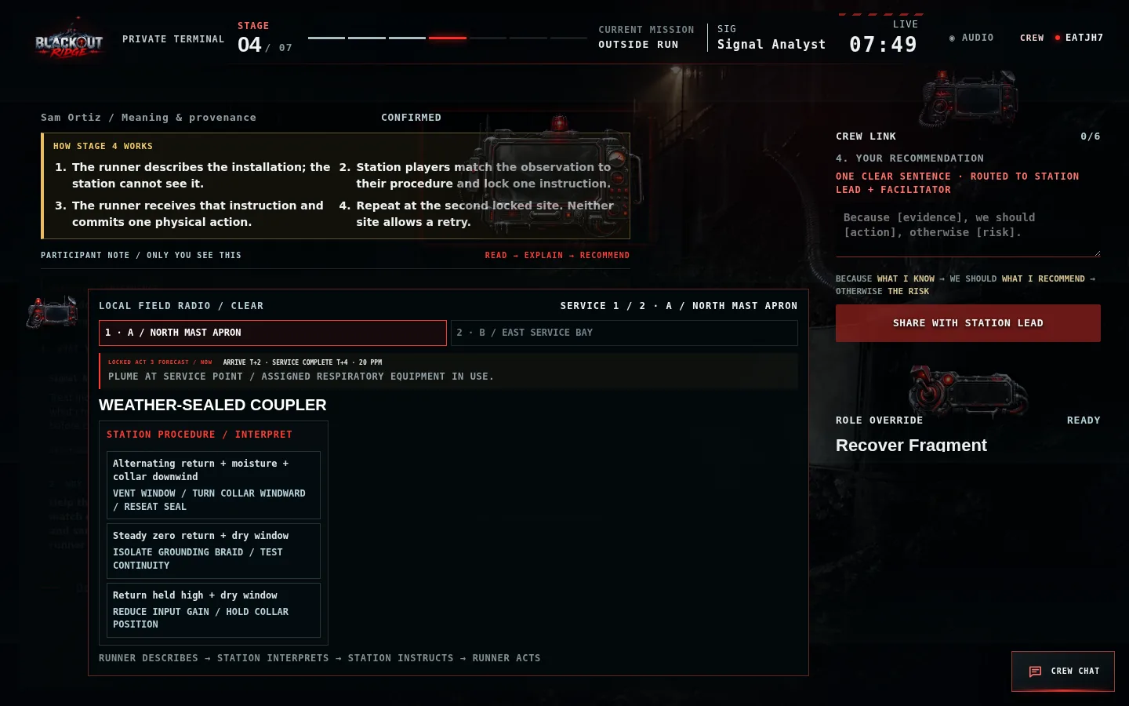
Figure 23. Station terminal: interpretation table and instruction controls, with no access to the runner's private observation.
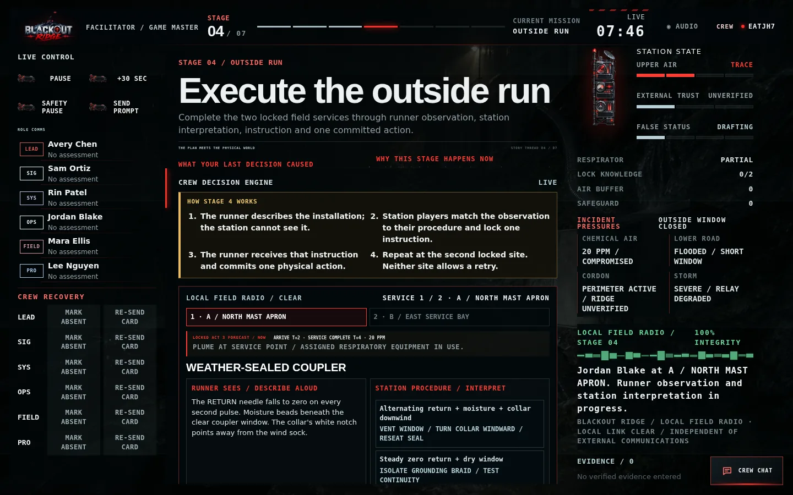
Figure 24. Facilitator oversight shows both sides for technical recovery while preserving the locked route and one-attempt rule.
- Locked input. Assign one runner. The two destinations, visit order and specialist equipment carry forward unchanged from Act 3.
- Core loop. At each location: runner observes and describes → station matches the complete condition to a procedure → station sends one instruction → runner commits one action.
- Physical translation. The station manual uses procedural terms while the runner controls use visible handles, tabs, vanes and landmarks. The crew must translate the instruction rather than copy an identical button label.
- Information split. The runner cannot read the manual; station players cannot see the installation. The shared screen exposes neither private puzzle side.
- No retry. A failed service remains NOT RESTORED and the runner continues to the second committed destination. Never substitute a third site.
- Location consequences. A restores inbound availability; B restores human-outbound availability; C restores camera/history and may show Mara returning toward Ridge; D restores ventilation infrastructure and later purge.
- Communications model. Act 4 determines availability. Act 2 determines quality: a restored external path is FULL if its station system works, otherwise DEGRADED.
- Guardrails. Local runner radio stays clear. Each active service repeats the locked Act 3 arrival, completion and concentration as visible reality, but there is no new route, equipment or gas-management decision.
- Handoff. After service two, the runner returns and the dashboard reveals the recovered operational combination without scoring the Act 3 diagnosis.

6.5 Stage 5 — Keep the cabin breathable
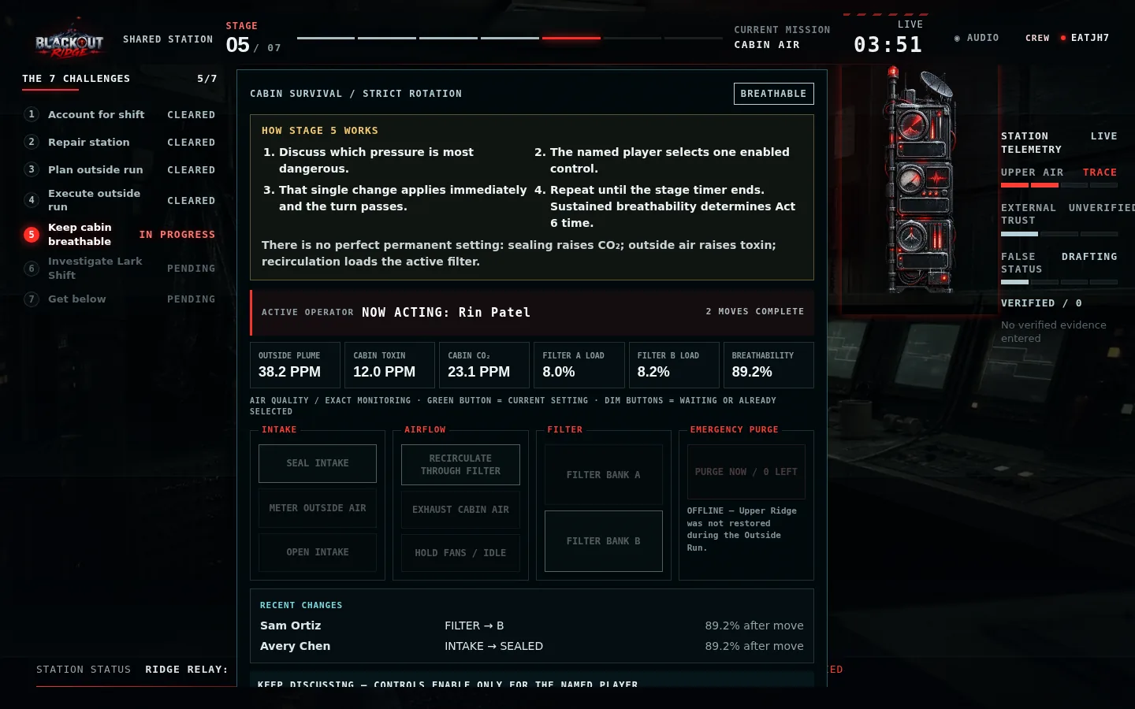
Figure 25. Shared cabin-air board: rising plume, cabin pressures, filter loads, current configuration and strict turn rotation.
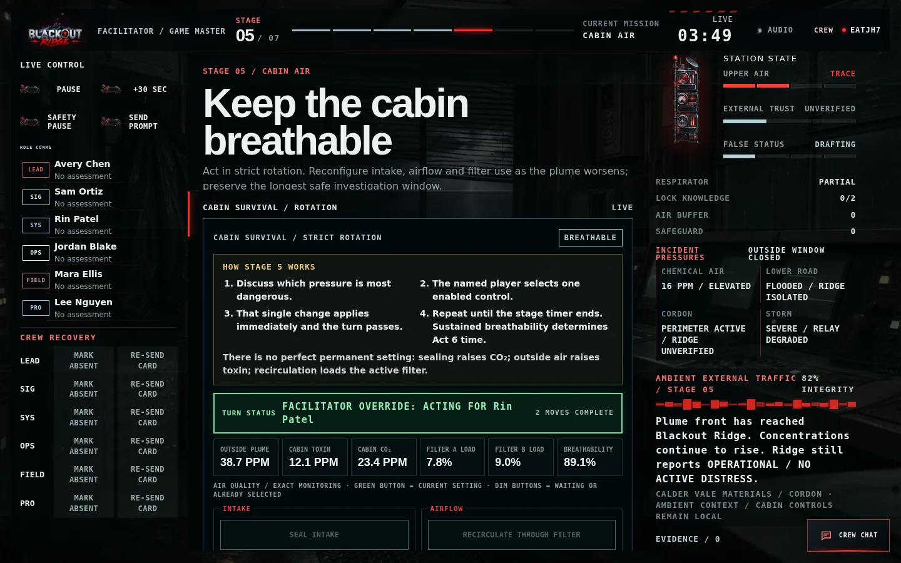
Figure 26. Facilitator oversight of the same live cabin model; controls act for the currently named player only.
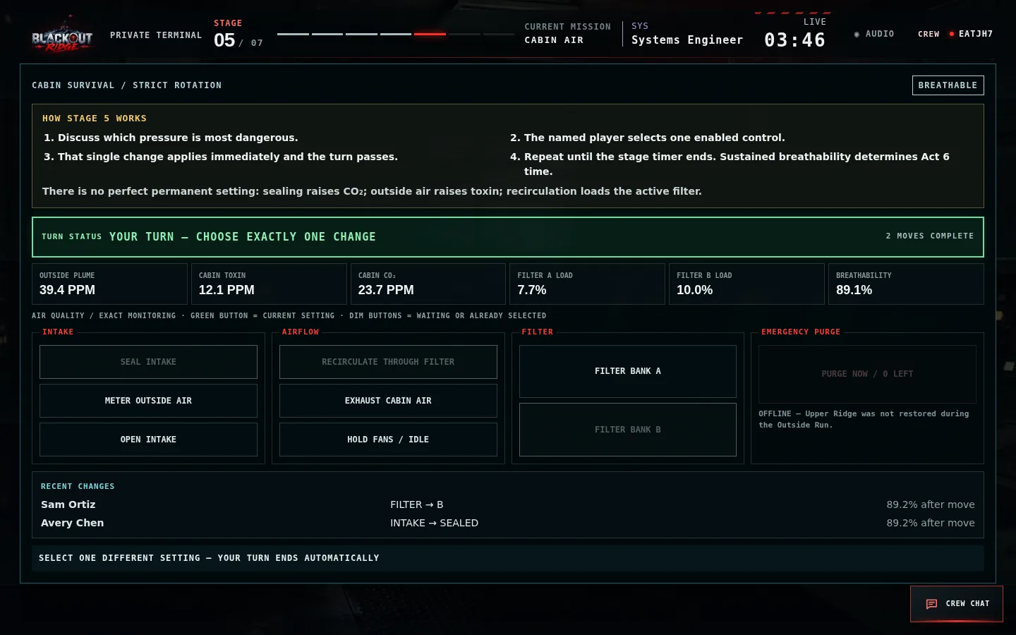
Figure 27. Private terminal: the same compact controls are available to every member, but only the named active player can act.
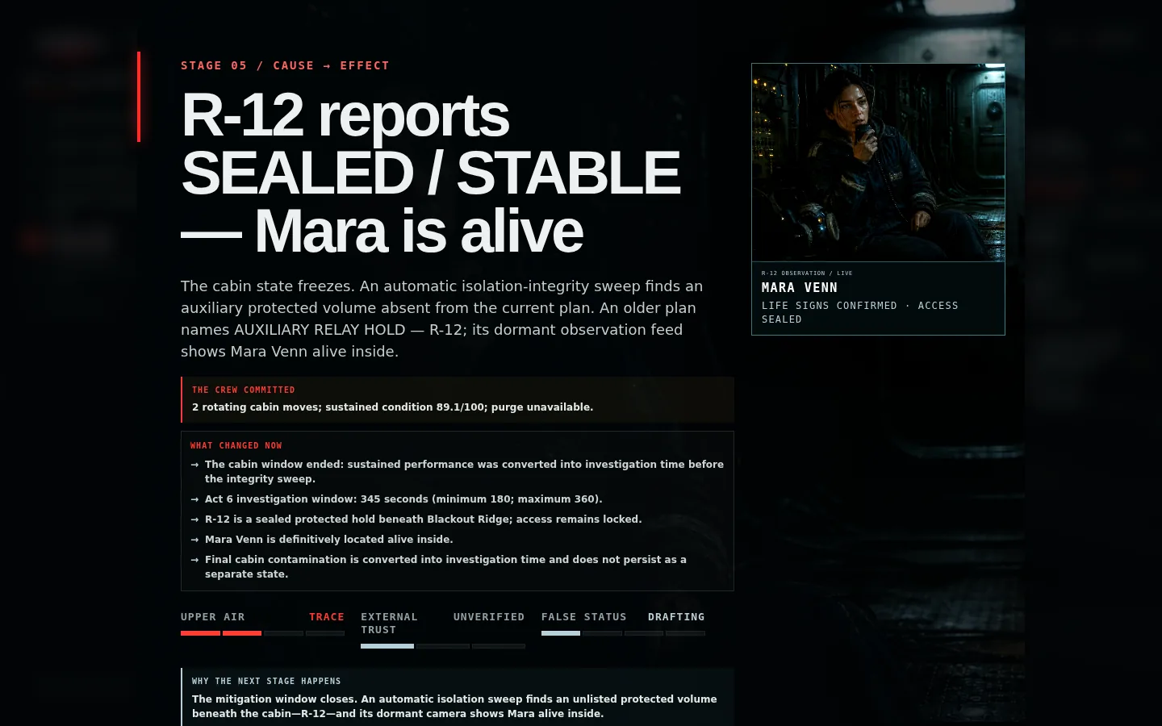
Figure 28. Automatic post-game reveal: the integrity sweep identifies sealed hold R-12 and the dormant camera definitively shows Mara alive.
- Objective. For four continuous minutes, keep the one occupied cabin breathable while outside contamination rises.
- Rotation. Players discuss freely. Only the named active terminal makes one change; control then passes automatically to the next present role.
- Tradeoffs. Sealing slows toxin but raises CO₂. Recirculation filters toxin but loads the selected bank. Exhaust lowers CO₂ while drawing plume inward. No setting stays safe.
- Monitoring consequence. Working Air Quality displays exact readings. If broken, the identical model remains playable through LOW, RISING, HIGH and CRITICAL warnings.
- Upper Ridge consequence. A restored service provides two finite Emergency Purge charges. Purge is strongest with sealed intake and recirculation, but cannot reset the cabin.
- Performance consequence. Sustained cabin condition grants a guaranteed 180–360 second investigation window in Act 6; move count and the final switch positions do not score.
- Automatic reveal. At timeout, an integrity sweep finds sealed auxiliary volume R-12. An old plan identifies Lower Route beneath the cabin and the dormant feed shows Mara Venn alive inside. Access remains locked.

6.6 Stage 6 — The Lark Shift
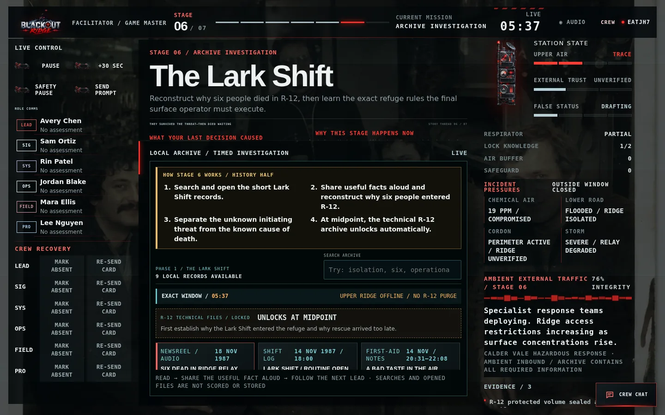
Figure 29. Phase 1: searchable short records reconstruct the Lark Shift without blaming people facing an impossible situation.
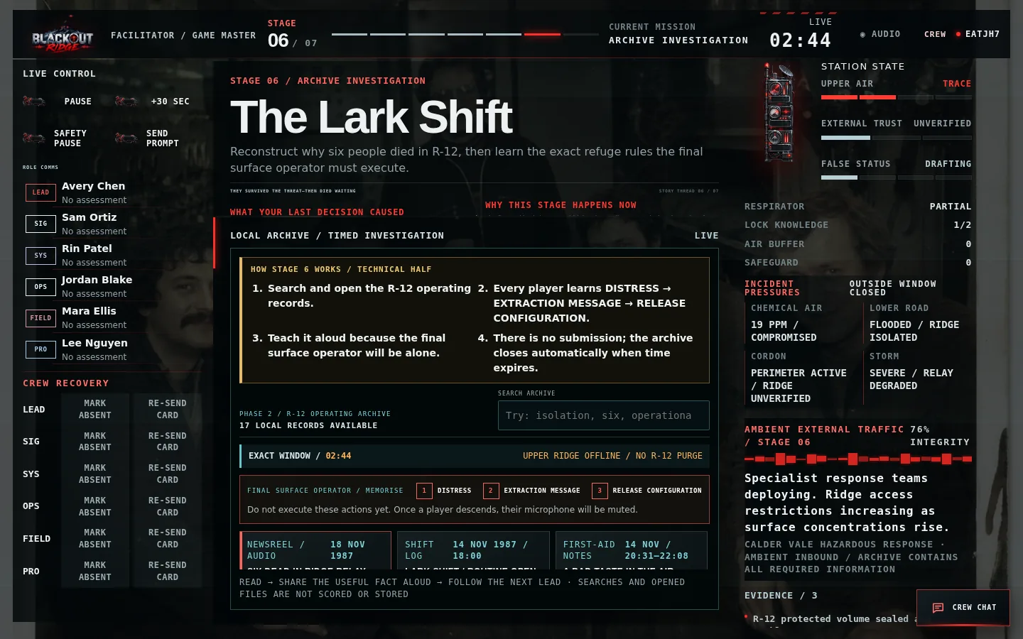
Figure 30. Phase 2: the R-12 operating archive pins the three separate finale tasks for every possible surface operator.
- Use exactly the 180–360 seconds earned in Stage 5; the archive closes automatically and has no scored answer.
- Phase 1 establishes ordinary start, gradual symptoms, rational checks, fear, deliberate refuge entry, secure isolation, no extraction request, false status and delayed fatal recovery. The initiating cause remains unresolved.
- At the midpoint, Phase 2 explains transfer contamination, finite protected air, conditional three-cycle purge and the retained release console.
- Every player must learn DISTRESS → EXTRACTION MESSAGE → RELEASE CONFIGURATION because descent order is hidden and microphones below will be muted.
- Searches and opened records are client-side only; inbound communications are atmospheric and never gate required information.

6.7 Stage 7 — Get Below
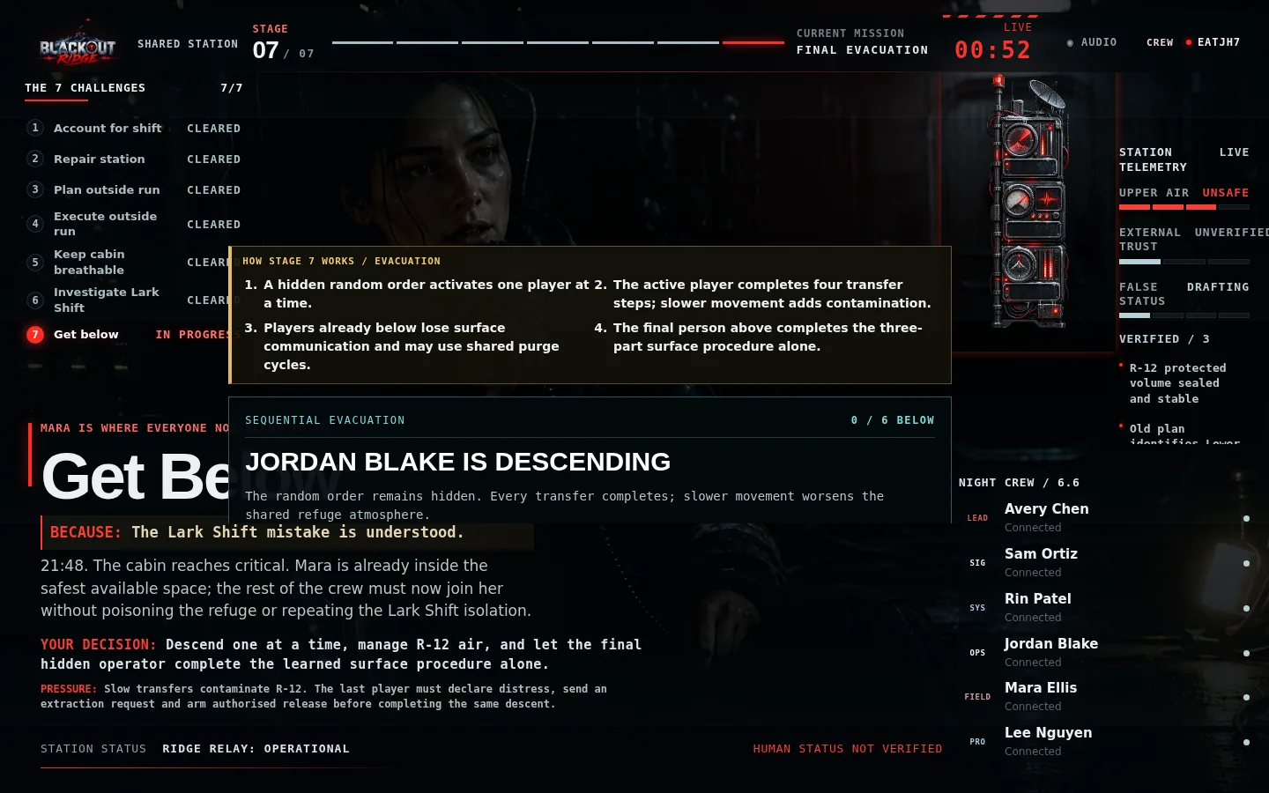
Figure 31. The shared display shows evacuation progress and refuge condition without revealing the hidden order.
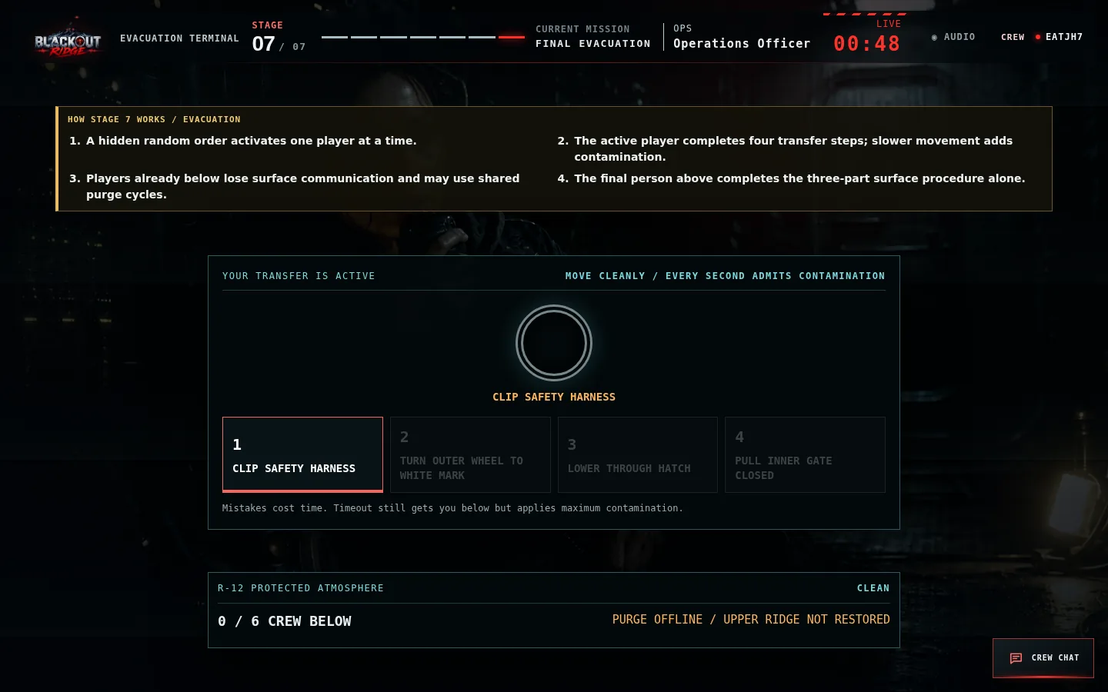
Figure 32. Only the active participant receives the physical transfer; slower movement worsens shared R-12 air.
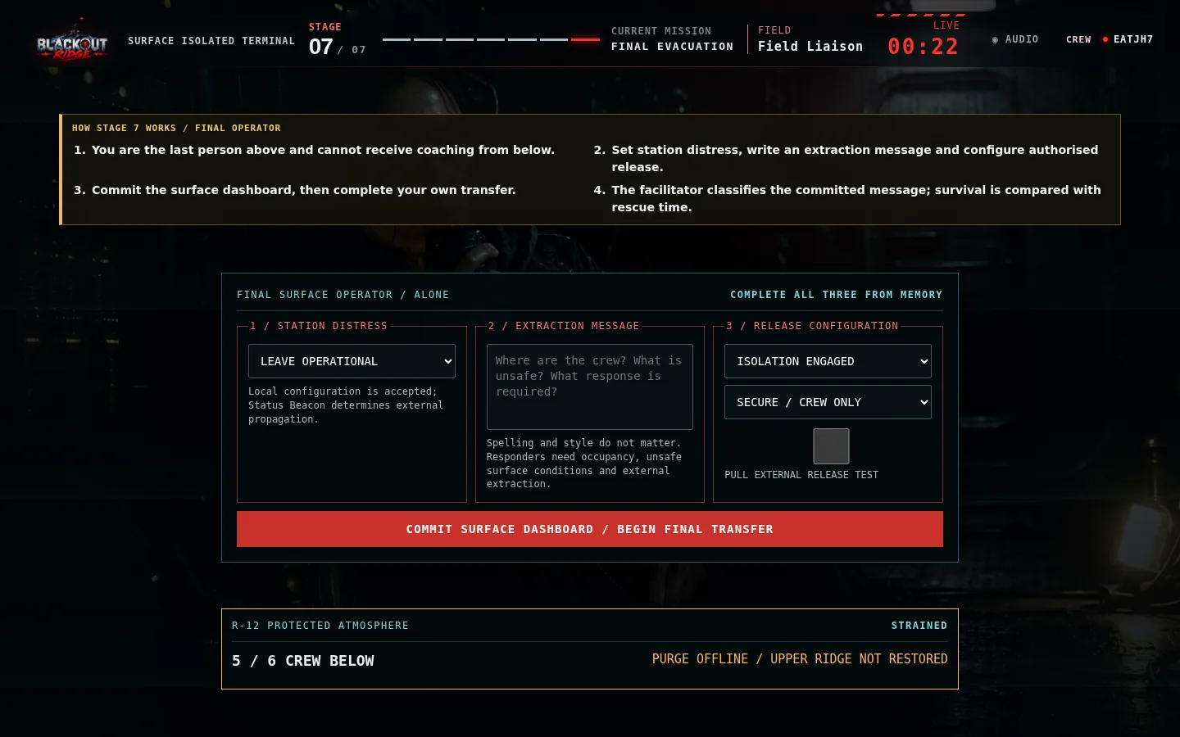
Figure 33. The final hidden participant receives the 30-second surface dashboard alone, using only rules taught in Act 6.
- The server-held random sequence activates one player at a time. Nobody sees an assigned position.
- Every transfer completes. Slower play, mistakes and timeout worsen shared R-12 contamination.
- Players below cannot coach the surface but may independently use shared purge cycles when Upper Ridge was restored.
- The final operator configures DISTRESS, sends a usable extraction request and enables authorised release before descending.
- The facilitator classifies the committed message by useful content, never grammar or style.
- Final air plus occupancy produces survival time; effective status, message and release produce rescue time. Their margin selects the ending.
- Confirm the final record only after checking for a genuine technical mis-entry. Do not change it to improve the outcome.

SECTION 7

Endings and debrief
Let the consequence land, then turn the experience into a concrete workplace action.

7.1 Ending preview and confirmation
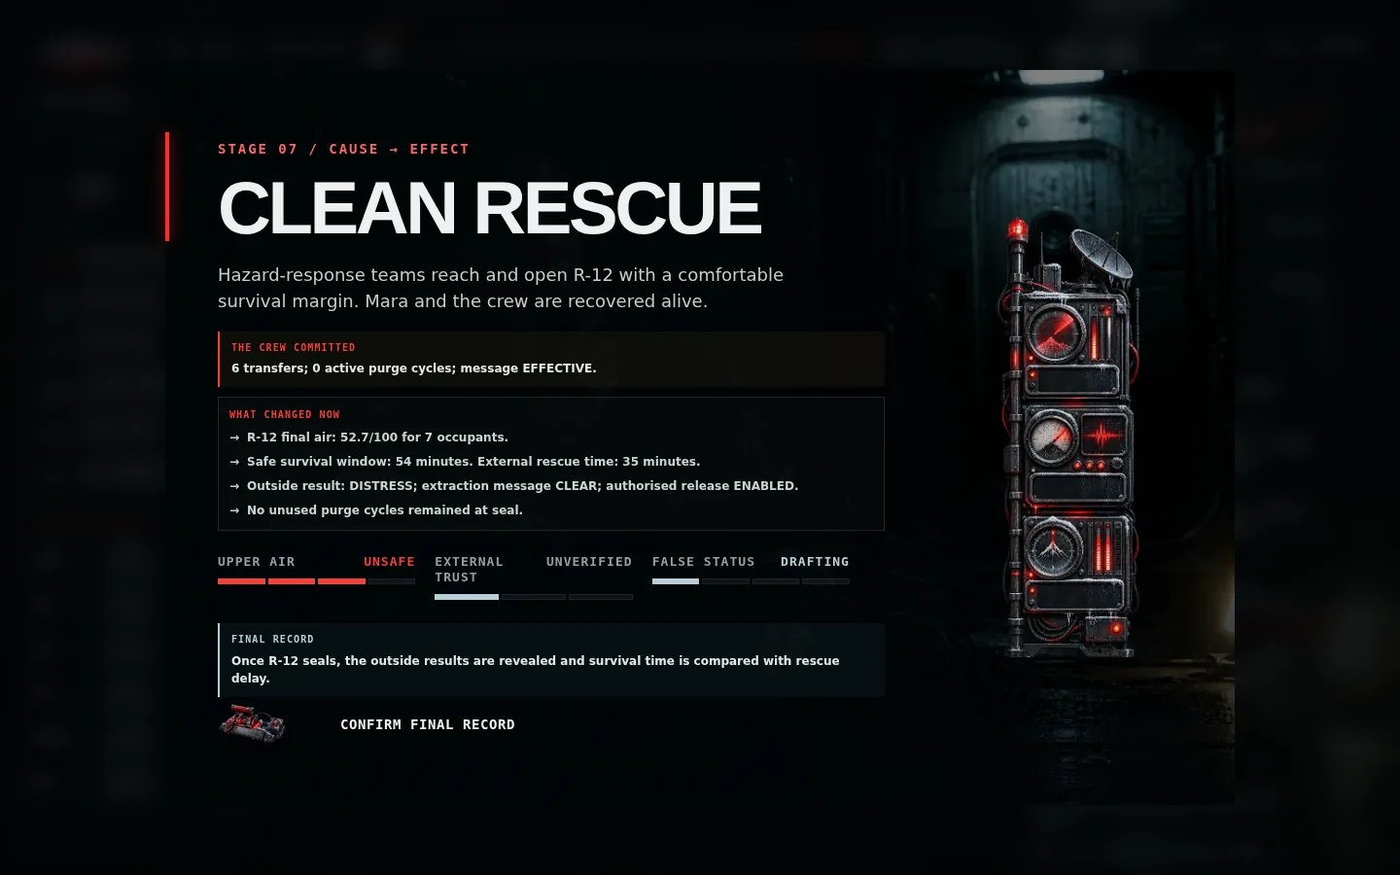
Figure 34. The facilitator privately previews the calculated ending before confirming the final record.
Ending band | Survival versus rescue | Human consequence
Clean Rescue | Comfortable positive margin | Mara and crew recovered alive
Close / Severe Rescue | Responders arrive near the limit | Everyone recovered with serious consequences
Rescue With Casualties | Safe window exceeded | Recovery succeeds but includes fatalities
Lark Shift Echo | Catastrophic negative margin | Responders open R-12 too late

The calculation remains hidden during play. The ending explains effective status, extraction message and release, then compares refuge survival time with rescue time without assigning individual casualties mechanically.

7.2 Clean Rescue presentation
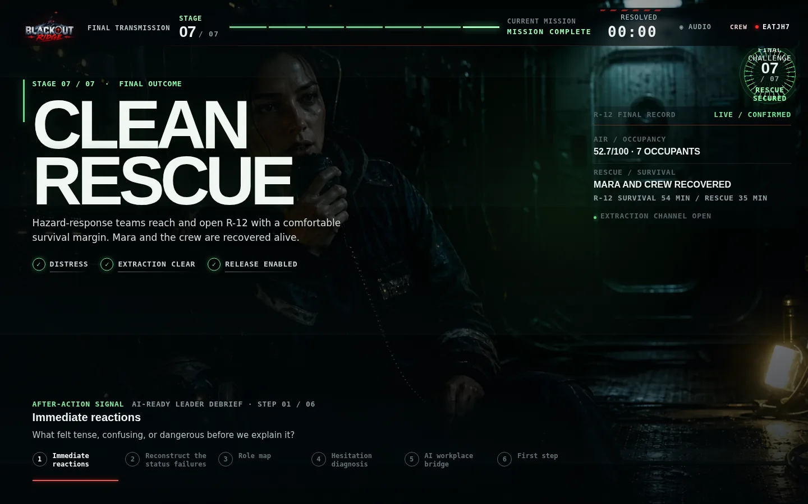
Figure 35. A Clean Rescue keeps Mara visible as the visual reward for preserving enough air and minimising external rescue delay.
1 Distress propagated externally. | 2 The extraction message was clear and authorised release was enabled. | 3 R-12 survival time exceeded responder arrival time by a comfortable margin.

VISUAL LOGIC
Mara’s photograph appears during active Stage 7. The final presentation keeps her prominent for Clean and Close/Severe Rescue, where Mara and the crew are recovered; casualty and Lark Shift Echo outcomes use the hold environment.

7.3 Six-step debrief
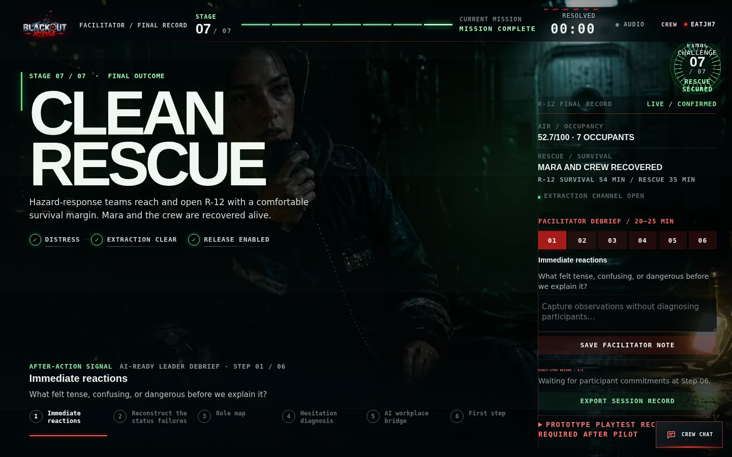
Figure 36. The facilitator advances one synchronized debrief step, records observations, and monitors participant first steps.
Step | Prompt purpose | Facilitator move
1. Immediate reactions | Name tension, confusion, and danger before explanation | Listen; do not correct interpretation yet
2. Reconstruct status failures | Trace OPERATIONAL, GREEN, NO ACTIVE DISTRESS, LOWER ROUTE | Map source → proxy → assumption → consequence
3. Role map | Identify what each responsibility protected | Invite the least-heard role first
4. Hesitation diagnosis | Separate evidence, risk, people, ownership, control, technical exposure | Discuss behavior, not personality labels
5. AI workplace bridge | Find analogous dashboards, models, vendors, summaries, or classifications | Ask what each real output actually measures
6. First step | Record one bounded workplace action per participant | Make it observable and specific

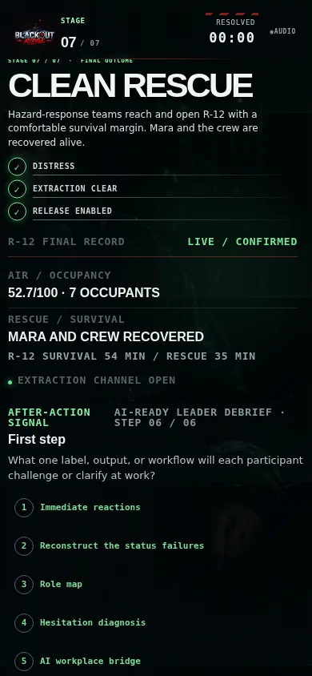
Figure 37. Every player sees the same current debrief prompt and records a specific first step at Step 6.

7.4 Export and retention
- Use Export Session Record on the facilitator debrief panel.
- The JSON export includes ending, metrics, decisions, debrief, playtest record, environment, official status, Crew Chat, and event history.
- Store the file according to the client organization’s privacy and retention policy.
- Do not interpret readiness lenses as diagnosis, certification, or individual scoring.
- If chat or free-text notes contain personal information, minimize distribution and delete according to policy.

7.5 Playtest record
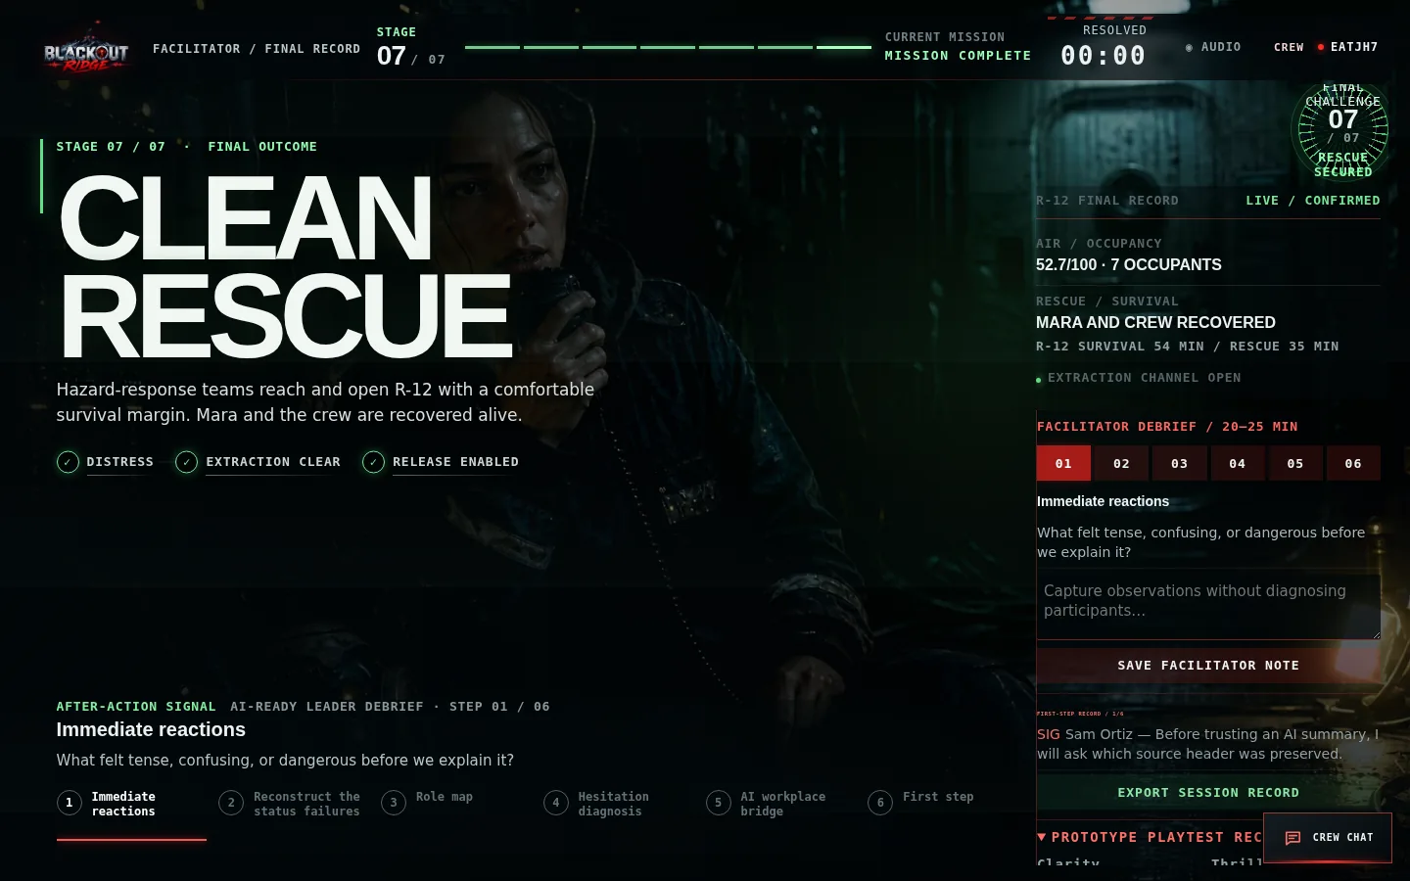
Figure 38. The post-session prototype record captures evidence-backed ratings and a proceed/revise/stop disposition.
Use playtest ratings to improve the experience, not to score participants. Record where rules needed explanation, whether every role contributed, whether physical and official stakes remained distinct, whether the signal stayed legible, whether the ending felt caused by earlier choices, and whether every participant produced a specific first step.

SECTION 8

Explaining the game to a client
A concise commercial and learning explanation for sponsors, observers, and delivery partners.

8.1 Thirty-second description
CLIENT ELEVATOR PITCH
“Blackout Ridge is a 70-minute, browser-based leadership simulation for four to seven participants. A remote station is making calm operational claims from incomplete data while a colleague is missing. Each participant sees different evidence, so the group must challenge automated labels, combine perspectives, act under uncertainty, and make an extraction request that an outside responder can use. The debrief connects those behaviors directly to AI-enabled work.”

8.2 Why the survival-horror format matters
- Urgency makes the cost of passive trust visible without requiring specialist technical knowledge.
- Unequal evidence creates a genuine reason for cross-functional voices to speak and be heard.
- Persistent consequences make abstract data-governance ideas experiential rather than lecture-based.
- The missing-person story keeps human outcomes visible when system records become abstract.
- Fail-forward design ensures every cohort reaches the finale and debrief, even after weak choices.

8.3 What an observer should watch
Behavior | Observable evidence | Debrief connection
Questions clean labels | Asks who produced it, when, and what it measures | Leadership fluency / practical scepticism
Surfaces missing people | Names Mara or the absent shift rather than accepting occupancy abstraction | People and adoption
Uses bounded action | Names a route, owner, abort rule, or safeguard | Value discovery / risk and guardrails
Shares private evidence | Reports confidence and provenance without overclaiming | Cross-functional collaboration
Communicates for receiver action | Specifies occupancy, unsafe conditions, location and required extraction | External response and communication
Balances both stakes | Preserves refuge air while reducing responder delay | Accountability and systems thinking

8.4 Suggested 12-minute client demonstration
1. Minute 0–2: show the cinematic boot, host setup, and role-claim flow.
2. Minute 2–4: open shared, player, and facilitator views side by side; explain privacy boundaries.
3. Minute 4–6: show Stage 1 unequal evidence and the recommendation route.
4. Minute 6–8: open Crew Chat and show role colors plus synchronized alerts.
5. Minute 8–10: jump to Stage 4 or Stage 6 to demonstrate bounded action and the searchable Lark Shift investigation.
6. Minute 10–11: show the hidden-order transfer, final surface dashboard, and the air-survival versus rescue-delay calculation.
7. Minute 11–12: show the ending and six-step debrief; close with the exported evidence record.

8.5 Delivery success criteria
- Participants can explain why OPERATIONAL was unsafe without saying the system was simply broken.
- Every role contributes a fact, question, recommendation, intervention, guidance burst, or finale ownership.
- The group distinguishes station operational status from human safety and external rescue readiness.
- The facilitator uses no more than one technical correction and does not need to reveal answers.
- Most participants identify one real workplace output whose source, proxy, or confidence they will clarify.
- The session fits the agreed time and all participant-care requests are handled without public explanation.

SECTION 9

Troubleshooting and recovery
Diagnose access, synchronization, role, mobile, audio, and timing problems without damaging the session.

9.1 Fast diagnosis
Symptom | Likely cause | Safe recovery
Game link does not open | Server stopped, wrong address, blocked port | Check /api/health; restart npm run dev; verify firewall/routing
Player sees join screen again | Missing/incorrect player token or different browser | Use original player link; avoid copying facilitator/shared URLs
Role cannot be selected | Already claimed or wrong crew configuration | Refresh roster; facilitator reassigns only if necessary
Start button disabled | Not all players connected or care brief unconfirmed | Complete roster and confirm participant care
Recommendation appears to do nothing | Blank text, network delay, or subtle prior UI state | Enter text; press Share with Station Lead; look for RECOMMENDATION SHARED
Other players cannot read recommendation | Designed privacy boundary | Station Lead/facilitator receive text; use voice or Crew Chat for full-group discussion
Chat message not visible | Viewing shared screen, offline tab, or blank message | Use authenticated player/facilitator view; reconnect; resend nonblank message
Shared display has no chat | Designed privacy boundary | Use player/facilitator terminal; shared view intentionally cannot read/post
Clock is wrong after interruption | Connection delay or paused state | Facilitator Pause/Resume; use +30 sec only for technical loss
Player cannot act | Marked absent/observer or not the assigned runner/lead | Facilitator marks present; check role ownership
Mara photo not visible at ending | Ending is Rescue With Casualties or Lark Shift Echo | Expected visual logic; Mara appears during active Stage 7 and both all-survivor rescue outcomes
Audio is silent | Audio is opt-in or browser blocked playback | Press Audio once; continue silently if preferred

9.2 Connection recovery
- Do not create a second session immediately. Most disconnects recover by reopening the same private link.
- Pause the clock if the interruption materially prevents contribution.
- Use Re-send Card when the participant is connected but cannot locate the current evidence.
- Use Mark Absent for a temporary step-out; observer-mode players may still use Crew Chat but cannot change game state.
- Reassign only when another participant must assume the responsibility. The event history records the transfer.
- Use a facilitator technical correction only for a proven interface/transcription error and include a clear audit note.

9.3 Browser and display guidance
- Prefer one game tab per role. Multiple copies of the same token can be confusing even though state is synchronized.
- Use 100% zoom. On small screens scroll; do not force desktop mode unless necessary.
- If an old image or stylesheet remains visible, perform one hard refresh. Static assets may cache for up to five minutes.
- If the connection-lost indicator remains, confirm the server is reachable and that proxies allow Server-Sent Events.
- Keep the facilitator console off the shared projector because it contains all role reports and the ending preview.

9.4 Server operator checks
Check | Command / location | Expected result
Start | npm run dev | Blackout Ridge running at http://localhost:4173
Health | GET /api/health | JSON with ok: true and session count
Persistence | data/sessions.json | Sessions survive a clean server restart
Automated validation | npm run check && npm test | All JavaScript syntax checks and tests pass
Port | TCP 4173 | Listening and reachable from participant network

SECTION A

Appendices
Printable checklists, scripts, control reference, glossary, and a one-page facilitator card.

Appendix A — Pre-session checklist
☐ Server is running and /api/health returns ok: true.
☐ Correct crew size selected: 4, 5, 6, or 7.
☐ Facilitator console is private and recoverable.
☐ Crew link tested on a second device.
☐ Shared display opens read-only and is visible at 100% zoom.
☐ Voice channel works for every participant.
☐ All role terminals show Connected.
☐ Participant-care statement read verbatim and confirmed.
☐ Audio choice explained; nobody is pressured to enable it.
☐ Clock, Pause, +30 sec, prompt, and Safety Pause located.
☐ Client retention policy agreed for chat, notes, and exports.
☐ 20–25 minutes protected for debrief.

Appendix B — Scripts at a glance

Participant care
This is a fictional survival-horror leadership exercise involving emergency pressure, missing-person themes and implied danger. If at any point you need to step out of the scenario, message me privately and I will accommodate that without drawing attention to it. You do not need to explain why.

Opening
You are the night crew at Blackout Ridge Signal Station. The storm has damaged the mast. Mara Venn is missing. The station is producing calm operational answers, but each of you can see different evidence. Share what matters, name what you are assuming, and make one crew decision before each window closes. You may be unable to save everything. Operational does not mean safe.

Mid-stage prompts
- What does this output actually measure?
- Which source and timestamp support that claim?
- Whose evidence have we not heard?
- What are you treating as observed versus inferred?
- What bounded move would test the most dangerous assumption?
- What must the outside receiver do differently after your message?
- Which player is active, which are waiting, and which are now isolated below?

Ending transition
Before we explain the system, take ten seconds to notice the difference between what the station recorded and what happened to the people. We will reconstruct that gap together.

Appendix C — One-page facilitator card
Stage | Decision rule | One useful prompt | Advance when
1 | YES/NO for all 6 staff | What proves departure rather than completed work? | Handover closes
2 | 1 unique failed system per player; 1 submission each | Which distinct capability are you trying to restore? | All submit or repair clock ends
3 | 2 locations + first target + exactly 2 items | Can you show function → component → location? | Plan is physically viable; no diagnosis score
4 | Locked route; 2 one-shot services | Which manual row matches every observation? | Both selected sites resolve
5 | One cabin-control move per active player | Which pressure improves, and which worsens? | Automatic R-12/Mara reveal
6 | Timed two-phase archive; no scored answer | What made the Lark Shift rescue arrive too late? | Archive window closes automatically
7 | Sequential transfers + solo surface operator | Will survival time exceed rescue time? | Message classified; preview checked; final record confirmed

ALWAYS REMEMBER
Safety outranks pacing. Technical recovery may restore the recorded intention; it must never be used to manufacture a better ending.

Appendix D — Glossary
Term | Meaning
Mara Venn | Missing Blackout Ridge colleague located in the Auxiliary Relay Hold
Lower Route | Ambiguous label initially treated as a road; evidence reveals a route beneath the station
Auxiliary Relay Hold | Buried legacy workplace protected—and potentially trapped—by a containment interlock
Lark Shift | Former crew whose human status diverged from the relay’s OPERATIONAL record
Cordon Control | Outside authority whose response depends on credible, specific Ridge traffic
OPERATIONAL | Relay transmission status; not a statement about human safety
Recommendation | Private written assessment routed to the Station Lead and facilitator
Crew Chat | Authenticated whole-crew typed discussion channel; excluded from shared display
Intervention / override | Once-per-session role safeguard that changes evidence, time, trust, or risk
Fail-forward | Weak choices worsen conditions or evidence but never remove later stages
Official Status | Progress of the station’s calm conclusion toward becoming authoritative
First step | Specific workplace label, output, or workflow each participant commits to challenge or clarify

Appendix E — Screenshot index
This guide contains 38 illustrated figures drawn from 38 current runtime screenshots captured during a complete isolated six-player session. Source images are stored beside this document in docs/client-guide/screenshots/ for client presentation reuse.
Coverage | Figures included
Onboarding | Boot, host configuration, join flow, assembly lobby
Core interfaces | Shared station, private player terminal, facilitator console, mobile views
Communication | Private recommendation workflow and open multi-color Crew Chat
Seven stages | Handover, repairs, Outside Plan, Outside Run, cabin air, Lark archive, evacuation finale
Outcomes | Ending preview, Clean Rescue with Mara, facilitator/player debrief, playtest record

Open the current game: http://151.243.217.9:4173/
END OF GUIDE

