BLACKOUT RIDGE
ACT 1 | HANDOVER
Developer Implementation Handoff
Status: Canonical implementation specification
Date: 9 September 2026
IMPLEMENTATION BOUNDARY
This document supersedes earlier Act 1 puzzle and UI guidance. The puzzle logic, screen contents, player allocation, timer, submission behaviour and audio below are fixed. Visual polish, animation, sound treatment, accessibility and implementation details can be refined, but do not add or reinterpret gameplay mechanics, clue logic, role powers, recommendations, instructional scaffolding or additional player actions without approval.
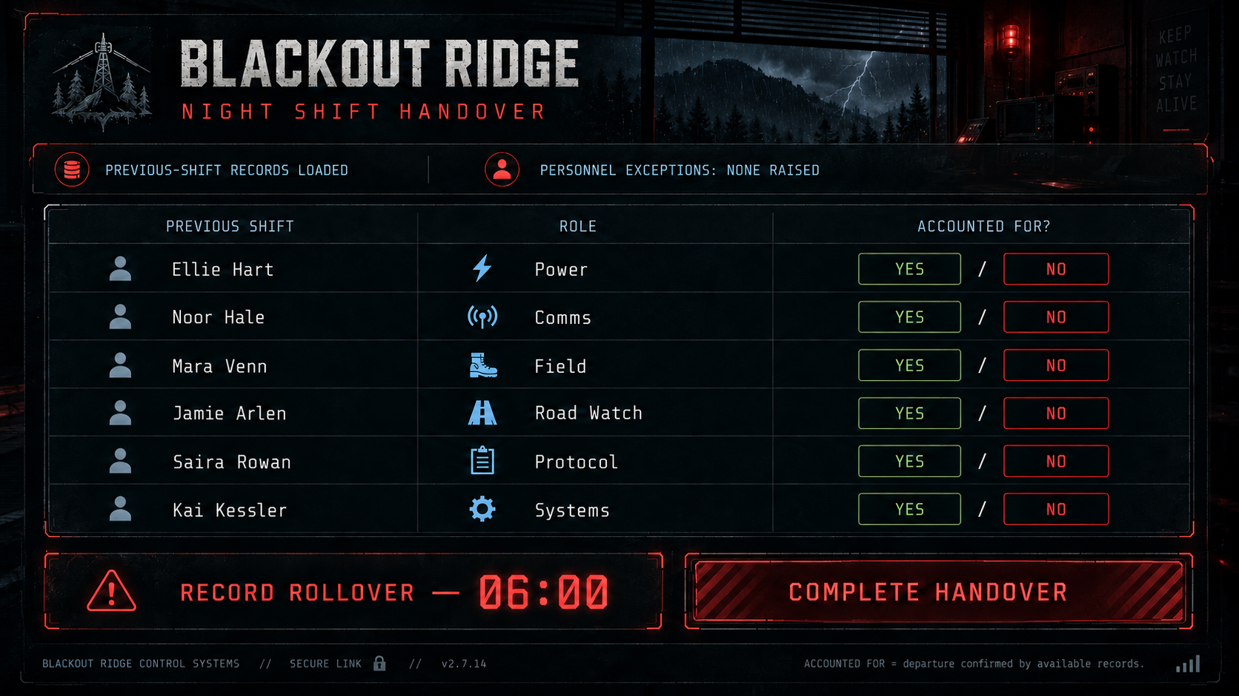

1. Lead-in video
Target duration: 30-45 seconds.
Purpose: move the players directly from the facilitator introduction into the fiction and establish Blackout Ridge as functional, isolated and exposed to an approaching storm.
1. Approach. Night. A vehicle travels along the exposed road towards Blackout Ridge. Rain is beginning, distant lightning is visible over the ridge, and the relay mast is visible ahead and operating normally. Routine radio traffic can be heard faintly. The mood is isolated and atmospheric, not yet overtly threatening.
2. Exterior. Establish Blackout Ridge as one small remote relay cabin with immediate external infrastructure: mast, generator, parking and surrounding access roads. The station is lit and operational.
3. Interior. Move into the cabin/control room. It should feel functional, recently occupied and slightly worn, as if the previous shift has just left. Displays are operating normally. There is no evidence of emergency, violence or abandonment.
4. Handover starts. The shared display activates with BLACKOUT RIDGE - NIGHT SHIFT HANDOVER, PREVIOUS-SHIFT RECORDS LOADED and PERSONNEL EXCEPTIONS: NONE RAISED. The six outgoing staff appear, the 06:00 RECORD ROLLOVER starts, and the seven private evidence screens become available. Act 1 begins immediately.

Do not foreshadow
• Mara's situation
• Lower Route
• Lark Shift
• the later chemical incident
• the anomalous voice
• R-12
The only developing threat in Act 1 is the approaching storm.

2. Canonical screens and player allocation
The eight supplied graphics are the canonical Act 1 interface reference. Screen content and puzzle evidence should not be rewritten or supplemented with instructional UI.
• Seven players: each player receives one of the seven private evidence screens; the facilitator operates the separate shared Handover screen.
• Four to six players: the same seven private evidence screens are paginated across the available player terminals. No evidence is removed or rebalanced.
• Every screen shows the same live 06:00 RECORD ROLLOVER timer.
• Only the facilitator/shared screen contains the YES/NO decisions and the active COMPLETE HANDOVER control.
• Private screens contain information only. They must not tell players what conclusion to draw, what question to ask, what to recommend or how to interpret evidence.
• An information box may explain the scope or provenance of a screen, but never the inference to make from it.
• The facilitator receives no privileged puzzle evidence.
• No correctness feedback is shown during the act.

Screen 1 - Facilitator / Night Shift Handover

Screen 2 - Shift Closeout
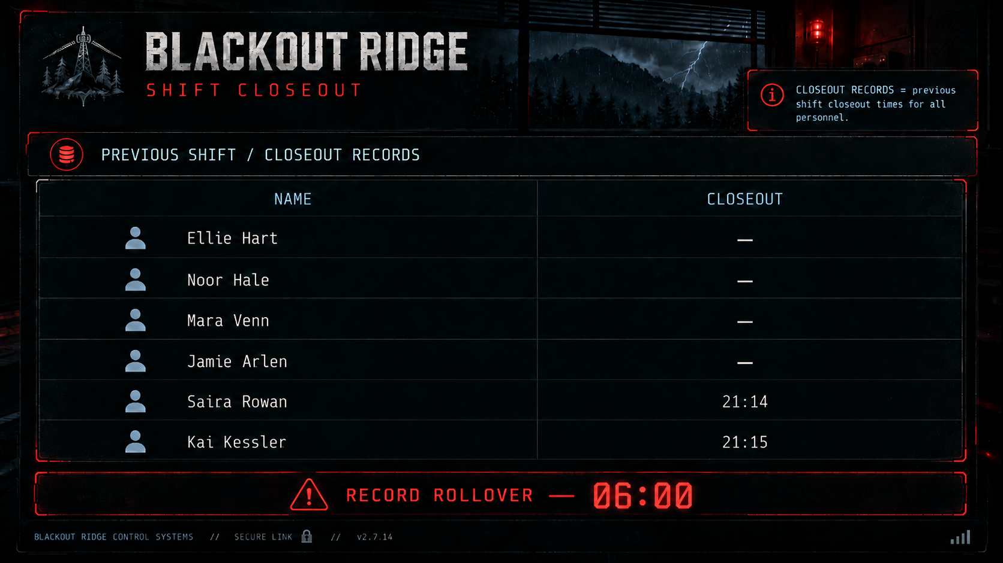

Screen 3 - External Movements
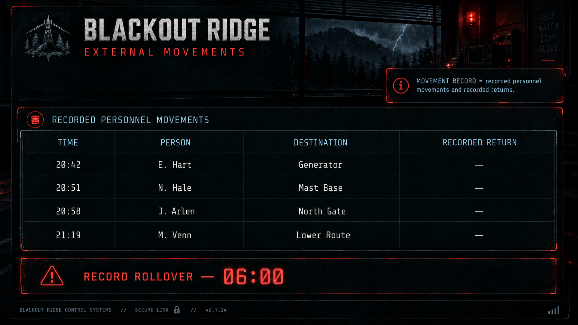

Screen 4 - Site Access
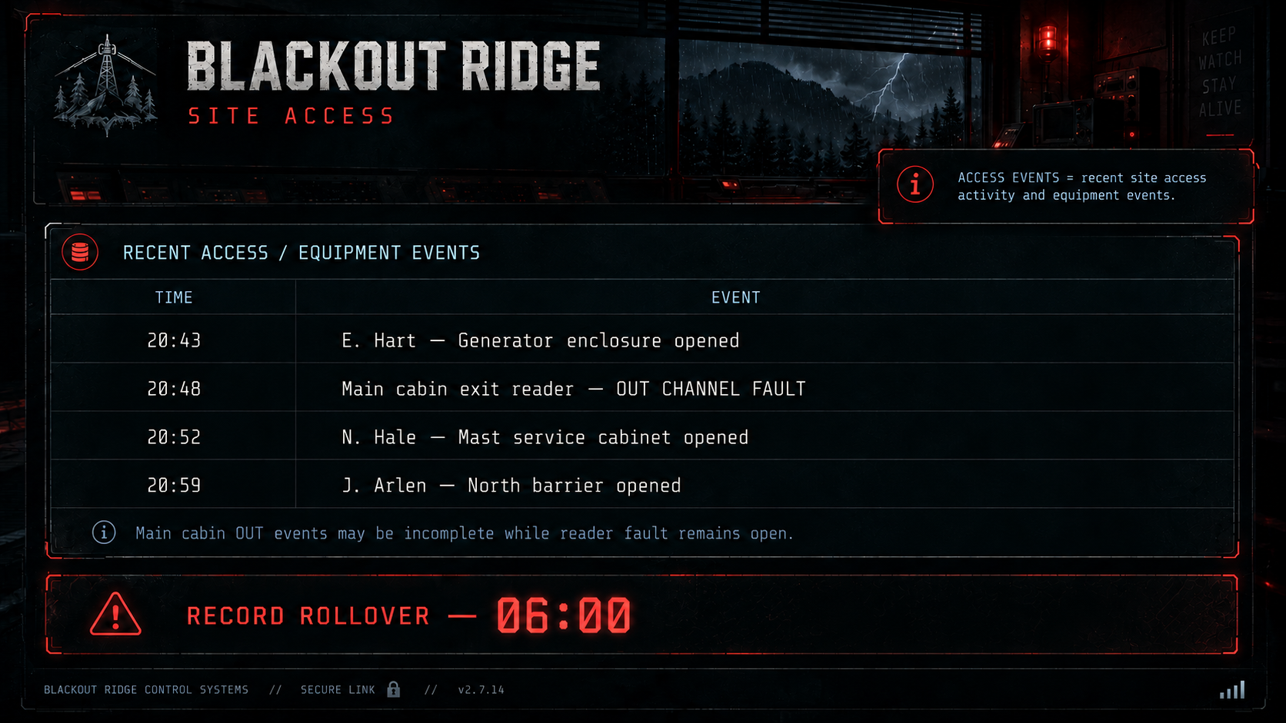

Screen 5 - Transport
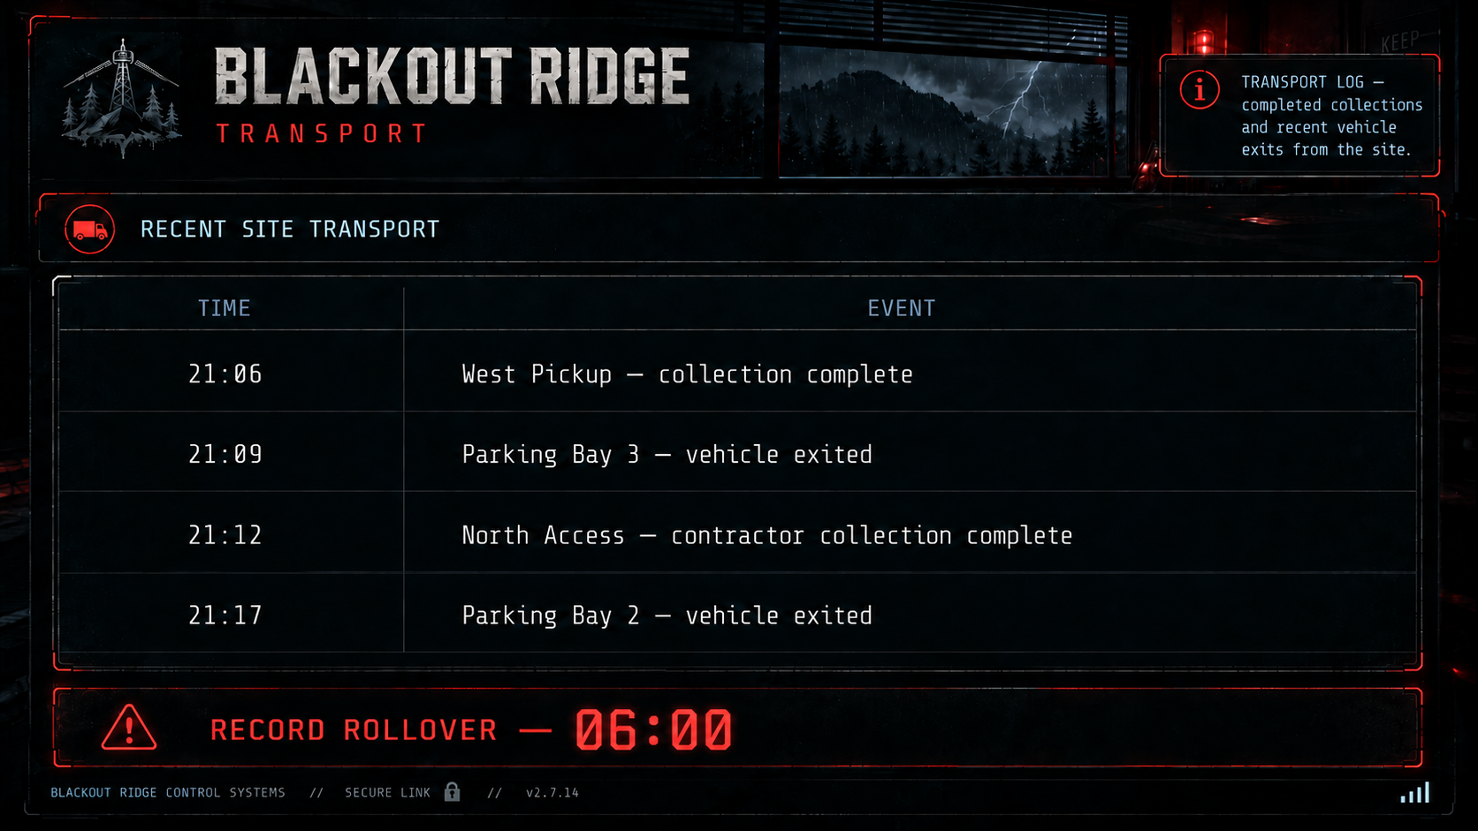

Screen 6 - Work / Maintenance
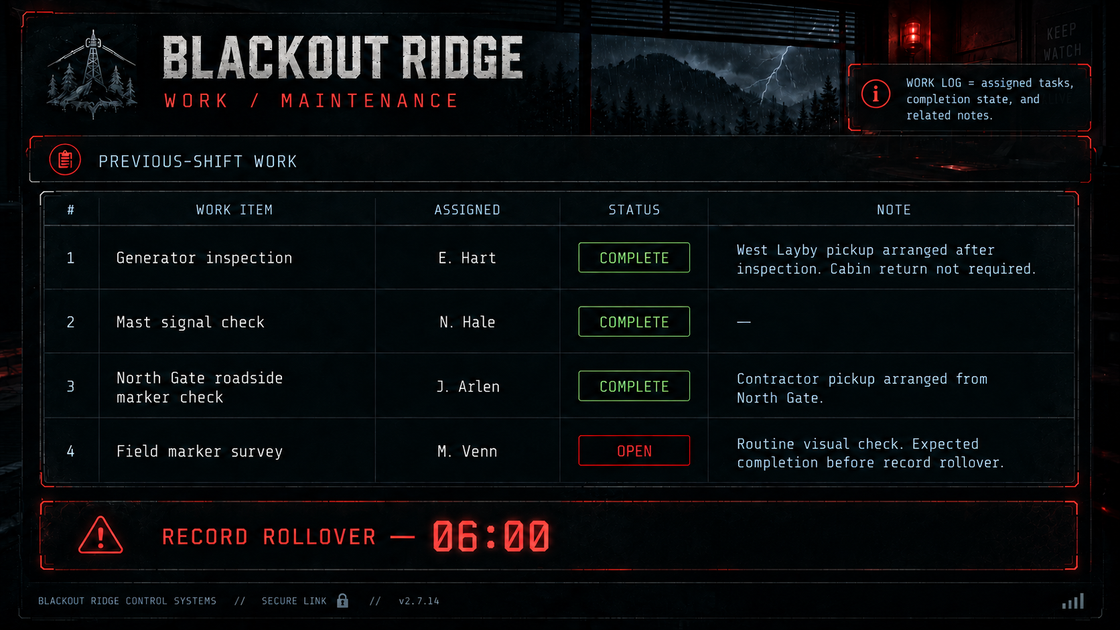

Screen 7 - Handover Comms
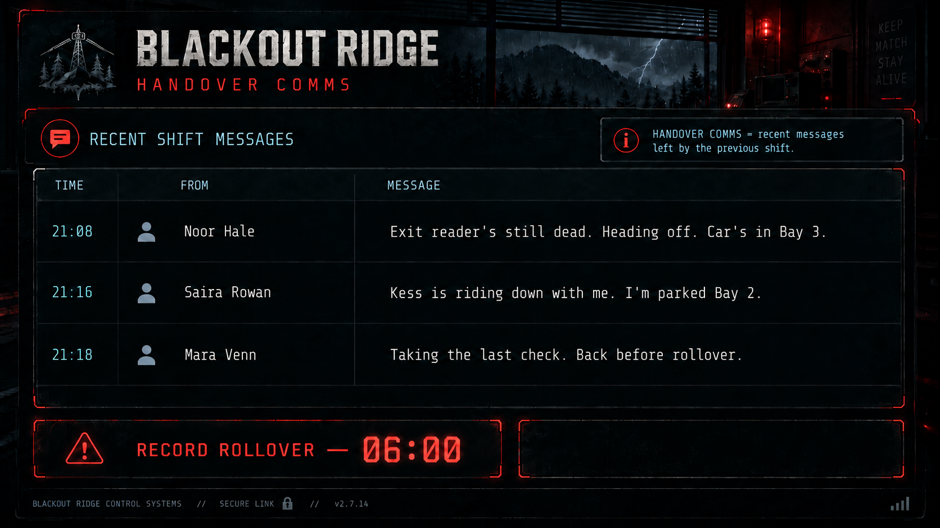

Screen 8 - Current Local Map
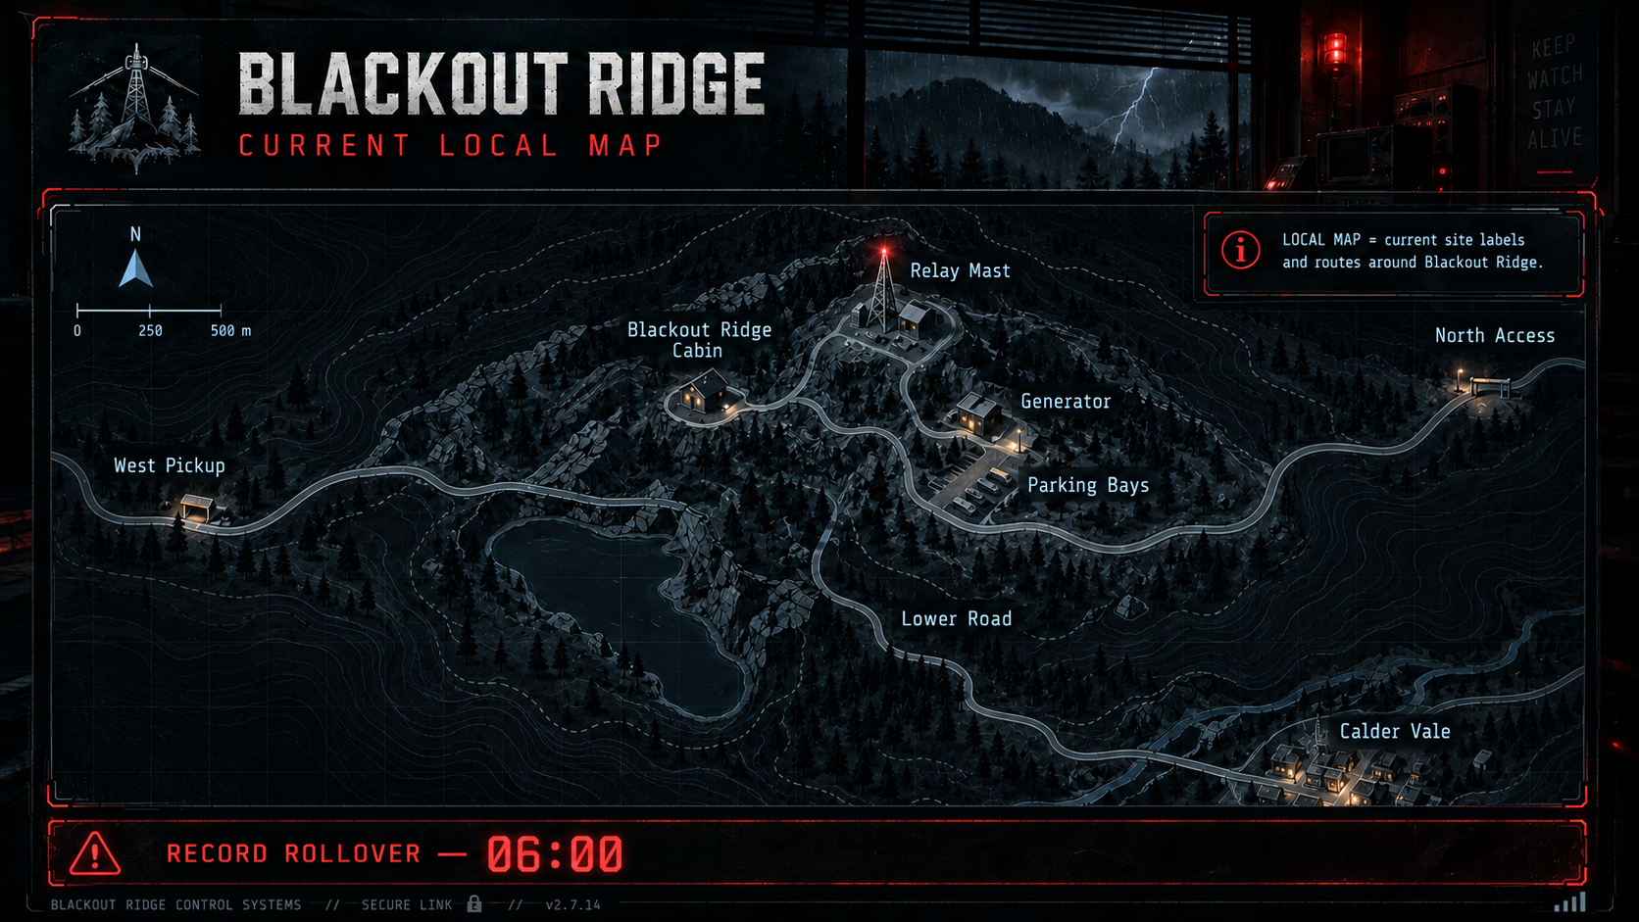

3. Puzzle resolution
Player question: Is each member of the previous shift accounted for?
ACCOUNTED FOR = departure confirmed by available records. A planned departure, last-known movement or open task is not sufficient.
Staff member | Answer | Resolution
Ellie Hart | YES | Movement places Ellie at the Generator. Work records show the inspection complete, a West Layby pickup arranged, and no cabin return required. The map uses West Pickup for that location; Transport confirms the collection completed.
Noor Hale | YES | No normal closeout is recorded. The cabin OUT reader is faulty. Noor identifies Bay 3 as her car and says she is leaving; Transport confirms the Bay 3 vehicle exited.
Mara Venn | NO | No closeout. Her final recorded movement is Lower Route. Her field task remains open but is not overdue, and she says she will return before rollover. Nothing subsequently confirms her departure.
Jamie Arlen | YES | Movement places Jamie at North Gate. His task is complete and contractor pickup is arranged there. The current map labels the location North Access; Transport confirms the contractor collection completed.
Saira Rowan | YES | Saira has completed closeout and identifies Bay 2 as her vehicle. Transport confirms the Bay 2 vehicle exited.
Kai Kessler | YES | Kai has completed closeout. Saira says Kess is riding down with her. Her Bay 2 vehicle subsequently exits.
Intended behaviour: several people initially appear unresolved; five cases resolve when records are combined; Mara's does not.
Lower Route: the words Lower Route appear only in Mara's movement record. The map instead shows Lower Road. West Layby / West Pickup and North Gate / North Access establish ordinary naming drift, so players should naturally infer Lower Route = Lower Road. Nothing in Act 1 suggests that inference is wrong.
Mara is unaccounted for, not yet formally missing or overdue.

4. Incoming audio
All players hear normal incoming tower traffic during the handover. It establishes the normal communications baseline, reinforces the station's relay function and lets the storm build pressure. It is not part of the personnel puzzle.
Approx. time | Source | Script | Purpose
~00:20 | Calder Dispatch | "Blackout Ridge, routine carrier check. Signal received five by five. No relay faults reported." | Normal communications baseline.
~00:50 | Calder Vale Materials | "Twenty-one twenty environmental check. Perimeter air quality within normal limits." | Establishes routine environmental monitoring and a normal air-quality baseline.
~02:30 | Calder Weather | "Electrical activity increasing across the western ridge. Remote sites advised to monitor strike conditions." | Storm pressure increases; no player action required.
~04:30 | Ridge Weather Alert | "Severe electrical activity approaching Blackout Ridge sector. Elevated mast-line strike risk." | Late pressure only. If the crew has already submitted, this transmission may not play.

Audio rules
• All players hear the same clean, intelligible transmission and captions/subtitles.
• Each transmission has a clear source identifier.
• No transmission contains personnel-puzzle evidence or mentions Mara, Lower Route or Lark Shift; there is no anomalous/internal voice in Act 1.
• Incoming traffic is recorded in the station Received Traffic Log for later use.

5. Submission and end of Act 1
• The crew has six minutes to reconcile the evidence. The facilitator records one collective YES / NO answer for each outgoing staff member; COMPLETE HANDOVER is active on the facilitator screen only.
• Answers can be changed while the timer is running.
• If the facilitator submits before 00:00, the current answers are recorded and Act 1 ends.
• If the timer reaches 00:00 first, the current answers are recorded automatically; any unselected staff member is recorded as UNRESOLVED.
• There is no correctness reveal, score, hard fail or later mechanical branch. What players understood about Mara carries forward only in their own memory.
• Act 2 begins immediately afterwards with its own opening video. The lightning strike and emergency transition are outside the Act 1 specification.

6. Acceptance conditions
• Eight Act 1 screens implemented with the supplied evidence and current staff names.
• The same live six-minute rollover timer is visible on all eight screens.
• Only the facilitator screen contains YES / NO controls and COMPLETE HANDOVER.
• Private screens contain evidence only: no recommendations, role powers, "what to say", consequence checks or clue interpretation.
• For 4-6 players, all seven evidence screens remain available through pagination.
• Audio assets and captions follow the scripts and constraints above.
• No correctness feedback or Act 1 mechanical branching is introduced.

