BLACKOUT RIDGE

Milestone 4 — Completion Report
Complete Game Implementation
All challenges, audio/signals, Outside Run, Hold/interlock, finale, endings, and debrief capture
Prepared: 07 September 2026

Status: COMPLETE

1. Executive summary
Milestone 4 delivers the full playable Blackout Ridge experience on top of the Milestone 3 multiplayer foundation. Every timed challenge, progressive signal treatment, physical Outside Run, rotating cabin-air survival and R-12 reveal, two-phase Lark Shift archive, hidden-order finale, four production ending bands, and synchronized debrief capture are implemented, server-authoritative, and covered by automated tests.
A facilitator can now run the complete 70-minute arc — 5 minutes briefing, 43 minutes gameplay, 20 minutes debrief, and 2 minutes operating buffer — across 4-, 5-, 6-, or 7-player crews without manual state calculation. Players receive role-specific private evidence; the shared station shows synchronized consequences; weak decisions fail forward rather than stopping the story.
This milestone is complete. The runtime matches the Milestone 1 design package and the playbook coverage audit in docs/full-system/PLAYBOOK-COVERAGE.md. Milestone 5 (live playtesting, pacing tuning, facilitator load testing, browser matrix, and production hardening) begins from this build.

2. Milestone 4 requirements vs delivery
Requirement | Implementation | Status
All seven challenges | Seven timed stages with distinct mechanics, consequences, and fail-forward resolution | Complete
Progressive audio/signals | Accessible transcripts; queued Act 1–3 recordings; viewer-specific clarity; opt-in ambience | Complete
Outside Run | Locked two-site route, runner assignment, four asymmetric service games, one attempt per site | Complete
Handover / cabin survival | Stage 1 six-person departure reconciliation; Stage 5 rotating air-control set piece and R-12 reveal | Complete
Finale | Hidden-order transfers, shared purge, solo surface operator and explicit rescue calculation | Complete
Endings | Four survival-margin outcomes with facilitator preview before final record confirmation | Complete
Debrief capture | Six synchronized steps, facilitator notes, first-step commitments, JSON export, playtest record | Complete

3. Seven-stage runtime (all challenges)
Each stage has one distinct interaction, explicit consequences, and a defined handoff to the next phase. Investigation and survival stages advance on their own clocks rather than forcing an artificial scored decision.
Stage | Title | Mechanic | Primary decision | Duration
1 | Account for the outgoing shift | Handover reconciliation | Collective YES/NO departure answer for each of six staff | 6 min
2 | Repair what the station needs | Prioritisation + private repairs | One distinct failed system per player; simultaneous one-shot games | 3 + 5 min
3 | Build the outside plan | Route + equipment planning | Two diagnosed sites, first target and exactly two specialist items | 7 min
4 | Execute the outside run | Two cooperative field services | Assign runner; observation → interpretation → instruction → action at both locked sites | 8 min
5 | Keep the cabin breathable | Rotating cabin controls | One control move per active player; preserve Act 6 time | 4 min
6 | The Lark Shift | Timed archive investigation | History first; R-12 rules and final-operator checklist at midpoint | 3–6 min
7 | Get Below | Evacuation finale | Sequential transfers, purge and final surface procedure | 8–10 min

- Server resolves every commit; clients cannot forge decisions or skip stages.
- Timer expiry follows an act-specific fail-forward rule and never strands or eliminates a participant.
- Stage 6 closes automatically and stores no search, reading or scored-answer state.
- Stage 7 requires facilitator confirmation before debrief and ending screens unlock.

4. Progressive signal and audio

4.1 Degraded transmissions
SIGNAL_TRANSMISSIONS in server/game-content.js defines stage-specific source headers, integrity percentages, and accessible transcripts. Act 2 repair state determines the quality of traffic received after each message arrives; the Act 3 obsolete internal fragment remains deliberately unidentified and unstored. The local Act 4 field link remains clear regardless of external communications state.
Stage | Integrity (designed) | Narrative job
1 | 100% | Establish a clear, attributed routine baseline
2 | State-dependent | Show how receive, attribution and storage repairs affect later traffic
3 | 11% | Impossible internal human fragment; unidentified and unstored
4 | 100% local | Reliable runner/station coordination independent of external paths
5 | State-dependent | Ambient plume update and false external station picture; no required game information
6 | Local archive | Explain the Lark Shift failure and teach the retained R-12 surface procedure
7 | External result revealed after seal | Separate distress propagation, extraction-message quality and responder release

4.2 Opt-in station audio
- prototype/audio.js — procedural ambience, feedback cues, and a no-overlap transmission queue.
- Browser autoplay policy respected: players opt in via the AUDIO toggle on the shared station HUD.
- Act 1 routine traffic, three Act 2 incident messages and the Act 3 impossible transmission have recorded WAV assets with matching on-screen transcripts.
- Cues fire on crew commits, field-service actions, debrief navigation, facilitator actions, and copy-link confirmation.
- Expanded dramatic sound design and a dedicated cinematic opening remain later production scope.

5. Outside Run (Stage 4)
- Act 3's two destinations, order and equipment remain locked; only the runner is assigned.
- At each site the runner sees the physical observation while station players see the interpretation manual.
- A station player locks one complete instruction; the runner commits one physical action with no retry.
- A/B restore external communications availability; C restores camera/history; D restores ventilation and later purge.
- Local field radio remains clear; the active site repeats its locked Act 3 arrival, completion and concentration without a second gas-management game.
- Failure continues to the next selected site and never permits route substitution.

6. Cabin survival and the R-12 reveal

6.1 Stage 1 — collective handover
The facilitator records one collective YES/NO departure answer for each of six people. Evidence is distributed, Noor is a deliberate multi-record false alarm, and Mara is the only departure the canonical records cannot establish. Submission shows no score and creates no persistent mechanical branch.

6.2 Stage 5 — cabin air
A four-minute server-authoritative model continuously advances toxin, CO₂, filter loading and outside plume. Every private terminal has the same controls, but strict role rotation enables one player at a time. Air Quality changes precision, Upper Ridge controls finite purge availability, and sustained performance sets Act 6 time. The timeout then reveals R-12 and Mara automatically through the integrity sweep and dormant camera.

6.3 Finale dependency model
Stage 7 resolves three separate external effects. Status Beacon controls whether DISTRESS propagates; Human Outbound plus the restored external path controls extraction-message quality; the final retained release configuration controls whether responders use normal recovery or slower forced access.

7. Finale, endings, and confirmation gate

7.1 Hidden-order evacuation
- A hidden random order activates one player's physical transfer at a time.
- Players below are isolated and may independently spend shared R-12 purge cycles.
- The final player completes a 30-second surface procedure alone, then performs the same transfer.
- Server compares occupancy-adjusted survival time with rescue delay from status, message and release.

7.2 Four production ending bands
Ending | Condition summary
Clean Rescue | Responders arrive with a comfortable survival margin
Close / Severe Rescue | Responders arrive near the protected-air limit
Rescue With Casualties | Recovery occurs after the safe window is exceeded
Lark Shift Echo | Accumulated delay is catastrophic; responders arrive too late

The facilitator sees pendingEnding with rescue, survival, and status dimensions before confirming the final record. Players cannot enter debrief until CONFIRM_ENDING is executed.

8. Debrief capture and session evidence

8.1 Six-step synchronized debrief
Step | Title | Purpose
1 | Immediate reactions | Surface survival pressure and emotional read
2 | Status failure map | OPERATIONAL, GREEN, NO ACTIVE DISTRESS, LOWER ROUTE false proxies
3 | Role map | Responsibility areas and reflection questions per role
4 | Readiness behaviour lenses | Facilitator-observed patterns — not personality scores
5 | AI-ready workplace bridge | False proxy, missing source, bounded test
6 | First workplace action | Each player records a bounded commitment (private to facilitator export)

8.2 Facilitator-only capture
- Per-step facilitator notes (up to 1,200 characters) saved server-side.
- Readiness profile signal toggles for observed behaviour lenses.
- Prototype playtest record with seven rating criteria, disposition, and reframe warning.
- Contribution metrics: reports, interventions, station instructions, and field-service attempts.
- Full session JSON export including decisions, history, debrief data, and ending record.
- Private role brief download (.txt) for remote or accessibility workflows.

9. Unequal information enforcement
Milestone 4 includes server-enforced information partitioning so no single role can solo-solve the incident. Recent verification added INFORMATION_MATRIX, INFORMATION_JOINS, and PRIVATE_PHRASE_OWNERS in game-content.js, viewer-aware signalTransmission() in the engine, and six-player Comms clue redistribution.
Criterion | Status
Information matrix covers every stage and core role | Complete
Private phrases stay with owning role only | Complete
Shared public intercept cannot solo-solve Lower Route before Stage 5 | Complete
Field Stage 3 alone cannot name buried route under cabin | Complete
Six-player mode redistributes critical Comms occupancy clue | Complete
Private cards include speak prompts and confidence labels | Complete

10. Runtime architecture
Component | File | Responsibility
HTTP API + SSE + persistence | server/server.js | Sessions, live events, JSON store, static delivery
Game engine | server/game-engine.js | Authorization, timers, consequences, finale, debrief, export
Game content | server/game-content.js | Stages, roles, signals, debrief steps, playtest criteria
Browser client | prototype/full-app.js | Four modes, all stage UIs, debrief, playtest form
Network layer | prototype/network.js | REST actions, SSE reconnect, token storage
Audio | prototype/audio.js + prototype/assets/audio | Opt-in ambience, queued recordings and interaction cues
Presentation | prototype/styles.css | Cinematic full-viewport layout, responsive breakpoints

11. Quality assurance
- npm run check — syntax validation of all JavaScript entry points.
- npm test — 60 automated tests covering strong/weak paths, all supported crew sizes, all four ending bands, HTTP/SSE integration, privacy, timers, archive/audio metadata, Outside Run, finale, debrief, and information matrix.
- docs/full-system/PLAYBOOK-COVERAGE.md — section-by-section audit against source playbook.
- Crew configurations validated for 4, 5, 6, and 7 players.

12. User guide — running a full session
This guide explains how to host, join, play, and debrief Blackout Ridge using the current build. Voice conversation stays on Teams or Zoom; the browser app supplies synchronized station state, private role evidence, timers, and facilitator controls. There is no personal score — the app records team decisions, station consequences, and a named ending for debrief.

12.1 Before you start
- Install Node.js 20+ and run npm run dev from the project root.
- Open http://localhost:4173 (or your deployed host) in a modern browser (Chrome, Edge, Firefox, Safari).
- Plan for 70 minutes total: ~5 min briefing, ~43 min gameplay, ~20 min debrief, ~2 min buffer.
- Each player needs their own device. One optional shared display (TV or screen-share tab) shows the room-facing station.
- Facilitator stays on the voice call but does not play a role.

12.2 Facilitator — create and open the session
- On the start screen, click ENGAGE STATION, then COMMAND AUTHORITY.
- Choose crew size: 4, 5, 6, or 7 terminals. Commercial sessions typically use 6 or 7.
- Click ARM NEW SESSION. The facilitator console opens with a six-character session code.
- Copy the crew link (TRANSMIT CREW LINK) and paste it into Teams/Zoom chat.
- Open the room display (ROOM DISPLAY) on a projector or screen-shared tab.
- Wait until every configured role shows CHANNEL LOCKED on the assembly roster.
- Read the participant-care statement aloud, then click CONFIRM BRIEF DELIVERED.
- Click START SHIFT to unlock Stage 1.

12.3 Players — join and claim a role
- Open the crew link (or enter the six-character code under CREW CHANNEL).
- Enter a display name (callsign) and choose one unclaimed responsibility.
- First come, first served. The facilitator can reassign later if someone disconnects.
- Your browser becomes your private terminal — you only see your own evidence card.
- If you refresh or drop off, reopen the same link; your role and information are restored.
- Optional: click ARCHIVE ROLE BRIEF to download your current private card as a text file.

12.4 The four browser views
View | Who uses it | What it shows
Game start / host | Facilitator (once) | Session creation and crew size selection
Shared station | Room display or screen-share | Tracks, timer, official traffic, crew roster, consequences
Private role terminal | Each player | Role evidence, crew report channel, one-use override, lead controls
Facilitator console | Facilitator only | Decision engine, live reports, timers, hints, safety, debrief, export

12.5 How each stage works
Every stage follows the same legible loop: escalating story pressure → structured private evidence → voice/chat discussion → live consequence preview → one crew commit → cause-and-effect reveal → explicit narrative bridge to the next emergency.
Interface cue | What it clarifies
Participant Note | What the role knows, what its confidence label means, why it matters now, and what to say aloud
Decision preview | What the current draft preserves/enables, what it costs/exposes, unresolved warnings, and whether it is legal to commit
Cause → Effect reveal | The exact commitment, immediate changes, updated persistent tracks, and why the following stage happens

Stage | Time | The problem | Team decision
1 — Account for the outgoing shift | 6 min | Six departures must be established before records roll over | Record a collective YES/NO answer for each person
2 — Repair what the station needs | 3 + 5 min | The strike leaves more failed systems than the crew can repair | Assign one distinct repair per player, then submit each private game once
3 — Build the outside plan | 7 min | Four genuine field faults; only two restore communications | Choose inbound/outbound sites, visit order and exactly two specialist items
4 — Execute the outside run | 8 min | Can the locked plan restore two selected services? | Assign runner; solve two cooperative observation–instruction–action games
5 — Keep the cabin breathable | 4 min | Contaminated air is entering the one occupied cabin | Take rotating control moves; preserve the Act 6 investigation window
6 — The Lark Shift | 3–6 min | Six people died after R-12 protected them | Investigate history, then learn the final surface procedure
7 — Get Below | 8–10 min | The cabin is critical and R-12 air is finite | Transfer sequentially, manage purge and complete the solo surface procedure

The facilitator records the collective Act 1 handover and Act 2 repair assignments; each assigned player submits their private repair once. The Station Lead or facilitator commits the Act 3 plan, while Acts 4–7 use their own runner, rotation, archive and evacuation controls. When a clock expires, the server applies that act's fail-forward rule—nobody is eliminated and the story always continues.

12.6 Stage 4 — Outside Run (special instructions)
- Assign the runner, then commit; never reopen Act 3 destinations, route order or equipment.
- Runner describes the private physical observation; station crew interprets its separate manual.
- Station locks one instruction, then the runner chooses one action. There is no retry.
- Repeat at the second locked site; failed service continues forward without a replacement destination.
- Read the returned dashboard state as operational consequence, not a score of the Act 3 diagnosis.

12.7 Facilitator controls during play
Control | When to use it
Pause / Resume | Technical issues, confusion, or a short break
+30 seconds | Connection failure only — not to rescue a slow debate
Send prompt / Clear prompt | Room is stuck on the rule, not the story (one hint per stage)
Safety pause | Participant distress — all screens go neutral; clocks stop
Re-send card | Player says their private evidence did not appear
Reassign role | Wrong seat taken or a player disconnected permanently
Mark absent / observer | Someone must step out; crew continues without them
Advance stage | Recovery only — if the app failed to move after a valid commit
Confirm final record | After Stage 7 — required before debrief unlocks

12.8 Role responsibilities and one-use overrides
Role | Lens during play | One-use override
Station Lead | Accountability; commits crew decisions | Hold the Clock (+60 s; official pressure advances)
Signal Analyst | Meaning and provenance of traffic | Recover Fragment (restore degraded source)
Systems Engineer | What a status actually measures | Trace Dependency (reveal subsystem behind a status)
Operations Officer | Bounded physical action | Controlled Test (preview cost, not outcome)
Field Liaison | People named in the data | Human Check (force named human into the record)
Protocol Officer | Risk and guardrails | Safety Condition (reduce worst physical cost once)
Comms Officer (7p) | Whether outsiders will believe the message | Request Readback (receiver interpretation)

No single role can solo-solve the incident. Major conclusions require information from at least two roles.

12.9 Ending, debrief, and export
- After R-12 seals and the committed extraction message is classified, the facilitator sees an ending preview with air, occupancy, rescue, survival and external-response dimensions.
- Click CONFIRM FINAL RECORD. All clients move to the ending screen and synchronized debrief.
- Advance debrief steps 1–6 together. Step 6 asks each player for one bounded workplace action.
- Facilitator saves notes per step and toggles observed behaviour lenses (not personality scores).
- Click EXPORT SESSION RECORD to download JSON with decisions, debrief, ending, and playtest data.
- After a pilot, complete the Prototype Playtest Record (seven ratings + disposition).

12.10 Troubleshooting
Issue | Fix
Player sees blank or stale screen | Hard refresh (Ctrl+Shift+R). Reopen the same crew link.
Cannot start shift | All terminals must be connected and participant care confirmed.
Wrong role taken | Facilitator uses Reassign on the assembly or live console.
Private card missing | Facilitator clicks Re-send card for that role.
Connection lost banner | Check network; app reconnects via SSE and restores token from localStorage.
Audio does not play | Click AUDIO on the shared station — browsers block autoplay until user gesture.

13. Screenshot evidence (current production build)
All figures below were captured from the live server-backed build on 07 September 2026 using snapshot mode and a full six-player demo session progressed through every stage. Screenshots are stored in docs/reports/screenshots/milestone-4-latest/. Regenerate with: npm run dev && node scripts/capture-milestone-4-screenshots.mjs

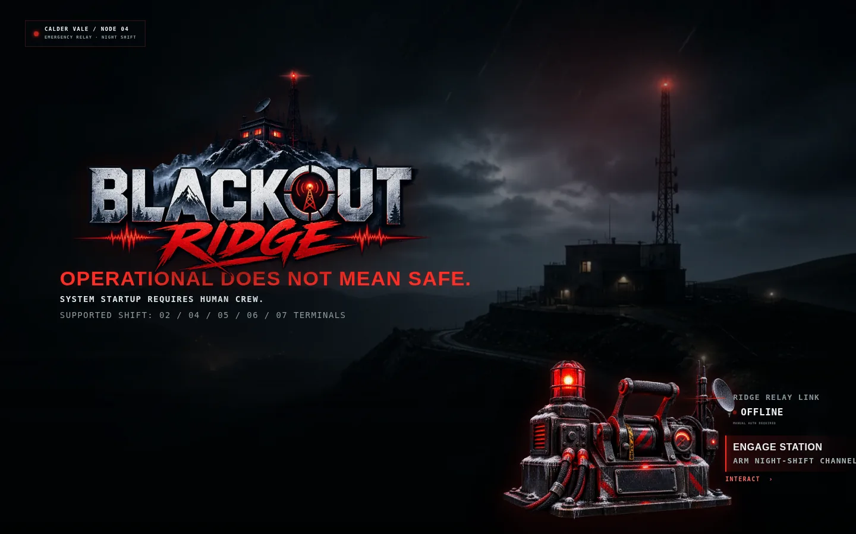
Figure 1 — Current station engagement screen (boot entry)

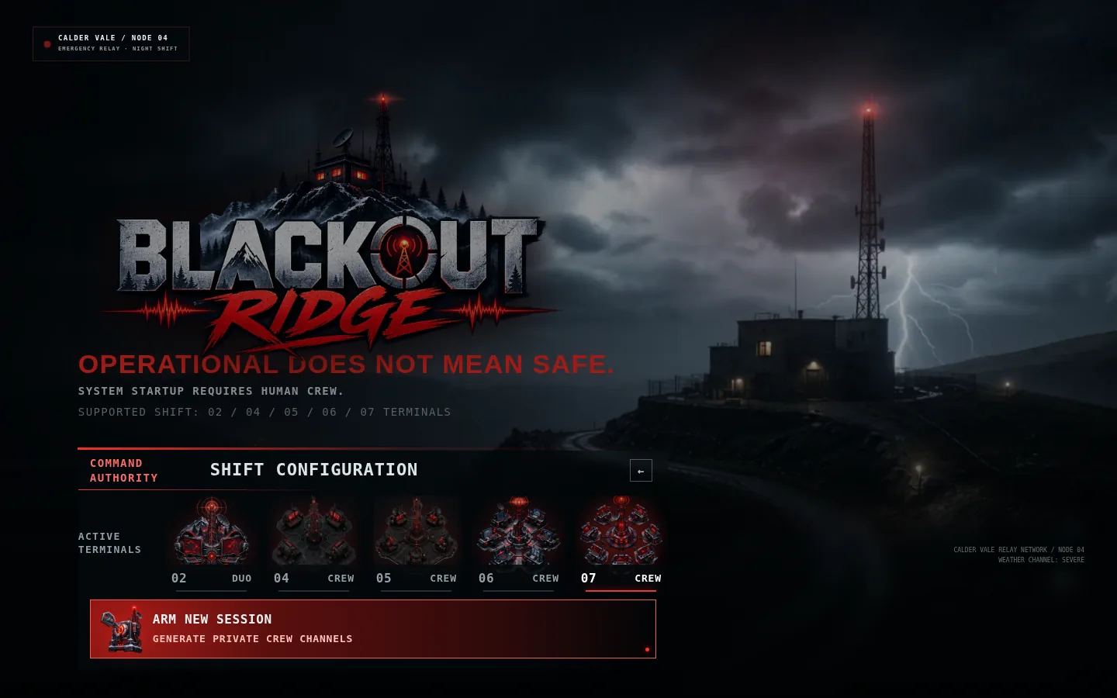
Figure 2 — Host shift configuration with distinct crew-size icons

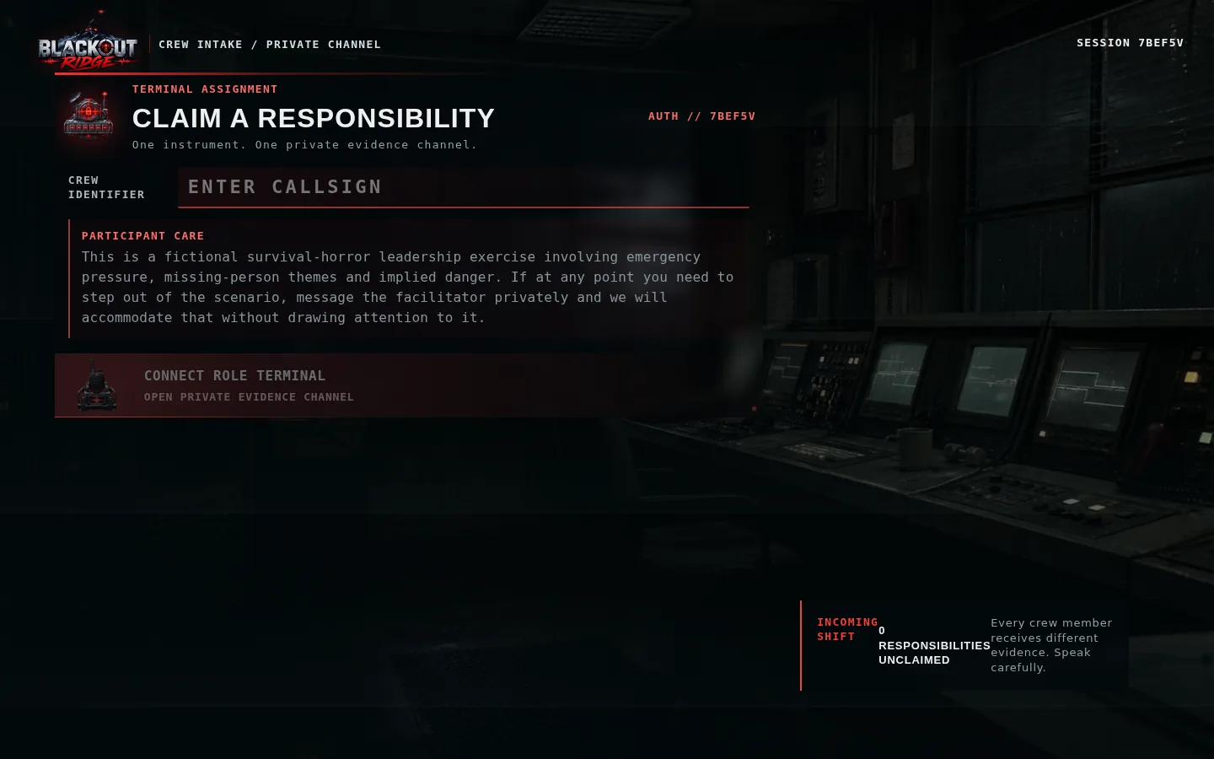
Figure 3 — Crew join flow with role instruments and participant care

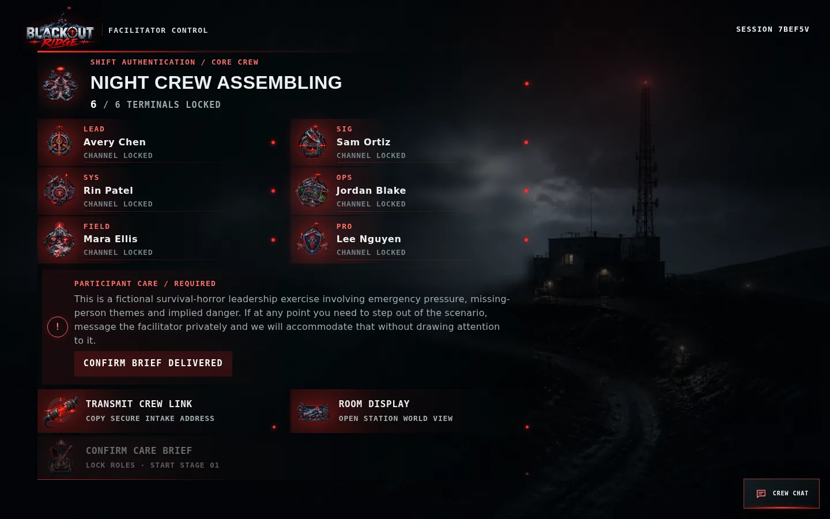
Figure 4 — Facilitator assembly lobby before shift start

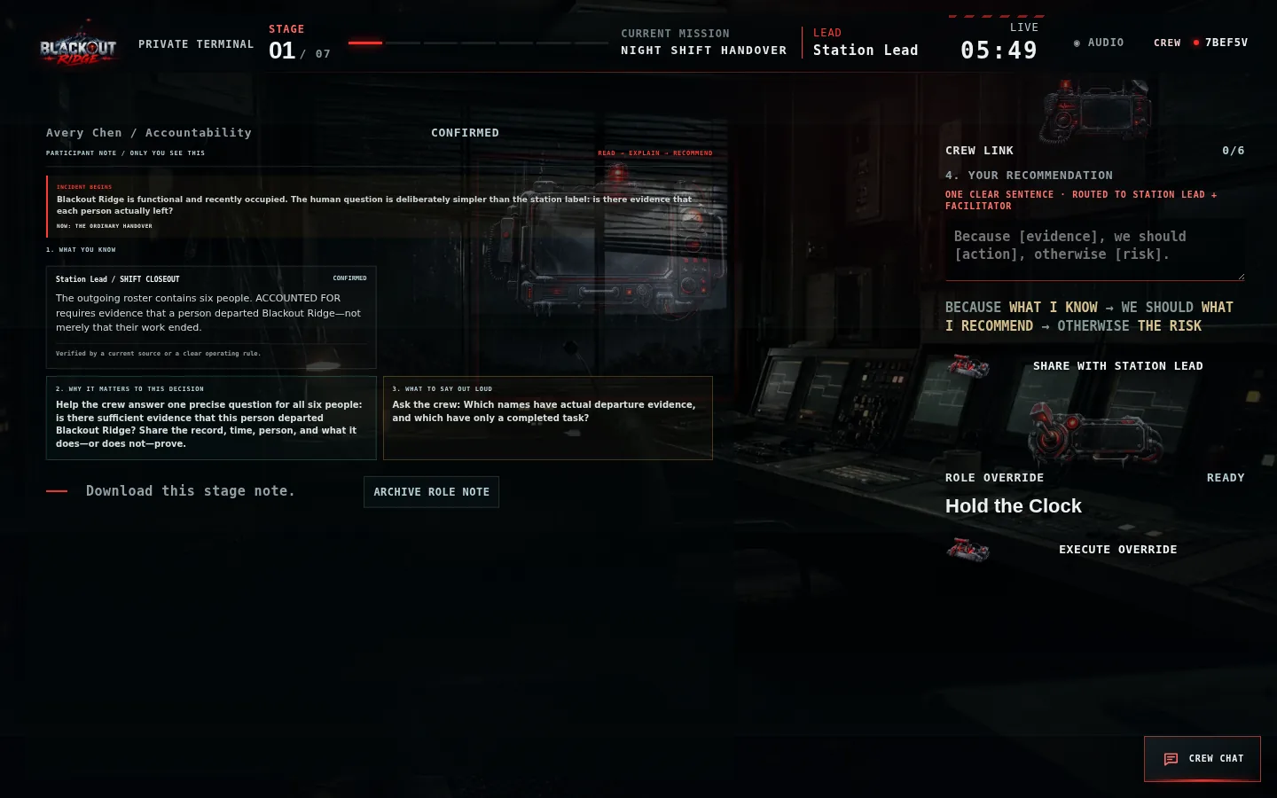
Figure 5 — Structured Participant Note and consequence preview on the Station Lead terminal

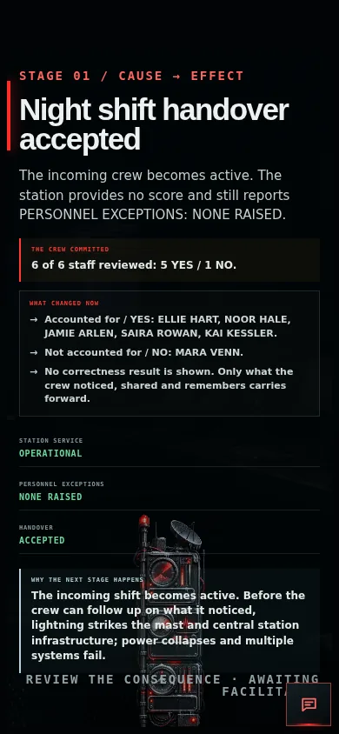
Figure 6 — Mobile cause-and-effect reveal with narrative bridge

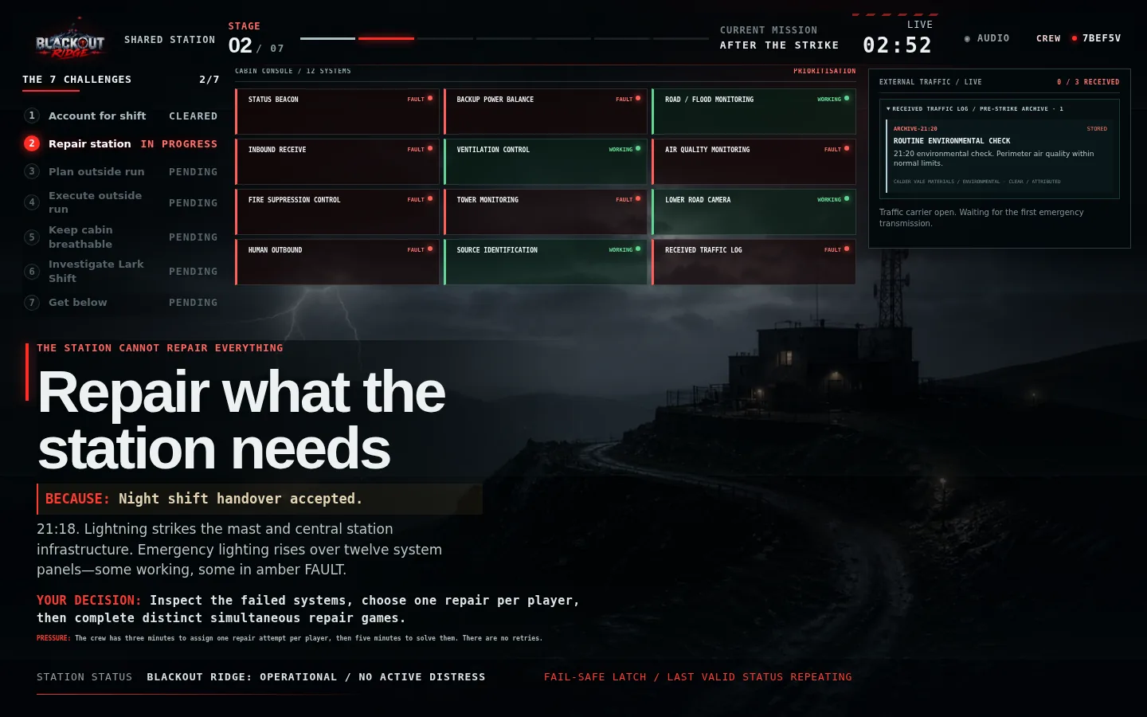
Figure 7 — Shared station during Stage 2 (After the Strike)

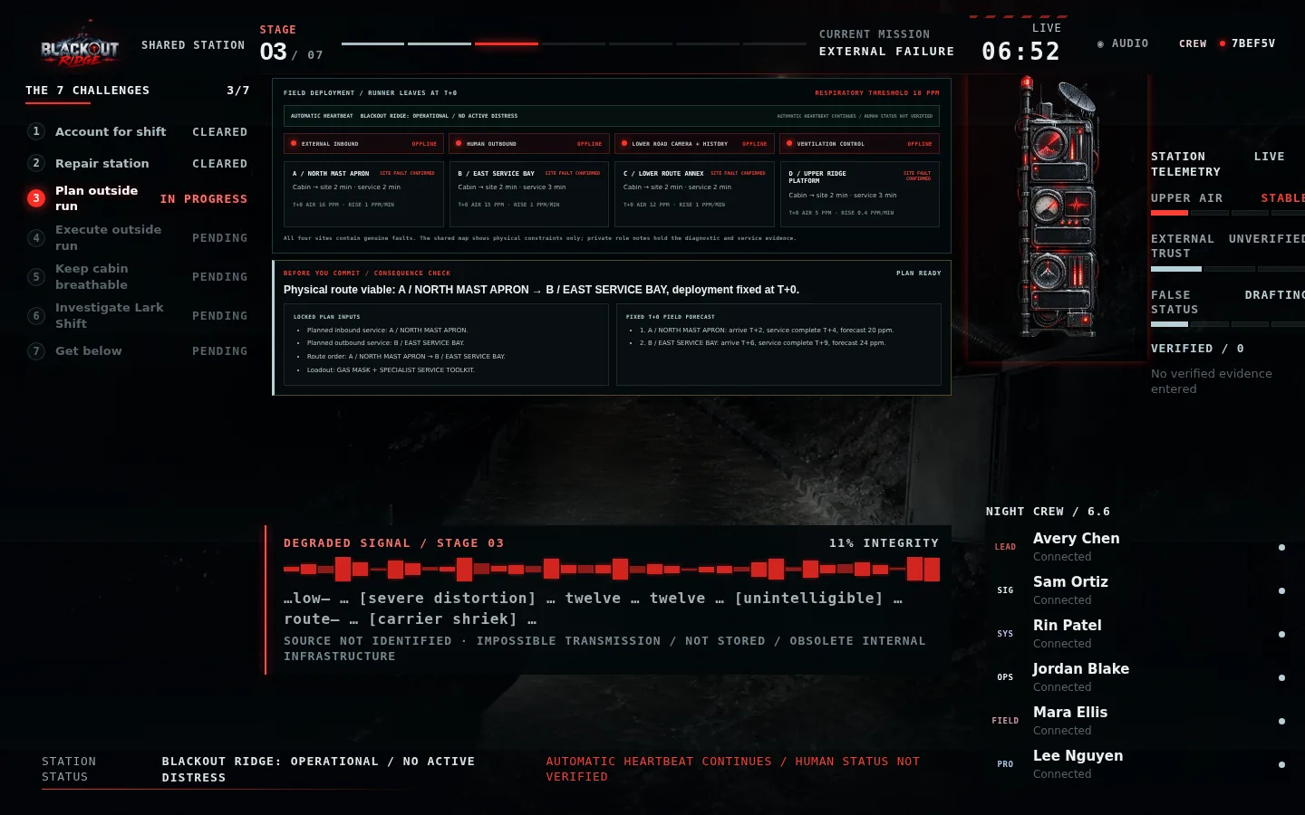
Figure 8 — Shared station during Stage 3 (Outside Plan)

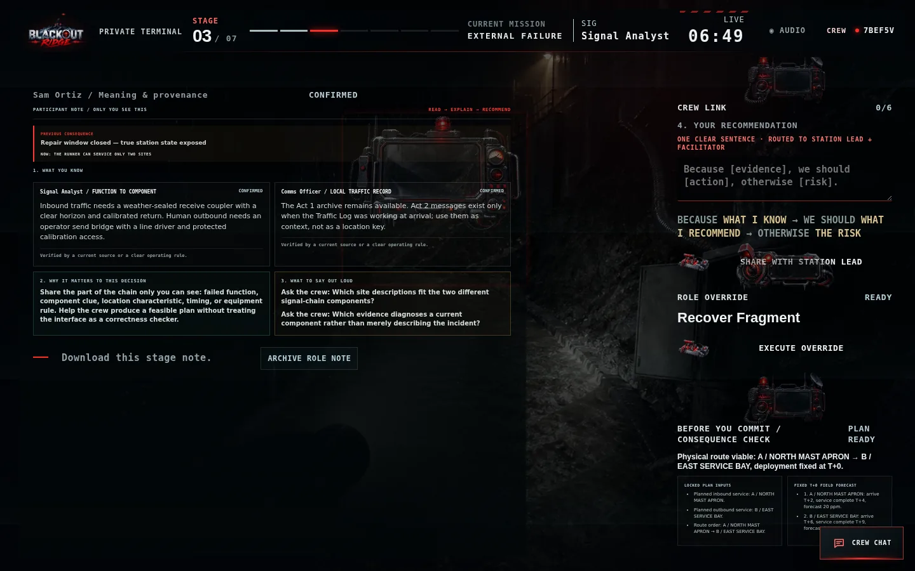
Figure 9 — Private Signal Analyst function-to-component evidence

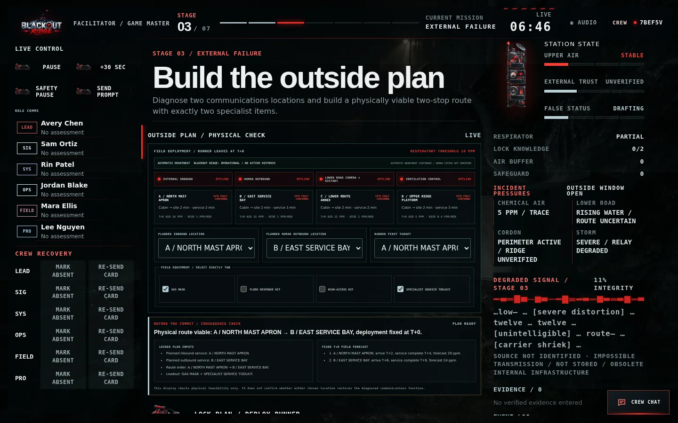
Figure 10 — Facilitator route, equipment and fixed T+0 feasibility console

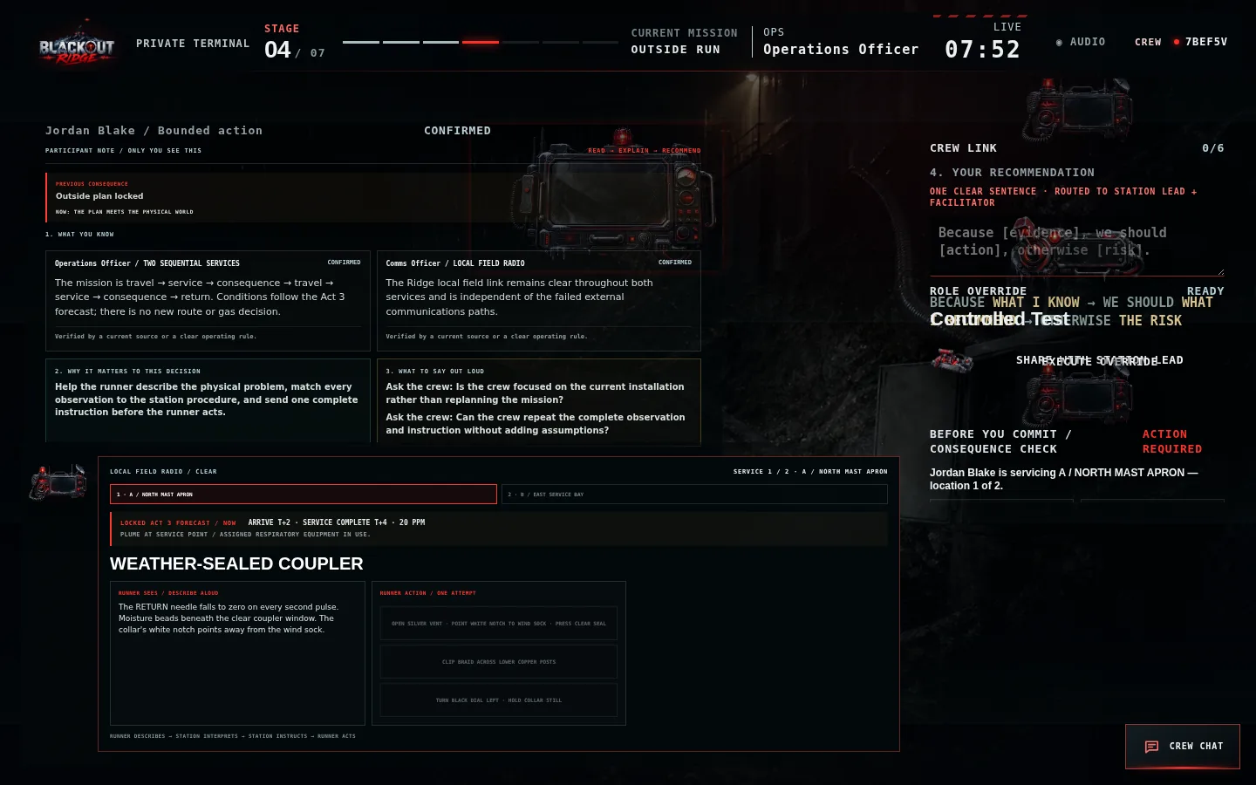
Figure 11 — Stage 4 runner-only physical observation and action view

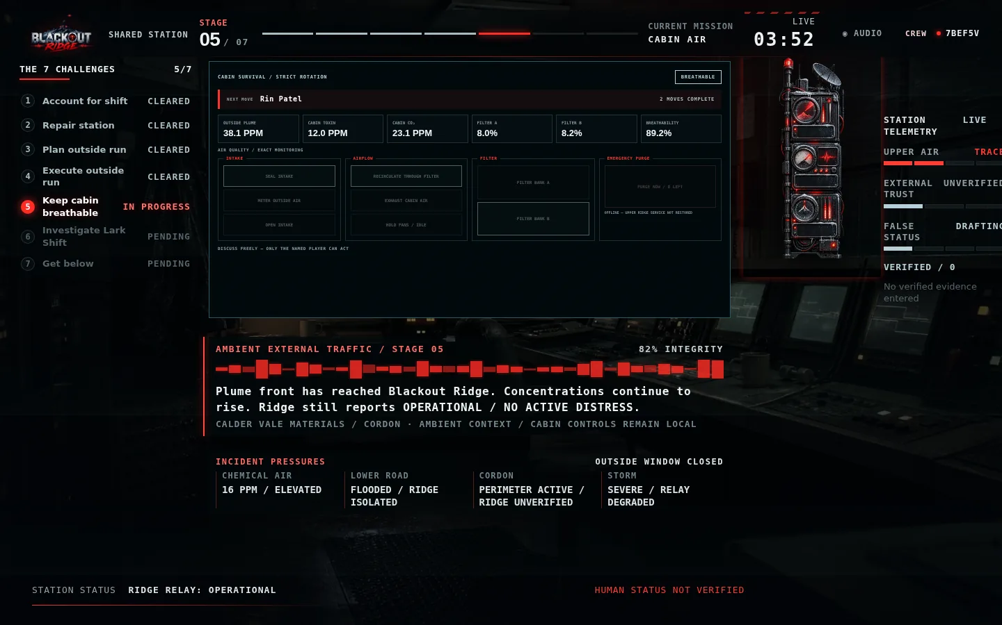
Figure 12 — Stage 5 shared cabin-air survival board

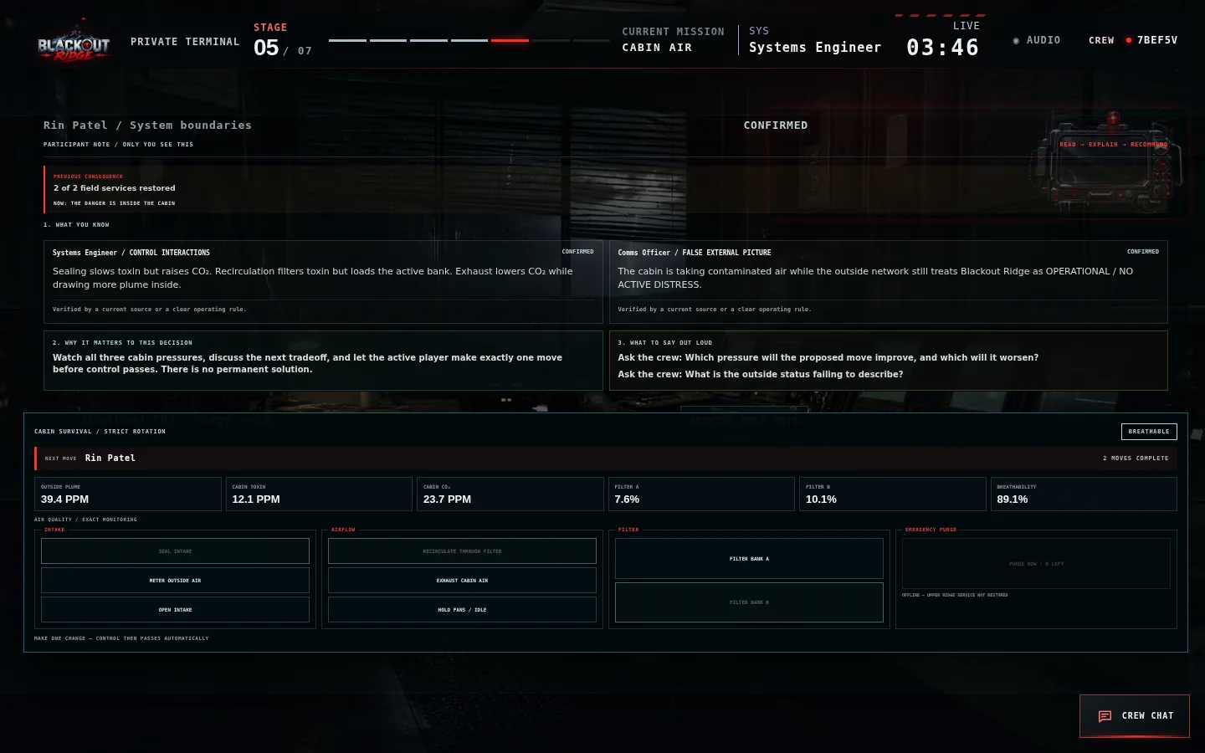
Figure 13 — Stage 5 private rotating cabin controls

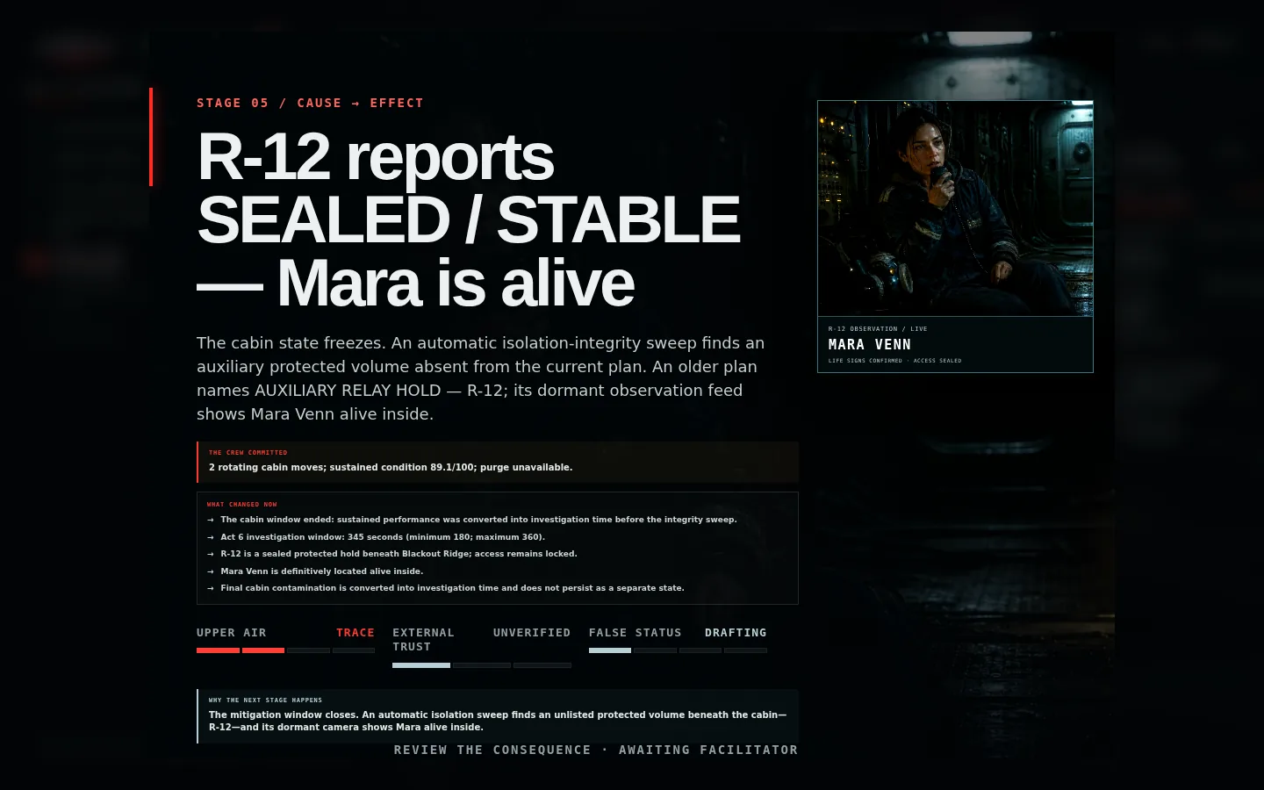
Figure 14 — Automatic R-12 integrity-sweep and Mara reveal

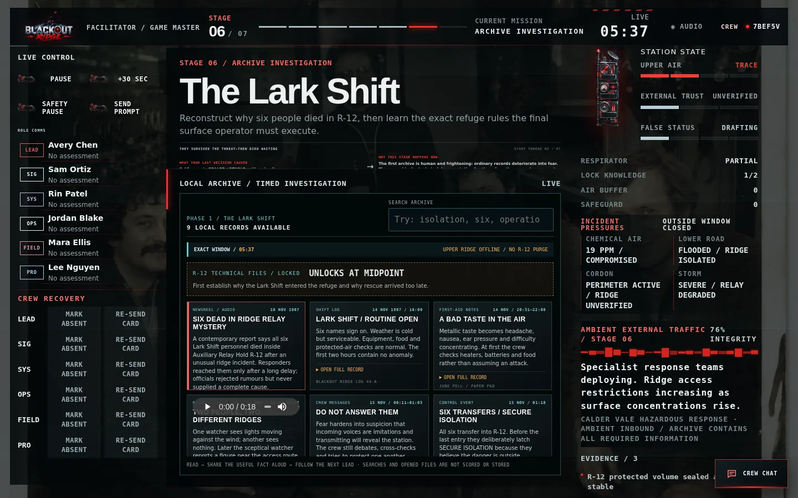
Figure 15 — Stage 6 searchable Lark Shift history

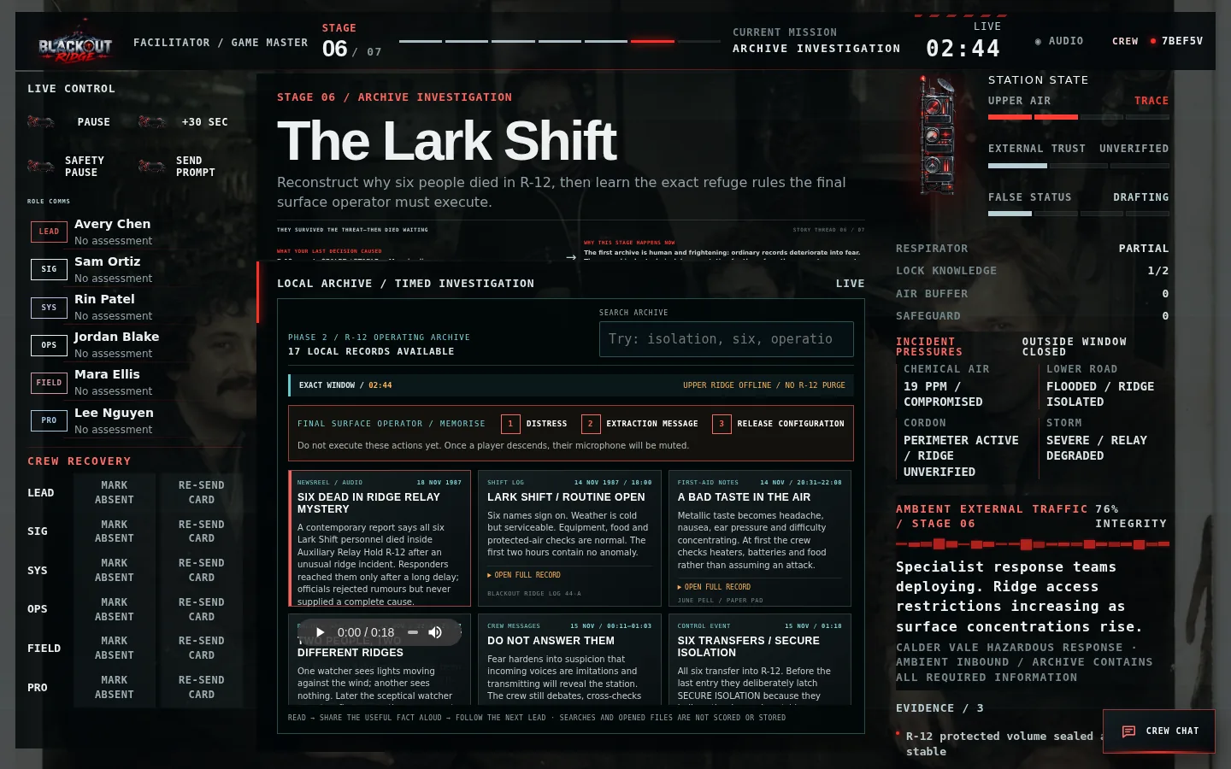
Figure 16 — Stage 6 R-12 technical archive and final-operator checklist

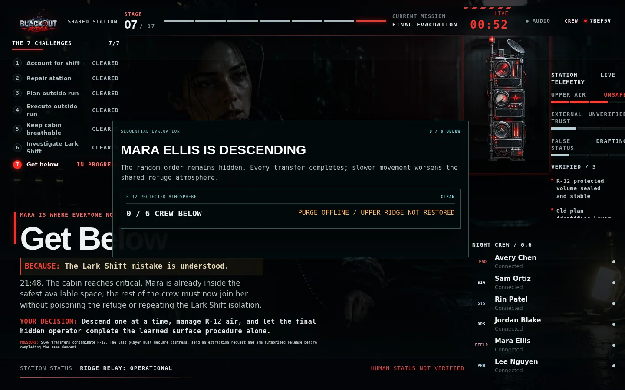
Figure 17 — Stage 7 finale on the shared station without hidden order

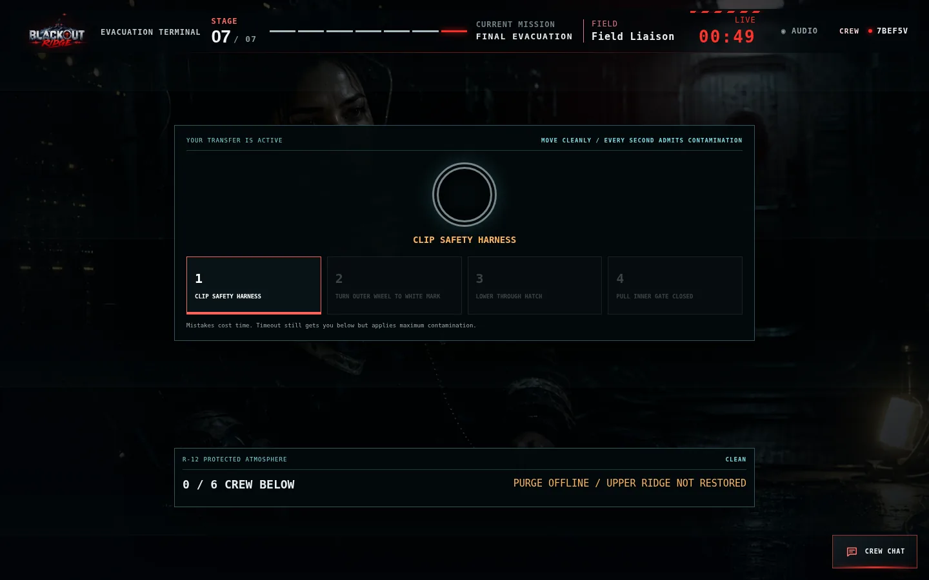
Figure 18 — Active player's one-at-a-time R-12 transfer

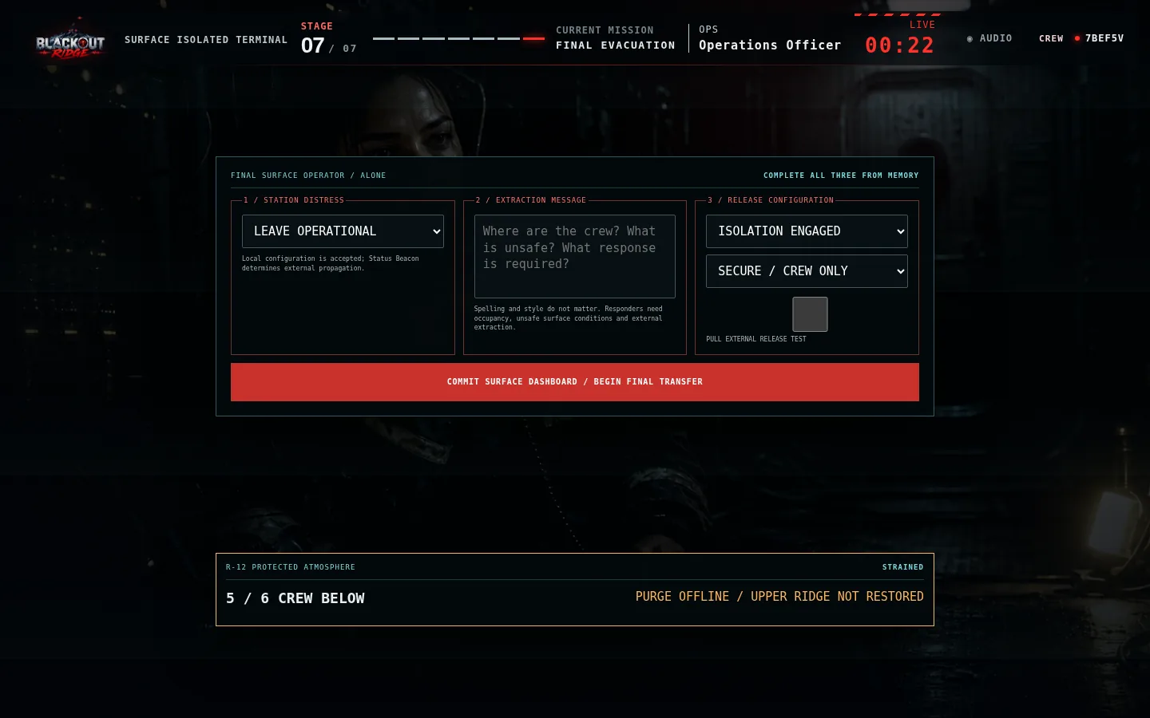
Figure 19 — Final surface operator's isolated three-part dashboard

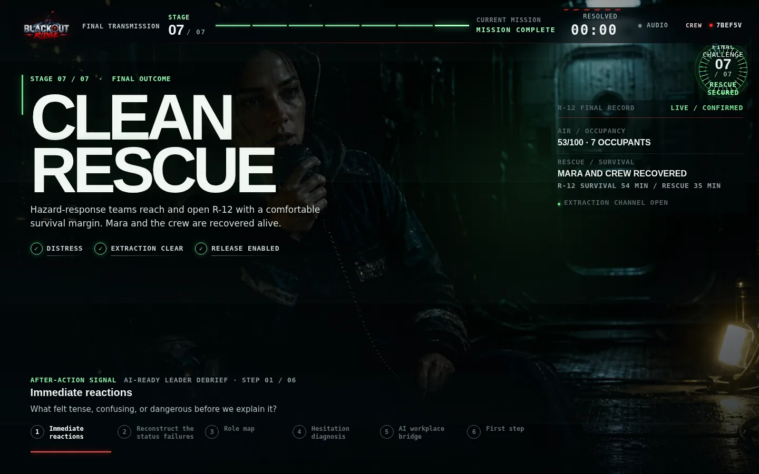
Figure 20 — Clean Rescue ending with external effects and rescue margin

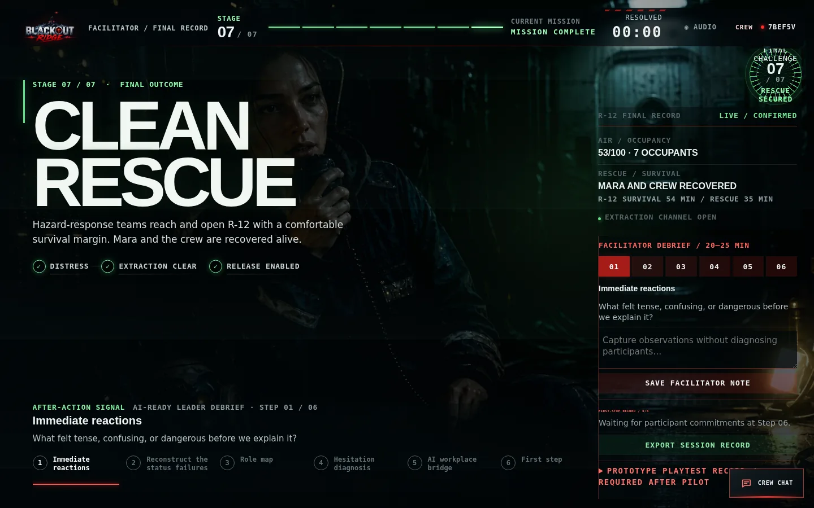
Figure 21 — Facilitator debrief console (six-step guide)

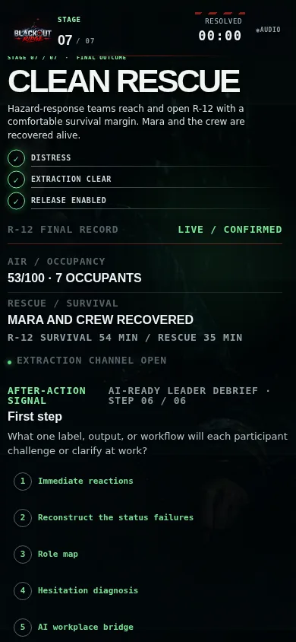
Figure 22 — Player debrief with first-step commitment (mobile)

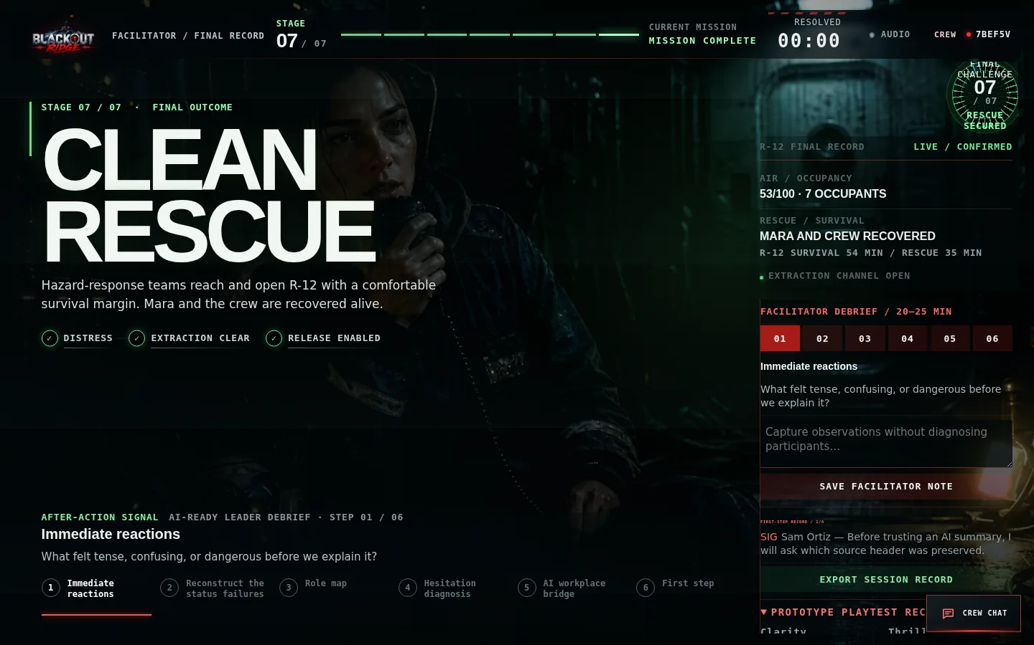
Figure 23 — Prototype playtest record after pilot session

14. Milestone 4 acceptance checklist
Criterion | Status
All seven challenges playable end-to-end | Complete
State-dependent traffic responds to receive, attribution, storage and external-path outcomes | Complete
Opt-in ambience, queued voiced transmissions and accessible transcripts | Complete
Outside Run: locked route, runner/station information split, four site games, no retry | Complete
Stage 1 handover and Stage 5 rotating cabin survival with performance-based Act 6 time | Complete
Stage 6 timed two-phase archive with local newsreel and R-12 operator checklist | Complete
Hidden-order evacuation finale with shared purge and solo surface operator | Complete
Four production endings with facilitator preview and confirmation gate | Complete
Six-step debrief synchronized across all clients | Complete
Session JSON export with decisions, debrief, and playtest data | Complete
Unequal information enforced in server logic and tests | Complete
Escalating stage-to-stage narrative bridges | Complete
Pre-commit previews and post-commit cause/effect explanations | Complete
Plain-language structured Participant Notes | Complete
Automated test suite passes | Complete

15. Explicitly deferred to later milestones
Item | Target milestone | Notes
Live 6–7 player playtesting and pacing tuning | Milestone 5 | Runtime captures playtest ratings; empirical validation required
Facilitator load testing across Teams/Zoom | Milestone 5 | One-console design complete; remote coordination untested at scale
Production deployment (TLS, managed DB, rate limits) | Milestone 5+ | Local JSON persistence sufficient for workshops
Expanded recorded sound library and cinematic opening | Milestone 6 | Core Act 1–3 transmissions are recorded; expanded dramatic treatment remains
Promotional video edit | Milestone 6 | Explicitly excluded from M1 design package

16. Handoff to Milestone 5
Milestone 4 completes the playable game. Milestone 5 should focus on facilitated pilot sessions (target: 6–7 players), difficulty and pacing adjustments from real crew behaviour, facilitator load under remote voice coordination, responsive/browser matrix testing, and facilitator documentation for external hosts. The playtest record and reframe warning in the runtime are ready to capture pilot outcomes.
Technical reference: docs/full-system/README.md and docs/full-system/PLAYBOOK-COVERAGE.md.

