**Triglycerides and cardiovascular disease: A Mendelian Randomization Study**

Jingran Wang

School of Biology and Basic Medical Sciences, Soochow University, Suzhou, China

**Abstract**

The causal relationship between triglycerides and cardiovascular disease remains uncertain despite positive associations observed in observational studies, which are susceptible to confounding and reverse causation. This study aimed to investigate the potential causal relationship between triglycerides and cardiovascular disease using a two-sample Mendelian randomization (TSMR) approach. Instrumental variables (IVs) representing independent genetic variants associated with triglycerides were derived from the Triglyceride Genetic Epidemiology (TG-GENE) consortium, encompassing genetic data from thousands of individuals. Outcome data for cardiovascular disease, including heart disease, stroke, and atherosclerosis, were obtained from a GWAS meta-analysis. TSMR analyses were conducted using various methods, such as inverse variance weighted (IVW), MR-Egger regression, weighted median estimator (WME), generalized summary data-based Mendelian randomization (GSMR), and robust adjusted profile score (RAPS), to explore the causal relationship between triglycerides and cardiovascular disease. Preliminary results from the Mendelian randomization analyses suggest a potential causal association between elevated triglyceride levels and cardiovascular disease. Further investigation is warranted to validate these findings and elucidate the underlying mechanisms.

**Keywords:** Mendelian randomization; triglyceride; causal inference; cardiovascular disease

1. **Introduction**

One significant risk factor for obesity-related diseases, is the level of triglycerides in the plasma. Studies have shown a strong prevalence of high triglyceride levels and low high-density lipoprotein cholesterol in individuals with high risk of cardiovascular disease.

Mendelian randomization (MR) is a method that uses genetic variants as instrumental variables to determine whether a risk factor causally affects a health outcome [8]. With the advancements in genome-wide association studies (GWAS) in the past decade, MR has been used to establish causal relationships between various factors and diseases [9]. However, there is limited research focused on the causal relationship between triglycerides and NIDDM.

In this study, we utilized a two-sample Mendelian randomization approach to estimate the causal effect of triglycerides on NIDDH. Then we reversed the exposure variable and outcome variable to investigate whether TG causes NIDDH or NIDDH causes the increase of TG. We retrieved data from the publicly available GWAS on the OpenGWAS project.

1. **Material**

2.1 Data Retrieval

Gene data related to exposure to triglycerides can be collected from the OpenGWAS website(<https://gwas.mrcieu.ac.uk/datasets/ieu-b-111/>). The dataset of UK Biobank includes 441,016 from European. The outcome variable data for cardiovascular was also from ieu OpenGWAS project(<https://gwas.mrcieu.ac.uk/datasets/ebi-a-GCST006867/>), which

had 61,714 NIDDH cases and 1,178 controls of European ancestry.

2.2 Select Instrumental Variable

After obtaining the data, we first process the exposure data by performing linkage disequilibrium (LD) pruning, with a threshold of r2 < 0.001 and a distance of < 10000 kb. We then filter the SNPs that have genome-wide significance (p < 5 × 10−8). Next, we need to harmonize the exposure and outcome data - which means the effect estimates are always on the same allele. Then, we utilized MRPRESSO package to

**Method**

* 1. Mendelian Randomization

1. **Outcome**

Table 1 presents the MR estimates for the relationship between elevated TG and NIDDH. The statistical significance of the results is consistent across all five methods, indicating a strong association. Specifically, the IVW method reveals a causal relationship between TG and NIDDH. The estimates from the other four analyses also align with these findings, reinforcing the evidence of an association between TG and NIDDH (Table 1).

Table 1. MR estimates from each method

The scatter plot(figure 1) displays the association between SNP-TG (x-axis, in SD units) and SNP-NIDDH (y-axis, log(OR)) with 95% confidence intervals. The effect sizes of the associations are visualized, and the regression slope of the line corresponds to the causal estimates obtained using the five Mendelian randomization (MR) methods. In the plot, SNP represents single nucleotide polymorphism.

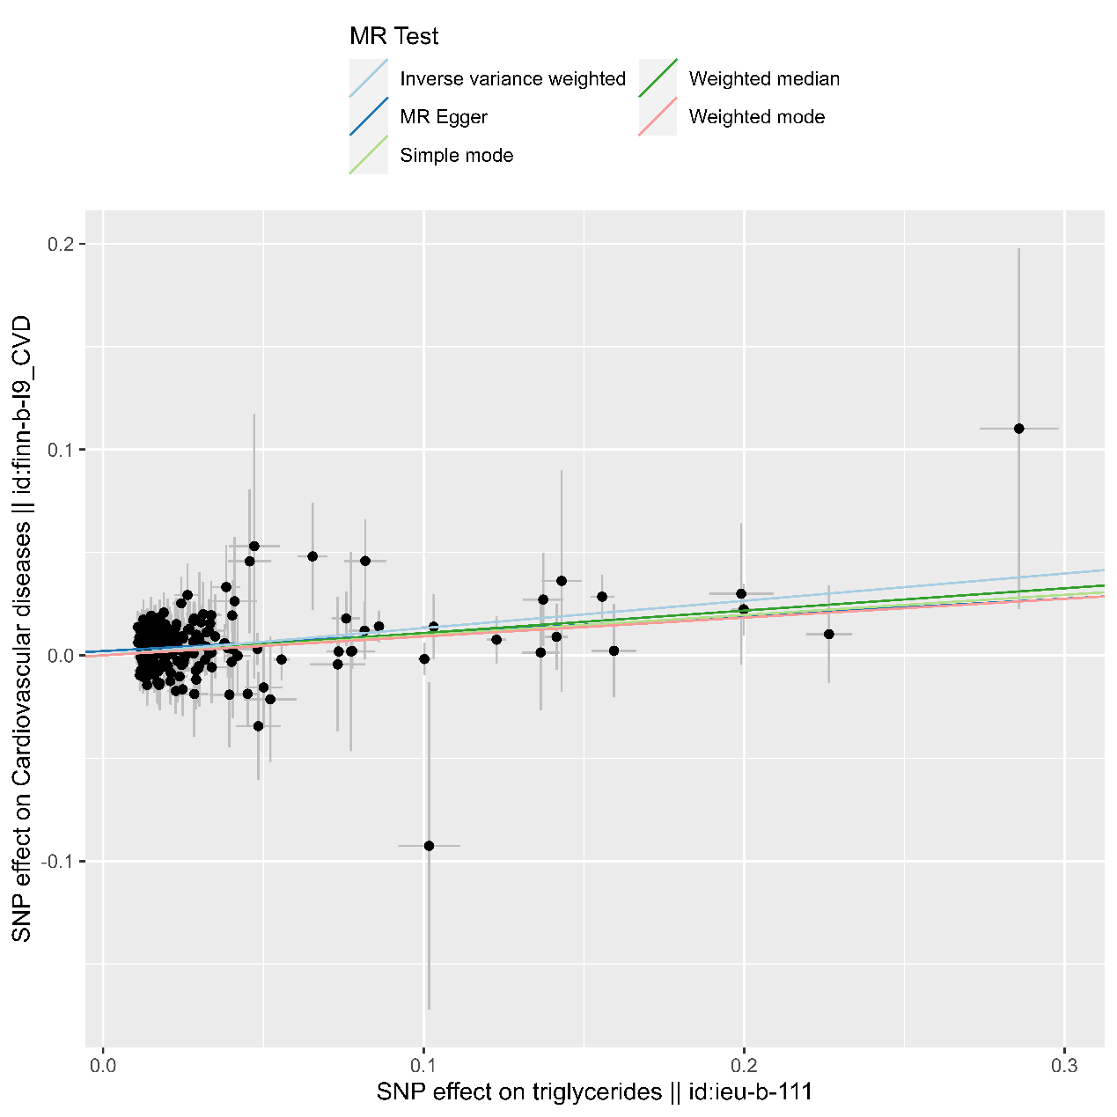

[1] Horton ES. NIDDM--the devastating disease. Diabetes Res Clin Pract. 1995 Aug;28 Suppl:S3-11. doi: 10.1016/0168-8227(95)01087-t. PMID: 8529517.

[2] Henning RJ. Type-2 diabetes mellitus and cardiovascular disease. Future Cardiol. 2018 Nov;14(6):491-509. doi: 10.2217/fca-2018-0045. Epub 2018 Nov 9. PMID: 30409037.

[3] Fletcher B, Gulanick M, Lamendola C. Risk factors for type 2 diabetes mellitus. J Cardiovasc Nurs. 2002 Jan;16(2):17-23. doi: 10.1097/00005082-200201000-00003. PMID: 11800065.

[4] Demir S, Nawroth PP, Herzig S, Ekim Üstünel B. Emerging Targets in Type 2 Diabetes and Diabetic Complications. Adv Sci (Weinh). 2021 Sep;8(18):e2100275. doi: 10.1002/advs.202100275. Epub 2021 Jul 28. PMID: 34319011; PMCID: PMC8456215.

[5] Kaze AD, Santhanam P, Musani SK, Ahima R, Echouffo-Tcheugui JB. Metabolic Dyslipidemia and Cardiovascular Outcomes in Type 2 Diabetes Mellitus: Findings From the Look AHEAD Study. J Am Heart Assoc. 2021 Apr 6;10(7):e016947. doi: 10.1161/JAHA.120.016947. Epub 2021 Mar 17. Erratum in: J Am Heart Assoc. 2021 Jul 20;10(14):e020749. PMID: 33728932; PMCID: PMC8174364.

[6] Zhang Y, Ding X, Hua B, Liu Q, Gao H, Chen H, Zhao XQ, Li W, Li H. Predictive effect of triglyceride‑glucose index on clinical events in patients with type 2 diabetes mellitus and acute myocardial infarction: results from an observational cohort study in China. Cardiovasc Diabetol. 2021 Feb 11;20(1):43. doi: 10.1186/s12933-021-01236-3. PMID: 33573649; PMCID: PMC7879620.

[7] Wang S, Shi J, Peng Y, Fang Q, Mu Q, Gu W, Hong J, Zhang Y, Wang W. Stronger association of triglyceride glucose index than the HOMA-IR with arterial stiffness in patients with type 2 diabetes: a real-world single-centre study. Cardiovasc Diabetol. 2021 Apr 22;20(1):82. doi: 10.1186/s12933-021-01274-x. PMID: 33888131; PMCID: PMC8063289.

[8] Bowden J, Holmes MV. Meta-analysis and Mendelian randomization: A review. Res Synth Methods. 2019 Dec;10(4):486-496. doi: 10.1002/jrsm.1346. Epub 2019 Apr 23. PMID: 30861319; PMCID: PMC6973275.

[9] Ma M, Zhi H, Yang S, Yu EY, Wang L. Body Mass Index and the Risk of Atrial Fibrillation: A Mendelian Randomization Study. Nutrients. 2022 Apr 29;14(9):1878. doi: 10.3390/nu14091878. PMID: 35565843; PMCID: PMC9101688.