# （MS15-034)(CVE-2015-1635)

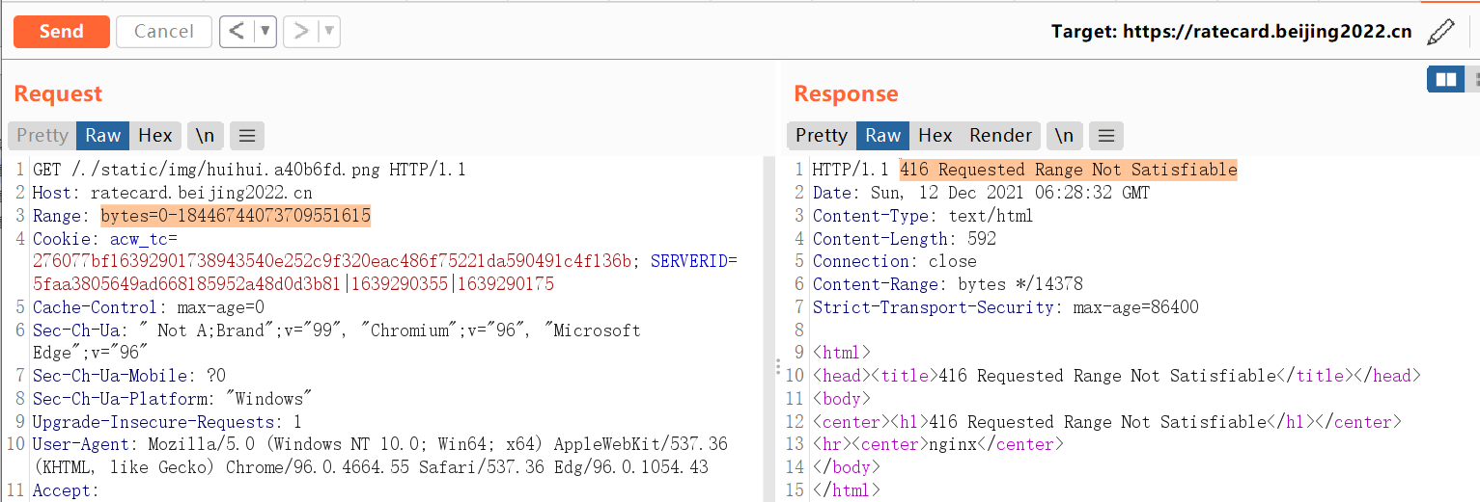

https://education.beijing2022.cn/img/logo.17682b8d.png

