Regression

What is happening in Regression (Behind the scenes)
Regression is a supervised learning method where the model learns a relationship between:
- Input features (X)
- Output value (Y = number)
Goal: learn a function that maps X → Y
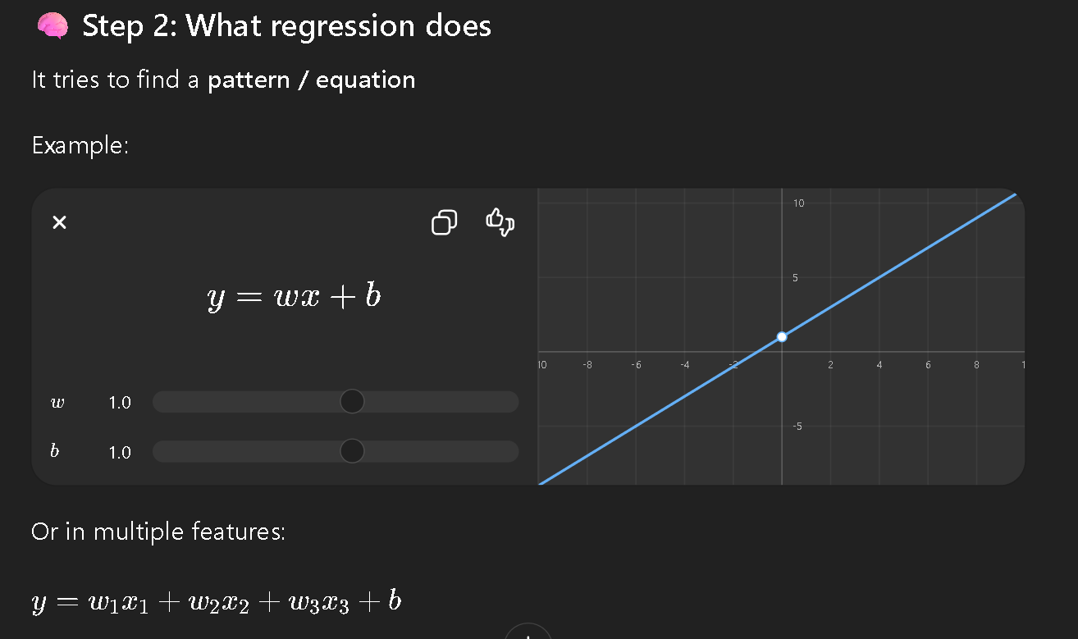

As we know these data first filled in the data set

What is a Dataset?
A dataset is just a table of information.
It has:
- Rows → observations
- Columns → features

2. Observation (Row)

An observation is a single row of data, while features are the input variables (columns) used to predict the target output in a dataset.
- An observation = one single data entry
- Example: one car wash record
Features
Cleanliness | Time | Price | Rating
8 | 30 | 20 | 4.5
Observation

3. Features (Columns)
A feature = a property or input used for prediction
From the table:
- Cleanliness → feature
- Time → feature
- Price → feature
4. Target / Label
This is what we want to predict:
- Rating → target (Y)
Think:
“What we are trying to learn”

How ML sees it internally
Instead of thinking table, ML sees:

Input vector (X):

$$X=(x_{1},x_{2},x_{3})=(Cleanliness,Time,Price)$$

Output:
$$Y=Rating$$

The same dataset structure (observations and features) can be used for both regression and classification; the difference depends on whether the target variable is continuous or categorical.
What is the data (features)?
Each car wash becomes a data point:
- Distance (km)
- Price ($)
- Rating (Star *)
- Wait time (min)
model looks like:

z=w1​⋅distance+w2​⋅price+w3​⋅rating+w4​⋅wait time+b
Where as b leads to bias here

So here we will use sigmoid property which help us to convert data in form of 0 and 1

: Decision Boundary (Classification)
- If $p>0.5$→ recommend this car wash
- If $p<0.5$→ don’t recommend

Error (Loss Function)
We measure how wrong the model is using log loss:
$$L=-[ylog⁡(p)+(1-y)log⁡(1-p)]$$
- $y$= actual result (user booked or not)
- $p$= predicted probability

