1.5.5 Cache Management
Caching is an important principle of computer systems. Here’s how it works. Information is normally kept in some storage system (such as main memory). As it is used, it is copied into a faster storage system— the cache—on a temporary basis. When we need a particular piece of information, we first check whether it is in the cache. If it is, we use the information directly from the cache.
Cache Management (Theoretical Answer)
Caching is an important technique used in computer systems to improve performance. Information is normally stored in a slower storage device such as main memory or disk. When this information is needed frequently, a copy of it is stored temporarily in a faster storage area called cache. Whenever the system needs data, it first checks the cache. If the data is found, it is used directly, reducing access time.

Hardware-Implemented Caches
Some caches are implemented completely in hardware and are not controlled by the operating system. Most computer systems contain an instruction cache, which stores instructions that are likely to be executed next. Without this cache, the CPU would have to wait several cycles to fetch instructions from main memory, resulting in poor performance.
Similarly, most systems also include one or more high-speed data caches that store frequently accessed data. These hardware caches are managed automatically by the processor. Since the operating system has no control over their operation, they are not a concern from the OS design perspective.

Need for Cache Management
Caches have limited size, so it is not possible to store all data in the cache. Therefore, deciding what data should remain in the cache and what should be removed becomes an important design issue. Proper selection of cache size and an efficient replacement policy can significantly improve system performance.

Cache Replacement Policies
When the cache becomes full, the system must remove some data to make space for new data. This is done using cache replacement algorithms. Common replacement policies include:
- Least Recently Used (LRU)
- First-In First-Out (FIFO)
- Least Frequently Used (LFU)
These algorithms help ensure that frequently or recently used data remains in the cache.

Movement of Data in Storage Hierarchy
The movement of information between different levels of the storage hierarchy can be explicit or implicit.
- Implicit data transfer is handled entirely by hardware. For example, transferring data from cache to CPU registers occurs automatically without operating system involvement.
- Explicit data transfer is controlled by the operating system. For instance, transferring data from disk to main memory requires OS intervention.

Conclusion
Cache management plays a vital role in improving system efficiency. While hardware caches operate independently of the operating system, software-controlled caches require careful management. Effective cache size selection and replacement policies help reduce access time and enhance overall system performance.

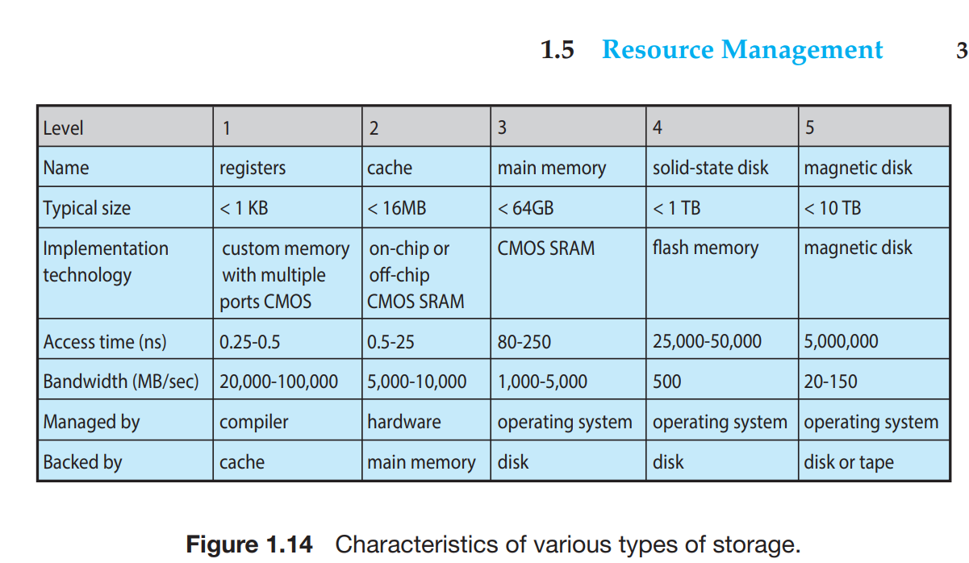
🔹 What is Caching?
Caching is a performance optimization technique where frequently used data is stored in a faster storage so it can be accessed quickly.
Core idea:
Keep copies of data closer to where it is needed.

🔹 Why Do We Need Cache?
Different storage devices have different speeds:
Storage Type | Speed | Cost
CPU Registers | Fastest | Very expensive
Cache (L1/L2/L3) | Very fast | Expensive
Main Memory (RAM) | Medium | Moderate
Disk / SSD | Slow | Cheap
If the CPU had to wait for RAM or disk every time → system would be very slow.
So we use cache as a middle layer.

🔹 How Caching Works (Simple Flow)
- Data is stored in main memory
- When the CPU needs data:
  - First, it checks the cache
- Two possible cases:
Cache Hit
- Data is found in cache
- CPU uses it immediately
- ⚡ Very fast access
Cache Miss
- Data is NOT in cache
- Data is fetched from main memory
- A copy is placed into the cache
- Slower than hit, but future accesses become fast

