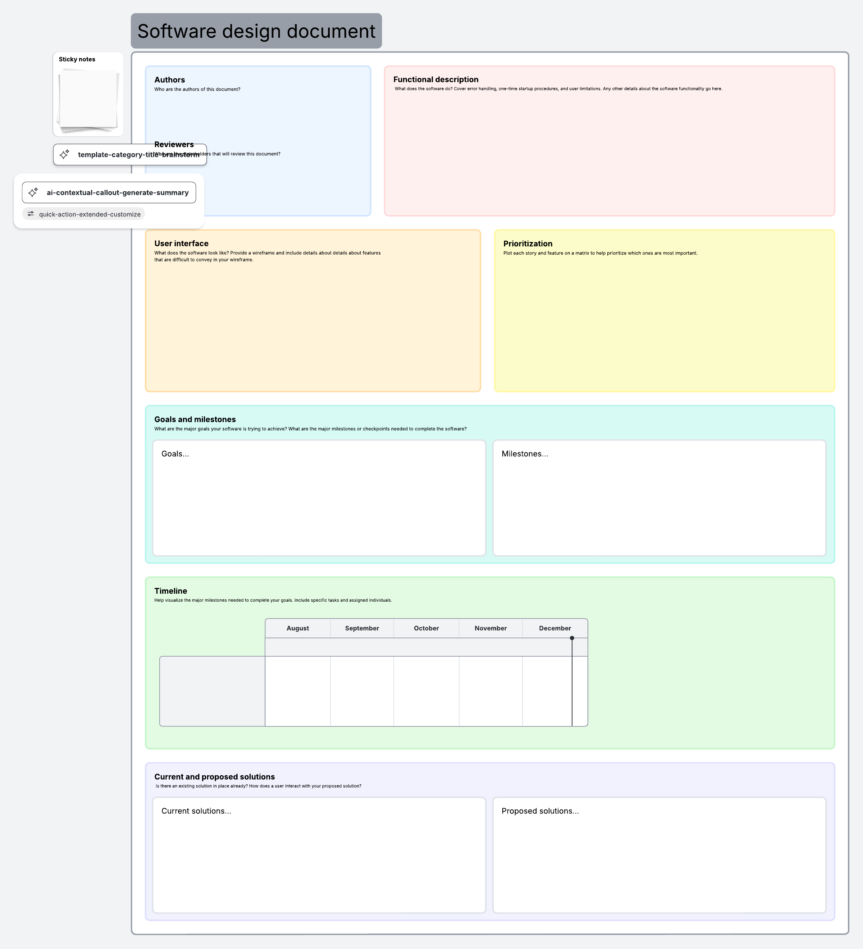
Our solution is an improved AR-based application that not only detects objects but also tells the user how far the object is and in which direction it is located.
The app uses voice output so visually impaired users can understand the information easily. It also includes features like emergency alerts and customizable settings to make the app more helpful and user-friendly.
Right now, there are apps that can detect objects using the camera. However, most of them only tell what the object is and do not give extra details like how far the object is or where it is located.
Also, many apps are not designed specifically for visually impaired users, so they lack proper voice guidance and accessibility features.
Testing & Final Submission
Core Development (AR + Detection)
Wireframing & Design
Project Planning & Research
N/A
April
March
The user interface is designed to be simple and accessible.
Main screens include:
- Home Screen: Allows users to start AR scan or voice scan
- Camera Screen: Displays live camera feed with direction indicators
- Result Screen: Shows detected object name, distance, direction, and voice output
- Settings Screen: Allows customization of voice speed, language, and sensitivity
The interface prioritizes clarity, minimal design, and accessibility for visually impaired users.
February
January
- Requirement Analysis Completed
- Wireframe Design Completed
- AR Detection Module Development
- Distance & Direction Feature Integration
- Voice Assistant Integration
- Testing and Debugging
- Final Submission
- To assist visually impaired users in identifying objects
- To provide real-time audio feedback
- To improve user safety through distance and direction awareness
- To create an accessible and easy-to-use interface
High Priority:
- Object Detection, Voice Output , Distance Calculation and Direction Detection are High Priorities.
Medium Priority:
- Voice Commands and Settings Customization
Low Priority:
- UI Themes (Dark Mode) and Additional language support
The system is an AR-based mobile application designed to assist visually impaired users. It uses the device camera to dectect real-world objects and provides information through both text and voice output.
The system enhances object detection by including spatial awareness features such as approximate distance and direction (e.g., left, right, front). The user can interact using voice commands or touch input.
Key functionalities include:
1. Real-time object detection 2. Voice feedback for accessibility 3. Distance estimation of detected objects. 4.Direction guidance relative to the user 5. Emergency alert feature 6. Customizable user settings
These are the six features that system will perform.
Professor: Nashid Anjum
Team Members: N/A
Author: Bhavneet
Course: Software Engineering
Project: AR-Based Accessibility Assistant

