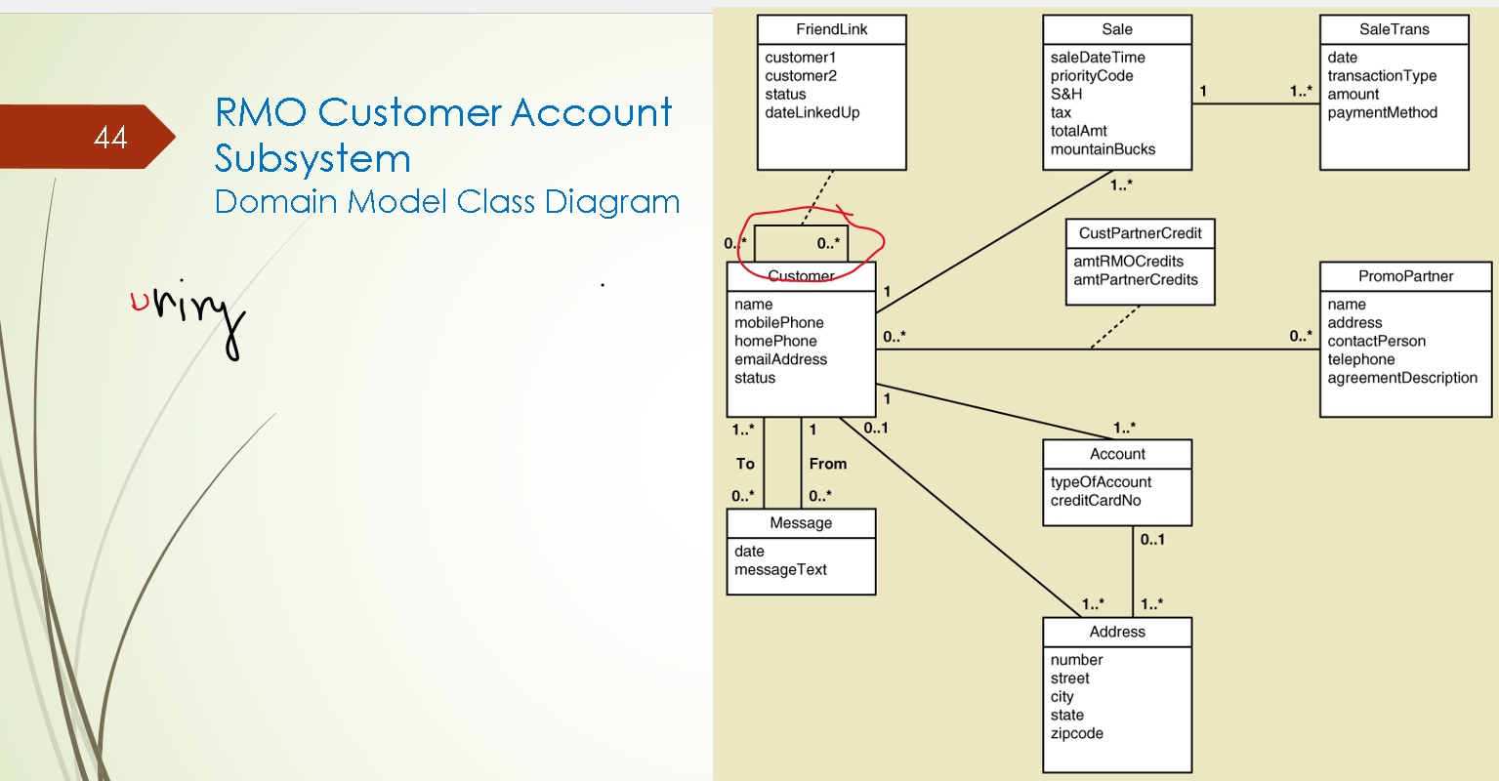
Association class is only for many to many
Inheritariance show triangle
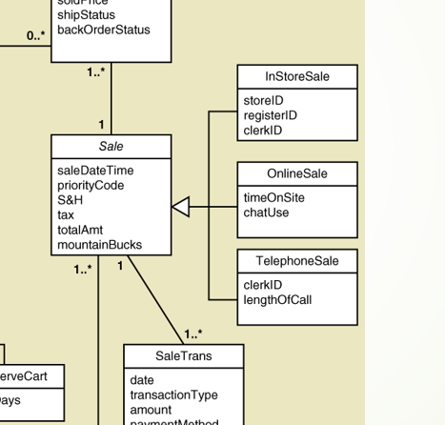 in stroe sale is sale
Online sale is sale
Telephone sale is sale
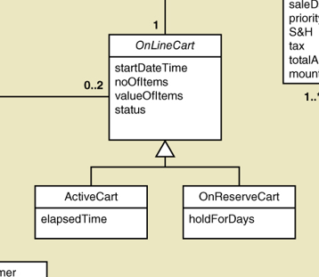

Active cart is online cart
Onreserve cart is online cart

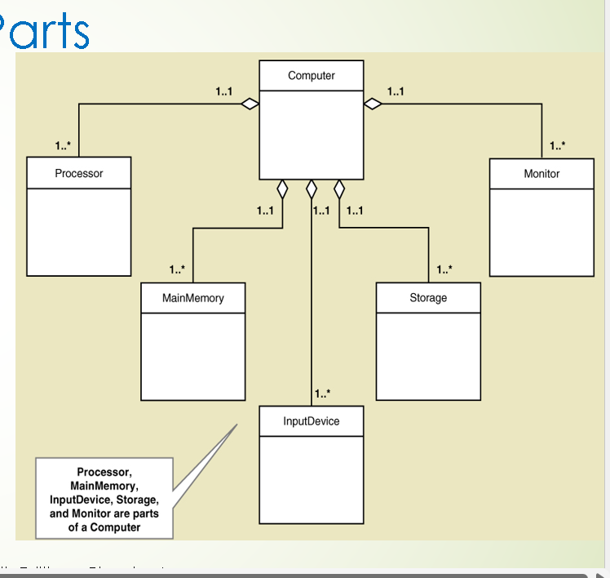
Diamond always on whole part class
Whole part relation have multiplicity .. computer can have one or more one ( comp can have more monitor )
Can monitor be more computer …No it has to attest one comp
What about comp and cameras ….?
Can comp have 0 camera …
Can desktop comp have one camera . SO comp ------------- 0…1 Camera
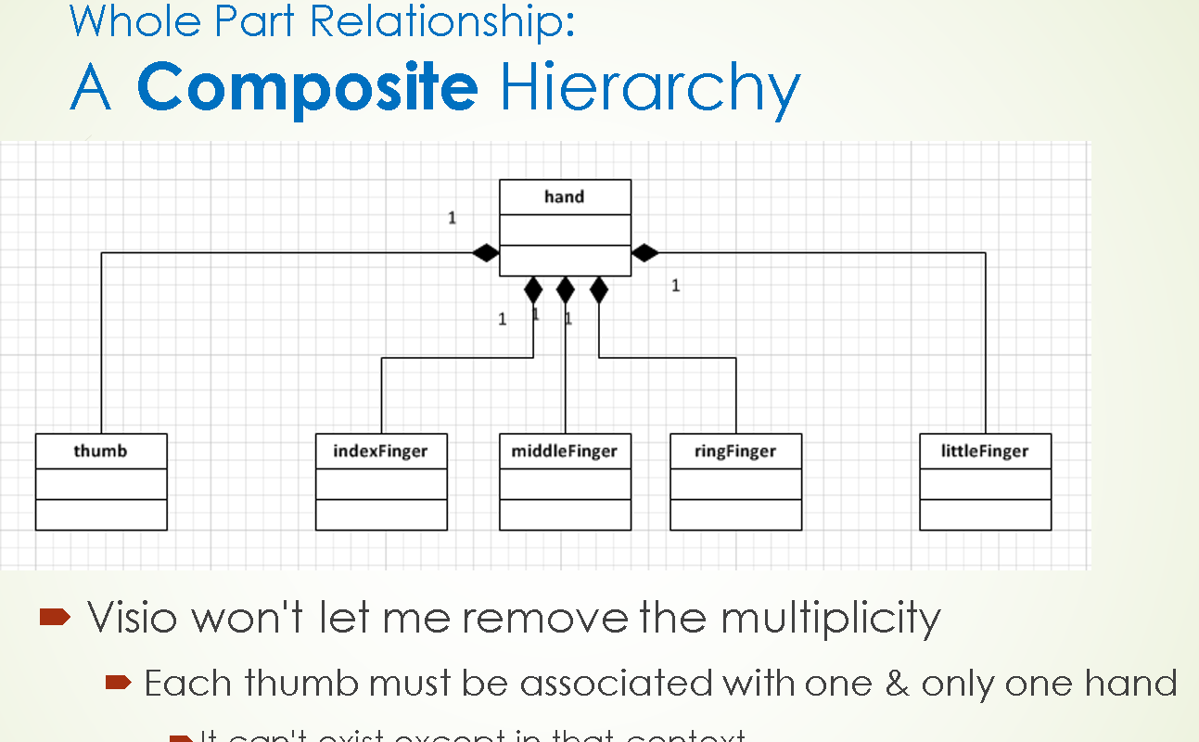

This is composite relationship while previous one was the just whole part aggregation ( parts were reusable )
Composite does not work like hand have five fingers no
So how ……..?
Thing cant exist with like hand have fingers
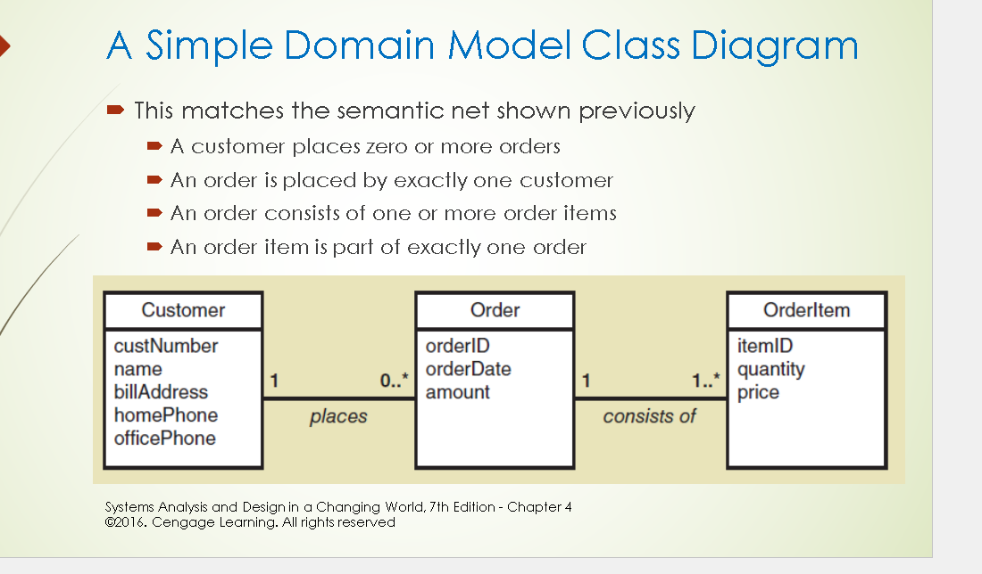
Entity can have one lay one that is association
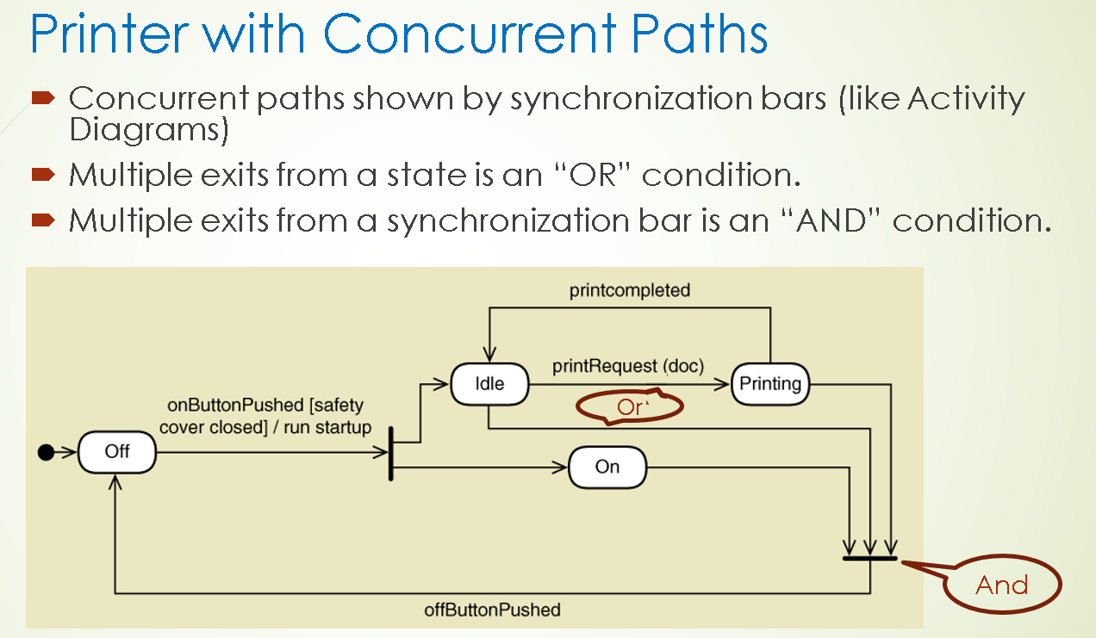

In domain what we have only the relations ….
So here we have the object that show behavior and there more knowledge about object shows its behavior

Door is instance of Class and it has two behavior it can be in close and open state .. How does it go from close to open some checker we have to happen
Guard condition has to be true like the knob of door has to be turned the transion happen form one to another state with have that condition
Guard condition is safety door close knob turned .. Door is open and lock is unlock

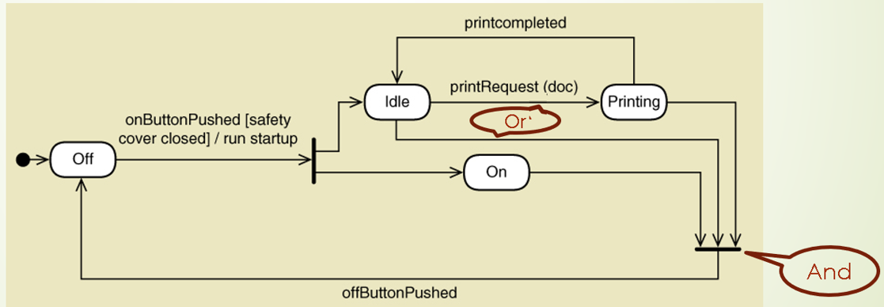
Action ---------- part of transion from off to on ( button push )

Does every transion need these three ( trigger , transion and guard condition ) no some may true some may not
If transion lead to more than one state we have the symbol that we call the synchronization bar there we got he two path names as concurrent path
State one can be have state concurrent with NOTHER
CAN BE on and IDLE ( PRINTING )
Transion come out form idle it can go to printing or go back to off state …….
How be build such state machine diagram we have 5 steps
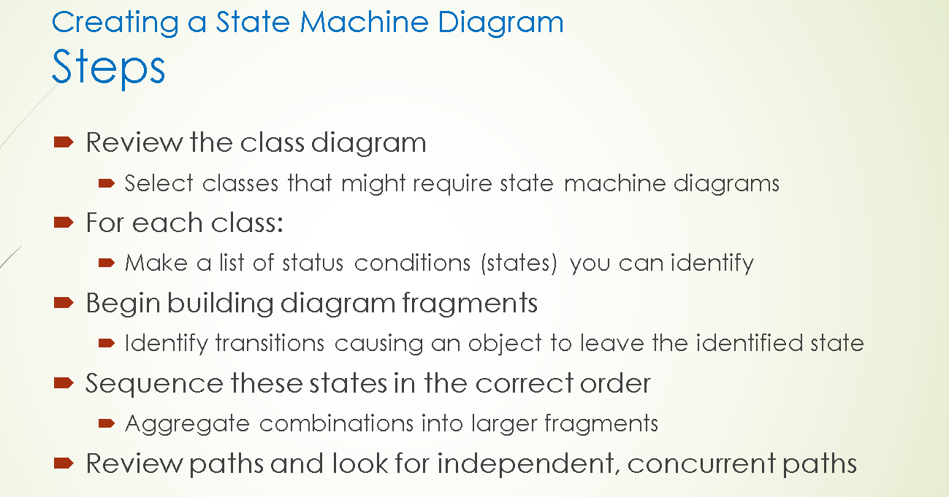
1 . Pick the domain class and pick up the object that varies its states
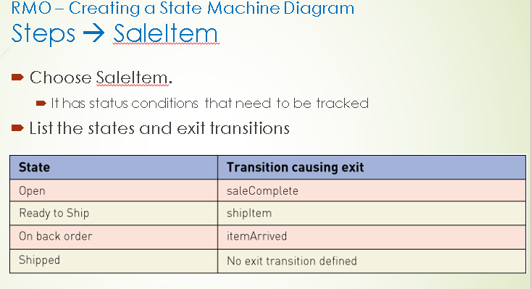
3. we see transion which lead us to take somewhere we have table like upeer mentioned
4. we ordering the states … ( Remember we done the note book )
We take those pairs state and transion and make to box arrow
Sale completet
Open

Each tarnation lead to another states from one to another
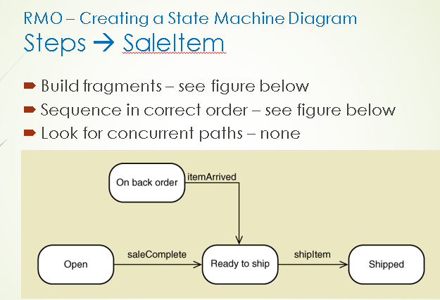
Is that complete yet Not its not …..
We add the Psedu State
We still miss that one state from where to where look at the on back order
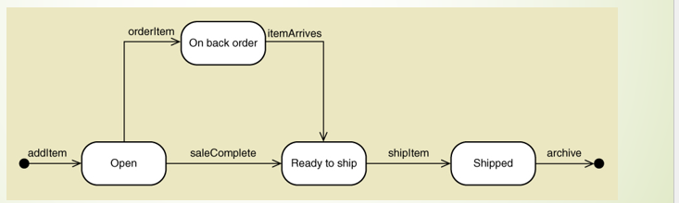

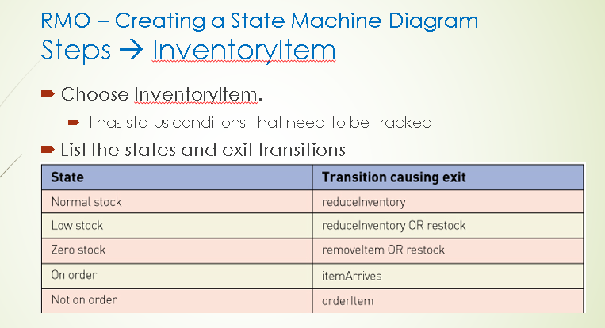
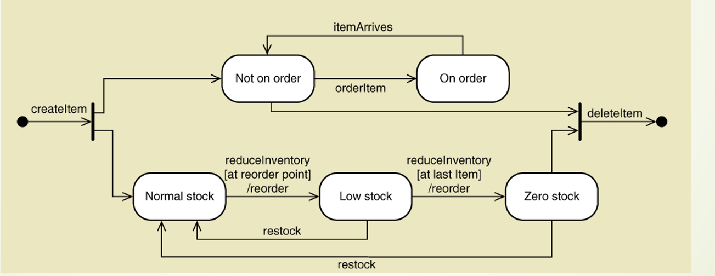
One state and another is domain class diagram

After lisiting all we cheack for concurrency

