**Steps to deploy Postgres DB and Node Js application**

1. Upload all the files to Cloud Shell from the .zip file
2. Deploy configMap from the below command

kubectl apply -f 1-statefulset-db-config.yaml

1. Deploy Kubernetes secret

kubectl apply -f 2-statefulset-db-secret.yaml

1. Deploy Headless service for Stateful set

kubectl apply -f 3-statefulset-headless-service.yaml

1. Deploy Stateful set for Postgres db

kubectl apply -f 4-statefulset-db.yaml

1. Build Docker image

docker build -t services:1 .

1. Login to Docker hub

Docker login

1. Tag the Docker image

docker tag 6593831ef017 lovekushkumar/6593831ef017

1. Push Docker image to Docker Hub

docker push lovekushkumar/6593831ef017

1. Deploy the microservices API and Load balancer

kubectl apply -f 6-microservice-api.yaml

1. Wait till the microservice-deployment displays Status as Ok (Fig 1) and Endpoint (Fig 2) as shown in below screenshots

Fig 1

Fig 2

1. Copy the Endpoint and try to browse in on Browser and it should display the data from database (assuming all Ips 0.0.0.0/0 is configured at Firewall)

**Docker Image published to Docker Hub**

<https://hub.docker.com/repository/docker/lovekushkumar/6593831ef017>

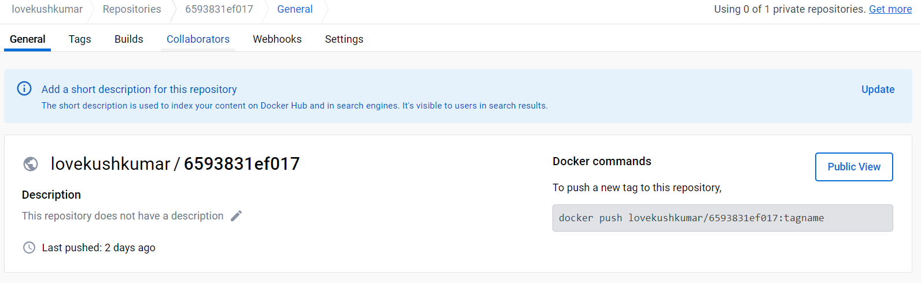

**Source code is added to Github**

[GitHub - LovekushKumar/nagpassingment_devopsK8s](https://github.com/LovekushKumar/nagpassingment_devopsK8s)

