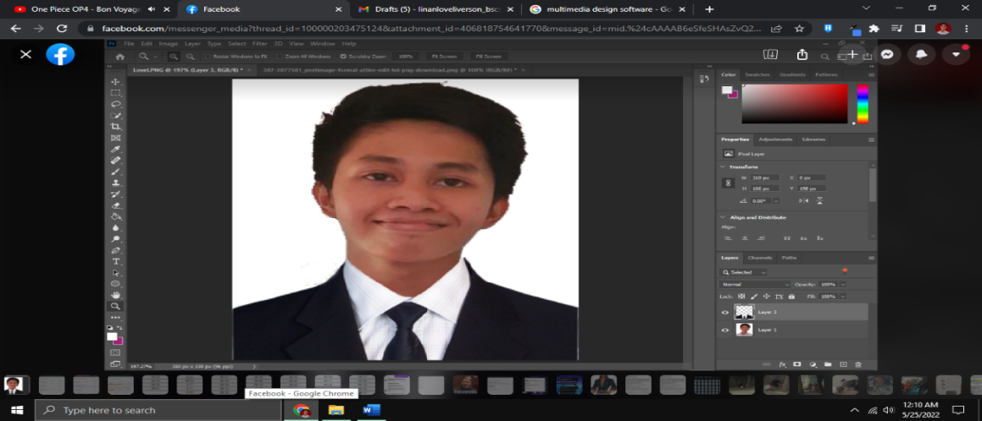

**Lovel Iverson D. Linan**

Sampaguita Compound Pilar Village Las Piñas City

09295049979

iversonlinan@gmail.com

* https://lovellinan.github.io/LovelLinan/#

**Objective**

To expand my knowledge and skills beyond what I learnt in school. I am completely dedicated to

your firm and my professional progress.

|  |  |
| --- | --- |
| **Education**  **Tertiary** Pamantasan ng Lungsod ng Muntinlupa  Muntinlupa City  Bachelor of Science in Computer Science  2018 – 2022  **Secondary** Centro Escolar Las Piñas  *Senior High*Las Piñas City  2016 – 2018  **Secondary** Las Piñas East National High School Talon Village Annex  *Junior High* Las Piñas City  2012 – 2016  **Elementary** Almanza Elementary School  Las Piñas City  2006 – 2012  **Academic Award**  2022 BS Computer Science Academic Excellence Award  GWA of 1.45  2021 BS Computer Science Dean’s Lister  GWA of 1.66  **Experiences**  2022 Highly Succeed Inc  Internship for Web Development Back - End | **Languages**   * PHP * Java * Python * JavaScript * C++ * SQL * HTML * CSS   **Framework**   * Laravel * Bootstrap   **Database Management**   * MySQL   **Tools**   * Adobe Photoshop * Microsoft Office * Sublime * Visual Basic |