**Logo via Adobeform**

1. In object library drag image

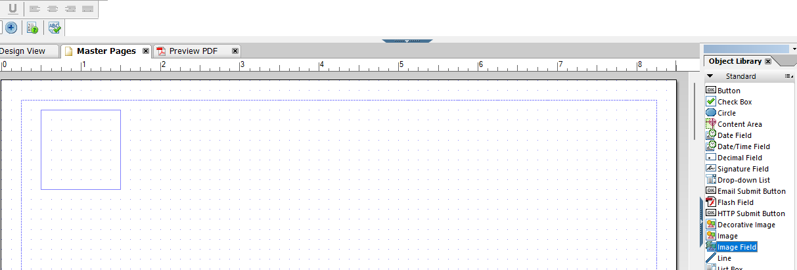

1. Click the container then assign image

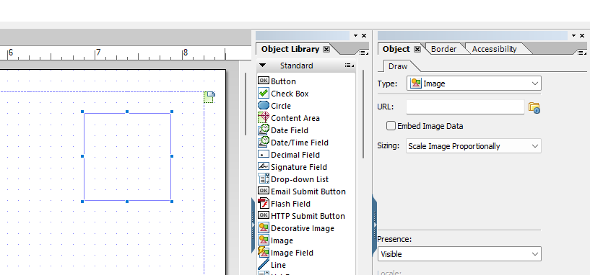

1. Check the checkbox embed image data

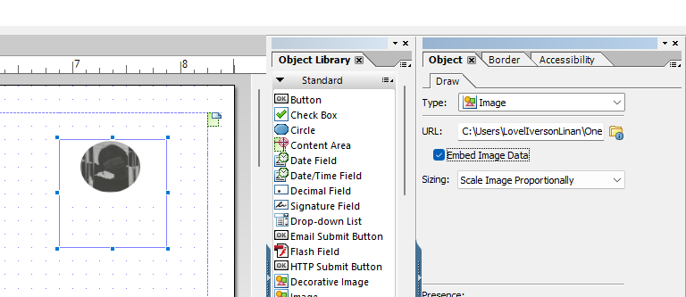

**Logo via SE78**

1. Go to t-code SE78
2. Open Graphics and select bitmap then assign a name

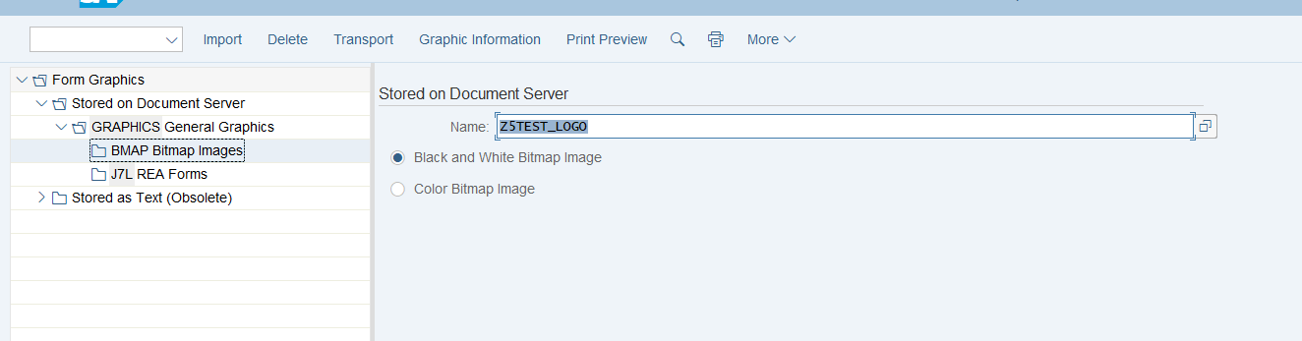

1. Click Import. Assign file name and continue

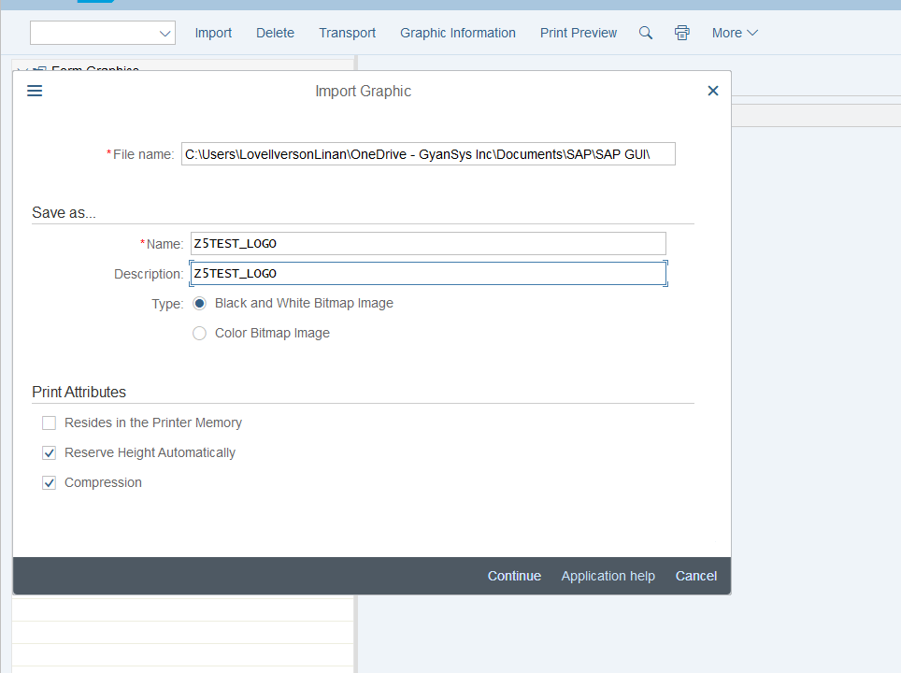

1. Click print preview

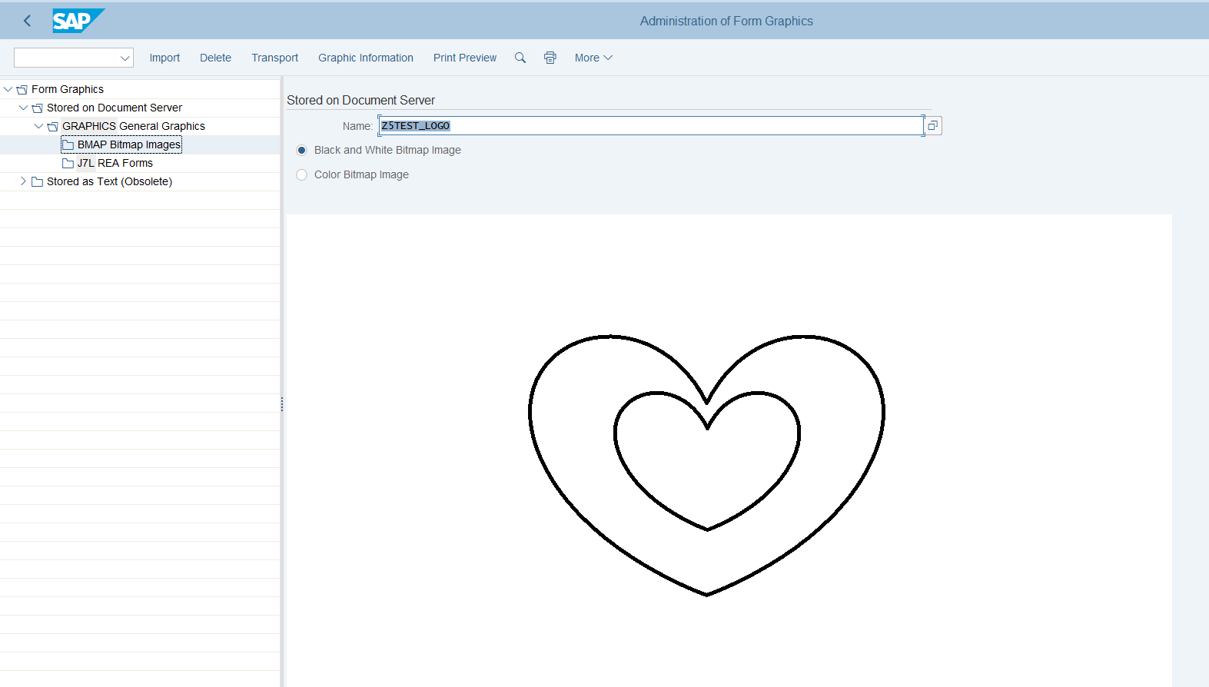

1. Go to the interface and add variable for logo. Add this to context in form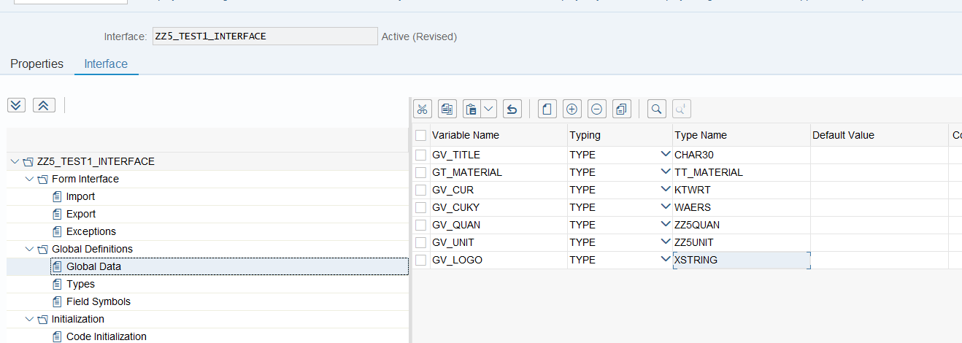
2. Go to initialization and use this retrieve the logo xstring

cl_ssf_xsf_utilities=>get_bds_graphic_as_bmp(

EXPORTING

p_object = 'GRAPHICS' *" GRAPHICS*

p_name = 'Z5TEST_LOGO' *" Name of the Logo*

p_id = 'BMAP'*" BMAP*

p_btype = 'BCOL' *" BCOL for color, 'BMON' for Black & White in SE78*

RECEIVING

p_bmp = gv_logo *"importing the logo xstring*

EXCEPTIONS

not_found = 1

internal_error = 2

OTHERS = 3

).

1. Add the created variable to context

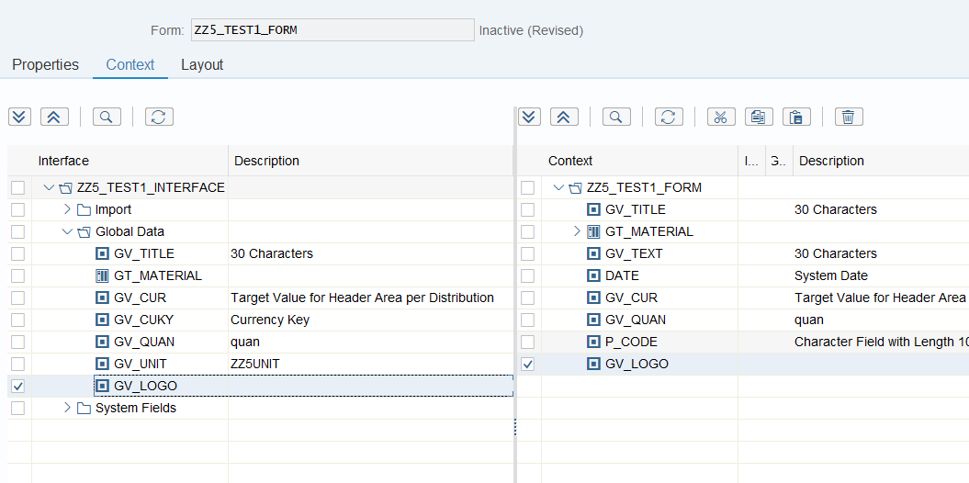

1. Right click the folder in context and create and graphic

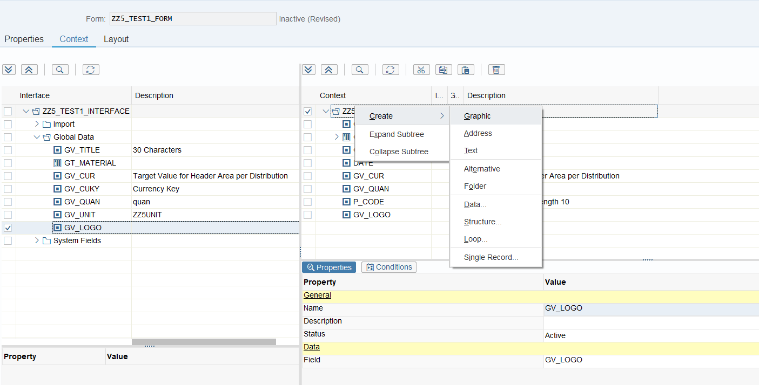

1. Customize Graphic Name

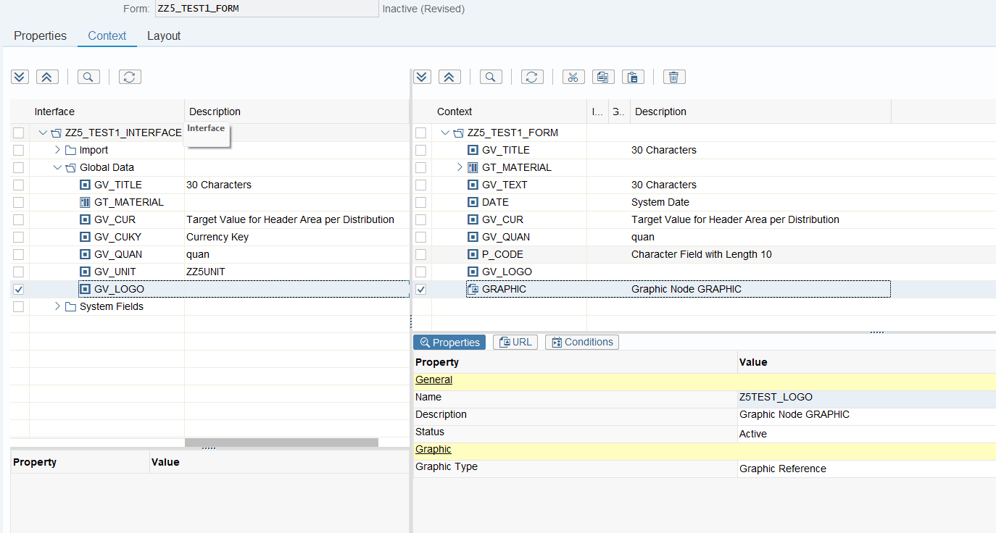

1. Change the graphic type to Object type. Assign value for field and MM Type

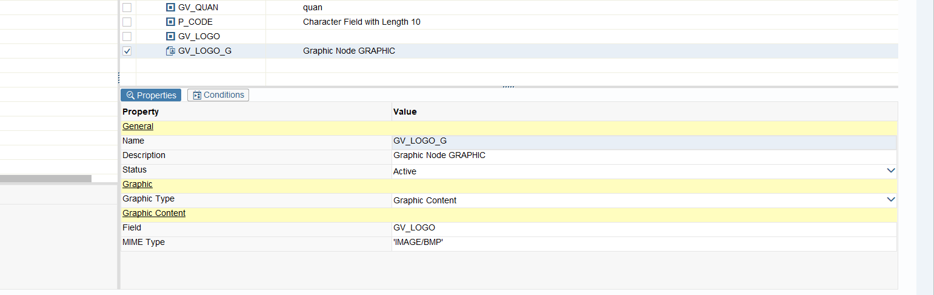

1. Go to layout and drag the graphics created. Do not check the checkbox in embedded image data.

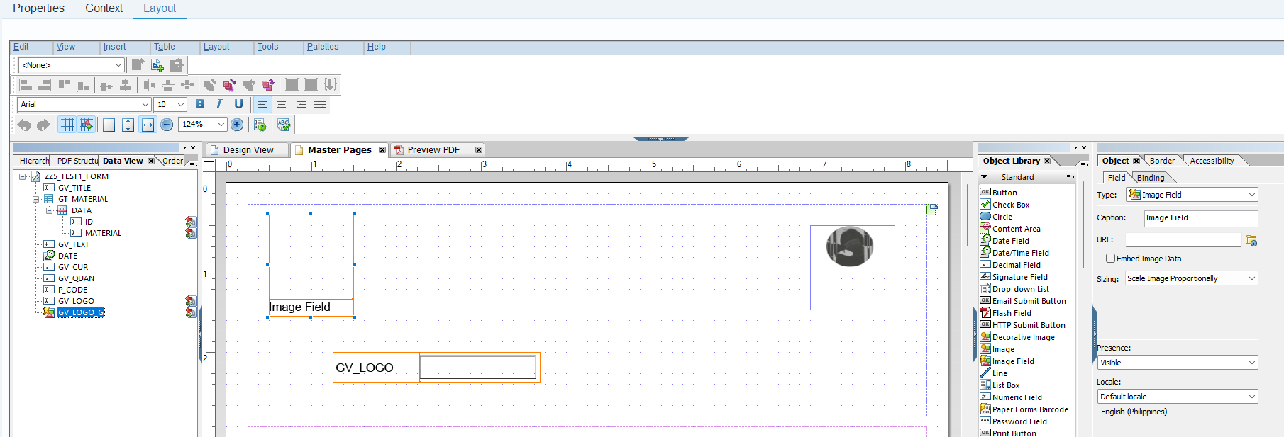

1. To remove the image field caption simply change the type to image then change again to image field and correct the binding name

