**Debug adobe forms**

1. General

* Program name: RSNAST00
* Find tnapr-ronam

1. Specific

* Go to se16n and find the program name

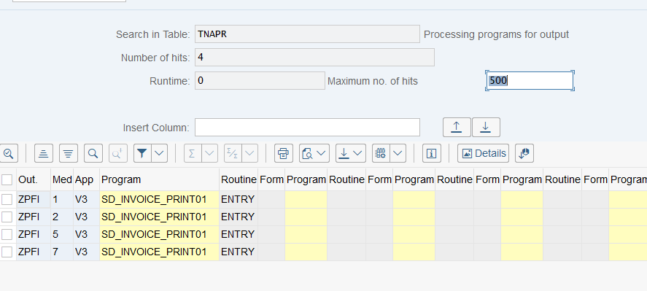

1. Debug the interface

TRY .

CALL FUNCTION 'FP_FUNCTION_MODULE_NAME'

EXPORTING

i_name = form *"form name*

IMPORTING

e_funcname = fm_name. *"generated fm name of the form*

CATCH cx_fp_api.

ENDTRY. *"catch the error for the function module*

After getting the fm /1BCDWB/SM00000088 convert to program to

/1BCDWB/SAPLSM00000088 and check to SE38