Sales Dashboard Report

Introduction
For this project, I created a Sales Dashboard in Microsoft Excel to analyze the overall sales performance of a company from 2014 to 2017. The main purpose of this dashboard is to understand sales trends, profit growth, customer contribution, and category-wise performance in a clear and visual way.

About the Data
The dataset contains information such as:
- Order Date
- Category and Sub-category
- State
- Customer Name
- Sales
- Profit
The data includes transactions from the years 2014 to 2017.
Before creating the dashboard, the data was cleaned properly so that pivot tables and charts work correctly.

Tools and Techniques Used
- Microsoft Excel
- Pivot Tables
- Pivot Charts
- Slicers for filtering by Category and Year
- Map Chart
- Data Cleaning (Date formatting and validation)

Dashboard Overview
The dashboard includes multiple sections:

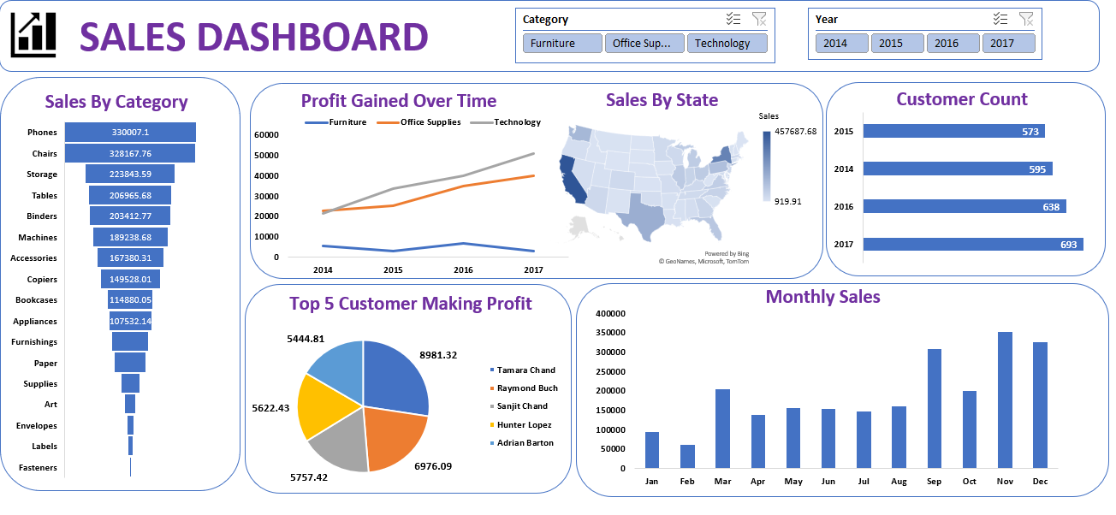

1. Sales by Category
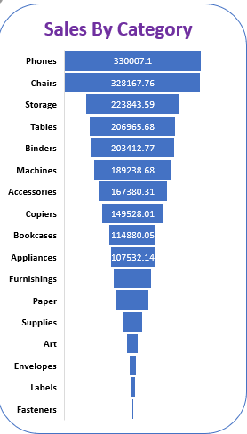
This section shows total sales for different categories like Phones, Chairs, Storage, Accessories, etc.
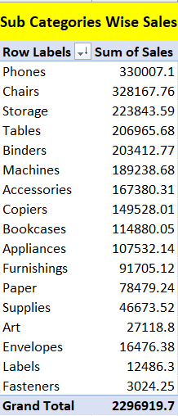

From the chart, it is clear that some categories like Phones and Chairs contribute more to total sales compared to others. Lower categories like Labels and Fasteners contribute less.

2. Profit Gained Over Time
This line chart shows profit trends from 2014 to 2017 for:
- Furniture
- Office Supplies
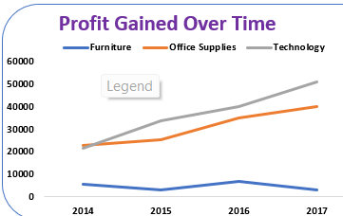
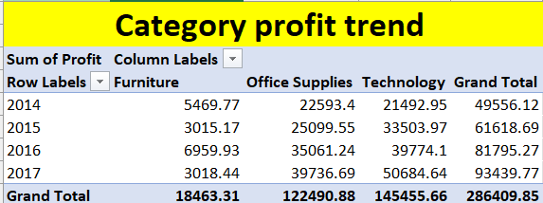
- Technology

We can observe that Technology shows steady growth in profit over the years. Profit overall is increasing year by year, which indicates business growth.

3. Sales by State
This is shown using a map chart. It helps in understanding which states are generating higher revenue. Some states have darker shades, meaning higher sales contribution compared to others.
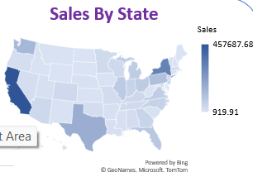
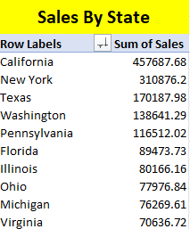

4. Customer Count (Year-wise)
This chart shows the number of customers each year.
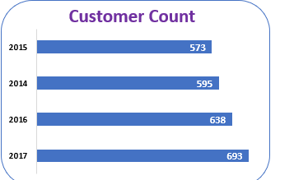
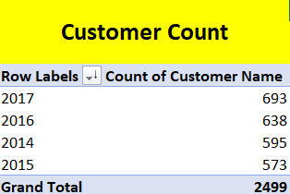

There is a gradual increase in customer count from 2014 to 2017. This indicates that the company is expanding and gaining more customers every year.

5. Top 5 Customers Making Profit
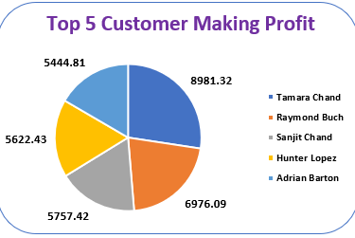
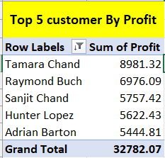
This pie chart shows the top 5 customers who generated the highest profit.

It highlights that a small number of customers contribute a large portion of profit. This information can help the company maintain good relationships with these key customers.

6. Monthly Sales
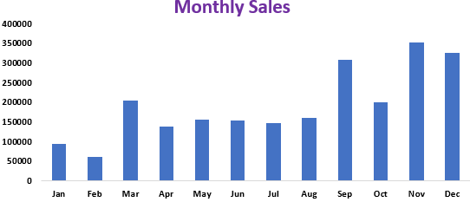
The monthly sales column chart shows fluctuations throughout the year.
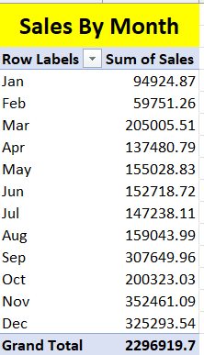
Sales are usually higher towards the end of the year, especially in November and December. This may be due to seasonal demand or year-end purchases.

Conclusion
Overall, this dashboard provides a clear and interactive way to analyze sales performance. It makes it easier to identify profitable categories, track yearly growth, and understand customer behavior.

