

Submitted to: Dr.Aditya Khamparia

INT246

Safe and Efficient Control of Hydro Power Plant by Fuzzy Logic

Name: BIDHUN JOSEPH

Registration number: 11801327

Roll no: B31

INTRODUCTION

Spillways are the water driven structures built to outperform the surplus water in the dam over it. Spillways might be Gated or ungated. Entryways fill the need of saving up to an ideal. Reservoir activity is the specialty of putting away and delivering the water through the store to serve the different needs and destinations consistently. Spillway doors permit the dam proprietor some adaptability in the activity of a dam both as far as flood tasks and for ecological deliveries. Spillway doors are intended to amplify the capacity limit of a dam while expanding the spillway limit with respect to a given headwater level. The peak of the spillway is generally given at F.R.L (Full Repository Level). Nonetheless, so as to control floods, the entryways could be given at the top and the water level could be expanded up to the greatest water level.

In the current examination for productive and compelling control of a gated spillway and supply activity utilizing fluffy rationale is examined.

WORKFLOW

Due to the nature of the problem. I had to find values that could be used for calculating the spillway gate openness. I kept the flow rate and water level adjusted to what other researchers did: 100m (maximum ) 100L/min(maximum)

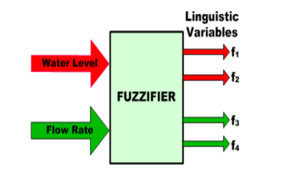

Spillway Gate: The application of FLC system for dam consisting of two input variables: “Water Level” and “Water flow Rate”. “Openness of the Spillway gate ” is output variable and is controlled by the FLC rule base. The main aim of this control problem is to discharge excess water (danger level or above) in shortest possible time for the overall safety of the system and thus bringing it back to safe or desired level (below danger level) through FLC.