PROJECT REPORT

##### DEPARTMENT OF Computer Science and Engr.

Lovely Professional University

**Prediction and analysis of College Football Using ML**

#### Submitted by:

### Ayush Srivastava

### 11709497

### Prashant Sirohi

### 11709395

### Shivmangal Singh Yadav

### 11709300

*Supervisor:* Dr. Aditya Khamparia

### April 12,2020

**Abstract**

Many techniques to predict the outcome of professional football matches have tra- ditionally used the number of goals scored by each team as a base measure for eval- uating a team’s performance and estimating future results. However, the number of goals scored during a match possesses an important random element which leads to large inconsistencies in many games between a team’s performance and number of goals scored or conceded.

The main objective of this project is to explore different Machine Learning techniques to predict the score and outcome of football matches, using in-game match events rather than the number of goals scored by each team. We will explore different model design hypotheses and assess our models’ performance against benchmark techniques.

In this project, we developed an ’expected goals’ metric which helps us evaluate a team’s performance, instead of using the actual number of goals scored. We com- bined this metric with a calculation of a team’s offensive and defensive ratings which are updated after each game and used to build a classification model predicting the outcome of future matches, as well as a regression model predicting the score of future games. Our models’ performance compare favourably to existing traditional techniques and achieve a similar accuracy to bookmakers’ models.

**Acknowledgments**

Firstly, I would like to thank my supervisor, Dr. Jonathan Passerat-Palmbach, for his constant support and help throughout the duration of the project. His confidence in my work encouraged me to do my best.

Secondly, I would like to thank my second marker, Prof. William Knottenbelt, for his expertise and for taking the time to discuss my ideas and to give me interesting insight.

Finally, I would also like to thank my family, for always believing in me, my friends, for their fun and support, Paul Vidal, for your friendship

**Introduction**

# Data Science for Football

As one of the most popular sports on the planet, football has always been followed very closely by a large number of people. In recent years, new types of data have been collected for many games in various countries, such as play-by-play data in- cluding information on each shot or pass made in a match.

The collection of this data has placed Data Science on the forefront of the football industry with many possible uses and applications:

* + - Match strategy, tactics, and analysis
    - Identifying players’ playing styles
    - Player acquisition, player valuation, and team spending
    - Training regimens and focus
    - Injury prediction and prevention using test results and workloads
    - Performance management and prediction
    - Match outcome and league table prediction
    - Tournament design and scheduling
    - Betting odds calculation

In particular, the betting market has grown very rapidly in the last decade, thanks to increased coverage of live football matches as well as higher accessibility to betting websites thanks to the development of mobile and tablet devices. Indeed, the foot- ball betting industry is today estimated to be worth between 300 million and 450 million pounds a year [1].

1

* 1. *MOTIVATION Chapter 1. Introduction*

# Motivation

A particularly important element of Data Science in football is the ability to evaluate a team’s performance in games and use that information to attempt to predict the result of future games based on this data.

Outcomes from sports matches can be difficult to predict, with surprises often pop- ping up. Football in particular is an interesting example as matches have fixed length (as opposed to racket sports such as tennis, where the game is played until a player wins). It also possesses a single type of scoring event: goals (as opposed to a sport like rugby where different events score a different number of points) that can hap- pen an infinite amount of times during a match, and which are all worth 1 point.

The possible outcomes for a team taking part in a football match are *win*, *loss* or *draw*. It can therefore seem quite straightforward to predict the outcome of a game. Traditional predictive methods have simply used match results to evaluate team per- formance and build statistical models to predict the results of future games.

However, due to the low-scoring nature of games (less than 3 goals per game on av- erage in the English Premier League in the past 15 years) (Fig.1.1), there is a random element linked to the number of goals scored during a match. For instance, a team with many scoring opportunities could be unlucky and convert none of their oppor- tunities into goals, whereas a team with a single scoring opportunity could score a goal. This makes match results an imperfect measure of a team’s performance and therefore an incomplete metric on which to predict future results.

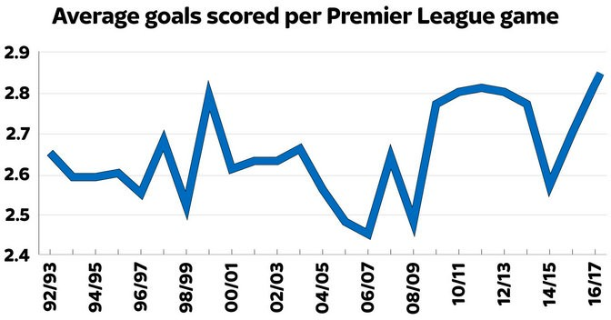

**Figure 1.1:** Average number of goals scored per game in the English Premier League [2]

A potential solution to this problem can be explored by using in-game statistics to dive deeper than the simple match results. In the last few years, in-depth match statistics have been made available, which creates the opportunity to look further

*Chapter 1. Introduction 1.3. OBJECTIVES*

than the match result itself. This has enabled the development of ’expected goals’ metrics which estimate the number of goals a team should have been expected to score in a game, removing the random element of goalscoring.

The emergence of new Machine Learning techniques in recent years allow for better predictive performance in a wide range of classification and regression problems. The exploration of these different methods and algorithms have enabled the devel- opment of better models in both predicting the outcome of a match and the actual score.

# Objectives

This project aims to extend the state of the art by combining two popular and mod- ern prediction methods, namely an expected goals model as well as attacking and defensive team ratings. This has become possible thanks to the large amount of data that is now being recorded in football matches.

Different Machine Learning models will be tested and different model designs and hypotheses will be explored in order to maximise the predictive performance of the model.

In order to generate predictions, there are some objectives that we need to fulfill: Firstly, we need to find good-quality data and sanitize it to be used in our models. In order to do so, we will need to find suitable data sources. This will allow us to have access to a high number of various statistics to use, compared to most of the past research that has been done on the subject where only the final result of each match is taken into account.

The main approach we will take is to build a model for expected goal statistics in order to better understand a team’s performance and thus to generate better pre- dictions for the future. To build this model, we will test different Machine Learning techniques and algorithms in order to obtain the best possible performance. We will be able to use data for shots taken and goals scored such as the location on the pitch or the angle to goal to estimate how many goals a team would have been expected to score during the game, and reduce the impact of luck on the final match result.

In parallel to this, we will generate and keep track of team ratings as football matches are played to take into account the relative strength of the opposition, in a similar way to the popular ELO rating system. This will allow us to better gauge a team’s current level and in consequence to generate better predictions for future games. These two key project objectives are presented in Fig.1.2.

An important part of this project will be to build a suitable Machine Learning train- ing and testing pipeline to be able to test new algorithms, with new features, and

* 1. *OBJECTIVES Chapter 1. Introduction*

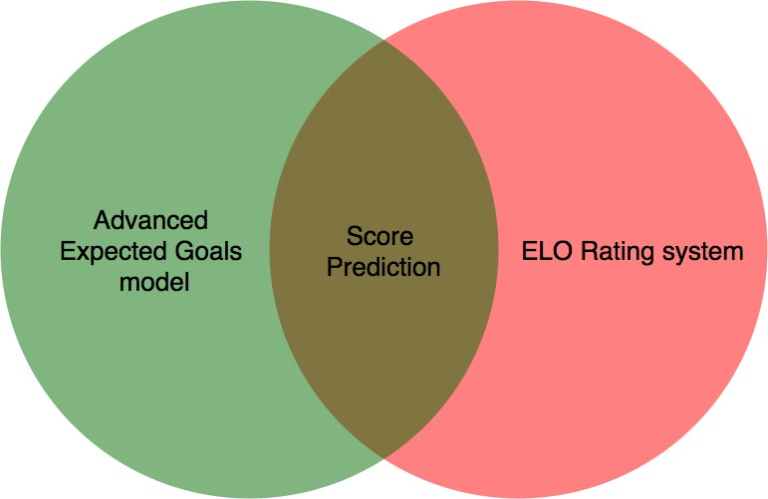

**Figure 1.2:** Key project objectives to generate predictions

compare it to other models with relative ease, which will result in a general project workflow illustrated in Fig.1.3.

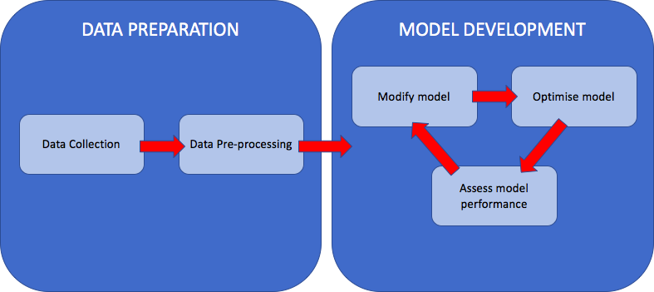

**Figure 1.3:** Project Workflow

Finally, our models will be assessed against benchmark predictive methods including bookmakers’ odds, using different performance metrics. A successful outcome for the project would be the creation of both a classification model capable of predicting a future game’s outcome, and a regression model capable of predicting a future game’s score, whose predictive performance compare favourably to different benchmark methods.

*Chapter 1. Introduction 1.4. CHALLENGES*

# Challenges

We face a number of challenges on the path to achieving the objectives we have set out:

**Data availability & quality**: Finding a public database of football data with the necessary statistical depth to generate expected goals metrics is an essen- tial part of the project. However, the leading football data providers do not make their information publicly available. We will need to scour various pub- lic football databases to find one that is suitable for us to use. The alternative approach in the case where we do not find a suitable database would be to find websites displaying the required data and using web scraping techniques to create our own usable database.

*•*

**Research and understanding of prediction landscape**: In order to design our models and test different hypotheses, we will need to undertake a thor- ough background research of prediction techniques and develop a mathemati- cal understanding of various Machine Learning algorithms that can be used for our predictions.

*•*

**Testing different models and parameters**: An important challenge will be to make the model training and testing tasks as quick and easy as possible, in order to test and compare different models. A robust pipeline will have to be built to enable us to find the best possible models.

*•*

# Contributions

An exploration of the Machine Learning landscape as well as past research in sports predictions, presented in Chapter 2.

*•*

A prepared and usable dataset containing all necessary statistics to generate expected goal metrics and calculate team ELO ratings, presented in Chapter 3.

*•*

A model training and testing pipeline allowing us to quickly and easily generate performance metrics for different models and hypotheses, presented in Chapter 5.

*•*

A classification model to predict match outcomes and a regression model to predict match results, presented in Chapters 4 and 6.

*•*

An assessment of our models’ performance against benchmark methods, pre- sented in Chapter 7.

*•*

**Background**

# Football Rules & Events

In this section, we will quickly present the rules of football, different match events and possible outcomes.

###### Simplified football rules:

* + - * Football is a game played with two opposing teams of 11 players and a ball, during 90 minutes.
      * On each side of the pitch, a team has a target called the goal in which they attempt to put the ball.
      * Scoring a goal gives a team 1 point.
      * The team with the largest number of points at the end of the game wins the match.
      * If both teams have scored the same number of goals, the game ends in a draw.

###### Domestic leagues competition format:

* + - * Each European country usually has a domestic league where clubs play against each other.
      * There are usually 20 teams in each league, with each team playing the others twice, once at their stadium (’home’ match) and once at the oppos- ing team’s stadium (’away’ match).
      * Winning a match gives a team 3 points, a draw gives each team 1 point.
      * The team with the highest number of points at the end of the season wins the league.

###### Main match events:

* + - * **Goals**: a goal is scored when the ball enters the opposing team’s goal.

6

* + - * **Shots**: a shot is when a player hits the ball towards the opposing team’s goal with the intention of scoring. There are many different kinds of shots, hit with different parts of the body or from different distances and angles.
      * **Passes**: a pass is when a player hits the ball towards another player of his team.
      * **Crosses**: a cross is when a player hits the ball from the side of the pitch towards the opposing team’s goal with the intention of passing the ball to one of his teammates.
      * **Possession**: the possession represents the fraction of the time that a team controls the ball in the match.
      * **Penalties & Free Kicks**: free kicks happen when a foul is committed by the opposing team on the pitch. In that case, the team that conceded the foul can play the ball from where the foul has happened. If the foul happens inside the penalty box (the zone near the goal), a penalty is awarded: the team that conceded the foul can shoot at goal from close range without anyone from the opposing team around.
      * **Cards**: cards are awarded whenever the referee deems a foul to be suit- ably important. Yellow cards are awarded for smaller fouls and do not have a direct consequence. However, two yellow cards collected by the same player result in a red card. If a player collects a red card, they have to leave the pitch, leaving their team with one less player. Red cards can also be directly obtained if a dangerous foul is committed or in other specific circumstances.
      * **Corners**: corners are awarded to the opposing team when a team hits the ball out of the pitch behind their goal. In this case, the ball is placed on the corner of the pitch and can be hit without any other player around.

# Machine Learning Techniques

In this section, we will present an overview of popular supervised Machine Learning techniques, for its subsets of classification and regression.

Supervised learning is the task of learning a function that maps input data to output data based on example input-to-output pairs. Classification happens when the out- put is a category, whereas regression happens when the output is a continuous num- ber. In our case, we want to predict the outcome category (home win/draw/away win) or the number of goals scored by a team (continuous number), so we are only interested in the supervised learning landscape of Machine Learning. We have sum- marised some popular supervised learning methods in Fig.2.1, which we will now cover in more detail.

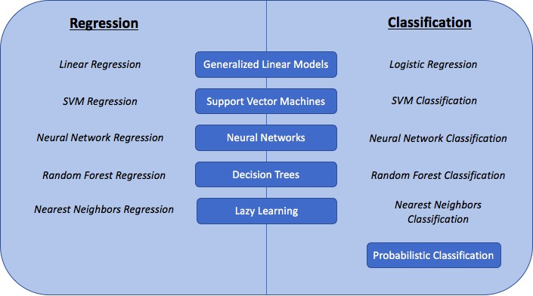

**Figure 2.1:** Overview of supervised Machine Learning techniques

## Generalized Linear Models

Generalized Linear Models are a set of regression methods for which the output value is assumed to be a linear combination of all the input values (Fig.2.2).

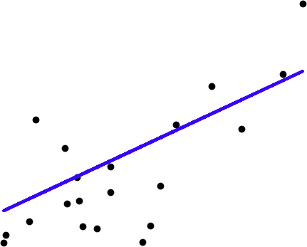

**Figure 2.2:** Linear Regression technique [3]

The mathematical formulation of the regression problem is:

*y* = *Ø*0 + *Ø*1*x*1 + *...* + *Ømxm* + *✏*

where:

* + - * *y* is the observed value/dependent variable
      * the *xk* are the input values/predictor variables
      * the *Øk* are the weights that have to be found
      * *✏* is a Gaussian-distributed error variable

Linear Regression fits a linear model with weights *Ø*ˆ

= (*Ø*ˆ1*, ..., Ø*ˆ*m*) by minimizing

the residual sum of squares between the actual responses *Y* in the dataset and the predicted responses *XØ* where *X* is the matrix of input variables in the dataset. This is the Ordinary Least Squares method:

*Ø*ˆ = min*Ø kXØ — Y k*2

Once the model has been fitted with the best possible weight *Ø*, the Linear Regres- sion model can generate a continuous output variable given a set of input variables.

On the other hand, Logistic Regression is a classification model for a binary output variable problem. Indeed, the output variable of the model represents the log-odds score of the positive outcome in the classification.

ln( *p*(*x*) )= *Ø*0 + *Ø*1*x*1 + *...* + *Ømxm*

1*—p*(*x*)

The log-odds score is a continuous variable which is used as input in a logistic func- tion (Fig.2.3):

*a*(*z*)= 1*—*

1+*e*

*z*

The logistic function outputs a number between 0 and 1 which is chosen to be the probability of the positive classification outcome given the input variables. Setting and optimizing a cut-off probability allows for classification decisions to be made when presented with new input variables.

Generalized Linear Models are a popular technique as they are easy to implement and, in many classification or regression problems, assuming linearity between pre- dictor variables and the outcome variable is sufficient to generate robust predictions. In addition to this, the fitted coefficients are interpretable, meaning that we can un- derstand the direction and magnitude of association between each predictor variable and the outcome variable.

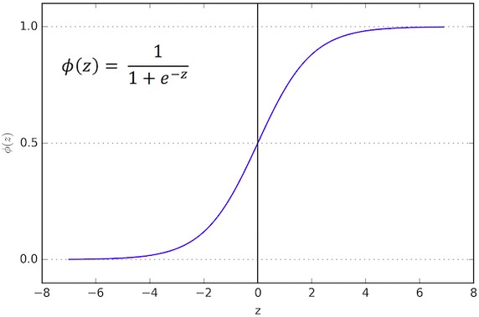

**Figure 2.3:** Logistic function [4]

However, using Generalized Linear Models can also have some disadvantages: the assumption that the input variables and output variable are linearly connected does not always fit the problem and can be too simple. Furthermore, if the input variables are highly-correlated, the performance of the model can be quite poor.

## Decision Trees

Decision Trees are a popular Machine Learning technique to link input variables, represented in the tree’s branches and nodes, with an output value represented in the tree’s leaves. Trees can both be used in classification problems, by outputting a category label, or in regression problems, by outputting a real number. Decision Trees can be fitted using different algorithms, including the CART or ID3 decision tree algorithms which are the most popular. These algorithms use a mix of greedy searching and pruning so that the tree both fits and generalizes the data to new in- put/output pairs.

Decision Trees have the advantage that they scale very well with additional data, they are quite robust to irrelevant features and they are interpretable: the choices at each node allow us to understand the impact of each predictor variable towards the outcome. However, decision trees can often become inaccurate, especially when exposed to a large amount of training data as the tree will fall victim to overfitting. This happens when the model fits the training data very well but is not capable of generalizing to unseen data, thus resulting in poor predictive performance.

Random Forests operate by building a large amount of decision trees during training, taking a different part of the dataset as the training set for each tree. For classifi-

cation problems, the final output is the mode of the outputs of each decision tree, whereas for regression problems, the mean is taken. This technique is illustrated in Fig.2.4.

This results in a model with much better performance compared to a simple decision tree, thanks to less overfitting, but the model is less interpretable as the decisions at the nodes of the trees are different for each tree.

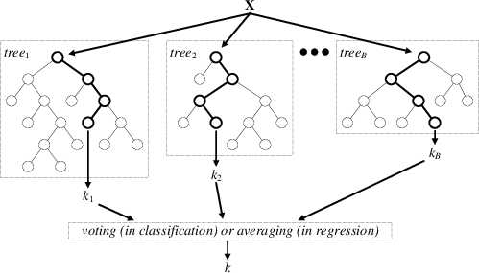

**Figure 2.4:** Random Forest technique [5]

## Probabilistic classification

Probabilistic classifiers are Machine Learning methods capable of predicting the probability distribution over classes given input variables.

One of the most popular probabilistic classifiers is the Naive Bayes classifier. It is a probabilistic classification method based on the ’naive’ assumption that every two different features are independent, thus enabling the use of Bayes’ Theorem:

*P* (*y|x*1*, ..., xn*)= *P* (*y*)*P* (*x*1*,...,xn|y*)

*P* (*x*1*,...,xn*)

where:

* + - * *y* is the target class
      * the *xi* are the predictor (input) variables

Using the independence assumption, this leads to the following:

*P* (*y|x*1*, ..., xn*) */ P* (*y*) Q*n P* (*xi|y*)

*i*=1

MAP (Maximum A Posteriori) estimation enables the creation of a decision rule (rule to choose the class to return as output) by choosing the most probable hypothesis.

For Gaussian Naive Bayes, the likelihood *P* (*xi y*) of the features is assumed to follow a Gaussian distribution, as illustrated in Fig.2.5:

*|*

*P* (*x |y*) = *p* 1 *exp*(*—* (*xi—µy* )2 )

*y*

*i*

2*⇡a*2

2*a*2

*y*

where the *ay* and *µy* parameters are estimated using Maximum Likelihood Estima- tion.

The advantages of using Naive Bayes classifiers is that they are highly scalable when presented with large amounts of data: indeed, they take an approximately linear time to train when adding features. However, even though the classifier can be robust enough to ignore the naive assumption, the predicted probabilities are known to be somewhat inaccurate.

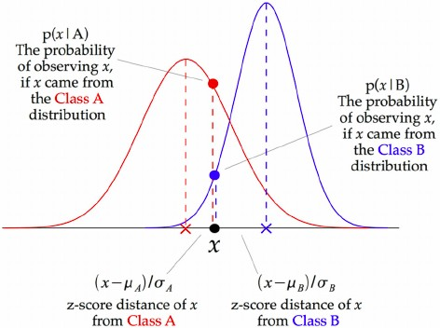

**Figure 2.5:** Gaussian Naive Bayes method

## Support Vector Machines

Support Vector Machines (SVMs) are Machine Learning models for both classifica- tion and regression. An SVM model represents the training data as points in space so that examples falling in different categories are divided by a hyperplane (see Fig.2.7) that is as far as possible from the nearest data point.

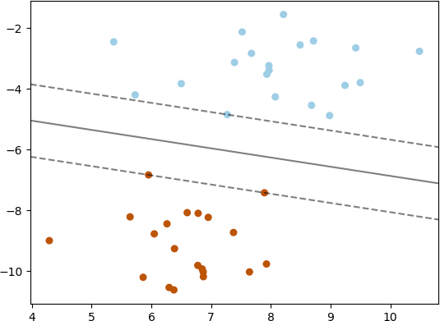

**Figure 2.7:** SVM Hyperplane for classification [8]

New inputs are mapped in the same way as the training data and classified as the category they fall into (which side of the hyperplane). When the data is not linearly separable, the kernel trick can be used, by using different possible kernel functions such as Radial Basis Functions (RBF) or polynomial functions, in order to map the data into high-dimensional feature spaces and find a suitable high-dimensional hy- perplane.

The above classification problem can be extended to solving regression problems in a similar way, by depending only on a subset of the training data to generate a re- gression prediction.

## Neural Network models

Neural Networks, also known as Artificial Neural Networks (ANNs), are systems that are based on a collection of nodes (neurons) that model at an algorithmic level the links between neurons in the human brain.

Each neuron can receive a signal from neurons and pass it on to other neurons. Two neurons are connected by an edge which has a weight assigned to it, which models the importance of this neuron’s input to the other neuron’s output. A neural network is usually composed of an input layer, with one neuron per input variable for the model, an output layer, composed of a single neuron which will give the classification or regression result, and a number of hidden layers between the two, containing a variable number of neurons in each layer. Fig.2.8 illustrates the archi- tecture of a neural network with one hidden layer.

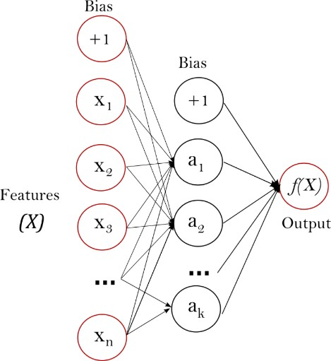

**Figure 2.8:** Neural Network diagram [9]

A neuron which receives an input *pj* from another neuron then computes its activa- tion value through its activation function *f* : *aj* = *f* (*pj*). The neuron’s output *oj* is then generated through its output function *fo* such that *oj* = *fo*(*aj*).

This leads us to the propagation function which calculates the input *pj* that a neuron

*j* receives in the network:

*pj* = *i oiwij* where *wij* is the weight between neurons *i* and *j*

P

Training the Neural Network model involves setting the correct weight between each

two neurons in the system. This is done through the back-propagation algorithm which inputs a new training example, calculates gradient of the loss function (a function which quantifies the error between the Neural Network prediction and the actual value) with respect to the weights and updates the weights from the output layer all the way back to the input layer:

*wij*(*t* + 1) = *wij*(*t*)+ *⌘ @C*

*@w*

*ij*

where:

* + - * *⌘* is the learning rate and determines the magnitude of change for the weights

*C* is the cost/loss function which depends on the learning type and neuron activation functions used

*•*

The advantages in using Neural Networks as classification or regression models are that they usually achieve a high level of predictive accuracy compared to other tech- niques. However, they require a very large amount of training data to optimise the model. In addition to this, neural networks are not guaranteed to converge to a single solution and therefore are not deterministic. Finally, Neural Networks are not interpretable: indeed, there are in general too many layers and neurons to under- stand the direction and magnitude of association of each input variable with the output variable through the different weights.

## Football prediction landscape

Generating predictions for football scores has been an important research theme since the middle of the 20th century, with the first statistical modelling approaches and insights coming from Moroney (1956) [10] and Reep (1971) [11] who used both the Poisson distribution and negative binomial distribution to model the amount of goals scored in a football match, based on past team results.

However, it was only in 1974 that Hill proved that match results are not solely based on chance, but can be modeled and predicted using past data [12].

The first breakthrough came from Maher [13] in 1982 who used Poisson distribu- tions to model home and away team attacking and defensive capabilities, and used

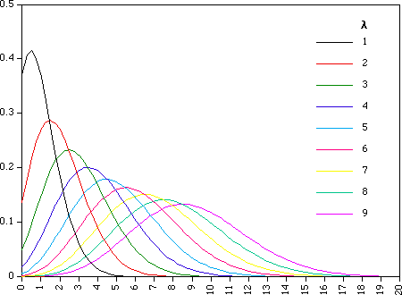

**Figure 2.9:** Poisson distribution for values of *Z* and k [15]

this to predict the mean number of goals for each team. Following this, Dixon and Coles [14] (1997) were the first to create a model capable of outputting probabilities for match results and scores, again following a Poisson distribution.

The Dixon and Coles model is still seen as a traditionally successful model, and we will use it as a benchmark against the models that we will be creating.

The Dixon and Coles model is based on a Poisson regression model, which means that an expected number of goals for each team are transformed into goal probabil- ities following the Poisson distribution (illustrated in Fig.2.9):

*P* (*k* goals in match)= *e—Z Zk*

*k*!

where *L* represents the expected number of goals in the match.

The Poisson distribution enables the calculation of the probability of scoring a certain number of goals for each team, which can then be converted into score probabilities and finally into match outcome probabilities.

Based on past results, the Dixon and Coles model calculates an attacking and de-

fensive rating for each team by computing Maximum Likelihood estimates of these ratings on past match results and uses a weighting function to exponentially down- weight past results based on the length of time that separates a result from the actual prediction time.

Rue and Salveson [16] (2000) chose to make the offensive and defensive parame- ters vary over time as more results happen, then using Monte Carlo simulation to generate predictions. In 2002, Crowder et al. [17] followed up on their work to create a more efficient update algorithm.

At the beginning of the 21st century, researchers started to model match results (win/draw/loss) directly rather than predicting the match scores and using them to create match result probabilities. For example, Forrest and Simmons (2000) [18] used a classifier model to directly predict the match result instead of predicting the goals scored by each time. This allowed them to avoid the challenge of interdepen- dence between the two teams’ scores.

During the same year, Kuypers [19] used variables pulled from a season’s match re- sults to generate a model capable of predicting future match results. He was also one of the first to look at the betting market and who tried to generate profitable betting strategies following the model he developed.

We have therefore seen that past research have tried to predict actual match scores as well as match results. It would be interesting in this project to look at the perfor- mance of generating a classification model for match outcome against a regression model for match scores.

We will now take a look at more recent research done on the subject, with the use of modern Machine Learning algorithms that will be interesting for us to investigate when trying different predictive models.

In 2005, Goddard [20] tried to predict football match results using an ordered probit regression model, using 15 years of results data as well as a few other explanatory variables such as the match significance as well as the geographical distance between the two teams. It was one of the first papers to look at other variables than actual match results. He compared the model predictions with the betting odds for the matches and found that there was the possibility of a positive betting return over time. Like Goddard, we will want to use other explanatory variables in our model than only match results, which will allow us to use different sets of features to try obtaining the best model possible.

It is also interesting to look at the algorithms used for predictions in other team sports: for example, in 2006, Hamadani [21] compared Logistic Regression and SVM with different kernels when predicting the result of NFL matches (American Football).

More recently, Adam (2016) [22] used a simple Generalised Linear Model, trained using gradient descent, to obtain match predictions and simulate the outcome of a tournament. He obtained good results, even with a limited set of features, and recommends to add more features and to use a feature selection process, which is something that will be interesting for us to do in this project considering the number of different features that will be available to us.

Tavakol (2016) [23] explored this idea even further: again using a Linear Model, he used historical player data as well as historical results between the two teams going head to head in order to generate predictions. Due to the large number of features available, he used feature extraction and aggregation techniques to reduce the number of features to an acceptable level to train a Linear Model.

There are multiple ways to reduce the number of features to train a Machine Learn- ing model: for instance, Kampakis [24] used a hierarchical feature design to pre- dict the outcome of cricket matches. On the other hand, in 2015, Tax et al. [25] combined dimensionality reduction techniques with Machine Learning algorithms to predict a Dutch football competition. They came to the conclusion that they ob- tained the best results for the PCA dimensionality reduction algorithm, coupled with a Naive Bayes or Multilayer Perceptron classifier. It will be interesting for us to try different dimensionality reduction techniques with our Machine Learning algorithms if we have a large number of features we choose to use. This also shows us that a large amount of data might not be required to build a Neural Network model and achieve interesting results.

Bayesian networks have been tested in multiple different recent research papers for predicting football results. In 2006, Joseph [26] built a Bayesian Network built on expert judgement and compared it with other objective algorithms, namely Decision Tree, Naive Bayesian Network, Statistics-based Bayesian Network and K-nearest- neighbours. He found that he obtained a better model performance for the Network built on expert judgement, however expert knowledge is needed and the model quickly becomes out of date.

Another type of Machine Learning technique that has been used for a little longer is an Artificial Neural Network (ANN). One of the first studies on ANN was made by Purucker in 1996 [27] to predict NFL games, who used backpropagation to train the network. One of the limitations of this study was the small amount of features used to train the network. In 2003, Kahn [28] extended the work of Purucker by adding more features to train the network and achieved much better results, confirming the theory that Artificial Neural Networks could be a good choice of technique to build sports predictive models.

Hucaljuk et al. (2011) [29] tested different Machine Learning techniques from mul- tiple algorithm families to predict football scores:

* + - * Naive Bayes (probabilistic classification)
      * Bayesian Networks (probabilistic graphical model)
      * LogitBoost (boosting algorithm)
      * K-nearest-neighbours (lazy classification)
      * Random Forest (decision tree)
      * Artificial Neural Networks

They observed that they obtained the best results when using Artificial Neural Net- works. This experiment is espacially interesting to us as we will want to test different algorithms in the same manner, to obtain the one that works the best for our data and features.

By looking at the past research done on the subject of building models to predict football match outcomes, we have been able to gain interesting information on the different techniques we should try using as well as the potential pitfalls we should avoid.

## ELO ratings

We will now look at two areas of research that are especially important considering the objective of our project: firstly, we will want to look at how team ratings have previously been used to improve predictions.

The most famous rating system, still used today, was invented in 1978 by Elo [30] to rate chess players. The name ”ELO rating” was kept for future uses, such as Buch- dahl’s 2003 paper [33] on using ELO ratings for football to update teams’ relative strength. These types of rating have also been used for other sports predictions, such as tennis. Indeed, Boulier and Stekler (1999) [31] used computer-generated rank- ings to improve predictions for tennis matches, while Clarke and Dyte (2000) [32] used a logistic model with the difference in rankings to estimate match probabilities.

In 2010, Hvattuma used an ELO system [34] to derive covariates used in regression models in the goal of predicting football match outcomes. He tested two different types of ELO ratings, one taking in account the match result (win/loss/draw) and another only taking the actual score in account. He used different testing bench- marks to evaluate his predictions, which enabled him to see that he obtained better results using ELO ratings than the other benchmarks he ran his model against. Rel- ative team strength ratings are very important to us in this project to encode past information and continuously update each team’s relative strength as new results are added to the model.

We will want to explore different possibilities of keeping track and updating these team ratings over time. Multiple approaches have already been explored: to gener- ate predictions for the football Euro 2016 tournament, Lasek (2016) [35] compared using ordinal regression ratings and using least squares ratings, combined with a Poisson distribution, to generate predictions and simulate the tournament a large number of times using Monte Carlo simulations. Viswanadha et al. (2017) [36] used player ratings rather than team ratings to predict the outcome of cricket matches using a Random Forest Classifier. Using player data to calculate relative player strengths and improve our model could be a potential extension to this project. Fi- nally, in 2013, Fenton [37] came up with a new type of team rating, called pi-rating. This rating dynamically rates teams by looking at relative differences in scores over time. There are clearly different ways of evaluating relative team strength and weak- ness, and we will need to try different techniques for this project to try and obtain the best predictions we can.

## Expected goals (xG) models

The second theme that is important to us for this project is building an expected goals model. This is a quite modern concept that aims to analyse match data to un- derstand how many goals a team should have scored considering the statistics that have been observed during the match. Using an expected goals model enables us to eliminate some of the randomness that is associated with actual goals scored and get a better picture of a team’s performance, and therefore strength.

In 2012, MacDonald [38] created an expected goals model to evaluate the perfor- mance of NHL (Hockey) matches, using two metrics:

* + - * The Fenwick rating (shots and missed shots)
      * The Corsi rating (shots, missed shots and blocked shots)

This enabled the evaluation of a team’s performance to understand if, for example, they were wasteful with their goal opportunities, or if they did not manage to create enough goalscoring opportunities. Very good results were obtained for this expected goals model, with more efficient estimates for future results. A possible extension for this paper would be to use the opponent’s data to calculate the expected goals. That is exactly what we will be trying to do with football: using both teams’ data to understand how many goals each team were expected to score in a match, and use this value to improve future predictions.

In 2015, Lucey [40] used features from spatio-temporal data to calculate the likeli- hood of each shot of being a goal. This includes shot location, defender proximity, game phase, etc. This allows us to quantify a team’s effectiveness during a game and generate an estimation for the number of goals they would have been expected to score. This example is particularly interesting for us, as we have geospatial data for shots and goals scored in matches. We will use that data to build an advanced ex- pected goals model to better understand how a team has actually performed during

the game.

Similarly, Eggels (2016) [39] used classification techniques to classify each scoring opportunity into a probability of actually scoring the goal, using geospatial data for the shot as well as which part of the body was used by the player. Difference classification techniques were tested including logistic regression, decision trees and random forest. We will also need in this project to test different methods of quanti- fying the probability of scoring a goal for each opportunity.

Finally, one of the most interesting examples for out project comes from a website named FiveThirtyEight [41], who combine an expected goals model with a team rating system to predict the outcome of future football matches. In essence, they keep an offensive and defensive rating for each time depending on an average of goals scored and expected goals that are recorded in each game. This allows them to forecast future results and run Monte Carlo simulations to try and predict compe- tition winners. It is interesting to note that the weight given to the expected goals decrease if a team is leading at the end of a match, which would be an hypothesis for us to explore.

For our project, we will take inspiration from these methods, but we will improve the expected goals model by testing different Machine Learning algorithms and adding features in order to try and output the best possible predictions.

**Dataset**

# Data origin

We have obtained a dataset from the Kaggle Data Science website called the ’Kaggle College foot ball analysis’ [42]. This database has been made publicly available and regroups data from three different sources, which have been scraped and col- lected in a usable database:

Game.csv

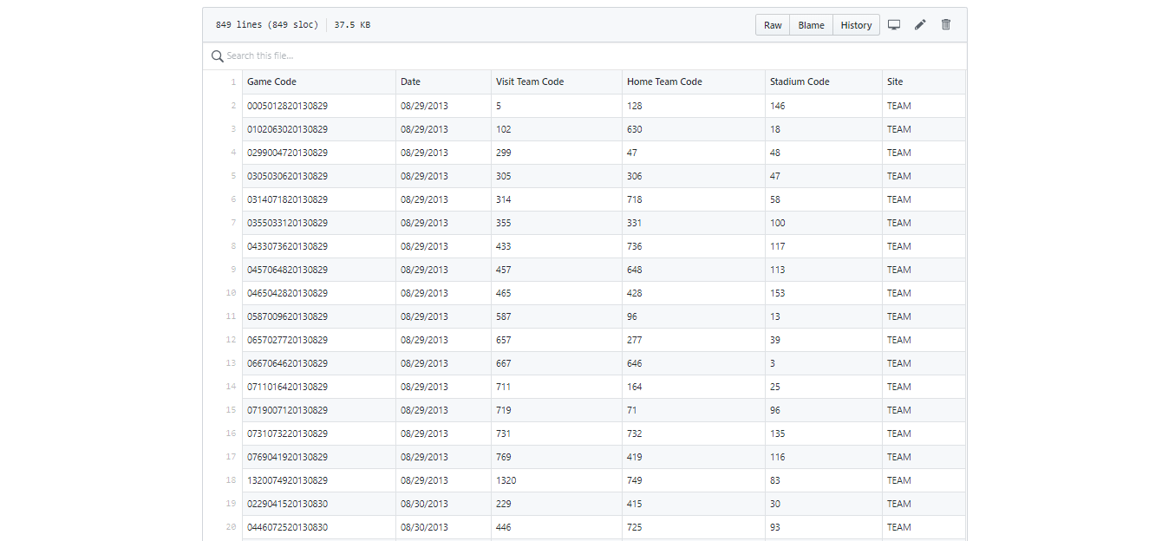

Game-statistics.csv

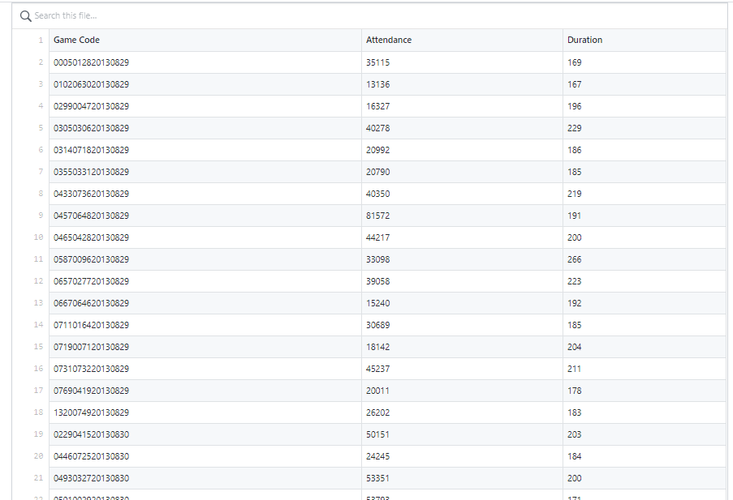

# Data features

A simplified diagram of the database structure and features is presented in Fig.3.1. We will now present the different tables and features that we have in our database and that we can use in our models:

* + - Matches table
      * ID
      * League ID
      * Season
      * Date
      * Home team ID
      * Away team ID

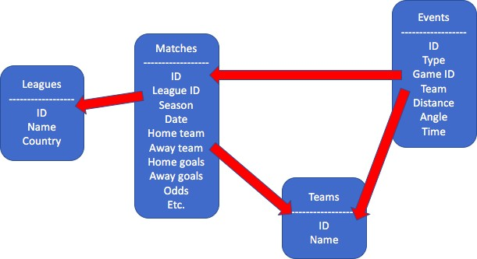

**Figure 3.1:** Structure of the Database

* + - Home team goals scored
    - Away team goals scored
    - Home team possession
    - Away team possession
    - Home win odds
    - Draw odds
    - Away win odds

Events tables:

*•*

Here is a list of the different match events tables that we have extracted:

* + - Goals
    - Shots on target
    - Shots off target
    - Corners
    - Crosses
    - Cards
    - Fouls

For each of these match event tables, we have the following features:

* + - ID
    - Type
    - Subtype
    - Game ID
    - Team ID
    - Player ID
    - Distance to goal (only for goals and shots)
    - Angle to goal (only for goals and shots)
    - Time elapsed

**Compilation Screenshots**



