**Ques 1.1- Research and list at least five benefits of cloud computing over traditional on premises infrastructure for banking management system.**

Here are some of the key benefits of cloud computing over traditional on-premises infrastructure for a banking management system:

1. [**Faster Processing Speed**: Cloud computing can handle vast amounts of customer data efficiently, improving the speed of customer interactions and data utilization](https://www.knowledgehut.com/blog/cloud-computing/cloud-computing-for-banks).

But in traditional on-premises, it takes a lot of time as well as efforts to do the same.

1. [**Centralized Data Repository**: Banks using cloud computing can seamlessly integrate operating systems and business applications, creating a centralized data repository](https://www.knowledgehut.com/blog/cloud-computing/cloud-computing-for-banks).

But in traditional on-premises, it is not possible to manage such a large repository.

1. [**Disaster Recovery**: Cloud computing provides robust disaster recovery solutions, ensuring business continuity even in the event of a data loss](https://www.knowledgehut.com/blog/cloud-computing/cloud-computing-for-banks).

But in traditional one, we don’t have any kind of backup in this case. If anything happens, we completely lose our data.

1. [**Data Security**: Cloud providers offer advanced security features that ensure the safety of sensitive banking data](https://www.knowledgehut.com/blog/cloud-computing/cloud-computing-for-banks).
2. [**Cost Efficiency**: Cloud computing reduces the need for expensive on-premises hardware, leading to significant cost savings](https://www.pwc.com/us/en/industries/financial-services/library/cloud-banking.html).

But in traditional on-premises, it takes the cost of building , software , hardware and also you have to pay to the employees as well as manager as a salary which cost much more than the cloud.

**Ques 1.2- Describe the Op Ex and Cap Ex models of financing IT infrastructure, providing examples of when each model is preferred.**

**Operating Expense (Op Ex) Model** Operating Expenses (Op Ex) are the costs that a business incurs as a part of its daily operations. [In the context of IT infrastructure, Op Ex refers to expenses incurred for services that are consumed on an ongoing basis and paid for as they are used1](https://iwv.works/blogs/transforming-your-it-infrastructure-into-an-opex-model/). [Examples include costs for Software-as-a-Service (SaaS) licenses, Infrastructure-as-a-Service (IaaS) subscriptions, internet, utilities, and maintenance](https://www.kaseya.com/blog/capex-vs-opex/) , GoKhana App of Capgemini, Uber, Zomato etc.

The Op Ex model is often preferred when:

* [The company wants to preserve capital and maintain flexibility](https://www.investopedia.com/ask/answers/112814/whats-difference-between-capital-expenditures-capex-and-operational-expenditures-opex.asp).
* [The company has limited capital for upfront investment](https://feniceenergy.com/decoding-opex-vs-capex-solar-models-in-india/).
* [The company experiences spikes in operating costs or a sudden surge in end-users or demand](https://www.liquidweb.com/blog/capex-vs-opex/).

**Capital Expense (Cap Ex) Model** Capital Expenditures (Cap Ex) are the funds used by a company to acquire, upgrade, and maintain physical assets. [In the context of IT, Cap Ex corresponds to the costs incurred for the purchase of infrastructure, such as hardware (e.g., servers) and equipment, that generally have a lifespan of two to 10 years](https://www.kaseya.com/blog/capex-vs-opex/), Netflix subscription for a year , Google Drive etc.

The Cap Ex model is often preferred when:

* [The company is prepared to make a substantial upfront investment](https://ornatesolar.com/blog/capex-vs-opex-solar-differences-benefits-and-how-to-choose-the-right-model)
* [The company is trying to invest in its future and wants to be most efficient with its long-term capital](https://www.investopedia.com/ask/answers/112814/whats-difference-between-capital-expenditures-capex-and-operational-expenditures-opex.asp).
* [The company wants to have more control and autonomy over its IT infrastructure](https://www.liquidweb.com/blog/capex-vs-opex/)

**Ques 2.1- Create a brief report differentiating between public, private and hybrid clouds. Include a diagram that represents each cloud model.**

**Public Cloud**

[A Public Cloud is a cloud computing model in which the infrastructure and services are owned and operated by a third-party provider and made available to the public over the internet](https://www.geeksforgeeks.org/public-cloud-vs-private-cloud-vs-hybrid-cloud/). [Examples of public cloud providers are Amazon Web Services (AWS), Microsoft Azure, and Google Cloud Platform (GCP)](https://www.geeksforgeeks.org/public-cloud-vs-private-cloud-vs-hybrid-cloud/).

**Advantages**:

* [**Cost Efficient**: You only pay for what you use](https://www.geeksforgeeks.org/public-cloud-vs-private-cloud-vs-hybrid-cloud/).
* [**Automatic Software Updates**: No need to manually update the software](https://www.geeksforgeeks.org/public-cloud-vs-private-cloud-vs-hybrid-cloud/).
* [**Accessibility**: Users can access their resources and applications from anywhere in the world](https://www.geeksforgeeks.org/public-cloud-vs-private-cloud-vs-hybrid-cloud/).

**Disadvantages**:

* [**Security and Privacy Concerns**: Public clouds can be vulnerable to data breaches and cyber attacks](https://www.geeksforgeeks.org/public-cloud-vs-private-cloud-vs-hybrid-cloud/).
* [**Limited Control**: Users have limited control over the infrastructure and resources](https://www.geeksforgeeks.org/public-cloud-vs-private-cloud-vs-hybrid-cloud/).
* [**Reliance on Internet Connectivity**: A reliable and stable internet connection is required](https://www.geeksforgeeks.org/public-cloud-vs-private-cloud-vs-hybrid-cloud/).
* [**Service Downtime**: There may be service downtime due to hardware failures, software issues, or maintenance activities](https://www.geeksforgeeks.org/public-cloud-vs-private-cloud-vs-hybrid-cloud/).
* [**Compliance and Regulatory Issues**: May not meet certain compliance or regulatory requirements](https://www.geeksforgeeks.org/public-cloud-vs-private-cloud-vs-hybrid-cloud/).
* [**Cost Overruns**: Usage exceeding anticipated levels can result in unexpected costs](https://www.geeksforgeeks.org/public-cloud-vs-private-cloud-vs-hybrid-cloud/).

**Private Cloud**

[Private Cloud is a cloud computing model that is dedicated solely to your organization](https://www.bmc.com/blogs/public-private-hybrid-cloud/). [It is stored on the organization’s own infrastructure](https://www.geeksforgeeks.org/public-cloud-vs-private-cloud-vs-hybrid-cloud/).

## Hybrid Cloud

[Hybrid Cloud is an environment that uses both public and private clouds](https://www.bmc.com/blogs/public-private-hybrid-cloud/). [It offers the benefits of both public and private clouds](https://www.geeksforgeeks.org/public-cloud-vs-private-cloud-vs-hybrid-cloud/).

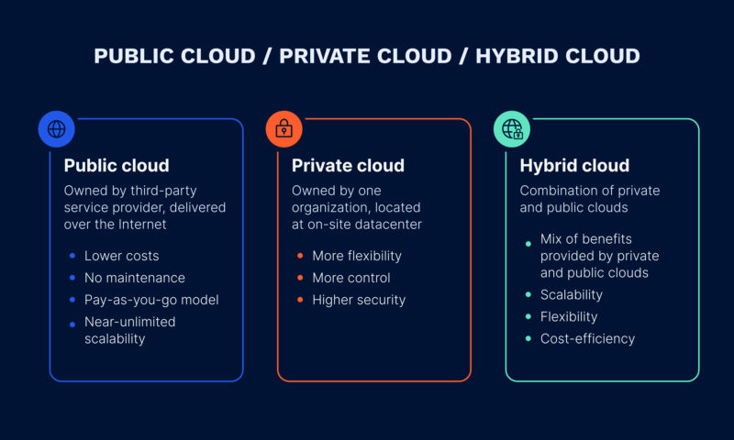

***CLOUD MODEL DIAGRAM—***

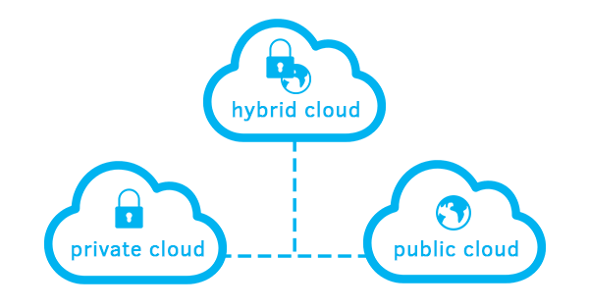

**Ques 2.2- For each cloud model, list one real world applications or scenario where that model where that model would be the most appropriate choice.**

1. **Public Cloud**: A common use-case for the public cloud is **web-based email** like Gmail or Yahoo Mail. [These services are hosted on the cloud provider’s infrastructure and can be accessed from anywhere with an internet connection](https://www.cbtnuggets.com/blog/certifications/cloud/4-cloud-deployment-models-with-examples-public-private-community-hybrid).
2. **Private Cloud**: Private clouds are often used by businesses that need to **protect sensitive data**. [For example, a healthcare organization might use a private cloud to store patient records and other confidential information](https://www.cbtnuggets.com/blog/certifications/cloud/4-cloud-deployment-models-with-examples-public-private-community-hybrid).
3. **Hybrid Cloud**: Hybrid cloud models are useful for businesses that have both **sensitive and non-sensitive data**. [For instance, a retail business might store sensitive customer data in a private cloud while using a public cloud for hosting its website](https://www.cbtnuggets.com/blog/certifications/cloud/4-cloud-deployment-models-with-examples-public-private-community-hybrid).