AIM: To understand devOps principles, practices and engineer roles and responsibilities.
THEORY: DevOps is a practice that aims to merge development, quality assurance, and operations into a single, continuous set. A DevOps engineer is responsible for application development management, continuous integration, continuous delivery, monitoring, reporting, security control, and ensuring effective collaboration between software developers, testers, and DevOps team members.
Principles of Devops:
7 key Principles
1. Collaboration
Collaboration is at the heart of DevOps. It involves breaking down traditional silos between development, operations, and other relevant teams. In a collaborative DevOps environment, cross-functional teams come together seamlessly. Developers, operations engineers, quality assurance professionals, and even business stakeholders work as a cohesive unit. This synergy enables them to share knowledge, skills, and responsibilities. Collaborative DevOps teams are empowered to jointly tackle complex challenges, leading to faster problem-solving and more efficient workflows.

2. Data-Based Decision Making
In DevOps, data is a valuable asset that drives informed decision-making. Organizations collect and analyze data from various sources within the software development and deployment lifecycle. This data includes metrics related to code quality, deployment frequency, and system performance. By harnessing the power of data analytics, DevOps teams gain valuable insights into their processes. They can identify trends, bottlenecks, and areas for improvement. These data-driven decisions empower teams to optimize workflows, enhance product quality, and meet customer expectations more effectively.

3. Customer-Centric Decision Making
DevOps places a strong emphasis on customer satisfaction. This principle ensures that every decision and development effort centers around meeting customer needs. To achieve this, organizations establish continuous feedback loops with their customers. They actively seek input and consider customer preferences during product development. User-centric design practices are also integrated into the development process, ensuring that the final product aligns with customer expectations. Customer-centric decision making ultimately leads to the delivery of products and services that resonate with and delight users.

4. Constant Improvement
DevOps embraces a culture of perpetual advancement. Team members are encouraged to consistently seek opportunities to enhance processes and deliver greater value. This culture promotes a mindset of experimentation and innovation. DevOps teams regularly review their workflows, tools, and methodologies. They identify areas where improvements can be made, whether through adopting new technologies, streamlining processes, or refining development practices. Continuous improvement ensures that organizations remain agile and responsive in a rapidly evolving technological landscape.

5. Responsibility Throughout the Life Cycle
DevOps principles advocate for end-to-end responsibility across the software development life cycle. This means that every team member takes ownership of their work from inception through production deployment. By minimizing handoffs and delays, DevOps teams ensure that accountability is maintained at every stage. Developers are responsible not only for coding but also for ensuring that their code functions as expected in a production environment. Operations engineers collaborate closely with developers to facilitate smooth deployments and maintenance. This end-to-end responsibility enhances the reliability and speed of software delivery.

6. Automation
Automation is a fundamental pillar of DevOps. It involves the systematic use of tools and practices to reduce manual intervention, minimize errors, and expedite the delivery pipeline. Automated testing, for example, allows for swift and consistent evaluation of code changes, significantly reducing the risk of introducing defects. Deployment pipelines are automated to ensure that code moves seamlessly from development to production environments. Automation not only accelerates the delivery of software but also enhances consistency and repeatability, making it a cornerstone of DevOps success.

7. Failure as a Learning Opportunity
In DevOps, failure is not viewed as a setback but as a valuable learning opportunity. This mindset shift fosters a culture of experimentation and resilience. When something goes wrong, DevOps teams engage in post-mortem analyses to understand the root causes of failures. They share these lessons learned across the organization, ensuring that mistakes are not repeated. This approach not only encourages innovation but also builds a robust foundation for continuous improvement. By embracing failure as a stepping stone to growth, DevOps teams adapt, innovate, and evolve to deliver better solutions to their customers.

DevOps Practices:
1. Agile project management
Agile is an iterative approach to project management and software development that helps teams deliver value to their customers faster and with fewer headaches. Agile teams focus on delivering work in smaller increments, instead of waiting for a single massive release date. Requirements, plans, and results are evaluated continuously, allowing teams to respond to feedback and pivot as necessary.

2. ​​​​​​​Shift left with CI/CD
When teams “shift left”, they bring testing into their code development processes early. Instead of sending multiple changes to a separate test or QA team, a variety of tests are performed throughout the coding process so that developers can fix bugs or improve code quality while they work on the relevant section of the codebase. The practice of continuous integration and continuous delivery (CI/CD), and deployment underpins the ability to shift left. Read more about CI/CD.

​​​​​​​3. Build with the right tools
A DevOps toolchain requires the right tools for each phase of the DevOps lifecycle, with key capabilities to improve software quality and speed of delivery. Read more about how to choose DevOps tools and review functionality for each phase of the DevOps lifecycle.

4. ​​​​​​​Implement automation
Continuous integration and delivery allows developers to merge code regularly into the main repository. Instead of manually checking code, CI/CD automates this process, from batching in a specified window to frequent commits. In addition to CI/CD, automated testing is essential to successful DevOps practices. Automated tests might include end-to-end testing, unit tests, integration tests, and performance tests. Read more about incorporating automation into your software development processes. Read more about automation.

​​​​​​​5. Monitor the DevOps pipeline and applications
It’s important to monitor the DevOps pipeline so a broken build or failed test doesn’t cause unnecessary delays. Automation improves the speed of development tremendously, but if there is a failure in an automated process and nobody knows about it, you’re better off doing the work manually. In a similar vein, it’s important to monitor production applications in order to identify failures or performance deficiencies, before you hear about them from your customers.

6. ​​​​​​​Observability
As the industry moved away from monolithic, on-premise systems and applications to cloud-native, microservice-based applications, monitoring is now considerably more complex. As a result, there is an increasing interest in observability. It is often said that the three pillars of observability are logs, traces, and metrics. Logs are generated by most systems components and applications and consist of time-series data about the functioning of the system or application. Traces track the flow of logic within the application. Metrics include CPU/RAM reservation or usage, disk space, network connectivity, and more. Observability simply means using all three of these sources of information in aggregate to make discoveries and predictions about the functioning of a complex system, which would otherwise be difficult to achieve. Read more about observability.

7. ​​​​​​​Gather continuous feedback
Continuous feedback ensures team members have all the information needed to do their jobs on a timely basis. From the development perspective this entails that the team is alerted to any pipeline failures immediately. It also means that clear, thorough code test results are made available to the developers as quickly as possible. From the product management perspective the team is made aware of any production failures or performance deficiencies, or reported bugs. In the past there was widespread belief that a development team could only optimize for speed or quality. Continuous feedback is one of the elements of DevOps that makes it possible to have both.

8. ​​​​​​​Change the culture
DevOps requires collaboration, transparency, trust, and empathy. If your organization is one of the rare ones where these qualities are already established, it should be fairly easy for your teams to adopt DevOps practices. If not, some effort will be required to develop these qualities. The most common organizational structures are siloed, meaning different teams have separate areas of ownership and responsibility and there is minimal cross-team communication or collaboration

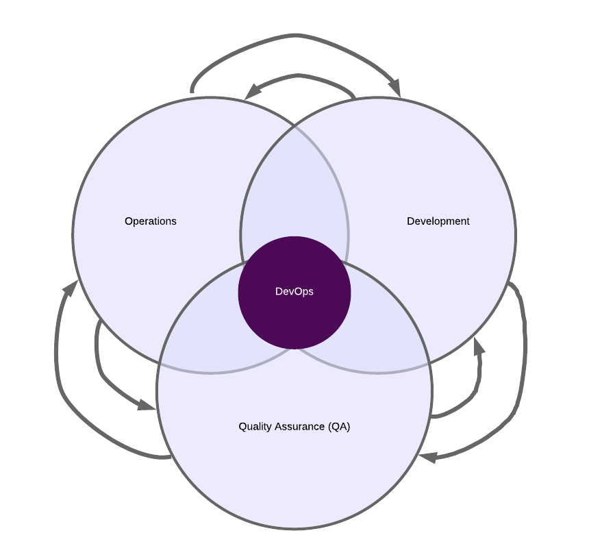
Engineer Roles and Responsibilities
1. Project Planning: Participate in processes of strategic project planning meetings · Provide end to end IT Solution that includes developing, building, installing.
2. Automate Processes: In addition, the specialist needs to constantly monitor all processes at each stage of the project to minimize problems in the final product. Skills.
3.Infrastructure management: Along with a deep understanding of development and operations principles, DevOps engineers often serve as cloud architects
4. Experience with devops tools: DevOps engineers will often be expected to have experience with one or more configuration management tools such as Chef, Puppet, or Ansible. Many organizations
5. Monitoring: Continuous Monitoring. DevOps engineers monitor how the created and integrated software performs and they look for opportunities to improve the performance.
6. Testing: Knowing project kpis and customer requirements. Applying DevOps practices and methodologies enables organisations to manage tool development, solution development, integrated tool and platform testing.
7. Deployment: DevOps engineers monitor how the created and integrated software performs and they look for opportunities to improve the performance. Continuous Deployment.

CONCLUSION: After learning DevOps principles, an engineer's roles and responsibilities typically include:
Continuous Integration and Continuous Delivery (CI/CD) Management: Introducing and managing the CI/CD workflow to enable continuous delivery of software.
Infrastructure Management: Overseeing the company's IT infrastructure, including cloud deployment and management.
Collaboration and Communication: Ensuring effective collaboration between software developers, testers, and other team members.
Performance Assessment and Monitoring: Monitoring system performance and recommending enhancements.
Security Control: Implementing and maintaining security measures, especially in cloud environments.
Documentation and Reporting: Writing specifications, documentation, and reports for the server-side features and the DevOps processes.
Problem-Solving and Troubleshooting: Quickly identifying and resolving issues in everyday processes.
The DevOps engineer is also expected to have a strong technical background, excellent communication and coordination skills, and the ability to work with diverse teams and departments

CONCLUSION: DevOps principles, practices and engineer roles and responsibilities were studied in detail.

