

+91 9779720767

1 77777 66666

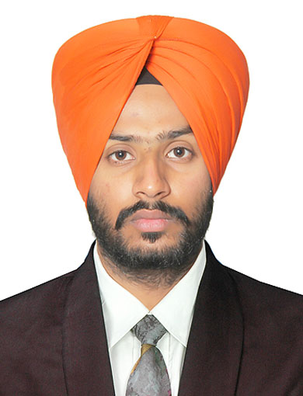

LOVEPREET SINGH



slovepreet435@@gmail.com

www.linkedin.com/lovepreet-singh-bains-a0792814a

DATA SCIENTIST



Hoshiarpur, Punjab



[LovepreetSingh-09](https://sdgjekxzr/)

SUMMARY

I am an enthusiastic learner seeking a full-time position in the field of Data Science and Machine Learning where I can expand my knowledge, learn new skills and contribute to the growth of the company.

TECHNICAL SKILLS

* Programming languages :-

Python, R, C, C++

* Data Modelling:-

Numpy, Pandas, Scikit-Learn, Tensorflow

* Data Visualization:-

Tableau, Matplotlib

* Data Management:-

MySQL, MS-Excel, Salesforce, Hadoop

* Platforms:-

Unix, MS Window7, 8, 10, 11

CERTIFICATIONS

* Applied Data Science with Python Specialization | University of Michigan | Sep’20
* Data Engineering, Big Data and Machine Learning Specialization | Google | Oct’20
* TensorFlow Developer Certification Program | DeepLearning.AI | Octt’20
* Natural Language Processing Specialization | DeepLearning.AI | Nov’20
* AI in Medicine Specialization | DeepLearning.AI | Nov’20
* Salesforce Developer Certification | Grazitti | Jan’23 – March’23

POWER SKILLS

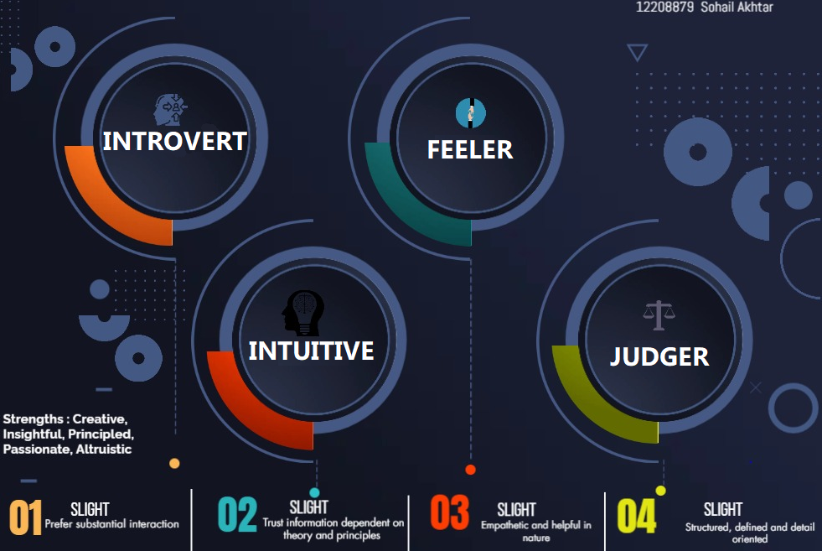

EXTRA CURRICULAR ACTIVITIES

Class-Representative in B.tech in LPU | Jan'20-Aug’20

ASME Coordinator in LPU | Oct'18

TRAINING PROGRAM

* Salesforce Developer Training Jan’23 -Feb’23

Online

* Gained hands-on experience in Customer Relationship Management (CRM).
* Performed automated and manual tasks on data and ensure that data created by organization is up to date and is available to use for various insights.
* Worked on Data Security to prevent sensitive data by setting permissions, roles, hierarchies and also using security at object, field and record level.
* Industrial Training Jun’18 – Jul’18

Sonalika International Tractors Ltd. | Hoshiarpur, Punjab

* Worked with the Project Manager in the engine assembly department.
* Managed Data of Engine Department using MS-Excel and used that data to make reports.

PROJECTS

WEB APP FOR PNEUMONIA DETECTION Oct’20

In this project, I created web application using flask and created a ResNet model which classifies an x-ray image uploaded by the user that whether it has pneumonia or not. The model was trained on a large dataset of x-ray images where I got 95% accuracy. Various libraries such as numpy, scikit-learn, tensorflow, matplotlib and flask was used to create the model and integrate it with the web app.

ELECTRIC BIKE WITH AUTOMATED RETRACTABLE WHEELSAug’19 – Dec’19

In this project a pair of retractable wheels were adjusted at the back side of the bike. The ECU was programmed in such a way that whenever it receives the signal from sensor about the low speed (15 kmph) of the vehicle, it sends a signal to the hub-motor to actuate the wheels to maintain the balance and prevent accidents which often happens with short-heighted and old-age people on two-wheelers.

US COVID-19 CASES ANALYSIS AND PATTERN PROJECTION Sep’20

This project is done by me to analyze the COVID-19 cases in US by doing statistical analysis on the data recorded day by day. A chart for active cases and deaths was created separately to understand the trend and pattern of the pandemic.

ACHIEVEMENTS

* Secured 1st Position in Essay Writing Competition Jan '14
* Awarded Certificate of Merit by GNP May’14
* Winner of Cricket Tournament at Khanpur Apr '21

EDUCATION

* M.Tech. in Data Science and Analytics Aug’22 - Present Lovely Professional University|Phagwara, IN CGPA - 9.21
* B.Tech. in Automobile Engineering Aug’16 - Aug’20 Lovely Professional University|Phagwara, IN CGPA - 8.68
* Higher Secondary (Non-Medical) Apr’14 – Mar’16 Rayat Bahra School of Education | Hoshiarpur, IN Percentage – 80.41%