

+91 9779720767

1 77777 66666

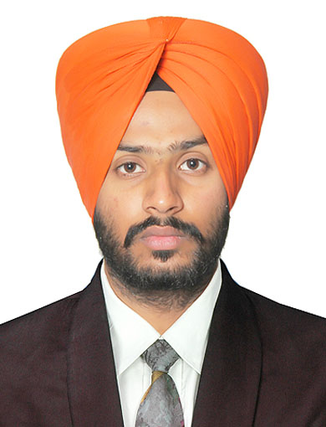

LOVEPREET SINGH

www.linkedin.com/lovepreet009



slovepreet435@gmail.com

DATA SCIENTIST



Hoshiarpur, Punjab



[LovepreetSingh-09](https://sdgjekxzr/)

SUMMARY TRAINING PROGRAM

An enthusiastic learner seeking a full-time position in the field of Data Science and Machine Learning where I can expand my knowledge, learn new skills and contribute to the growth of the company.

TECHNICAL SKILLS

* Programming languages :-

Python, R, C, C++

* Data Modelling:-

Numpy, Pandas, Scikit-Learn, Tensorflow

* Data Visualization:-

Tableau, Matplotlib

* Data Management:-

MySQL, MS-Excel, Salesforce, Hadoop

* Platforms:-

Unix, MS Window7, 8, 10, 11

CERTIFICATIONS

* Applied Data Science with Python Specialization | University of Michigan | Sep’20
* Data Engineering, Big Data and Machine Learning Specialization | Google | Oct’20
* TensorFlow Developer Certification Program | DeepLearning.AI | Oct’20
* Natural Language Processing Specialization | DeepLearning.AI | Nov’20
* AI in Medicine Specialization | DeepLearning.AI | Nov’20
* Salesforce Developer Certification | Grazitti | Jan’23 – Mar’23

POWER SKILLS

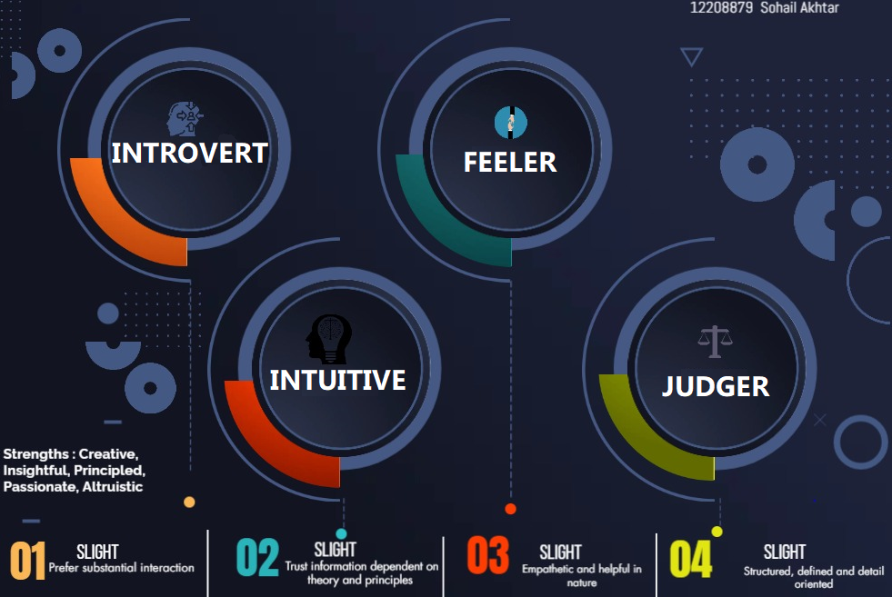

EXTRA CURRICULAR ACTIVITIES

Class-Representative in B.tech in LPU | Jan'20-Aug’20

ASME Coordinator in LPU | Oct'18

* Salesforce Developer Training Jan’23 -Feb’23

Online

* Gained hands-on knowledge in Customer Relationship Management (CRM).
* Learned to manage data and to use it to create reports and dashboards.
* Worked on Data Security to prevent sensitive data by setting permissions, roles, hierarchies and also using security at object, field and record level.
* Learned to automate tasks like record creation, updation, sending emails etc.
* Used Customer Service template to create website with chat snap-ins and knowledge.
* Industrial Training Jun’18 – Jul’18

Sonalika International Tractors Ltd. | Hoshiarpur, Punjab

* Worked in the engine assembly department to gain insights of various engine parts.
* Managed engine specifications related data to make reports using Ms-Excel.

PROJECTS

* WEB APP FOR PNEUMONIA CLASSIFICATION Sep’21 - Oct’21
* Created a convolutional neural network model by using tensorflow to classify pneumonia from x-ray images.
* Used several libraries such as scikit-learn, numpy and matplotlib to evaluate and visualize the model performance such as precision, recall and accuracy using different model parameters.
* Best model achieved 95% accuracy on the test dataset.
* Created a web application using flask to upload x-ray images of lungs.
* Integrated the developed model with the web-app to present the prediction and probability.

* US COVID-19 CASES ANALYSIS AND PATTERN PROJECTION Sep’20
* Used pandas library to import and clean the dataset and then to transform it into proper date and time format for analysis and visualization.
* Used matplotlib and seaborn libraries to present the number of daily cases and deaths in different bar graphs.
* Used lines on the same graph to present 7-day moving average for cases and deaths respectively to present the pattern formation.
* Highlighted top 5 states in terms of both cases and deaths on the respective graphs.

ACHIEVEMENTS

* Secured 1st Position in Essay Writing Competition Jan '14
* Awarded Certificate of Merit by GNP May’14
* Winner of Cricket Tournament at Khanpur Apr '21

EDUCATION

* M.Tech. in Data Science and Analytics Aug’22 - Present Lovely Professional University|Phagwara, IN CGPA - 9.21
* B.Tech. in Automobile Engineering Aug’16 - Aug’20 Lovely Professional University|Phagwara, IN CGPA - 8.68
* Higher Secondary (Non-Medical) Apr’14 – Mar’16 Rayat Bahra School of Education | Hoshiarpur, IN Percentage – 80.41%